Introduction

Problem Scenario
Retail and student traders should have safe and low-cost learning environments concerning the learning of trading mechanics, strategy testing, and developing confidence without exposing capital. Paper-trading platforms that are currently in existence tend to lack both personalized learning and deliberate practice coupled with actionable feedback; they either replicate the user interface of a live broker with no pedagogy or provide automated backtests without step-by-step learning. The statistics of surveys and usage of the platform indicate that some beginners drop out due to their initial losses or lack of understanding; there is also a gap in education between studying courses and their application. The proposed project aims to fill that gap by integrating an interactive paper-trading experience, adaptive learning modules, strategysimulation and analytics to expedite the acquisition of skills.

Solution
The given system is a web application that emulates the real market conditions with historical and simulated live data, offers a sandbox to place orders and has learning features: interactive tutorials, performance diagnostics and adaptive quizzes, a strategy lab where user can code, backtest and paper-run strategies. The application will provide learning paths based on the level (beginner to intermediate to advanced), tips provided in context when making a trade, and post-trade analytics that will help identify common errors and propose micro-lessons. This is a combination of an experimental trading sandbox and instructional scaffold to generate measurable learning outcomes.

Aim and objectives

Aim
To design and develop a secure, responsive paper-trading web application with built-in adaptive learning that helps novice traders progress toward intermediate skill through practice, feedback and analytics.

Objectives
- Deliver core paper-trading features (market feed simulation, order handling, portfolio tracking) within the first 12 weeks.
- Create at least 12 interactive lessons and 8 adaptive quizzes on trading basics and risk management.
- Develop a strategy lab for scripting simple strategies and backtesting them on historical data.
- Implement a performance analytics engine that computes key metrics and suggests follow-up lessons.
- Conduct a small user study (≥10 participants) to evaluate improvement in knowledge and simulated performance.

Literature Review

Investment Simulators and Paper Trading

In universities Educational stock market games like Stock-Trak and the Investopedia Stock Simulator are used extensively as tools to teach portfolio management, but with more emphasis on competition, rankings, than on structured pedagogy or feedback.

The studies on trading simulators indicate that trading simulators enhance financial literacy and confidence with the help of instructional scaffolding and reflection activities.

Gamification in Finance Education

The gamification of learning (points, badges, leaderboards) has been discovered to get more (financial) education learners to engage, but it is essential that the game elements coincide with learning objectives to have the desired impact on learning.

PaperTrade embraces the concept of light gamification (streaks, goals, badges) but emphasizes more on the analytics-based feedback.

Adaptive Learning Systems

Adaptive learning systems adapt the difficulty of the content depending on the learner performance and have better chances of retention as opposed to a fixed content.

Adaptive quizzes can address the false beliefs about risk and leverage in finance education, although the current trading simulators often do not incorporate the personalization.

Backtesting and Strategy Analysis

The QuantConnect and TradingView tools offer advanced backtesting platforms, though intended for advanced users, and need knowledge of code. They are not meant to be user friendly pedagogical platforms.

The PaperTrade strategy lab is deliberately over simplified: pre-defined strategies and simple scripting about a small number of indicators.

Comparison Table

Platform / Project | Type | Strengths | Limitations vs PaperTrade
Investopedia Stock Simulator | Web stock simulator | Widely used, realistic prices, contests & rankings. | Little structured teaching; no adaptive feedback.
TradingView Paper Trading | Charting + paper trades | Professional charts, many assets & indicators. | Geared towards advanced traders; limited pedagogy.
StockTrak | Educational simulator | Classroom management features for lecturers. | Learning resources not tightly integrated with trades.
Generic demo accounts on brokers | Broker demos | Same UX as live platforms, realistic execution. | No tailored learning; can be overwhelming.
PaperTrade (proposed) | Educational web app | Integrated learning paths, analytics-driven feedback, strategy lab designed for beginners. | Smaller asset universe; initially limited indicators and order types.

Methodology

Considered Methodologies
- Waterfall: Simple to manage, maintain and documcent tasks but inflexible when it comes to evolving requirements such as new learning features and analytics.

- Spiral/RUP: Where it does good on emphasizing the risks of the project but that also creates heavy documents

- Agile: supports incremental delivery of working features and frequent feedback cycles from test users.

Selected Methodology

In the end for the project Agile Iterative Method with two week sprints. Here are some dkey characteristics of this methodology.
A basic trading dashboard is the first of incremental prototypes, followed by a watchlist, backend APIs, learning modules, and backtesting.

Constant feedback: early iterations are tested by friends or classmates, and their input influences lesson design and UI adjustments.

Features in the prioritized backlog are roughly arranged as follows: must-have → should-have → could have.

Gantt Chart
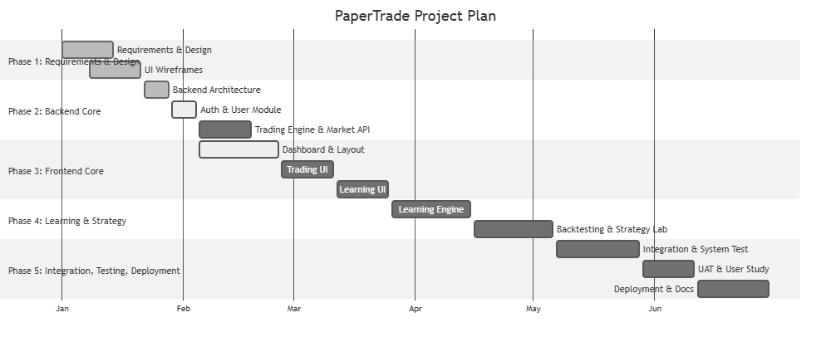
Figure 1: Gantt Chart

WBS

WBS CODE | Task/ Work package | Description | Duration | Deliverables
1.0 | Project  Initiation | Define project scope, stakeholders, constraints, risks, and feasibility | 1 week | Project charter,  scope document
1.1 | Requirement Gathering | Identify all functional and non-functional requirements for the system | 1 week | Requirement specification document
1.2 | System Design Approval | Confirm and approve UI layout, system architecture, and project plan | 1 week | Signed-off design and architecture blueprint
2.0 | System Design | Create technical architecture, UI design, and database structures | 2 weeks | System design documentation
2.1 | UI Wireframe Design | Design mid-  fidelity  wireframes for dashboard, trading module, and  learning module | 1 week | Figma wireframes
2.2 | Backend  Architecture  Design | Define API endpoints, data models, authentication flows, and database schema | 1 week | Backend architecture and database schema

3.0 | Backend  Development | Implement core server logic and APIs | 4 weeks | Backend services and endpoints
3.1 | Authentication Module | Implement  registration, login, JWT sessions, and user management | 1 week | Auth API and user database
3.2 | Paper Trading Engine | Implement order placement, trade simulation logic, and portfolio updating | 2 weeks | Trading simulation API and core trading logic
3.3 | Market Data Module | Integrate or simulate market price feeds for assets | 1 week | Market data feed API
4.0 | Frontend  Development | Create user interface for all modules | 4 weeks | Functional user interface
4.1 | Dashboard UI | Display  portfolio, market prices, charts, and alerts | 2 weeks | Trading dashboard interface
4.2 | Order  Placement UI | Build the UI for buy/sell orders, order types, and validations | 1 week | Order placement screen
4.3 | Learning Module UI | Implement UI  for tutorials, quizzes, and progress tracking | 1 week | Learning content interface
5.0 | Learning  Engine  Development | Implement adaptive learning rules and logic | 3 weeks | Learning backend engine

5.1 | Lesson  Content  Creation | Create educational content, quizzes, examples, and explanations | 2 weeks | Lesson and  quiz bank
5.2 | Analytics  Integration | Track user performance and suggest targeted lessons using analytics | 1 week | Learning analytics engine
6.0 | Backtesting & Strategy Tools | Develop tools to test trading strategies with historical data | 3 weeks | Strategy lab and backtesting module
6.1 | Backtest Engine | Code engine  for historical simulation and performance  results | 2 weeks | Backtesting results generator
6.2 | Strategy Editor | Provide UI for defining or selecting preset strategies | 1 week | Strategy editor interface
7.0 | Integration & Testing | Integrate modules and validate overall system functionality | 3 weeks | Fully integrated system
7.1 | Unit Testing | Test individual components and endpoints | 1 week | Unit test reports
7.2 | User  Acceptance  Testing (UAT) | Collect user feedback, measure  usability, and refine system | 2 weeks | UAT report and refinements
8.0 | Deployment | Host and publish the system online | 1 week | Live deployed application
8.1 | Cloud  Deployment | Configure database, hosting | 1 week | Public URL and working deployment
 |  | services, and secure access
9.0 | Documentation & Presentation | Produce technical and academic documentation | 2 weeks | Complete  project report and presentation
9.1 | Technical  Documentation | Write technical manual, API documentation, setup procedures | 1 week | Technical documentation pack
9.2 | Final  Presentation | Prepare and deliver final presentation | 1 week | Presentation  slides and demo

8. Milestone
Milestone Code | Milestone | Completion  Criteria | Expected Date
M1 | Project Initiation  Complete | Scope, problem  definition, feasibility  documented | Week 1
M2 | Requirements  Finalised | Functional & nonfunctional requirements approved | Week 2
M3 | System Design Approved | Architecture, DB schema, and UI wireframes signed-  off | Week 4
M4 | Backend Core Completed | Authentication, trading engine & market API functional | Week 8
M5 | Frontend Core Completed | Dashboard, order  interface & learning UI working | Week 12
M6 | Learning Engine Implemented | Lessons, quizzes & adaptive  suggestions active | Week 15
M7 | Backtesting Tools Ready | Strategy editor & backtest results operational | Week 18

Development Till Date

Structure Diagram

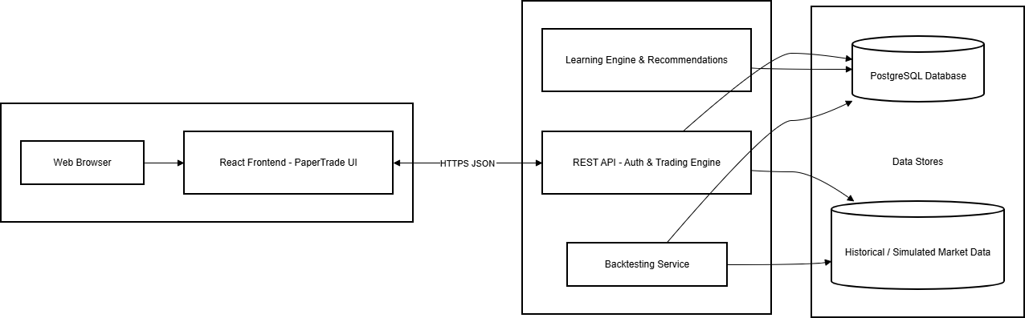

Flow Chart

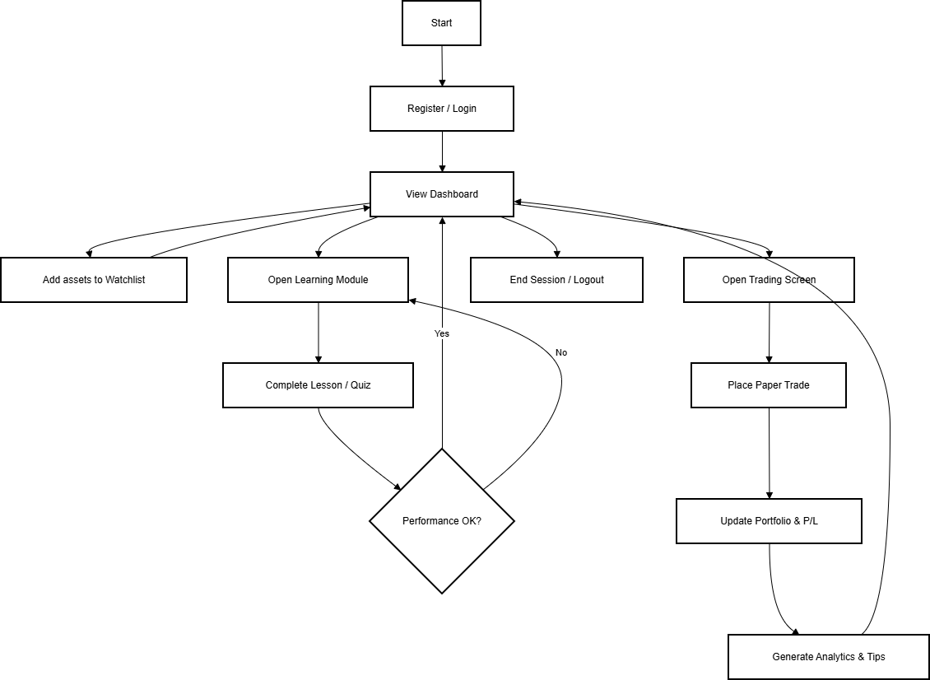

Use Case

ERD

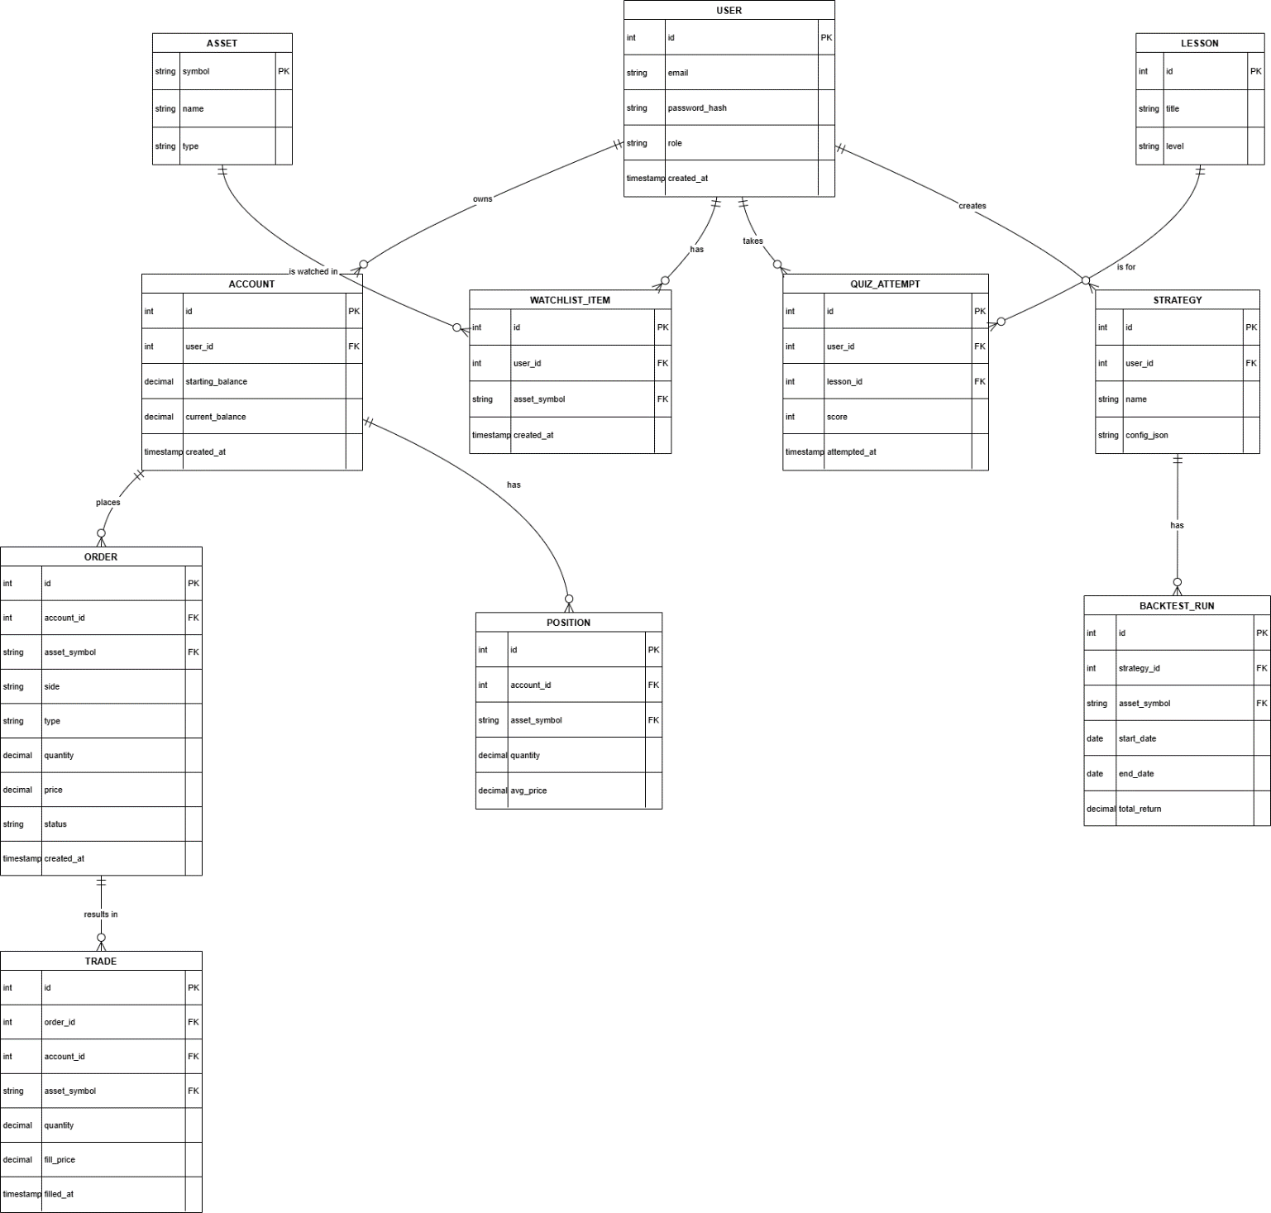

Sequence Diagram

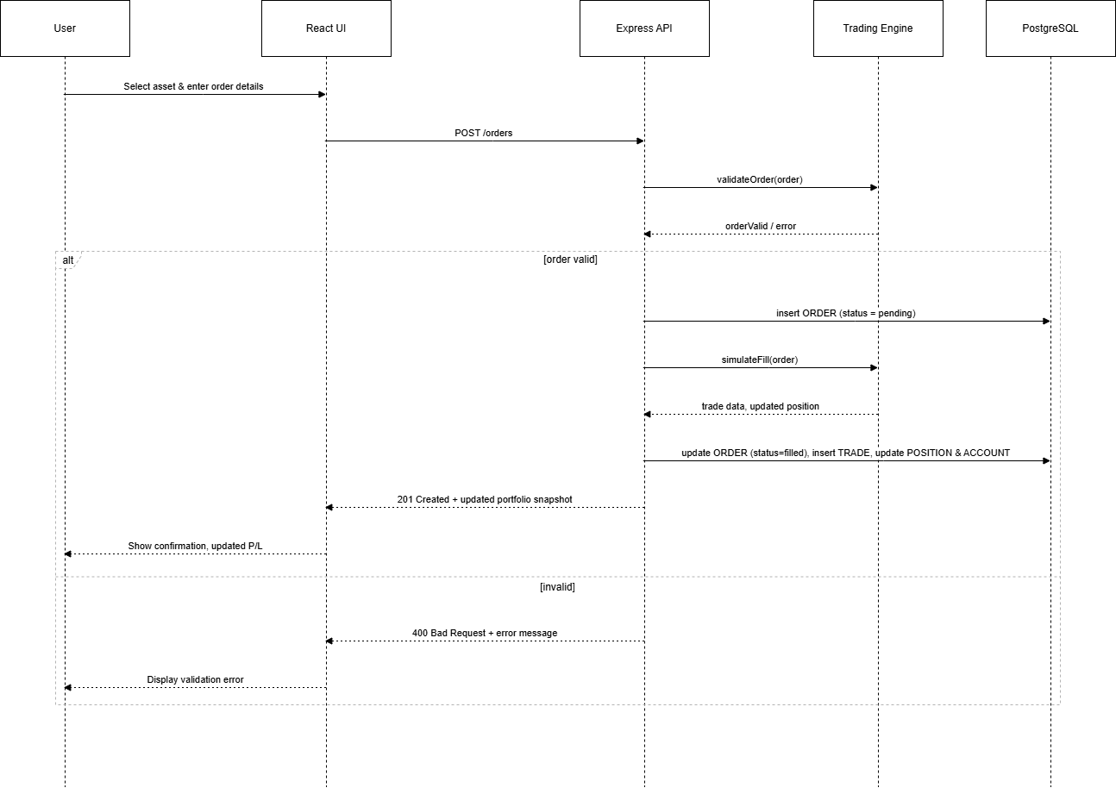

Development Status

This segment is a summary of the milestones that have been made thus far in the development of the PaperTrade crypto trading simulator. The current work undertaken has been aimed at creating the background of the project, the main system architecture, front end interface, establishing the base back-end API services, and beginning to integrate the database to facilitate the long-term storage of trading-related information.

Project Development Set up
The first step was the setup of the full-stack development environment. This included:

Installing Express, PostgreSQL, React, Node.js.

Developing an individual folder of frontend and backend.

Setting up package managers and dependencies.

Establishing Git project structure to keep track of the version.

Developing development scripts that are reusable.

Testing and validation of the environment were done to make sure that tools are compatible.

This stage has developed a consistent base to continue with the implementation.

System Architecture and Design

A layered system architecture was designed consisting of:
- Client-side React frontend
- Backend REST API using Node.js & Express
- PostgreSQL database for persistent storage
- Modular services for future expansion (authentication, analytics, live pricing)
Key design objectives included:
- Scalability for future enhancements
- Separation of concerns
- Reusable and modular components
- Support for simulated and real-time market feeds
- Maintainability and structured development workflow

Frontend Development

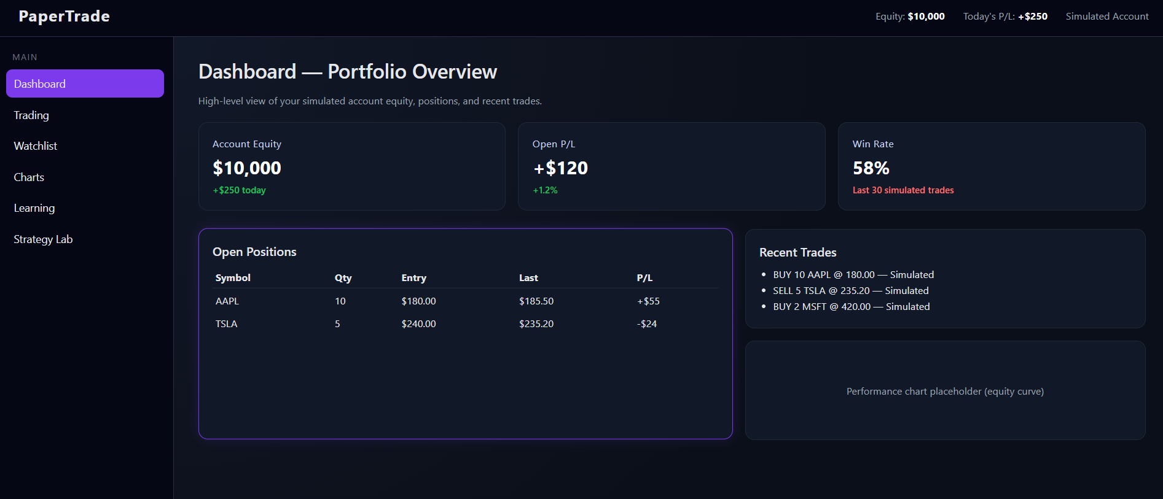

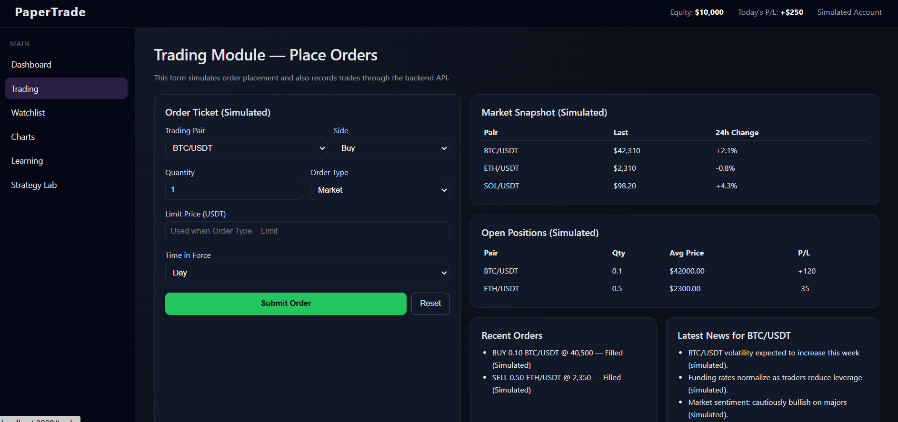

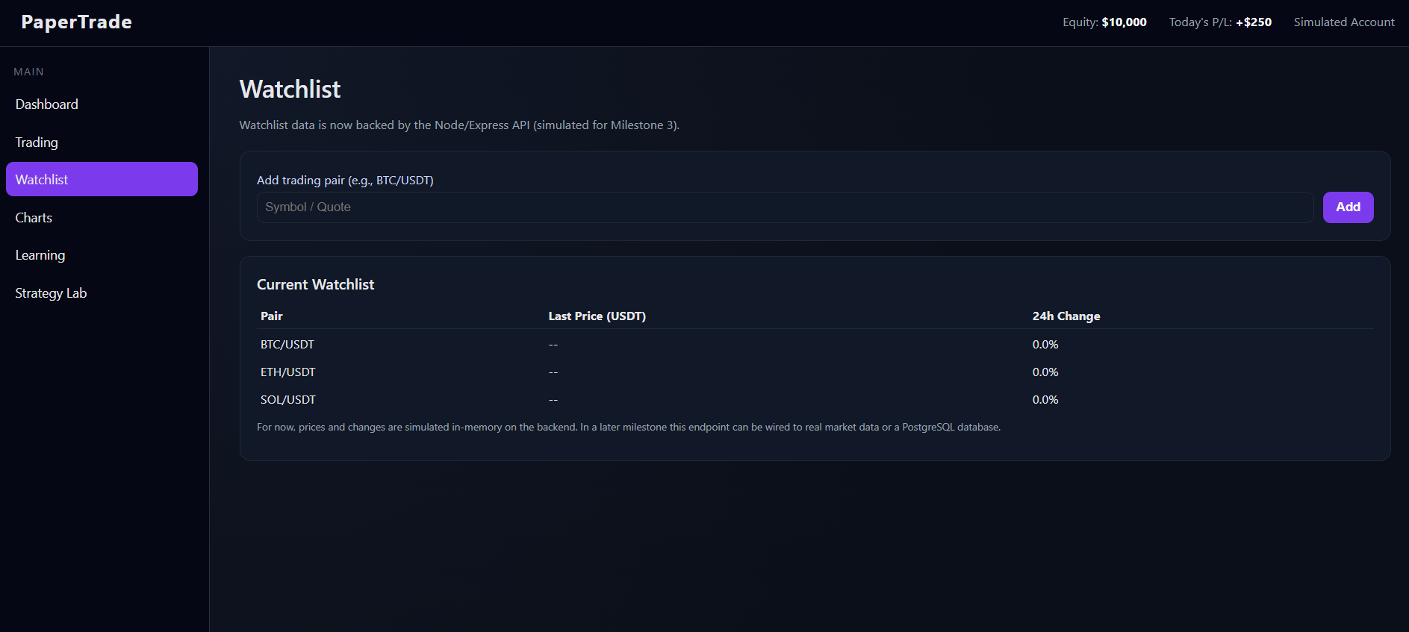

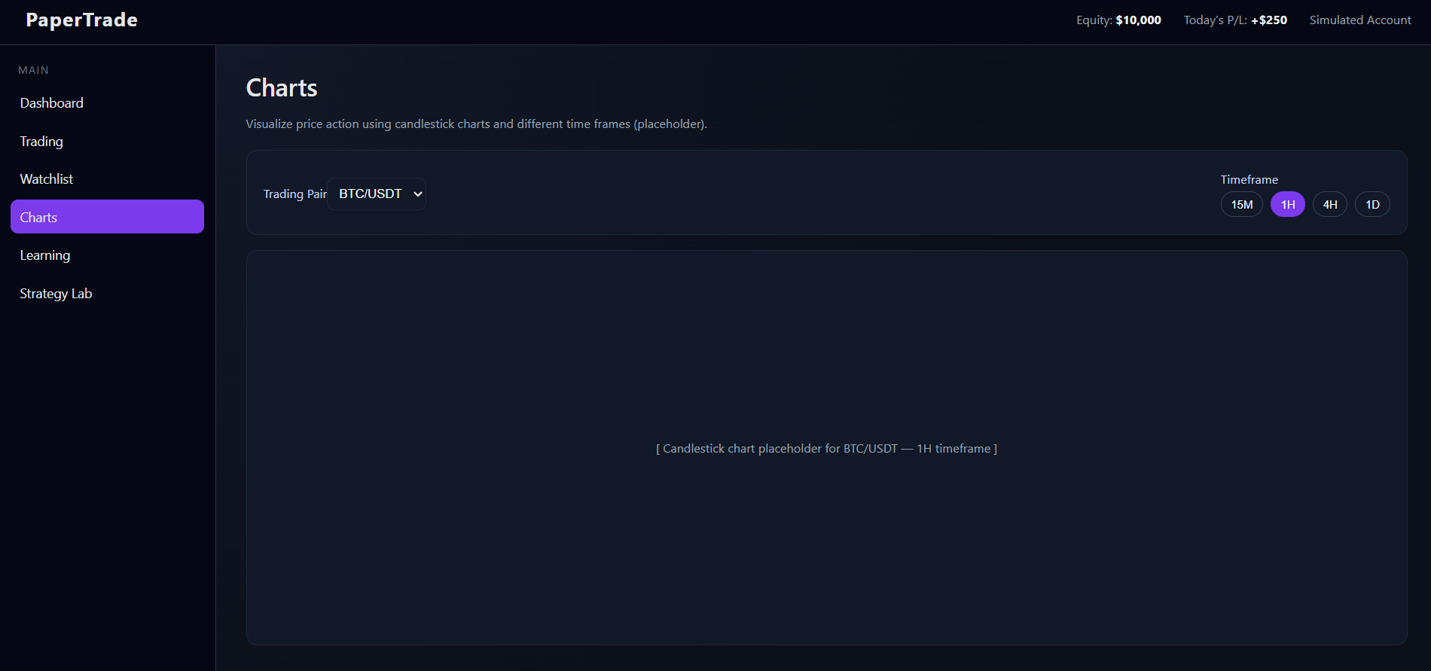

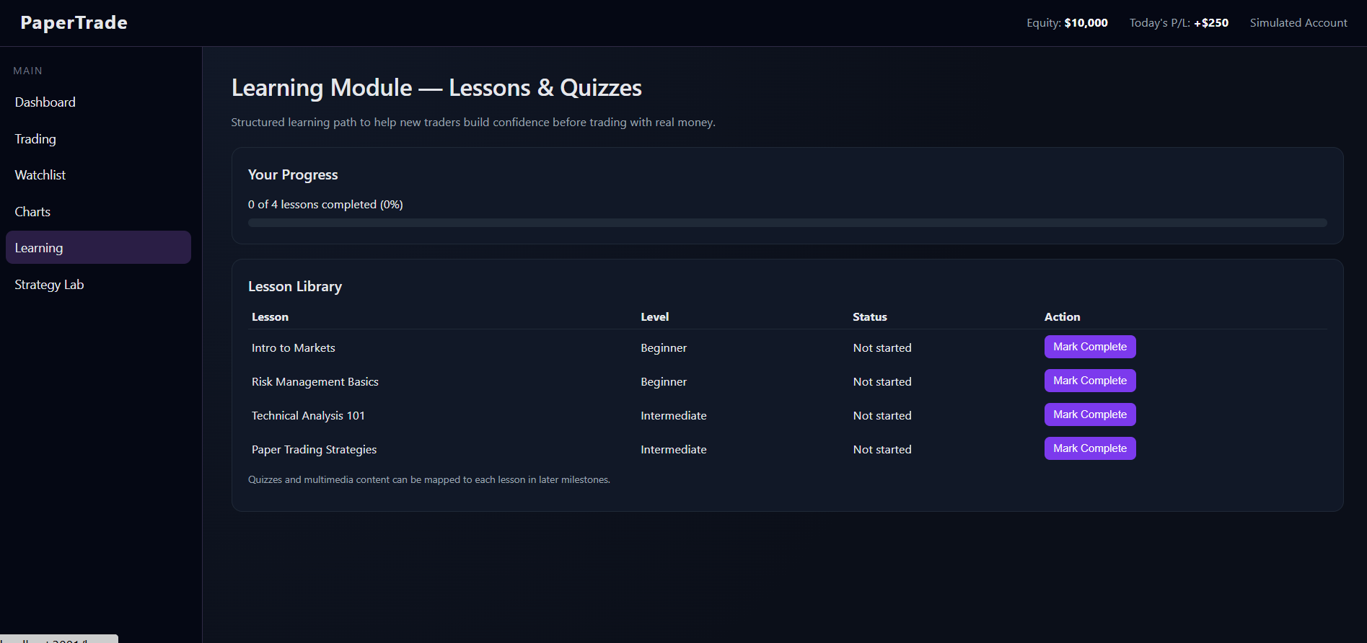

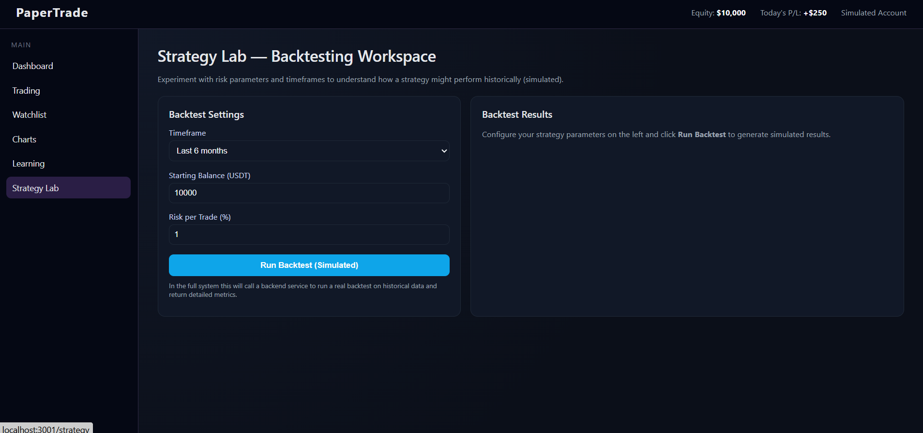

- A modern dashboard-style interface optimized by React.js has been created to the frontend interface.

- The existing completed UI modules are:

- Dashboard layout & navigation sidebar.

- Dashboard statistics cards

- Trading interface wireframe.

- Watchlist page

- Charts and analytics page dummy.

- Placeholders of learning and strategy lab.

- The theme is improved according to the feedback of the users:

- Dark mode design

- Black and purple colour palette.

- Better visibility of text to read.

- New typography and space.

- Interactive UI elements

- A component based design.

- The UI has become realistic with the appearance of a trading-platform like experience but at the same time, it is intuitive and user friendly.

Working Feature

There is now a working Watchlist page.
Features finished:
To add trading pairs, enter this field.
Display table for items on the watchlist
Change values and placeholder prices
Integrated backend API connection
Error management for unavailable servers
The capacity to change the API connection port
At the moment, the watchlist is linked to
Node.js Express API (data simulation)
Later milestones will see an upgrade to actual crypto data APIs.
Successful full-stack integration is demonstrated by this feature.

Development Overview

Phase | Task | Description | Status | Remarks
Planning | Requirement Analysis | Identification of user needs and problem scope | Completed | Validated with supervisor
 | Problem Definition | Definition of research problem and goals | Completed | Finalised
 | Literature Review | Reviewing academic and industry sources | Ongoing | Additional sources being added
System Design | System Architecture Design | Layered architecture and workflow design | Completed | Supports modular design
 | UI Wireframing | Initial mock-ups and page layout design | Completed | Iterated after feedback
 | Database Schema Planning | Entity and table structure planning | Ongoing | Refining relationships and constraints
Frontend Development | React Project Setup | Project structure and dependencies | Completed | Stable
 | Dashboard UI | Portfolio cards, statistics and overview | Completed | Current dark theme applied
 | Watchlist UI | Add trading pair and display list | Completed | Connected to backend API
 | Charts Page Layout | UI layout for analytics and charts | Uncompleted | To be implemented after data layer
 | Learning & Strategy Lab Pages | Layout and navigation only | Ongoing | Content and logic to be added
Backend Development | Node/Express Setup | REST API server configuration | Completed | Running with Nodemon
 | Watchlist API | Endpoints for watchlist operations | Completed | Tested with frontend
 | PostgreSQL Setup | Database installation and basic configuration | Completed | papertrade DB created
 | Database Integration | Connecting backend services to PostgreSQL | Ongoing | Migration and queries being added
 | Authentication System | User registration, login and session handling | Uncompleted | Planned for next milestone
 | Trading Simulation Engine | Portfolio logic and paper-trade execution | Uncompleted | Scheduled after DB integration
 | Live Market Data API Integration | Pulling prices from external crypto/FX APIs | Uncompleted | Initially will use simulated data
Testing & Evaluation | API Testing | Functional testing of backend endpoints | Uncompleted | To start after DB integration stabilises
 | Frontend–Backend Integration Testing | Checking full request/response flow | Uncompleted | Planned with API testing
 | Usability and Performance Testing | User experience and performance checks | Uncompleted | Final phase before submission
Documentation | Interim Report | Progress and system documentation | Ongoing | Sections being drafted and refined
 | Final Report | Complete technical and evaluation report | Uncompleted | To start after core implementation
 | Presentation and Demo Preparation | Slides, demo script and rehearsal | Uncompleted | Final milestone activity

Future WORK

Conclusion

This coursework has successfully demonstrated the design and the project plan of a comprehensive paper trading web app filled with adaptive learning capabilities. With the integration of trading functionalities with interactive lessons, quizzes and performance based feedback, the system has addressed a vulnerable gap between theoretical financial education and practical real life trading experience. The scheduled and structured development plan of 24 weeks has included a systematic progression as it integrates requirement analysis and system design to implementation, testing, deployment and documentation.
The proposed solution not only allows users to practice trading in a risk free environment but also enriches their understanding of financial concepts and decision-making strategies through many available guided learning modules. Moreover, the addition of backtesting engine and analytics further empowers users to evaluate and refine their strategies that promotes evidence- based trading habits.
Therefore, the project is a huge contribution that serves as an educational tool for novice traders, students and financial learners. Its design makes it a strong foundation for future enhancements such as AI- driven recommendations, and other mobile platform expansion. Hence, the paper trading web app stands as a strong system that is capable of bridging the learning-practice divide in financial literacy and digital trading ecosystems.

Appendix

Frontend

Statcard.js

export default function StatCard({ label, value, note }) {
const isPositive = note && note.trim().startsWith("+");

return (
<div className="card">
<div
style={{
fontSize: "13px",
color: "#cbd5f5",
marginBottom: "6px",
letterSpacing: "0.02em",
}}
>
{label}
</div>

<div
style={{
fontSize: "24px",
fontWeight: 700,
color: "#ffffff",
}}
>
{value}
</div>

{note && (
<div
style={{
marginTop: "6px",
fontSize: "12px",
fontWeight: 500,
color: isPositive ? "#22c55e" : "#f87171",
}}
>
{note}
</div>
)}
</div>
);
}

MainLayout.js

// src/layout/MainLayout.js
import { NavLink } from "react-router-dom";

export default function MainLayout({ children }) {
return (
<div className="app-shell">
{/* Top header */}
<header className="app-header">
<div className="app-logo">PaperTrade</div>
<div className="app-header-info">
<span>
Equity: <strong>$10,000</strong>
</span>
<span>
Today&apos;s P/L:{" "}
<strong className="text-green">+$250</strong>
</span>
<span className="text-muted">Simulated Account</span>
</div>
</header>

{/* Body: sidebar + main content */}
<div className="app-body">
{/* Sidebar */}
<aside className="app-sidebar">
<div className="nav-section-title">Main</div>
<ul className="nav-list">
<li>
<NavLink
to="/"
end
className={({ isActive }) =>
"nav-link" + (isActive ? " nav-link-active" : "")
}
>
Dashboard
</NavLink>
</li>
<li>
<NavLink
to="/trade"
className={({ isActive }) =>
"nav-link" + (isActive ? " nav-link-active" : "")
}
>
Trading
</NavLink>
</li>
<li>
<NavLink
to="/watchlist"
className={({ isActive }) =>
"nav-link" + (isActive ? " nav-link-active" : "")
}
>
Watchlist
</NavLink>
</li>
<li>
<NavLink
to="/charts"
className={({ isActive }) =>
"nav-link" + (isActive ? " nav-link-active" : "")
}
>
Charts
</NavLink>
</li>
<li>
<NavLink
to="/learn"
className={({ isActive }) =>
"nav-link" + (isActive ? " nav-link-active" : "")
}
>
Learning
</NavLink>
</li>
<li>
<NavLink
to="/strategy"
className={({ isActive }) =>
"nav-link" + (isActive ? " nav-link-active" : "")
}
>
Strategy Lab
</NavLink>
</li>
</ul>
</aside>

{/* Main content */}
<main className="app-main">{children}</main>
</div>
</div>
);
}

Charts,js

// src/pages/Charts.js
import React, { useState } from "react";
import MainLayout from "../layout/MainLayout";

export default function Charts() {
const [selectedPair, setSelectedPair] = useState("BTC/USDT");
const [timeframe, setTimeframe] = useState("1H");

return (
<MainLayout>
<h1 className="page-title">Charts</h1>
<p className="page-subtitle">
Visualize price action using candlestick charts and different time
frames (placeholder).
</p>

{/* Controls */}
<div
className="card"
style={{
marginBottom: 16,
display: "flex",
alignItems: "center",
justifyContent: "space-between",
gap: 16,
flexWrap: "wrap",
}}
>
<div>
<label style={{ fontSize: 13, color: "#cbd5f5" }}>
Trading Pair
</label>
<select
value={selectedPair}
onChange={(e) => setSelectedPair(e.target.value)}
style={{
marginTop: 4,
padding: 8,
borderRadius: 8,
border: "1px solid #1f2937",
background: "#111827",
color: "#f9fafb",
}}
>
<option>BTC/USDT</option>
<option>ETH/USDT</option>
<option>SOL/USDT</option>
<option>BNB/USDT</option>
</select>
</div>

<div>
<label style={{ fontSize: 13, color: "#cbd5f5", marginBottom: 4 }}>
Timeframe
</label>
<div style={{ marginTop: 4, display: "flex", gap: 8 }}>
{["15M", "1H", "4H", "1D"].map((tf) => (
<button
key={tf}
onClick={() => setTimeframe(tf)}
style={{
padding: "6px 10px",
borderRadius: 999,
border:
timeframe === tf
? "1px solid #7c3aed"
: "1px solid #374151",
background:
timeframe === tf ? "#7c3aed" : "transparent",
color: "#f9fafb",
fontSize: 12,
cursor: "pointer",
}}
>
{tf}
</button>
))}
</div>
</div>
</div>

{/* Chart placeholder */}
<div
className="card"
style={{
height: 420,
display: "flex",
alignItems: "center",
justifyContent: "center",
color: "#9ca3af",
fontSize: 13,
}}
>
[ Candlestick chart placeholder for {selectedPair} —{" "}
{timeframe} timeframe ]
</div>
</MainLayout>
);
}

DashBoard.js

// src/pages/Charts.js
import React, { useState } from "react";
import MainLayout from "../layout/MainLayout";

export default function Charts() {
const [selectedPair, setSelectedPair] = useState("BTC/USDT");
const [timeframe, setTimeframe] = useState("1H");

return (
<MainLayout>
<h1 className="page-title">Charts</h1>
<p className="page-subtitle">
Visualize price action using candlestick charts and different time
frames (placeholder).
</p>

{/* Controls */}
<div
className="card"
style={{
marginBottom: 16,
display: "flex",
alignItems: "center",
justifyContent: "space-between",
gap: 16,
flexWrap: "wrap",
}}
>
<div>
<label style={{ fontSize: 13, color: "#cbd5f5" }}>
Trading Pair
</label>
<select
value={selectedPair}
onChange={(e) => setSelectedPair(e.target.value)}
style={{
marginTop: 4,
padding: 8,
borderRadius: 8,
border: "1px solid #1f2937",
background: "#111827",
color: "#f9fafb",
}}
>
<option>BTC/USDT</option>
<option>ETH/USDT</option>
<option>SOL/USDT</option>
<option>BNB/USDT</option>
</select>
</div>

<div>
<label style={{ fontSize: 13, color: "#cbd5f5", marginBottom: 4 }}>
Timeframe
</label>
<div style={{ marginTop: 4, display: "flex", gap: 8 }}>
{["15M", "1H", "4H", "1D"].map((tf) => (
<button
key={tf}
onClick={() => setTimeframe(tf)}
style={{
padding: "6px 10px",
borderRadius: 999,
border:
timeframe === tf
? "1px solid #7c3aed"
: "1px solid #374151",
background:
timeframe === tf ? "#7c3aed" : "transparent",
color: "#f9fafb",
fontSize: 12,
cursor: "pointer",
}}
>
{tf}
</button>
))}
</div>
</div>
</div>

{/* Chart placeholder */}
<div
className="card"
style={{
height: 420,
display: "flex",
alignItems: "center",
justifyContent: "center",
color: "#9ca3af",
fontSize: 13,
}}
>
[ Candlestick chart placeholder for {selectedPair} —{" "}
{timeframe} timeframe ]
</div>
</MainLayout>
);
}

Learning .js

// src/pages/Learning.js
import React, { useState } from "react";
import MainLayout from "../layout/MainLayout";

const initialLessons = [
{ id: 1, title: "Intro to Markets", level: "Beginner", completed: false },
{
id: 2,
title: "Risk Management Basics",
level: "Beginner",
completed: false,
},
{
id: 3,
title: "Technical Analysis 101",
level: "Intermediate",
completed: false,
},
{
id: 4,
title: "Paper Trading Strategies",
level: "Intermediate",
completed: false,
},
];

export default function Learning() {
const [lessons, setLessons] = useState(initialLessons);

const total = lessons.length;
const completed = lessons.filter((l) => l.completed).length;
const progress = total === 0 ? 0 : Math.round((completed / total) * 100);

function toggleComplete(id) {
setLessons((prev) =>
prev.map((l) =>
l.id === id ? { ...l, completed: !l.completed } : l
)
);
}

return (
<MainLayout>
<h1 className="page-title">Learning Module — Lessons & Quizzes</h1>
<p className="page-subtitle">
Structured learning path to help new traders build confidence
before trading with real money.
</p>

{/* Progress card */}
<div className="card" style={{ marginBottom: 16 }}>
<h2>Your Progress</h2>
<p style={{ marginBottom: 8, fontSize: 13 }}>
{completed} of {total} lessons completed ({progress}%)
</p>
<div
style={{
width: "100%",
height: 10,
background: "#1f2937",
borderRadius: 999,
overflow: "hidden",
}}
>
<div
style={{
width: `${progress}%`,
height: "100%",
background: "#22c55e",
}}
/>
</div>
</div>

{/* Lessons table */}
<div className="card">
<h2>Lesson Library</h2>
<table className="table">
<thead>
<tr>
<th>Lesson</th>
<th>Level</th>
<th>Status</th>
<th>Action</th>
</tr>
</thead>
<tbody>
{lessons.map((l) => (
<tr key={l.id}>
<td>{l.title}</td>
<td>{l.level}</td>
<td>{l.completed ? "Completed" : "Not started"}</td>
<td>
<button
onClick={() => toggleComplete(l.id)}
style={{
padding: "6px 10px",
borderRadius: 6,
border: "none",
cursor: "pointer",
background: l.completed
? "#4b5563"
: "#7c3aed",
color: "#f9fafb",
fontSize: 12,
}}
>
{l.completed ? "Mark Incomplete" : "Mark Complete"}
</button>
</td>
</tr>
))}
</tbody>
</table>
<p className="text-muted" style={{ marginTop: 8, fontSize: 11 }}>
Quizzes and multimedia content can be mapped to each lesson in later
milestones.
</p>
</div>
</MainLayout>
);
}

StrategyLab.js

// src/pages/StrategyLab.js
import React, { useState } from "react";
import MainLayout from "../layout/MainLayout";

export default function StrategyLab() {
const [timeframe, setTimeframe] = useState("6M");
const [startingBalance, setStartingBalance] = useState(10000);
const [riskPerTrade, setRiskPerTrade] = useState(1);
const [result, setResult] = useState(null);

function runBacktest() {
const rand = Math.random();
const totalReturn = (rand * 40 - 10).toFixed(2); // -10% to +30%
const maxDrawdown = (rand * 20).toFixed(2); // 0–20%
const winRate = (50 + rand * 30).toFixed(1); // 50–80%
const trades = Math.floor(20 + rand * 40);

setResult({
totalReturn,
maxDrawdown,
winRate,
trades,
});
}

return (
<MainLayout>
<h1 className="page-title">Strategy Lab — Backtesting Workspace</h1>
<p className="page-subtitle">
Experiment with risk parameters and timeframes to understand how a
strategy might perform historically (simulated).
</p>

<div
style={{
display: "grid",
gridTemplateColumns: "1.4fr 2fr",
gap: "16px",
}}
>
{/* LEFT: configuration */}
<div className="card">
<h2>Backtest Settings</h2>

<div style={{ marginBottom: 10 }}>
<label style={{ fontSize: 13, color: "#cbd5f5" }}>
Timeframe
</label>
<select
value={timeframe}
onChange={(e) => setTimeframe(e.target.value)}
style={{
marginTop: 4,
width: "100%",
padding: 8,
borderRadius: 8,
border: "1px solid #1f2937",
background: "#111827",
color: "#f9fafb",
}}
>
<option value="3M">Last 3 months</option>
<option value="6M">Last 6 months</option>
<option value="1Y">Last 1 year</option>
<option value="5Y">Last 5 years</option>
</select>
</div>

<div style={{ marginBottom: 10 }}>
<label style={{ fontSize: 13, color: "#cbd5f5" }}>
Starting Balance (USDT)
</label>
<input
type="number"
value={startingBalance}
onChange={(e) => setStartingBalance(e.target.value)}
style={{
marginTop: 4,
width: "100%",
padding: 8,
borderRadius: 8,
border: "1px solid #1f2937",
background: "#111827",
color: "#f9fafb",
}}
/>
</div>

<div style={{ marginBottom: 16 }}>
<label style={{ fontSize: 13, color: "#cbd5f5" }}>
Risk per Trade (%)
</label>
<input
type="number"
value={riskPerTrade}
onChange={(e) => setRiskPerTrade(e.target.value)}
style={{
marginTop: 4,
width: "100%",
padding: 8,
borderRadius: 8,
border: "1px solid #1f2937",
background: "#111827",
color: "#f9fafb",
}}
/>
</div>

<button
onClick={runBacktest}
style={{
width: "100%",
padding: 10,
borderRadius: 8,
border: "none",
background: "#0ea5e9",
color: "#f9fafb",
fontWeight: 600,
cursor: "pointer",
}}
>
Run Backtest (Simulated)
</button>

<p className="text-muted" style={{ marginTop: 8, fontSize: 11 }}>
In the full system this will call a backend service to run a real
backtest on historical data and return detailed metrics.
</p>
</div>

{/* RIGHT: results */}
<div className="card">
<h2>Backtest Results</h2>

{result ? (
<>
<p style={{ fontSize: 13, marginBottom: 10 }}>
Timeframe: <strong>{timeframe}</strong> | Starting balance:{" "}
<strong>${startingBalance}</strong> | Risk/trade:{" "}
<strong>{riskPerTrade}%</strong>
</p>

<ul
style={{
fontSize: 13,
marginBottom: 12,
paddingLeft: 18,
lineHeight: 1.6,
}}
>
<li>
Total return:{" "}
<strong
className={
Number(result.totalReturn) >= 0
? "text-green"
: "text-red"
}
>
{result.totalReturn}%
</strong>
</li>
<li>
Max drawdown: <strong>{result.maxDrawdown}%</strong>
</li>
<li>
Win rate: <strong>{result.winRate}%</strong>
</li>
<li>
Number of trades: <strong>{result.trades}</strong>
</li>
</ul>

<div
style={{
borderTop: "1px solid #1f2937",
paddingTop: 10,
fontSize: 12,
color: "#9ca3af",
}}
>
Equity curve / distribution charts can be added here in future
milestones to give a richer visual understanding of the
strategy&apos;s behavior.
</div>
</>
) : (
<p style={{ fontSize: 13, color: "#9ca3af" }}>
Configure your strategy parameters on the left and click{" "}
<strong>Run Backtest</strong> to generate simulated results.
</p>
)}
</div>
</div>
</MainLayout>
);
}

Trading.js

// src/pages/Trading.js
import React, { useState } from "react";
import MainLayout from "../layout/MainLayout";

const API_BASE = "http://localhost:4000";

export default function Trading() {
const [symbol, setSymbol] = useState("BTC/USDT");
const [side, setSide] = useState("Buy");
const [qty, setQty] = useState(1);
const [orderType, setOrderType] = useState("Market");
const [limitPrice, setLimitPrice] = useState("");
const [timeInForce, setTimeInForce] = useState("Day");

const [positions, setPositions] = useState([
{ symbol: "BTC/USDT", qty: 0.1, avgPrice: 42000, unrealizedPL: 120 },
{ symbol: "ETH/USDT", qty: 0.5, avgPrice: 2300, unrealizedPL: -35 },
]);

const [orders, setOrders] = useState([
{ id: 1, text: "BUY 0.10 BTC/USDT @ 40,500 — Filled (Simulated)" },
{ id: 2, text: "SELL 0.50 ETH/USDT @ 2,350 — Filled (Simulated)" },
]);

const [submitError, setSubmitError] = useState("");
const [submitting, setSubmitting] = useState(false);

async function handleSubmit(e) {
e.preventDefault();

const qtyNumber = Number(qty) || 0;
if (!symbol || qtyNumber <= 0) return;

const priceText =
orderType === "Market"
? "MKT"
: limitPrice
? Number(limitPrice).toFixed(2)
: "LIMIT";

const localText = `${side.toUpperCase()} ${qtyNumber} ${symbol.toUpperCase()} @ ${priceText} — Simulated`;

// 1) Update local UI immediately (for responsiveness)
const localOrder = { id: Date.now(), text: localText };
setOrders((prev) => [localOrder, ...prev]);

const sign = side === "Buy" ? 1 : -1;

setPositions((prev) => {
const existing = prev.find(
(p) => p.symbol.toUpperCase() === symbol.toUpperCase()
);
if (!existing) {
return [
...prev,
{
symbol: symbol.toUpperCase(),
qty: sign * qtyNumber,
avgPrice: limitPrice ? Number(limitPrice) : 100,
unrealizedPL: 0,
},
];
}

return prev.map((p) => {
if (p.symbol.toUpperCase() !== symbol.toUpperCase()) return p;
return {
...p,
qty: p.qty + sign * qtyNumber,
};
});
});

// 2) Also send to backend for persistence (best-effort)
try {
setSubmitting(true);
setSubmitError("");

const res = await fetch(`${API_BASE}/api/trades`, {
method: "POST",
headers: { "Content-Type": "application/json" },
body: JSON.stringify({
side,
symbol,
qty: qtyNumber,
price: orderType === "Market" ? 0 : Number(limitPrice) || 0,
note: "Submitted from Trading UI (simulated)",
}),
});

if (!res.ok) {
const body = await res.json().catch(() => ({}));
throw new Error(body.error || `Server returned ${res.status}`);
}

// backendTrade is not strictly needed right now, but you *could* use it
// const backendTrade = await res.json();
} catch (err) {
console.error("Failed to send trade to backend:", err);
setSubmitError("Order recorded locally but backend call failed.");
} finally {
setSubmitting(false);
}

// Reset qty but keep symbol/side
setQty(1);
}

function handleReset() {
setSymbol("BTC/USDT");
setSide("Buy");
setQty(1);
setOrderType("Market");
setLimitPrice("");
setTimeInForce("Day");
setSubmitError("");
}

return (
<MainLayout>
<h1 className="page-title">Trading Module — Place Orders</h1>
<p className="page-subtitle">
This form simulates order placement and also records trades through the
backend API.
</p>

<div
style={{
display: "grid",
gridTemplateColumns: "1.5fr 2fr",
gap: "16px",
}}
>
{/* LEFT: Order ticket */}
<div className="card">
<h2>Order Ticket (Simulated)</h2>
<form onSubmit={handleSubmit}>
{/* Row 1: symbol + side */}
<div
style={{
display: "grid",
gridTemplateColumns: "1.4fr 1fr",
gap: "10px",
marginBottom: "10px",
}}
>
<div>
<label style={{ fontSize: 13, color: "#cbd5f5" }}>
Trading Pair
</label>
<select
value={symbol}
onChange={(e) => setSymbol(e.target.value)}
style={{
marginTop: 4,
width: "100%",
padding: 8,
borderRadius: 8,
border: "1px solid #1f2937",
background: "#111827",
color: "#f9fafb",
}}
>
<option>BTC/USDT</option>
<option>ETH/USDT</option>
<option>SOL/USDT</option>
<option>ADA/USDT</option>
</select>
</div>
<div>
<label style={{ fontSize: 13, color: "#cbd5f5" }}>Side</label>
<select
value={side}
onChange={(e) => setSide(e.target.value)}
style={{
marginTop: 4,
width: "100%",
padding: 8,
borderRadius: 8,
border: "1px solid #1f2937",
background: "#111827",
color: "#f9fafb",
}}
>
<option>Buy</option>
<option>Sell</option>
</select>
</div>
</div>

{/* Row 2: qty + order type */}
<div
style={{
display: "grid",
gridTemplateColumns: "1fr 1fr",
gap: "10px",
marginBottom: "10px",
}}
>
<div>
<label style={{ fontSize: 13, color: "#cbd5f5" }}>
Quantity
</label>
<input
type="number"
min="0"
step="0.01"
value={qty}
onChange={(e) => setQty(e.target.value)}
style={{
marginTop: 4,
width: "100%",
padding: 8,
borderRadius: 8,
border: "1px solid #1f2937",
background: "#111827",
color: "#f9fafb",
}}
/>
</div>
<div>
<label style={{ fontSize: 13, color: "#cbd5f5" }}>
Order Type
</label>
<select
value={orderType}
onChange={(e) => setOrderType(e.target.value)}
style={{
marginTop: 4,
width: "100%",
padding: 8,
borderRadius: 8,
border: "1px solid #1f2937",
background: "#111827",
color: "#f9fafb",
}}
>
<option>Market</option>
<option>Limit</option>
</select>
</div>
</div>

{/* Limit price */}
<div style={{ marginBottom: "10px" }}>
<label style={{ fontSize: 13, color: "#cbd5f5" }}>
Limit Price (USDT)
</label>
<input
type="number"
value={limitPrice}
onChange={(e) => setLimitPrice(e.target.value)}
placeholder="Used when Order Type = Limit"
style={{
marginTop: 4,
width: "100%",
padding: 8,
borderRadius: 8,
border: "1px solid #1f2937",
background: "#111827",
color: "#f9fafb",
}}
/>
</div>

{/* Time in force */}
<div style={{ marginBottom: "16px" }}>
<label style={{ fontSize: 13, color: "#cbd5f5" }}>
Time in Force
</label>
<select
value={timeInForce}
onChange={(e) => setTimeInForce(e.target.value)}
style={{
marginTop: 4,
width: "100%",
padding: 8,
borderRadius: 8,
border: "1px solid #1f2937",
background: "#111827",
color: "#f9fafb",
}}
>
<option>Day</option>
<option>GTC</option>
</select>
</div>

{/* Error, if backend fails */}
{submitError && (
<div
style={{
marginBottom: 10,
fontSize: 12,
color: "#fca5a5",
}}
>
{submitError}
</div>
)}

{/* Buttons */}
<div style={{ display: "flex", gap: 8 }}>
<button
type="submit"
disabled={submitting}
style={{
flex: 1,
padding: 10,
borderRadius: 8,
border: "none",
background:
side === "Buy" ? "#22c55e" : "#f87171",
opacity: submitting ? 0.8 : 1,
color: "#0b0f19",
fontWeight: 600,
cursor: submitting ? "default" : "pointer",
}}
>
{submitting ? "Submitting..." : "Submit Order"}
</button>
<button
type="button"
onClick={handleReset}
style={{
padding: "10px 14px",
borderRadius: 8,
border: "1px solid #4b5563",
background: "transparent",
color: "#e5e7eb",
cursor: "pointer",
}}
>
Reset
</button>
</div>
</form>
</div>

{/* RIGHT: same as before – market snapshot, positions, orders, news */}
<div
style={{
display: "grid",
gridTemplateRows: "auto auto auto",
gap: "16px",
}}
>
<div className="card">
<h2>Market Snapshot (Simulated)</h2>
<table className="table">
<thead>
<tr>
<th>Pair</th>
<th>Last</th>
<th>24h Change</th>
</tr>
</thead>
<tbody>
<tr>
<td>BTC/USDT</td>
<td>$42,310</td>
<td className="text-green">+2.1%</td>
</tr>
<tr>
<td>ETH/USDT</td>
<td>$2,310</td>
<td className="text-red">-0.8%</td>
</tr>
<tr>
<td>SOL/USDT</td>
<td>$98.20</td>
<td className="text-green">+4.3%</td>
</tr>
</tbody>
</table>
</div>

<div className="card">
<h2>Open Positions (Simulated)</h2>
<table className="table">
<thead>
<tr>
<th>Pair</th>
<th>Qty</th>
<th>Avg Price</th>
<th>P/L</th>
</tr>
</thead>
<tbody>
{positions.map((p) => (
<tr key={p.symbol}>
<td>{p.symbol}</td>
<td>{p.qty}</td>
<td>${p.avgPrice.toFixed(2)}</td>
<td
className={
p.unrealizedPL >= 0 ? "text-green" : "text-red"
}
>
{p.unrealizedPL >= 0 ? "+" : ""}
{p.unrealizedPL}
</td>
</tr>
))}
</tbody>
</table>
</div>

<div
style={{
display: "grid",
gridTemplateColumns: "1.4fr 1.6fr",
gap: "16px",
}}
>
<div className="card">
<h2>Recent Orders</h2>
<ul
style={{
fontSize: 13,
paddingLeft: 18,
margin: 0,
lineHeight: 1.6,
}}
>
{orders.map((o) => (
<li key={o.id}>{o.text}</li>
))}
</ul>
</div>

<div className="card">
<h2>Latest News for {symbol}</h2>
<ul
style={{
fontSize: 13,
paddingLeft: 18,
margin: 0,
lineHeight: 1.6,
}}
>
<li>
{symbol} volatility expected to increase this week
(simulated).
</li>
<li>
Funding rates normalize as traders reduce leverage
(simulated).
</li>
<li>
Market sentiment: cautiously bullish on majors (simulated).
</li>
</ul>
<p
className="text-muted"
style={{ marginTop: 8, fontSize: 11 }}
>
* In a later milestone this will be powered by a real news API
for the selected asset.
</p>
</div>
</div>
</div>
</div>
</MainLayout>
);
}

