CUSTOMER GUIDE

CareChart Customer Configuration and User Guide
Hospital setup and daily workflows for doctors and care teams
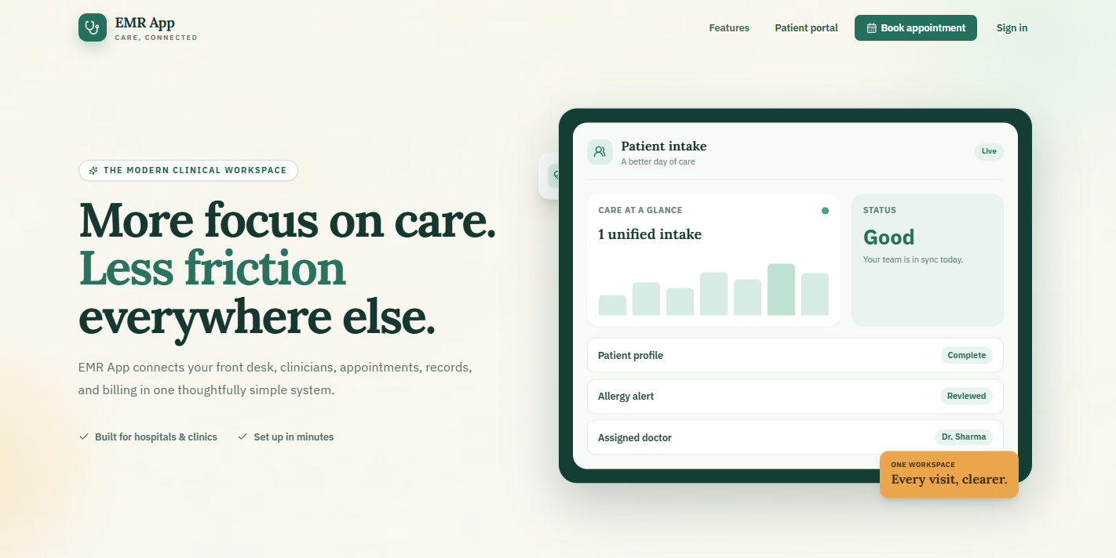
CareChart public home page and access points
Audience | Edition | Scope
Doctors, administrators and authorized hospital staff | Customer edition - September 2026 | Outpatient setup, clinical workflow, diagnostics, billing and patient access

Demonstration data All names, identifiers and clinical information shown in this guide are fictional and are intended only for training and presentation.

PRODUCT OVERVIEW

A connected outpatient workflow
CareChart brings registration, appointments, consultations, diagnostics, records, billing and patient access into one hospital-scoped workspace.
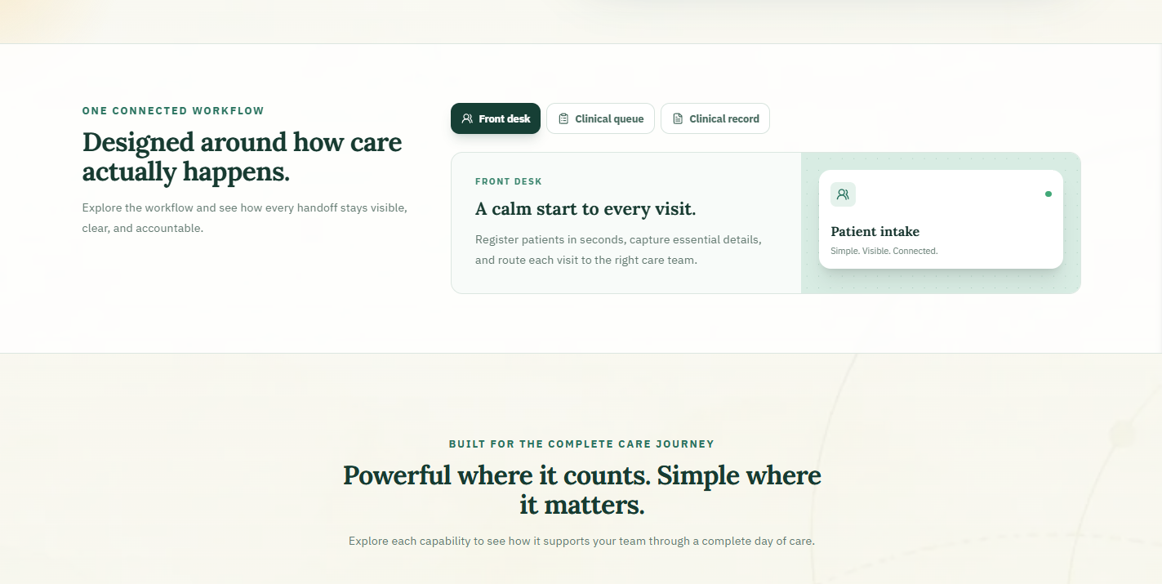
Product overview showing the main hospital workflows
- One patient record. Clinical, diagnostic and billing information stays connected to the same hospital record.
- Role-based access. Staff see the areas needed for their assigned work.
- Traceable activity. Important security and operational actions are recorded for authorized review.
Clinical responsibility CareChart records information and displays workflow alerts. It does not replace professional judgement, hospital policy or the clinician's responsibility for patient care.

PRODUCT OVERVIEW

What the platform covers
The customer experience extends from appointment request through clinical documentation, reports, invoices and patient access.
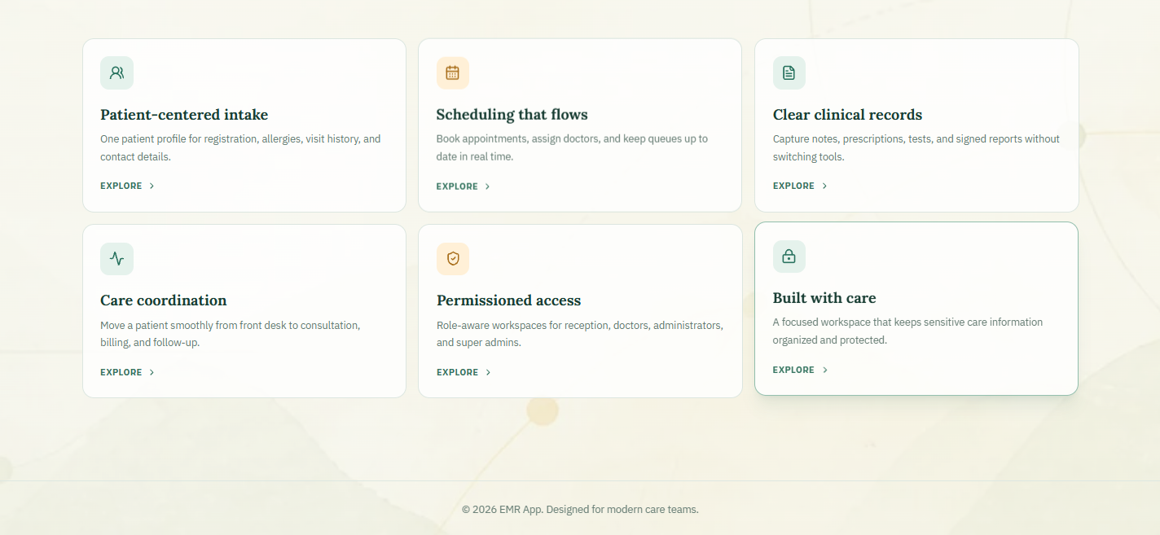
CareChart capability summary
Area | Primary purpose
Front Desk | Find or register patients, manage arrivals and begin visits.
Doctor's Desk | Open the waiting room and document consultations.
Patient Records | Review permitted longitudinal patient information.
Diagnostics | Process operational orders, reports and clinical acknowledgement.
Billing | Generate invoices and record payments or refunds.
Patient Portal | Give an activated patient access to their own information.

GUIDE MAP

Use the guide by role
Administrators should complete hospital configuration first. Other staff can begin with the section that matches their daily work.
Role | Start with | Typical responsibility
Hospital administrator | Administration and configuration | Hospital account, staff access, clinics, schedules, prices and order capabilities
Doctor | Doctor's Desk and consultation | Clinical documentation, prescriptions, requested tests and imaging, report review
Front desk | Patient registration and appointments | Patient identity, arrivals, appointments and queue entry
Lab or radiology | Diagnostics | Operational worklist processing and report upload
Billing | Invoices and payments | Invoice review, payment, refund, print and void workflows
Patient | Patient portal | Account activation and access to the linked patient record

Recommended reading order
1. Access and hospital selection
2. Hospital configuration and staff setup
3. Daily patient and clinical workflows
4. Diagnostics, documents, billing and audit
5. Patient portal, go-live controls and troubleshooting
Before entering real patient information Complete the hospital's clinical, privacy, legal, security, backup and operational approvals. Test the full workflow with fictional patients first.

ACCESS

Staff sign in
Each staff member should use an individual account. Shared credentials prevent reliable access control and audit review.
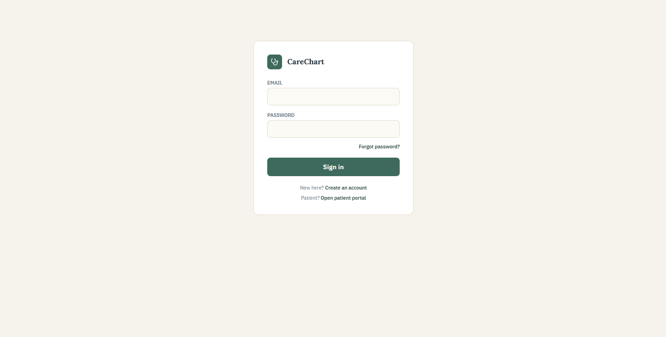
Staff sign-in page
1. Enter the email address assigned to your account.
2. Enter your password and select Sign in.
3. Use the approved password-reset process when access is lost.
4. Confirm the hospital shown after sign-in before opening patient information.
Safe access Never share passwords, reuse another employee's account or leave a signed-in device unattended.

ADMINISTRATION

Create and select a hospital workspace
Super Admin users can create hospital accounts and switch between the hospital workspaces assigned to them.
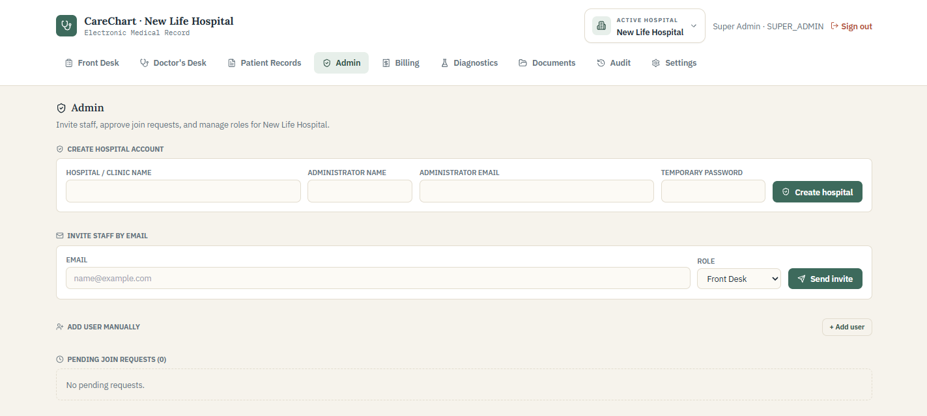
Administration page for hospital creation and staff onboarding
1. Enter the hospital name and the first administrator's details.
2. Create the hospital, then select it from Active Hospital.
3. Verify the selected hospital before configuring clinics or inviting staff.
Workspace boundary Changing the active hospital changes the workspace. It does not move patients, visits, invoices, staff or settings between hospitals.

ADMINISTRATION

Review staff access
Administrators should keep the staff list current and assign the smallest role needed for each person's work.
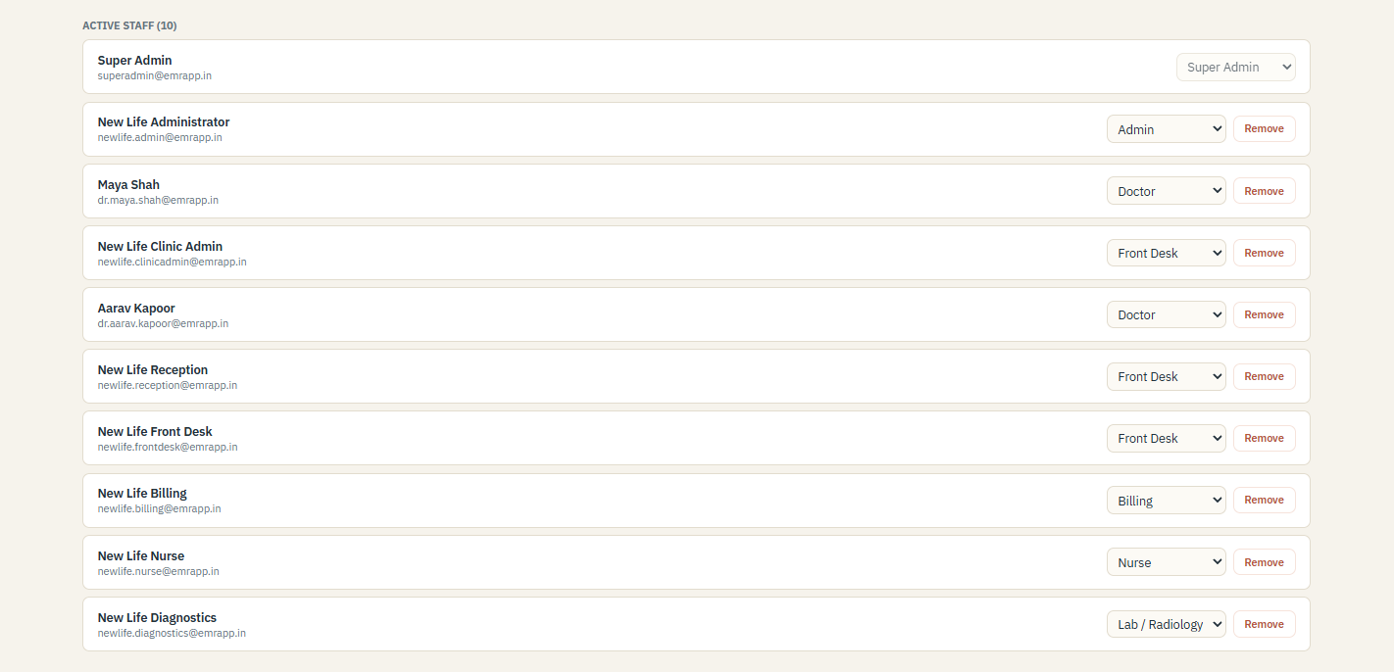
Active staff list and role management
- Confirm the person's name, email and current duties before changing a role.
- Remove or suspend access promptly when a person leaves or no longer needs the system.
- Never reuse a former employee's account for another staff member.

HOSPITAL CONFIGURATION

Configure locations and departments
Configuration belongs to the active hospital. Begin with the locations where care is delivered.
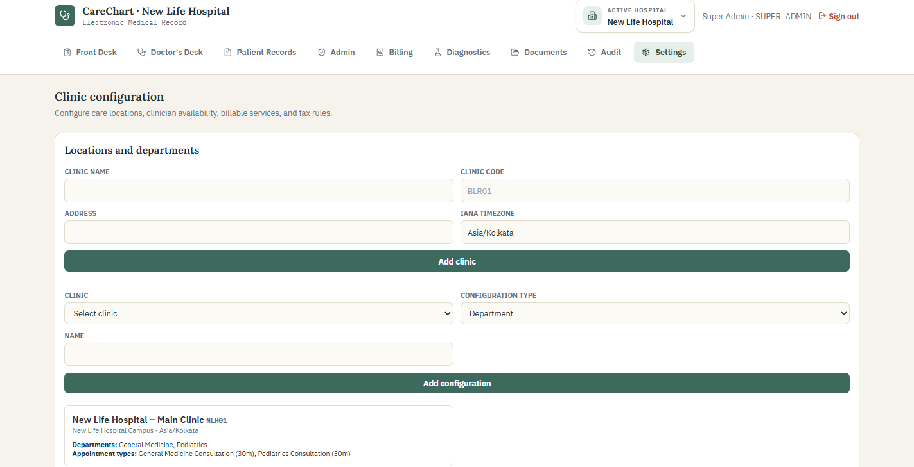
Clinic locations and department configuration
1. Enter the clinic name, code, address and IANA timezone, such as Asia/Kolkata.
2. Add the departments and appointment types used at that location.
3. Use stable clinic codes so reporting and integrations remain consistent.

HOSPITAL CONFIGURATION

Link practitioners and weekly schedules
A doctor account must be linked to a practitioner profile and clinic before reliable scheduling can begin.
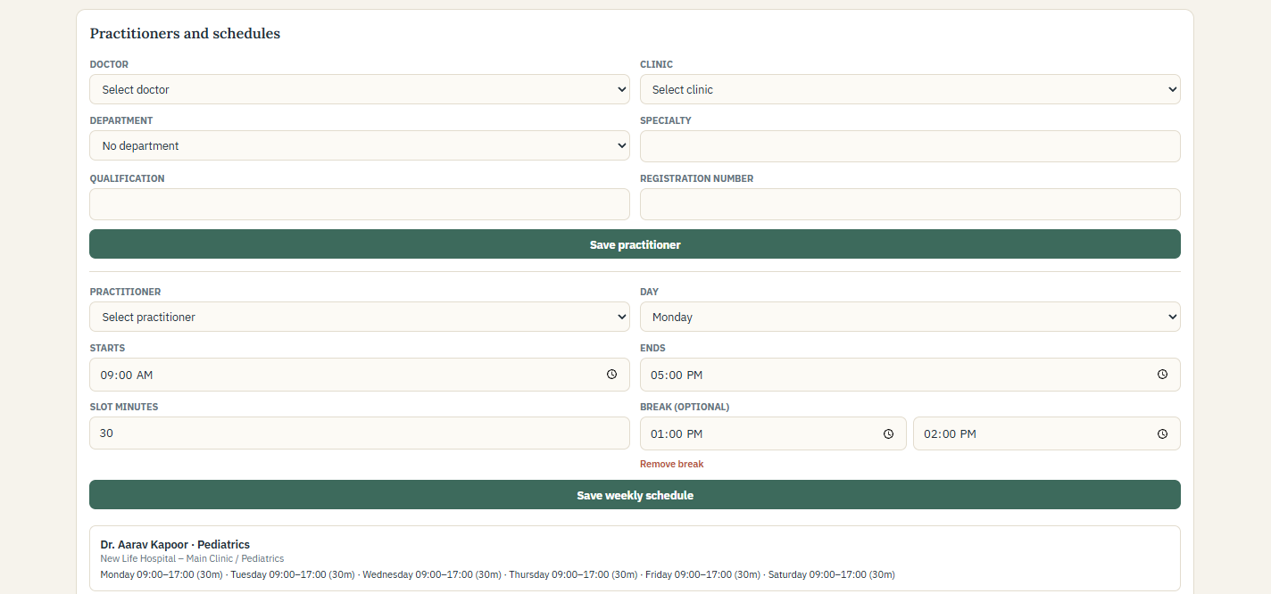
Practitioner profile and weekly schedule configuration
1. Choose the doctor, clinic and department.
2. Record specialty, qualification and registration number as required by hospital policy.
3. Set each working weekday, start and end time, slot length and optional break.
4. Review the saved weekly schedule before publishing appointment availability.

HOSPITAL CONFIGURATION

Control blocked time and holidays
Use blocked periods for practitioner-specific unavailability and clinic holidays when an entire location is closed.
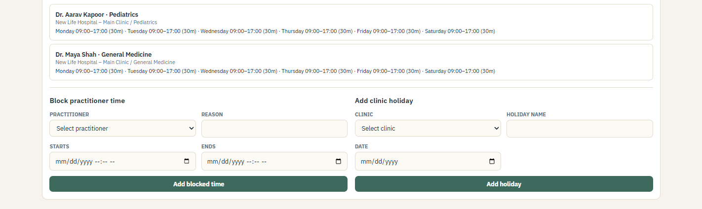
Blocked practitioner time and clinic holiday controls
- Blocked time. Record leave, meetings or another period when one practitioner cannot accept appointments.
- Clinic holiday. Close appointment availability for the selected clinic and date.
- Clear labels. Enter a useful reason or holiday name so staff can understand why slots are unavailable.

HOSPITAL CONFIGURATION

Enable only the operational order systems in use
CareChart separates clinical recommendations from operational orders sent to hospital departments or imaging systems.
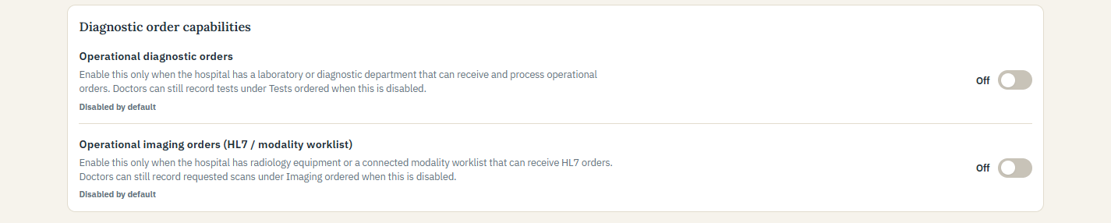
Hospital-level controls for operational diagnostic and imaging orders
- Operational diagnostic orders. Enable only when the hospital has a laboratory or diagnostic department that will receive and process orders.
- Operational imaging orders. Enable only when radiology equipment or a connected HL7 modality worklist is configured and validated.
- Default state. Both controls remain off until an authorized administrator enables them.
Doctor workflow Doctors can still record requested investigations under Tests ordered and Imaging ordered when operational integrations are disabled.
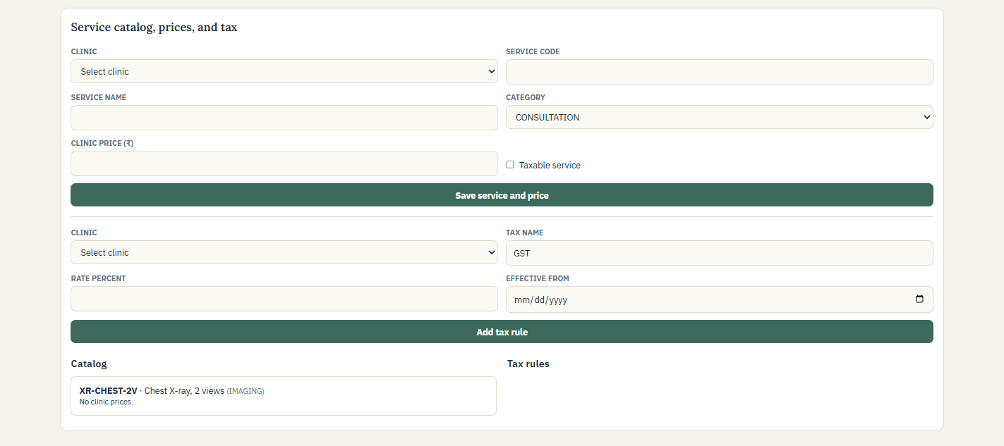
Service catalog, clinic pricing and tax configuration

FRONT DESK

Manage arrivals from one workspace
The Front Desk workspace combines the daily appointment schedule with patient search and walk-in registration.
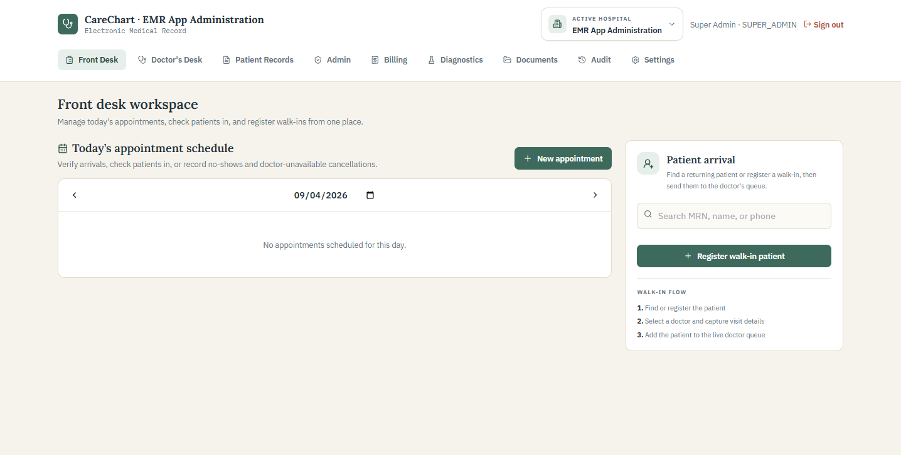
Front Desk schedule and patient arrival panel
1. Search by MRN, patient name or phone before creating a new record.
2. Verify more than one identifier before selecting a patient.
3. Register a walk-in only when no correct existing record is found.
4. Check scheduled patients in when they arrive so they enter the doctor's queue.

FRONT DESK

Register a new patient
Capture the minimum information required for safe identification and the current visit.
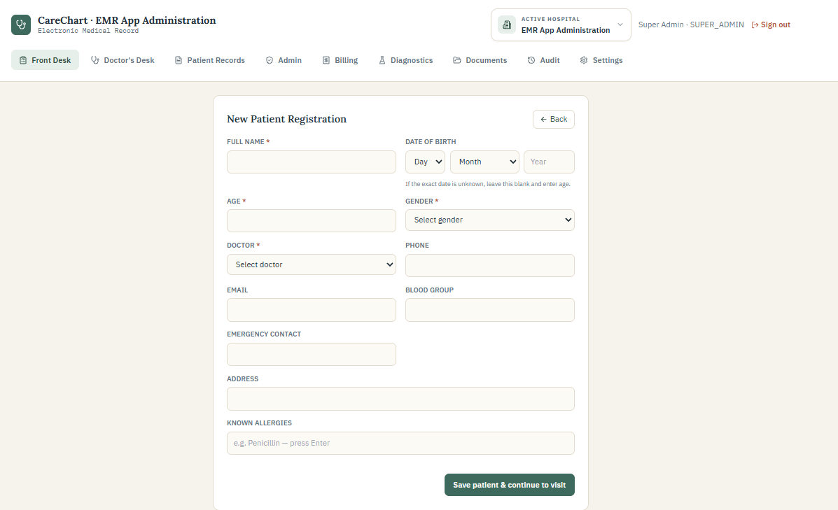
New patient registration with simplified day, month and year entry
1. Enter the patient's full name as provided.
2. Choose day and month, then type the four-digit birth year. Age is calculated automatically.
3. If the exact birth date is unknown, leave all three birth-date fields blank and enter age.
4. Record gender, doctor, contact information and address according to hospital policy.
5. Enter each known allergy separately and review the information before saving.

APPOINTMENTS

Book an appointment from the schedule
Authorized staff can create an appointment for an existing patient and assign it to the appropriate doctor and time.
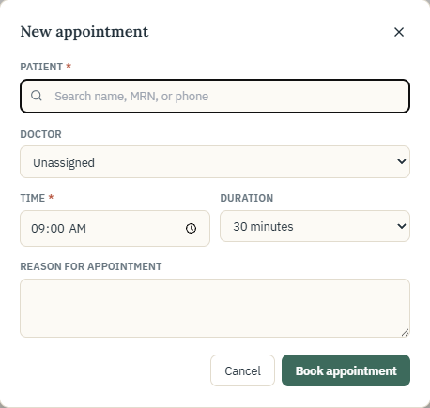
Manual appointment form
1. Search for and select the correct patient.
2. Choose the doctor, time, duration and reason for appointment.
3. Review availability, then select Book appointment.

APPOINTMENTS

Offer public appointment requests
The public booking page allows a patient to request an available doctor and time without using the staff workspace.
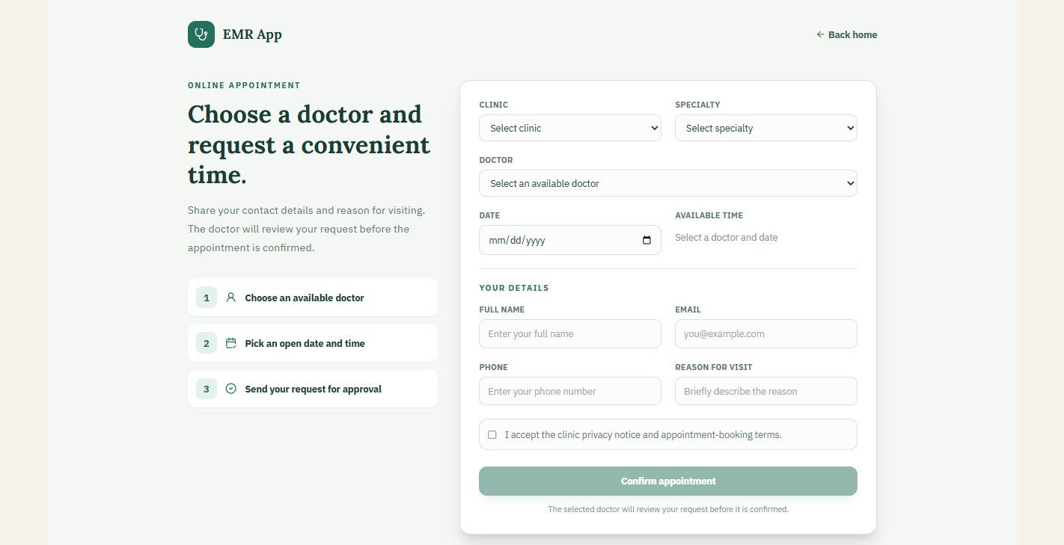
Public appointment request page
- The patient chooses the hospital, clinic, doctor, date and available time.
- A request is not a completed visit. Authorized staff or the doctor reviews it before confirmation.
- Front Desk checks the patient in on arrival.

DOCTOR WORKFLOW

Open the waiting room
Doctor's Desk combines appointment requests, confirmed appointments and patients waiting for consultation.
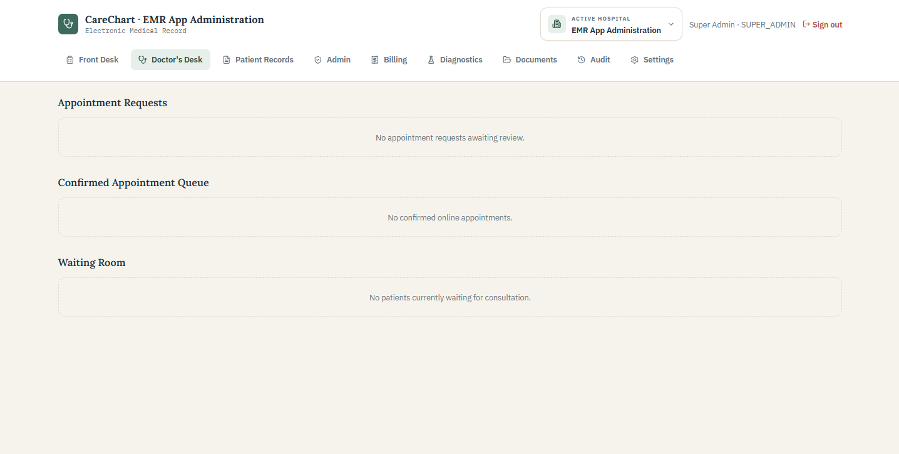
Doctor's Desk appointment queues and waiting room
1. Review pending appointment requests according to the hospital's booking process.
2. Open a patient from Waiting Room only when ready to begin the consultation.
3. Confirm the patient and visit reason before documenting clinical information.

DOCTOR WORKFLOW

Document the consultation
The consultation begins with patient identity, allergy status, chief complaint and available vital signs.
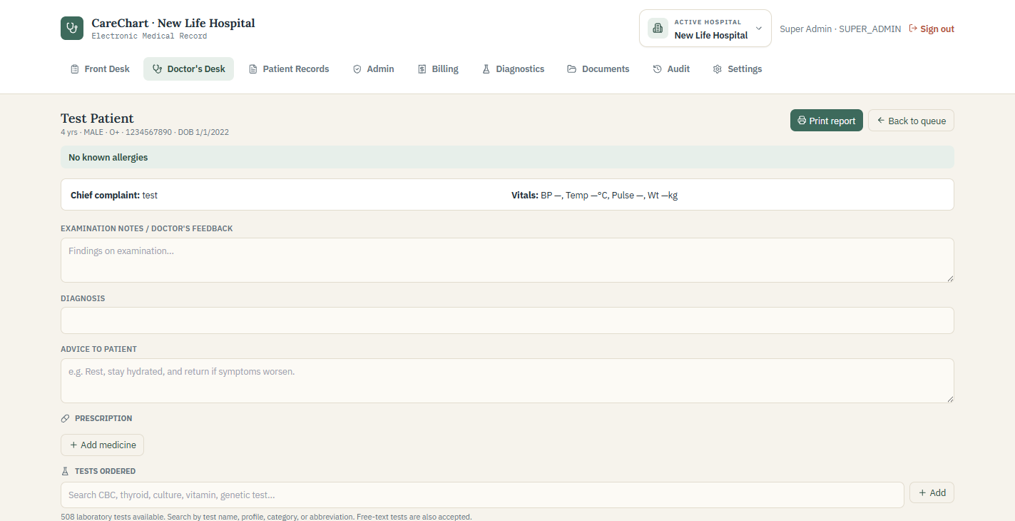
Clinical consultation form with patient header and primary documentation fields
1. Verify the patient header and review allergy information before prescribing.
2. Record examination findings, diagnosis and advice in clear clinical language.
3. Add medicines only after reviewing allergies, duplicate therapy and displayed safety warnings.
4. Use Tests ordered to search the laboratory catalog or enter an appropriate free-text test.

DOCTOR WORKFLOW

Record imaging and control operational orders
The clinical recommendation fields remain available even when the hospital does not operate an internal laboratory or imaging worklist.
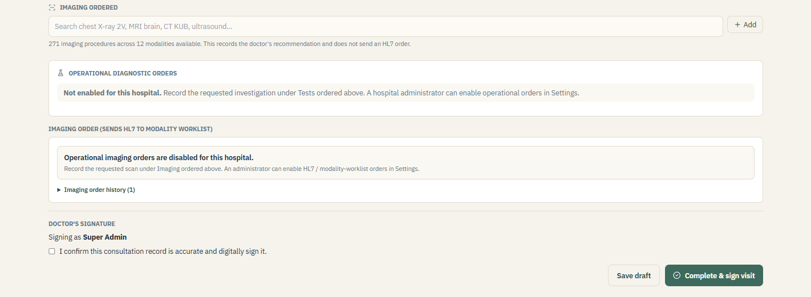
Imaging recommendations, disabled operational orders and visit signature
- Imaging ordered. Search the catalog by procedure, modality or body part. The catalog includes 271 procedures across 12 modalities in this edition.
- Tests ordered. Search the laboratory catalog by name, profile, category or abbreviation. Free-text entry remains available.
- Operational orders. When disabled, the application records recommendations without creating departmental or HL7 work.
- Signature. Save a draft while documentation is incomplete. Confirm the signature and complete the visit only after reviewing the record.
Corrections after signing Use the hospital's approved amendment process so the original signed record remains traceable.

PATIENT RECORDS

Find the correct patient record
Patient Records provides hospital-scoped search and access to permitted longitudinal information.
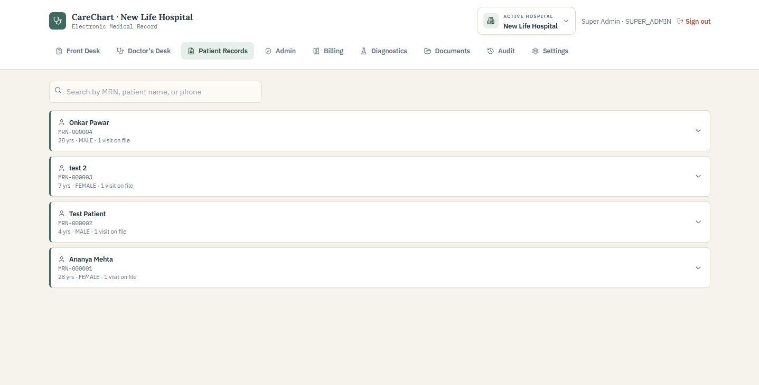
Patient Records search results
1. Search by MRN, patient name or phone.
2. Verify more than one identifier before opening the record.
3. If two records may belong to the same person, stop and use the approved duplicate-review process.

PATIENT RECORDS

Review the longitudinal clinical summary
The selected record brings together demographics, safety information, encounters, medication history and other permitted clinical information.
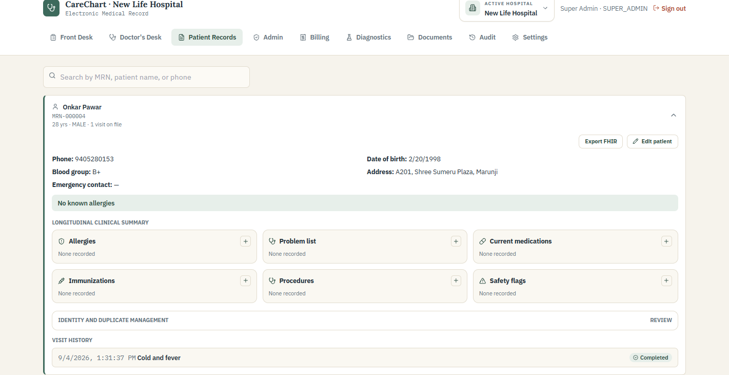
Expanded patient record and clinical summary
- Review allergies and active safety information before clinical decisions.
- Use the encounter history to understand previous diagnoses, medicines, tests and imaging recommendations.
- Edit demographics only after confirming the information with the patient and following hospital policy.
Minimum necessary access Open a patient record only when it is needed for assigned work. Patient access may be recorded in audit history.

DIAGNOSTICS

Process operational diagnostic orders
The Diagnostics workspace is used only for orders created through the enabled operational workflow.
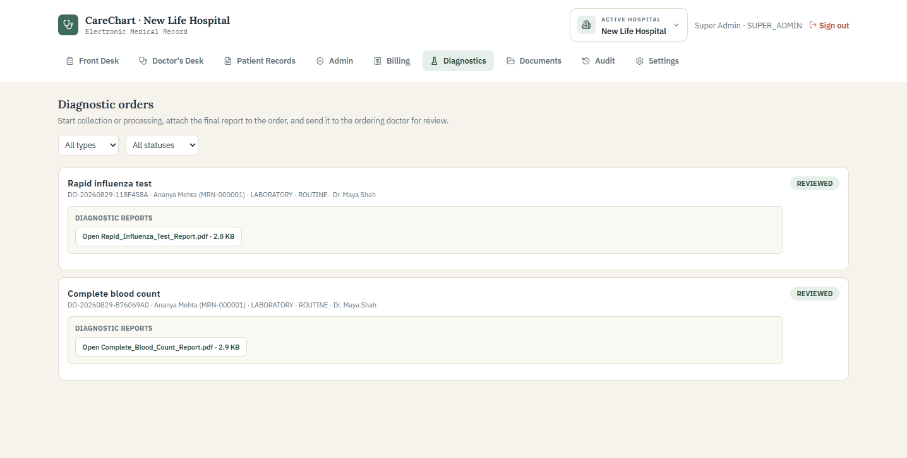
Diagnostics worklist with report processing and completed orders
1. Filter the worklist by type or status when needed.
2. Begin collection or processing only when the sample or patient reaches the department.
3. Complete the work in the hospital's approved laboratory or radiology process.
4. Attach the final approved report and send it to the ordering doctor.
5. The ordering clinician opens and acknowledges the completed report after review.
Status meaning Completed means a report was uploaded. Reviewed means an authorized clinician acknowledged it. Neither status replaces clinical review of the report.

DOCUMENTS

Store approved patient documents
Documents keeps supported patient files inside the selected hospital workspace with controlled access.
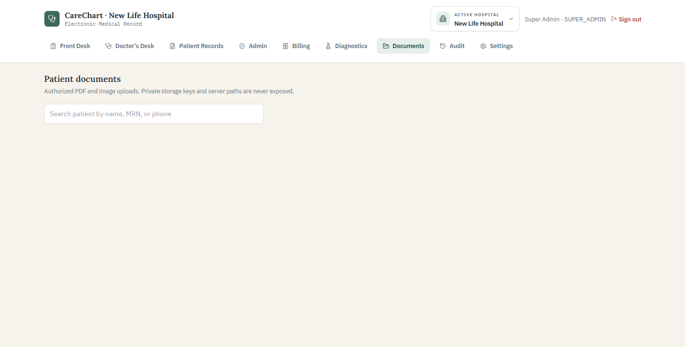
Patient document search and upload workspace
1. Search for the patient and verify the correct record.
2. Choose an approved PDF, JPEG or PNG file.
3. Link a final report to its diagnostic order when applicable.
4. Confirm the patient, document type and active hospital before upload.
Upload safety Do not upload unrelated files, passwords, multi-patient exports or documents that have not been approved under hospital policy.

BILLING

Review invoices and outstanding balances
Billing lists invoices for the active hospital and provides access to the full invoice workflow.
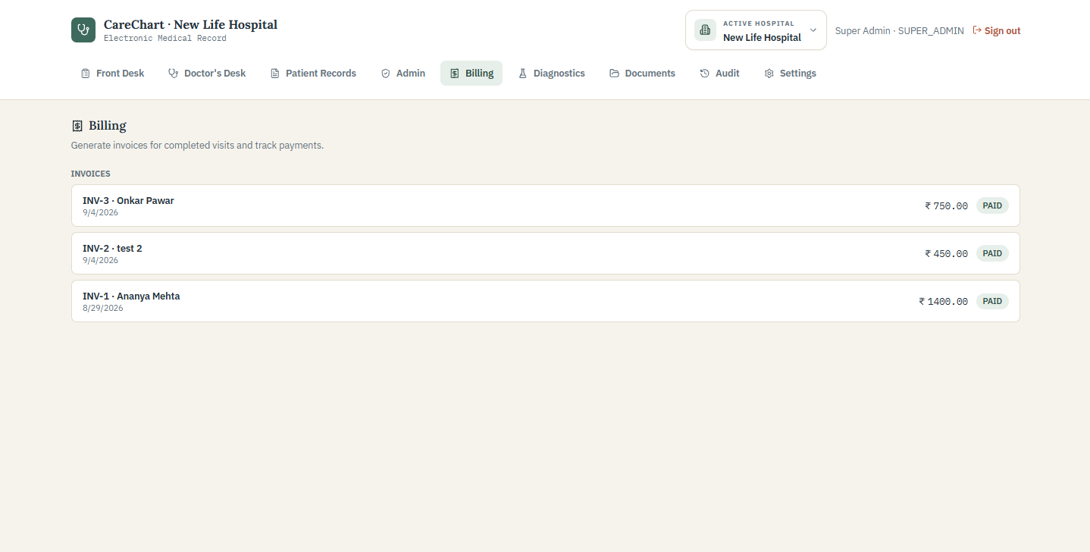
Billing list with invoice status and balance
1. Open the correct patient invoice after confirming the visit and invoice date.
2. Review status, total, amount paid and remaining balance.
3. Investigate unexpected zero prices before collecting payment.

BILLING

Finalize invoice items and payments
Invoice prices are populated from the active clinic's configured service catalog and must be reviewed before payment is recorded.
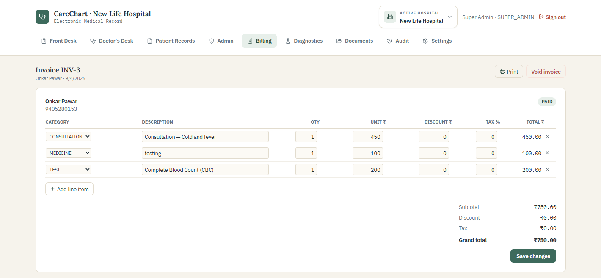
Invoice detail with line items, discounts, tax and totals
- Review every line item, quantity, unit price, discount, tax and total.
- Save changes only after the invoice matches the approved services.
- Record the payment method and reference used by the hospital.
- For refunds or voids, enter a clear reason so the original transaction remains traceable.
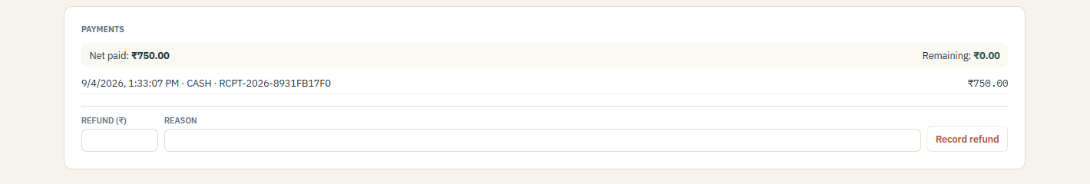
Payment and refund history

AUDIT

Review important activity
Audit history provides an append-only view of important security and workflow events for the active hospital.
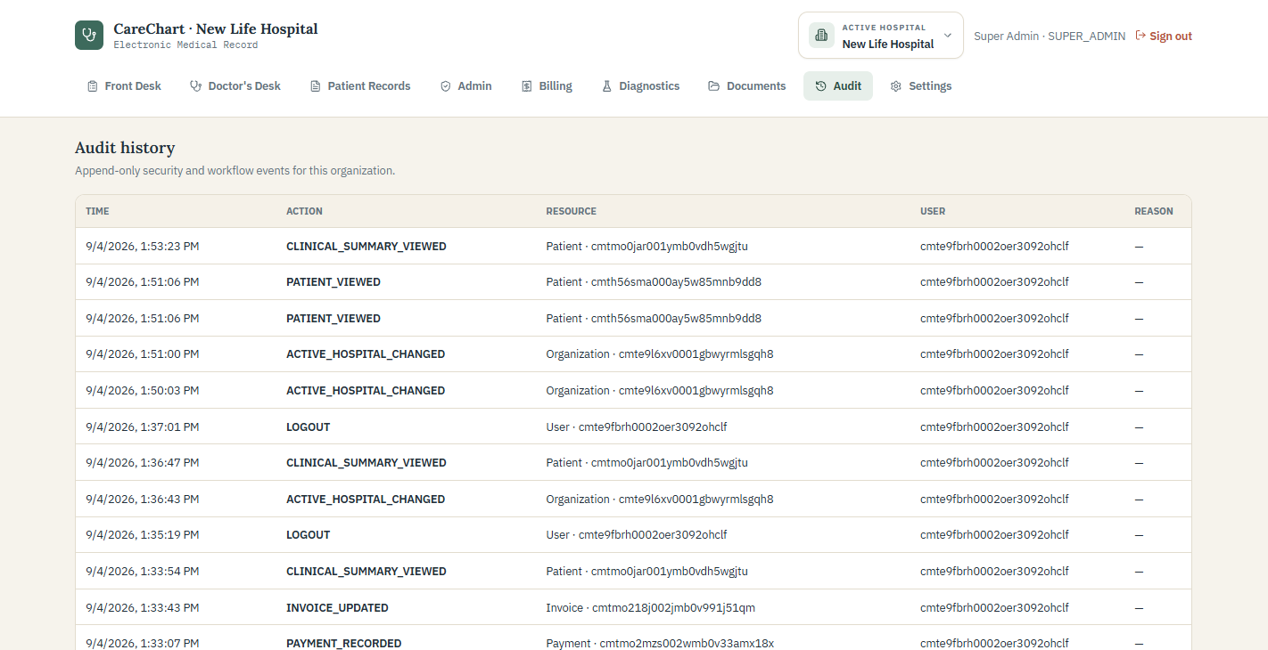
Audit history with time, action, resource, actor and reason
- Use audit history only for authorized operational, privacy, security and support reviews.
- Search by event details when investigating a known action or time period.
- Do not place passwords, tokens or unnecessary clinical information in an audit reason.
Interpretation An audit event shows that an action occurred. It does not by itself determine whether that action was clinically appropriate.

PATIENT PORTAL

Use the separate patient sign in
Patients use the patient portal rather than the staff sign-in page.
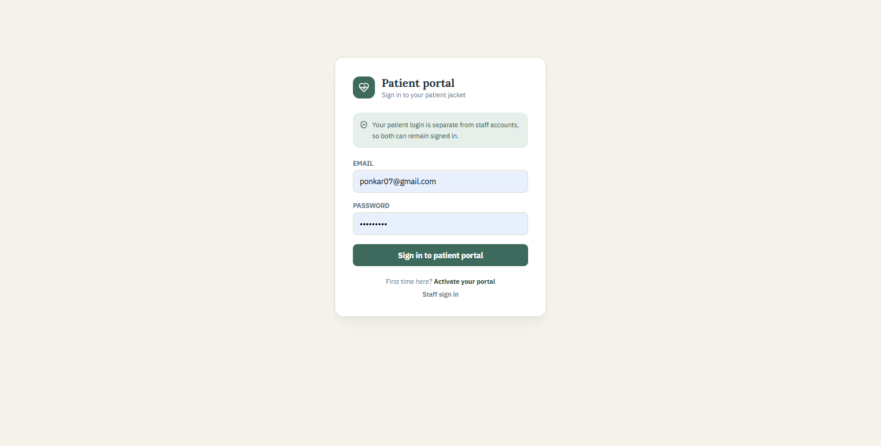
Patient portal sign-in page
- The patient enters the registered email address and portal password.
- Staff should direct patients to the approved password-reset or support process when access is lost.
- A portal account must remain linked only to the correct patient record.

PATIENT PORTAL

Activate patient access
Portal activation should follow the hospital's identity-verification process before an account is created.
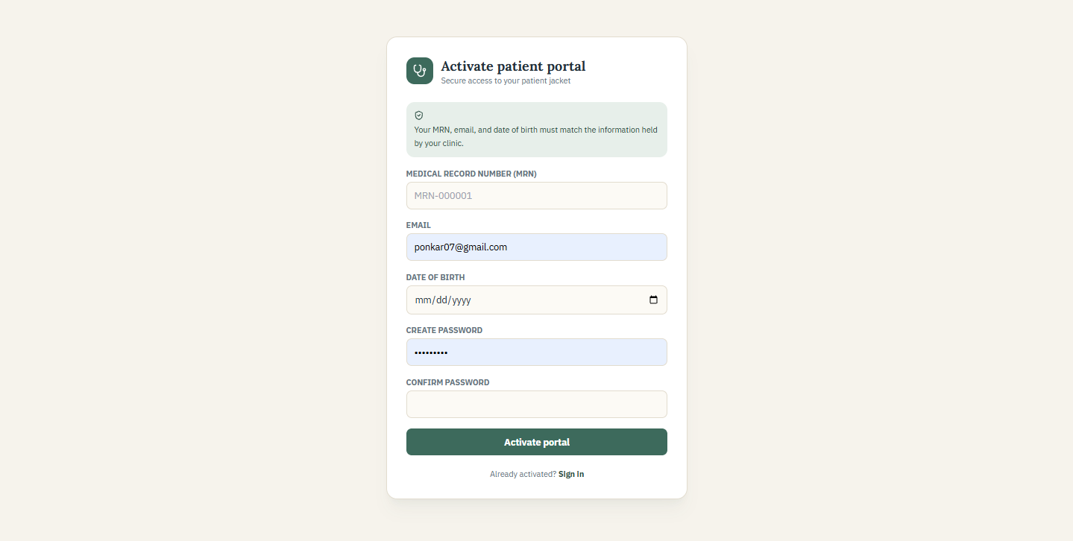
Patient portal activation form
1. Confirm the patient's MRN, registered email and date of birth.
2. Ask the patient to create a private password that follows the displayed requirements.
3. Do not activate access using an unverified email address or another person's device without consent.

PATIENT PORTAL

Review the patient dashboard
After sign-in, the patient sees only the information connected to the activated patient account.
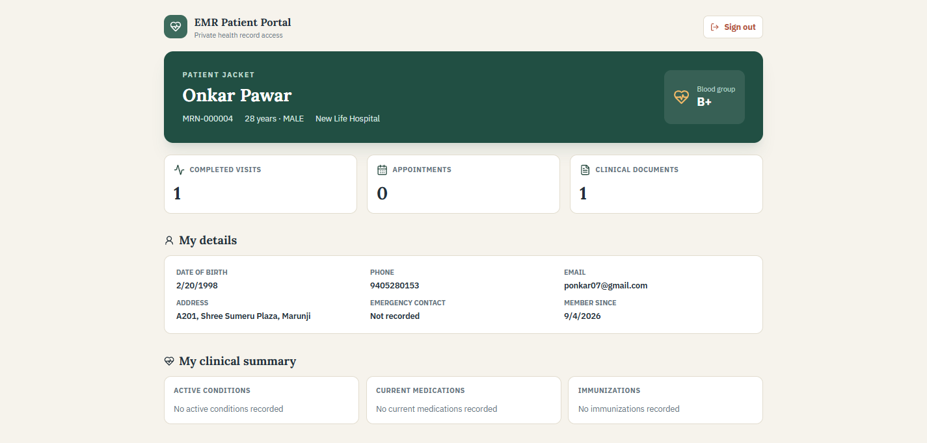
Patient dashboard with details and clinical summary
- The dashboard summarizes demographics, clinical information and recent activity available to the patient.
- Patients should contact the hospital through the approved channel if information appears incorrect.
- Portal access does not replace urgent or emergency clinical communication.

PATIENT PORTAL

View records and billing history
The patient portal presents available records and billing information without exposing the staff workspace.
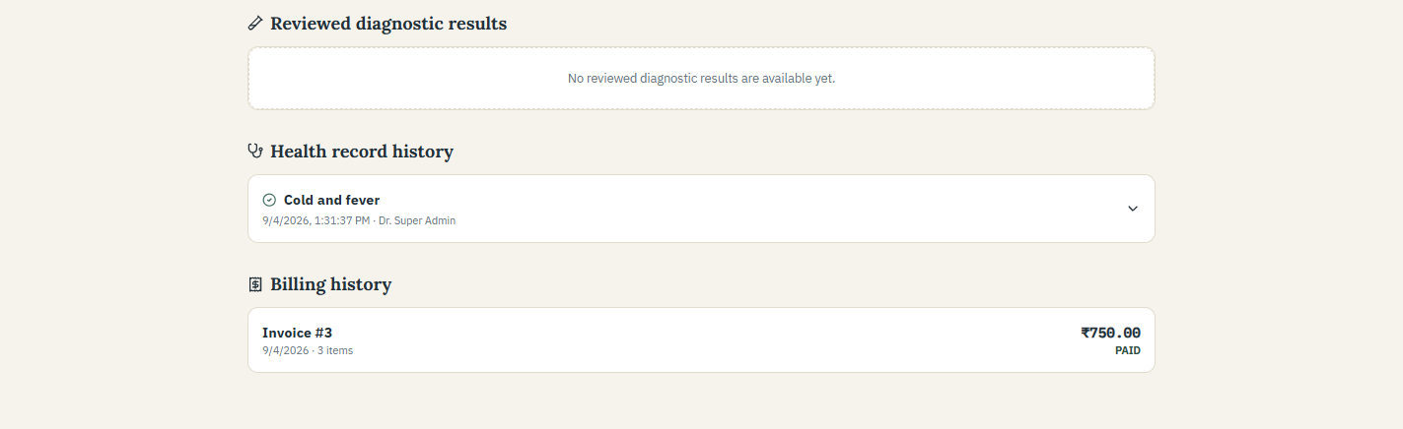
Patient records and billing history
- Open the relevant section to review available record or invoice details.
- Use the hospital's approved process for corrections, copies or billing questions.
- Sign out after using a shared or public device.

GO LIVE

New hospital setup checklist
Complete and approve each item before entering real patient information.
- Hospital account created and selected as the active hospital
- Clinic locations, codes, addresses, timezones, departments and appointment types entered
- Doctor accounts linked to practitioner profiles and weekly schedules verified
- Breaks, blocked periods and clinic holidays tested
- Operational diagnostic and imaging capabilities enabled only when integrations are ready
- Service catalog, clinic prices and tax rules approved by the hospital's finance owner
- Staff accounts assigned the minimum required roles
- Email delivery, document storage, encryption, malware scanning, HTTPS and audit review tested
- Encrypted backups completed and a restore test documented
- A complete fictional-patient workflow successfully tested
Approval Clinical, operational, privacy, legal, security and finance owners should approve the configured workflow before real use.

DAILY OPERATIONS

Daily workflow checklists

Walk-in visit
1. Front Desk searches for or registers the patient.
2. Front Desk starts the visit and selects the doctor.
3. Doctor opens the patient from Waiting Room.
4. Doctor documents the consultation, recommendations and any enabled operational orders.
5. Lab or radiology processes operational work and uploads the final report when applicable.
6. Ordering clinician reviews the report.
7. Billing reviews the invoice and records payment.

Online appointment
1. Patient submits a public appointment request.
2. Authorized staff or the doctor reviews and confirms it.
3. Front Desk verifies and checks the patient in on arrival.
4. The clinical, diagnostic and billing workflow continues as for a walk-in visit.

PRIVACY AND SECURITY

Protect patient and hospital information
Every user is responsible for handling patient information only for approved hospital work.
- Use an individual account and lock the device when stepping away.
- Confirm the active hospital and patient before viewing, entering, uploading, printing or billing information.
- Access only the minimum information needed for assigned work.
- Use fictional identities in demonstrations, training materials and sales presentations.
- Remove patient details, staff emails, internal identifiers, tokens and private URLs from support screenshots.
- Follow the hospital's approved retention, backup, access-review and incident-response procedures.
- Apply the legal and regulatory requirements relevant to the hospital and deployment location.
Important This guide explains product workflows. It is not a certification of regulatory compliance, clinical safety or production readiness.

SUPPORT

Troubleshooting and safe escalation
Problem | First checks
Wrong hospital is shown | Open Active Hospital if authorized, or confirm assignment to the correct hospital.
A menu is missing | Check the signed-in role; functions outside that role are hidden.
Patient is not found | Confirm the hospital and search another approved identifier before creating a record.
Doctor is missing | Confirm an active doctor account is linked to a practitioner profile and clinic.
No appointment slots | Check schedule, breaks, blocked time, holidays and existing appointments.
Invoice price is zero | Verify the service name and active clinic price in Settings.
Report cannot be uploaded | Confirm the order status and use an approved file type within the size limit.
Page remains loading | Refresh once, then contact support with the page name and approximate time.

Information safe to send support
- Page name and approximate time of the issue
- Your role and the hospital name shown in the header
- The non-sensitive error message and steps that led to it
- A screenshot only after patient details, credentials, tokens, emails, identifiers and private URLs are removed
Do not send Passwords, authentication codes, database credentials, complete patient exports or unapproved clinical documents.

