LinkedIn Influencer Data

Exploratory Data Analysis Report

Capstone Project: TrendPilot
A System for Creating Engaging LinkedIn Posts
Data Analysis Phase

Table of Contents
1. Executive Summary 3
2. Introduction and Objectives 4
3. Dataset Overview 5
4. Data Gap Analysis - Missing Values 6
5. Data Quality Assessment 9
6. Distribution Analysis of Key Metrics 12
7. Content Analysis 15
8. Engagement Analysis 18
9. Correlation Analysis 22
10. Top Performers Analysis 24
11. Data Gap Risk Assessment 26
12. Impact on Final Project 28
13. Recommendations 31
14. Conclusion 33

1. Executive Summary
This comprehensive Exploratory Data Analysis (EDA) report examines a dataset of LinkedIn posts from 69 influential professionals, comprising 34,012 individual posts. The analysis was conducted to support the development of TrendPilot, a system designed to help users create engaging LinkedIn posts optimized for maximum likes (reactions) and comments.
The primary objectives of this EDA were to: (1) identify data gaps and missing values that could impact model development, (2) assess the quality and reliability of the available data, (3) understand the distribution and relationships between key engagement metrics, and (4) evaluate how data limitations might affect the final project deliverables.

Key Findings at a Glance
Data Completeness: The dataset achieves 86.7% overall completeness and 95.4% completeness for core features essential to engagement prediction. This indicates the data is suitable for building machine learning models.
Critical Data Gap: Views data is 100% missing across all records. This is a significant limitation as it prevents optimization for post reach and virality metrics.
Engagement Metrics: Reactions and comments data is 100% complete, providing a solid foundation for building engagement prediction models. These metrics show a strong positive correlation (r=0.823).
Content Availability: 94.1% of posts have content text available, enabling robust natural language processing (NLP) analysis for content optimization features.
Media Impact: Video and image content significantly outperform articles in engagement metrics, with videos generating an average of 866 reactions compared to 161 for articles.
Temporal Limitation: Timestamps are stored in relative format ("1 day ago", "2 weeks ago") rather than absolute dates, preventing optimal posting time recommendations.

Data Quality Assessment Summary
Overall Data Completeness | 86.7%
Core Features Completeness | 95.4%
Quality Assessment | GOOD
Suitability for ML | SUITABLE

2. Introduction and Objectives

2.1 Background
LinkedIn has emerged as the premier professional networking platform, with over 900 million users worldwide. For professionals, thought leaders, and businesses, creating engaging content on LinkedIn is crucial for building personal brands, establishing thought leadership, and driving business outcomes. However, the factors that contribute to high-engagement posts are not always intuitive, and users often struggle to optimize their content for maximum impact.
This EDA supports the development of TrendPilot, an intelligent system designed to analyze patterns in successful LinkedIn posts and provide data-driven recommendations for content creation. By studying posts from verified influencers who consistently achieve high engagement, we can extract insights that will benefit everyday LinkedIn users.

2.2 Analysis Objectives
This exploratory data analysis was conducted with the following specific objectives:
- Identify Data Gaps: Systematically catalog missing values, incomplete records, and data quality issues that could affect downstream analysis and model development.
- Assess Data Quality: Evaluate the reliability, consistency, and accuracy of the collected data through statistical analysis and anomaly detection.
- Understand Engagement Patterns: Analyze the distribution of engagement metrics (reactions, comments, views) and identify patterns associated with high-performing content.
- Evaluate Feature Relationships: Examine correlations between content characteristics (length, hashtags, media type) and engagement outcomes.
- Impact Assessment: Determine how identified data gaps and quality issues will affect the feasibility and scope of planned features in the final system.

2.3 Methodology
The analysis was conducted using Python with the following key libraries: Pandas for data manipulation, NumPy for numerical operations, Matplotlib and Seaborn for static visualizations, and Plotly for interactive dashboards. The analysis followed a structured approach:
- Data loading and initial inspection
- Missing value analysis and visualization
- Data type verification and conversion
- Statistical summary generation
- Distribution analysis with appropriate transformations
- Correlation analysis between features
- Segmented analysis by media type and influencer
- Risk assessment and impact evaluation

3. Dataset Overview

3.1 Data Source and Collection
The dataset comprises LinkedIn posts collected from 69 verified influencers across various industries and professional domains. These influencers were selected based on their established presence on the platform, consistent posting activity, and demonstrated ability to generate engagement. The data includes both profile-level information (name, headline, location, followers) and post-level details (content, media, hashtags, engagement metrics).

3.2 Dataset Dimensions
Total Records (Posts) | 34,012
Total Features (Columns) | 19
Unique Influencers | 69
Average Posts per Influencer | 493

3.3 Feature Descriptions
The dataset contains 19 features capturing various aspects of influencer profiles and their posts. Understanding each feature is crucial for effective analysis and feature engineering.

Profile-Level Features
Feature | Data Type | Description
slno | int64 | Sequential identifier for each record
name | object | Full name of the LinkedIn influencer
headline | object | Professional headline displayed on the profile
location | object | Geographic location of the influencer
followers | float64 | Total number of followers for the profile
connections | object | Number of connections (often shows "500+" for max)
about | object | Biography/about section from the profile

Post-Level Features
Feature | Data Type | Description
time_spent | object | Relative time since post was published (e.g., "1 day ago")
content | object | Text content of the LinkedIn post
content_links | object | Hyperlinks mentioned in the post content
media_type | object | Type of media attached (article, image, video, etc.)
media_url | object | URL(s) of attached media
num_hashtags | int64 | Count of hashtags used in the post
hashtag_followers | int64 | Aggregate followers of hashtags used
hashtags | object | List of hashtags with their URLs

Engagement Metrics
Feature | Data Type | Description
reactions | int64 | Total reactions (likes, celebrates, etc.) on the post
comments | int64 | Total number of comments on the post
views | float64 | Number of views/impressions (NOTE: 100% missing)
votes | object | Poll votes if the post contains a poll

4. Data Gap Analysis - Missing Values
A thorough understanding of missing data is essential for any data science project. Missing values can introduce bias, reduce statistical power, and limit the features that can be implemented in the final system. This section provides a comprehensive analysis of missing data patterns in the LinkedIn influencer dataset.

4.1 Missing Values Summary
The following table presents a complete inventory of missing values across all 19 features in the dataset, sorted by the percentage of missing data from highest to lowest.
Column | Missing Count | Missing % | Data Type
views | 34,012 | 100.00% | float64
votes | 33,926 | 99.75% | object
connections | 8,299 | 24.40% | object
media_type | 7,233 | 21.27% | object
location | 2,272 | 6.68% | object
content | 2,016 | 5.93% | object
followers | 42 | 0.12% | float64
time_spent | 1 | 0.00% | object
All other columns (reactions, comments) | 0 | 0.00% | various

4.2 Visual Analysis of Missing Data
The visualization below provides two complementary views of the missing data pattern. The left panel shows a bar chart of missing percentages by column, making it easy to identify which features have the most significant data gaps. The right panel displays a heatmap of the missing data pattern across a sample of 1,000 records, revealing whether missing values are randomly distributed or follow specific patterns.
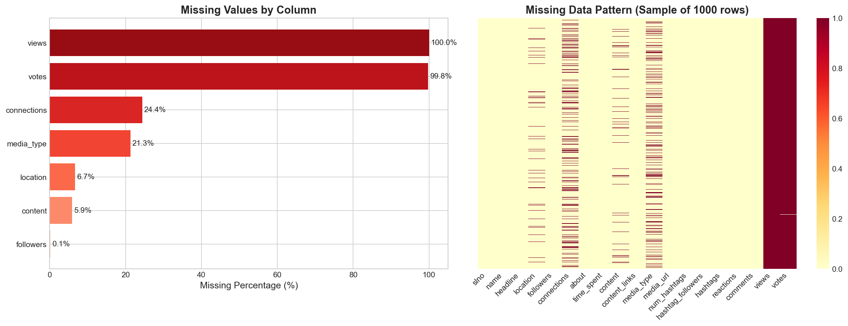
Figure: Missing Data Analysis - Bar Chart and Pattern Heatmap

4.3 Interpretation of Missing Data Patterns

Critical Missing Data (>50%)
Two features have critically high levels of missing data that effectively render them unusable for analysis:
views (100% missing): The views column is entirely empty across all 34,012 records. This represents a significant data collection gap, as views/impressions are a key metric for understanding post reach and virality. Without this data, we cannot optimize content for maximum visibility or calculate view-to-engagement conversion rates. This gap likely resulted from LinkedIn API limitations or scraping restrictions that prevented access to view counts.
votes (99.75% missing): The votes column is nearly empty, with only 86 non-null values out of 34,012 records. However, this is expected behavior rather than a data quality issue - votes only apply to poll-type posts, which represent only 0.25% of the dataset. The 86 valid entries correspond exactly to the 86 poll posts in the data.

Moderate Missing Data (10-50%)
Two features fall into the moderate missing data category, requiring careful consideration for analysis:
connections (24.40% missing): Approximately one quarter of records lack connection count data. However, analysis of available data reveals that this field has limited analytical value - 99.7% of non-null values show "500+" (the LinkedIn display cap), while only 80 records show the actual count of 171. This categorical nature limits its usefulness for quantitative analysis.
media_type (21.27% missing): About 21% of posts lack media type classification. This could indicate text-only posts without attachments, or could represent a data collection gap. Further investigation suggests these are likely text-only posts, as they still contain content but no media_url entries.

Minor Missing Data (<10%)
Several features have minor missing data that can be handled through standard imputation or exclusion techniques:
location (6.68% missing): Geographic location is missing for 2,272 records. This prevents geographic analysis for a subset of data but does not significantly impact content analysis features.
content (5.93% missing): Post content text is missing for 2,016 records. While this is a core feature, the 94% availability rate is sufficient for training NLP models. Missing content may indicate posts that were primarily media-based (images/videos) with minimal or no text.
followers (0.12% missing): Only 42 records lack follower count data, representing negligible missing data that can be easily imputed using the influencer's other posts.

5. Data Quality Assessment
Beyond missing values, data quality encompasses issues such as duplicate records, inconsistent formatting, outliers, and data type mismatches. This section examines these aspects to ensure the dataset is suitable for building reliable machine learning models.

5.1 Duplicate Records Analysis
Duplicate records can artificially inflate dataset size and skew analysis results. We examined the dataset for both exact duplicate rows and duplicate content.
Duplicate Type | Count | Percentage
Exact duplicate rows | 0 | 0.00%
Duplicate content text | 757 | 2.37%

The dataset contains no exact duplicate rows, indicating good data collection practices. However, 757 posts (2.37%) share identical content text. This could represent: (1) influencers reposting their own successful content, (2) common phrases or templates used across posts, or (3) cross-posted content. For model training, these duplicates should be considered - they may need to be deduplicated or weighted appropriately depending on the modeling approach.

5.2 Numerical Column Statistics
Understanding the statistical properties of numerical features is essential for feature engineering and model development. The table below presents comprehensive descriptive statistics for key numerical columns.
Statistic | Followers | Num Hashtags | Reactions | Comments | Eng. Rate*
Count | 33,970 | 34,012 | 34,012 | 34,012 | 33,970
Mean | 1,125,922 | 2.10 | 473 | 27 | 0.77
Std Dev | 3,057,750 | 3.52 | 4,164 | 216 | 3.91
Min | 171 | 0 | 0 | 0 | 0.00
Median (50%) | 408,254 | 0 | 36 | 2 | 0.11
Max | 18,289,351 | 48 | 391,498 | 32,907 | -
Skewness | High + | High + | High + | High + | High +

*Engagement Rate = Reactions per 1,000 followers

Key Observations from Statistics
Highly Skewed Distributions: All engagement metrics show extreme positive skewness, with means significantly higher than medians. For example, the mean reactions (473) is over 13 times the median (36). This indicates a small number of viral posts driving up averages, while most posts receive modest engagement.
Wide Range of Followers: Influencer follower counts span from 171 to over 18 million, representing a 100,000x range. This diversity is valuable for understanding how engagement scales with audience size.
Hashtag Usage Patterns: The median hashtag count is 0, meaning more than half of posts use no hashtags. The average of 2.1 hashtags is pulled up by a minority of posts with heavy hashtag usage (max 48).
Zero-Value Prevalence: A significant portion of posts have zero comments (32%) or zero reactions (3.1%), indicating that even influencer content doesn't always generate engagement.

5.3 Connections Field Analysis
The connections field exhibits unusual characteristics that warrant special attention. LinkedIn displays "500+" for users who have reached the connection limit, rather than showing the actual count.
Value | Count | Percentage
500+ | 25,633 | 75.4%
171 | 80 | 0.2%
Missing | 8,299 | 24.4%

This analysis reveals that the connections field has limited analytical utility. The overwhelming majority (99.7%) of non-null values are capped at "500+", making it essentially a binary indicator rather than a continuous variable. For modeling purposes, this field should either be: (1) converted to a binary feature (has_500_plus_connections), (2) excluded from analysis, or (3) treated as categorical.

5.4 Time Field Analysis
The time_spent field captures when posts were published, but in a relative format rather than absolute timestamps.
Time Value | Count
1 year ago | 7,753
2 years ago | 5,728
3 years ago | 3,759
4 years ago | 2,126
3 months ago | 1,456
2 months ago | 1,448
4 months ago | 1,279
10 months ago | 1,247
11 months ago | 1,133
Other values | ~9,000

The relative time format presents a significant limitation for temporal analysis. Without absolute timestamps, we cannot: (1) determine optimal posting times (day of week, hour of day), (2) analyze engagement trends over time, (3) account for LinkedIn algorithm changes, or (4) perform time-series forecasting. The data does show that posts span approximately 4+ years, providing good temporal diversity.

6. Distribution Analysis of Key Metrics
Understanding the distribution of engagement metrics is crucial for several reasons: (1) it informs the choice of statistical methods and machine learning algorithms, (2) it helps identify appropriate data transformations, and (3) it reveals the natural variation in post performance that models must capture.

6.1 Engagement Metrics Distribution
The following visualization shows the distribution of four key metrics: reactions, comments, views, and followers. Due to the extreme skewness of these distributions, a logarithmic transformation (log(x+1)) was applied for visualization purposes.
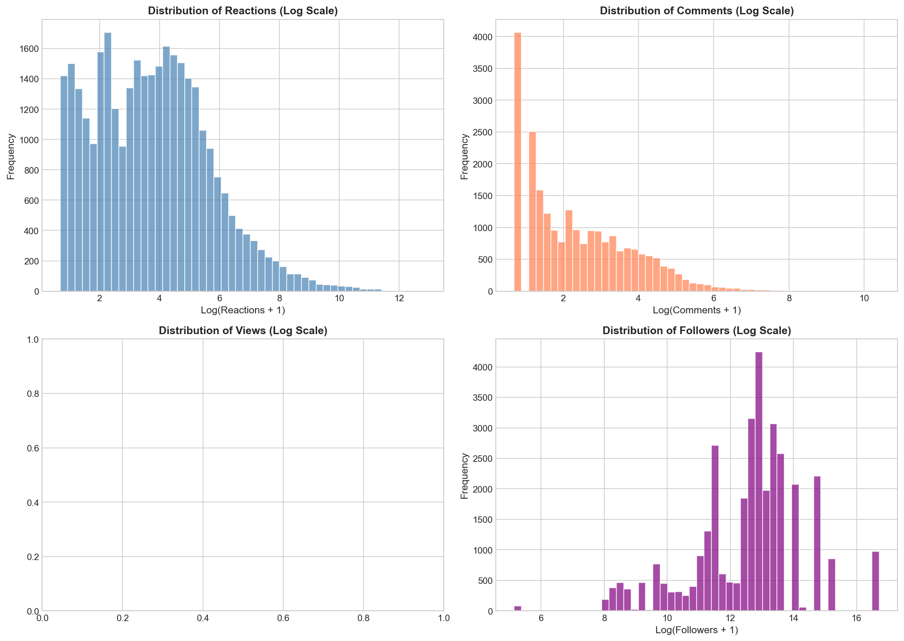
Figure: Distribution of Engagement Metrics (Log Scale)

Interpretation of Engagement Distributions
Reactions Distribution (Top Left): The log-transformed reactions show a roughly normal distribution centered around log(36) ≈ 3.6, indicating that most posts receive between 10-100 reactions. The long right tail represents viral posts with thousands to hundreds of thousands of reactions. This suggests a log-normal distribution is appropriate for modeling.
Comments Distribution (Top Right): Comments follow a similar log-normal pattern but are shifted left, reflecting that comments are less common than reactions. The peak around log(2) ≈ 0.7 indicates that most posts receive 0-5 comments. The 32% of posts with zero comments appear as a spike at the origin.
Views Distribution (Bottom Left): This panel is empty because views data is 100% missing. This represents a critical data gap that prevents reach optimization.
Followers Distribution (Bottom Right): Follower counts span a wide range on the log scale, from around 5 (≈150 followers) to 17 (≈18 million followers). The distribution appears bimodal, suggesting two distinct groups of influencers in the dataset.

6.2 Outlier Detection
Outliers can significantly impact model performance and must be carefully identified and handled. The box plots below show the distribution of each metric on a log scale, highlighting potential outliers as points beyond the whiskers.
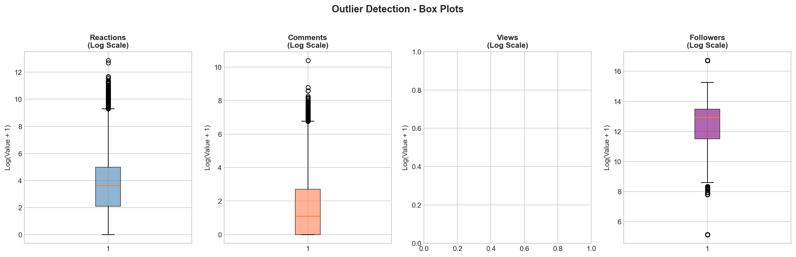
Figure: Outlier Detection Box Plots (Log Scale)

The box plots reveal several important insights about outliers in the dataset:
- All metrics show numerous outliers on the high end, represented by dots above the upper whiskers.
- These outliers represent viral posts that significantly outperform typical content.
- For reactions, the interquartile range (IQR) spans roughly log(7) to log(143), or 7-143 reactions.
- Extreme outliers include posts with 391,498 reactions (max) and 32,907 comments (max).
- For modeling, these outliers could be: (1) capped/winsorized, (2) log-transformed, or (3) modeled separately.

7. Content Analysis
Content characteristics play a crucial role in determining post engagement. This section analyzes the textual properties of posts, including length, word count, hashtag usage, and media type distribution. These insights will inform the content optimization features of the final system.

7.1 Content Length Statistics
Post length can impact readability, engagement, and algorithmic visibility. The following analysis examines both character count and word count distributions.
Metric | Characters | Words
Average | 308 | 49
Median | 210 | 33
Maximum | 1,394 | 260
Empty Posts | 2,016 (5.9%) | -

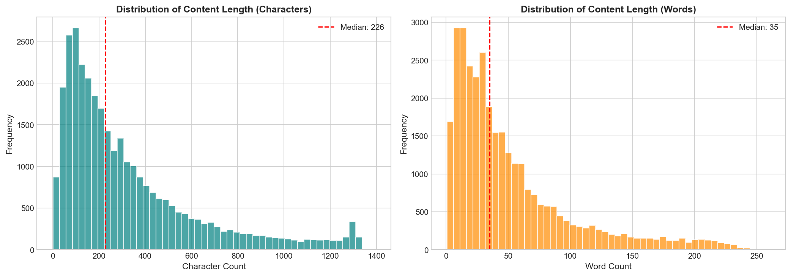
Figure: Distribution of Content Length (Characters and Words)

The content length distributions reveal several patterns relevant to content optimization:
Moderate Length Preference: The median post contains 210 characters (~33 words), suggesting that successful influencers tend to keep posts concise. This aligns with LinkedIn best practices recommending 150-300 characters for optimal engagement.
Right-Skewed Distribution: Both character and word count distributions are right-skewed, with a long tail of longer posts. Some influencers write detailed, longer-form content up to 1,394 characters.
Empty Content: 5.9% of posts have no text content. These are likely media-focused posts (images, videos) that rely on visual content rather than text to convey their message.

7.2 Hashtag Analysis
Hashtags can increase post visibility by connecting content to broader conversations and making posts discoverable to users following specific topics. This analysis examines hashtag usage patterns among influencers.
- Posts with hashtags: 14,405 (42.4%)
- Posts without hashtags: 19,607 (57.6%)
- Average hashtags per post: 2.10
- Maximum hashtags in a post: 48
- Most common count: 0 (no hashtags)

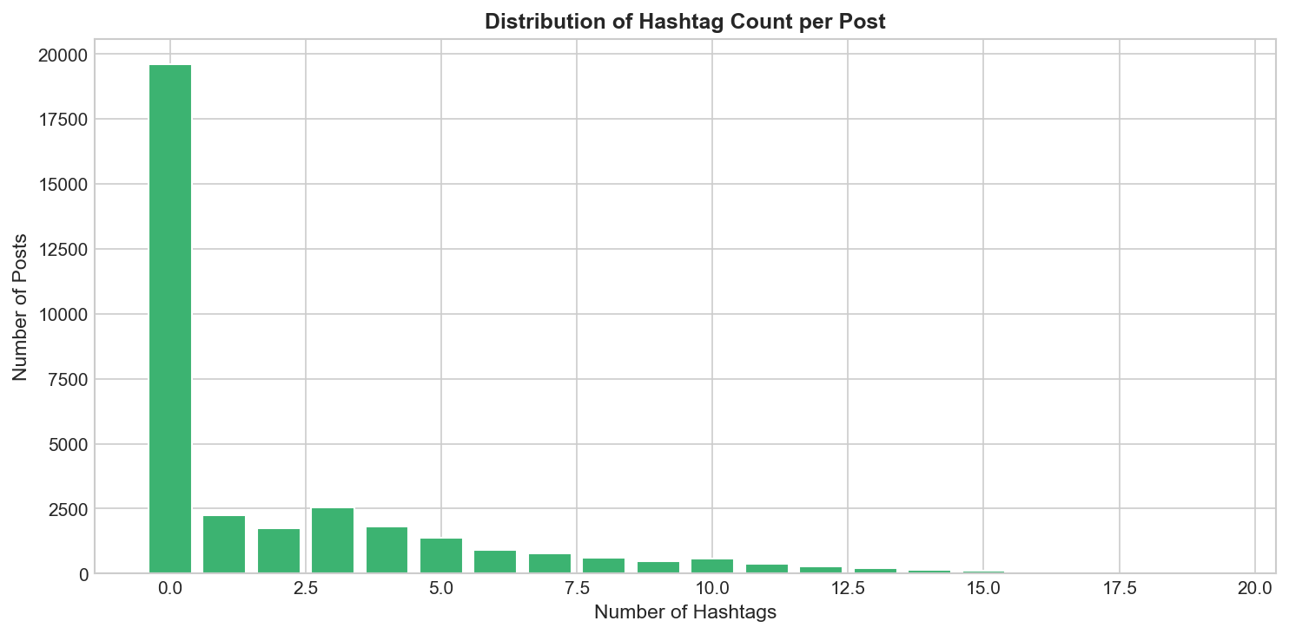
Figure: Distribution of Hashtag Count per Post

The hashtag distribution reveals an interesting pattern: the majority of influencer posts (57.6%) use no hashtags at all. Among posts that do use hashtags, 1-5 hashtags is most common. This challenges the common advice to always include hashtags - successful influencers may rely more on their established audience and content quality than hashtag-based discovery. However, the correlation between hashtag count and engagement should be examined before drawing conclusions.

7.3 Media Type Distribution
The type of media attached to a post can significantly impact its performance. LinkedIn supports various media types including articles, images, videos, documents, and polls.
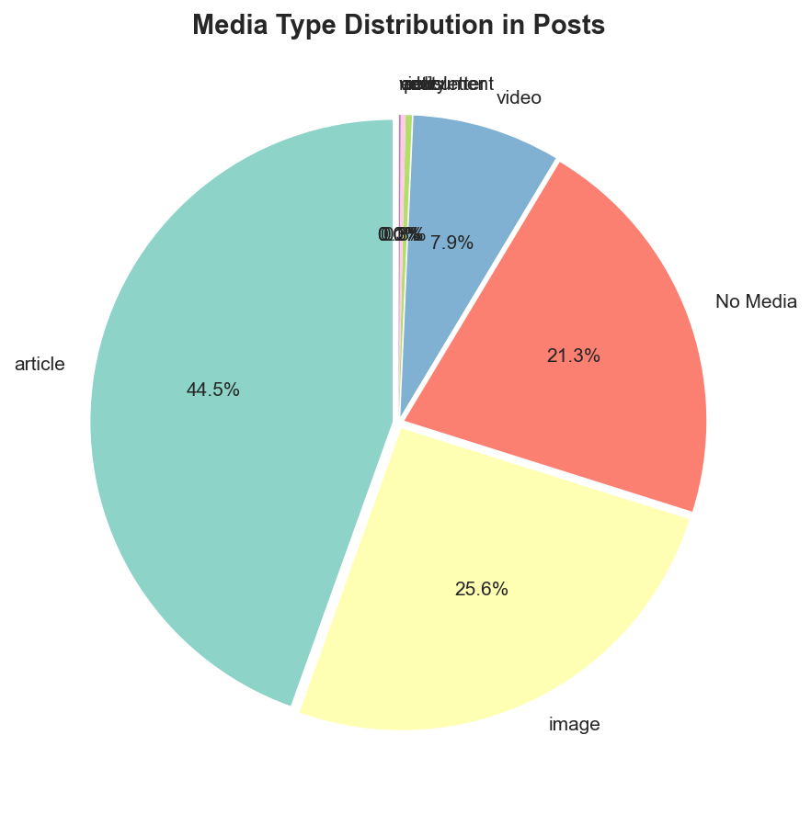
Figure: Distribution of Media Types in Posts

The pie chart reveals the following media type distribution:
Articles (44.5%): Nearly half of all posts include article links, reflecting LinkedIn's positioning as a platform for sharing professional insights and external content.
Images (25.6%): About a quarter of posts feature images, used for infographics, quotes, and visual storytelling.
No Media (21.3%): Over one-fifth of posts are text-only, demonstrating that compelling text content can stand on its own without media attachments.
Videos (7.9%): Video content represents a smaller but significant portion of posts. As we'll see in the engagement analysis, videos often achieve the highest engagement despite their lower frequency.
Other (0.7%): Documents, polls, newsletters, and other media types make up a small fraction of posts.

7.4 Topic Modelling
Topic modeling was performed on a subset of the dataset consisting of posts from the most recent three months, rather than the full historical data. This design choice was intentional, as influencer content trends—particularly on professional platforms like LinkedIn—are highly time-sensitive. Restricting the analysis to recent data ensures that the extracted topics reflect current audience interests, platform norms, and emerging trends, rather than outdated or no-longer-relevant themes.

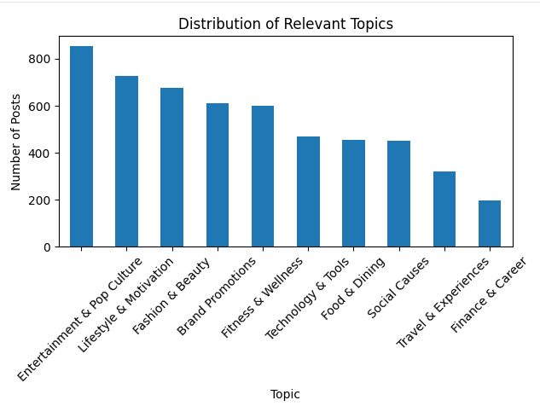
The topic distribution reveals that Entertainment & Pop Culture and Lifestyle & Motivation dominate recent influencer content, indicating a strong emphasis on broad, engagement-driven themes. In contrast, Finance & Career and Travel & Experiences are comparatively underrepresented, suggesting that these topics occupy more specialized niches. Technology & Tools and Brand Promotions show moderate representation, highlighting a growing presence of professional and commercial discourse within influencer content.
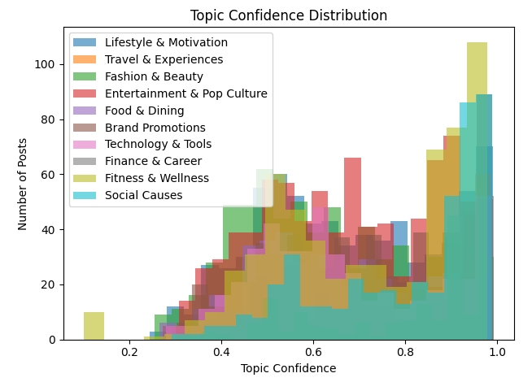
The topic confidence distribution demonstrates that most topics achieve high confidence scores (primarily between 0.6 and 0.9), indicating well-defined and semantically coherent topic clusters. Topics such as Fitness & Wellness, Social Causes, and Lifestyle & Motivation exhibit particularly strong confidence, reflecting consistent language usage. Lower confidence dispersion observed in Brand Promotions and Entertainment & Pop Culture suggests mixed or hybrid content styles, where promotional messaging or storytelling spans multiple themes.
Overall, using a recent data subset improves the relevance, interpretability, and actionability of the topic modeling results. The findings indicate that while general-interest content dominates in volume, professionally oriented topics especially Finance & Career and Technology & Tools are less frequent yet semantically robust, making them well-suited for targeted LinkedIn content strategies and thought leadership initiatives.

8. Engagement Analysis
Engagement metrics are the primary target variables for the TrendPilot system. Understanding how engagement varies across different content types and influencers is essential for building effective recommendation models. This section provides detailed analysis of engagement patterns.

8.1 Engagement by Media Type
Different media types generate significantly different levels of engagement. The following analysis compares average and median engagement metrics across all media types in the dataset.
Media Type | Count | Avg Reactions | Med. Reactions | Avg Comments | Med. Comments
Video | 2,690 | 866 | 114 | 70 | 12.5
Image | 8,708 | 824 | 87.5 | 40 | 6
Article | 15,144 | 161 | 13 | 10 | 1
Document | 113 | 95 | 51 | 29 | 9
Poll | 86 | 58 | 29.5 | 34 | 22.5
Entity | 32 | 50 | 13.5 | 4 | 0
Newsletter | 4 | 17.5 | 19 | 1 | 1
View | 2 | 4 | 4 | 0 | 0

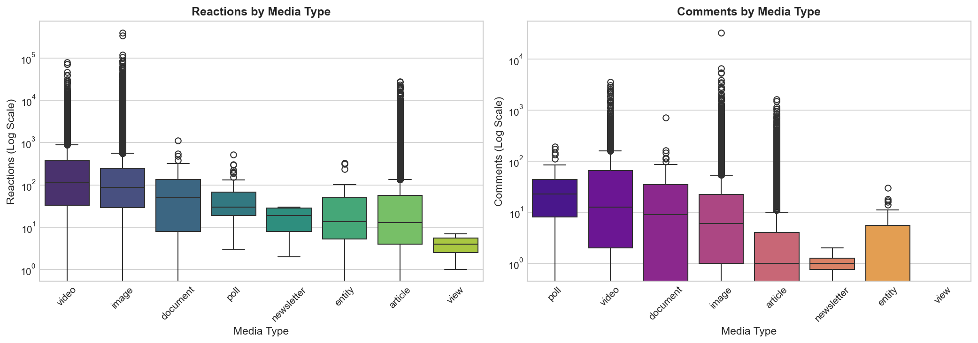
Figure: Engagement Comparison by Media Type (Log Scale)

Key Insights from Media Type Analysis
Video Dominates Engagement: Video content generates the highest average engagement with 866 reactions and 70 comments per post. The median video post receives 114 reactions - nearly 9x the median article. This strongly suggests that users should prioritize video content when seeking maximum engagement.
Images Outperform Articles: Image posts average 824 reactions compared to 161 for articles. Despite articles being the most common media type (44.5% of posts), they generate the lowest engagement per post among the major categories. This represents a potential optimization opportunity.
Polls Drive Comments: While polls have lower reaction counts, they generate disproportionately high comment engagement (median 22.5 comments). Polls may be effective for starting conversations and increasing audience interaction.
Document Performance: Documents (PDFs, slideshows) show solid performance with median 51 reactions, suggesting they're effective for sharing detailed professional content.

8.2 Engagement Rate Analysis
Raw engagement counts can be misleading because influencers with larger followings naturally receive more engagement. Engagement rate normalizes for audience size, providing a fairer comparison of content effectiveness. We calculate engagement rate as reactions per 1,000 followers.
Metric | Value
Mean Engagement Rate | 0.77 reactions per 1K followers
Median Engagement Rate | 0.11 reactions per 1K followers
Standard Deviation | 3.91

The large gap between mean (0.77) and median (0.11) engagement rates indicates high variability in content performance. Even among established influencers, most posts achieve modest engagement rates, while a small percentage of posts dramatically outperform the rest. This suggests that content quality and relevance matter more than follower count alone.

9. Correlation Analysis
Understanding the relationships between different features is essential for feature engineering and identifying predictors of engagement. This section examines correlations between key metrics using Pearson correlation coefficients.

9.1 Correlation Matrix
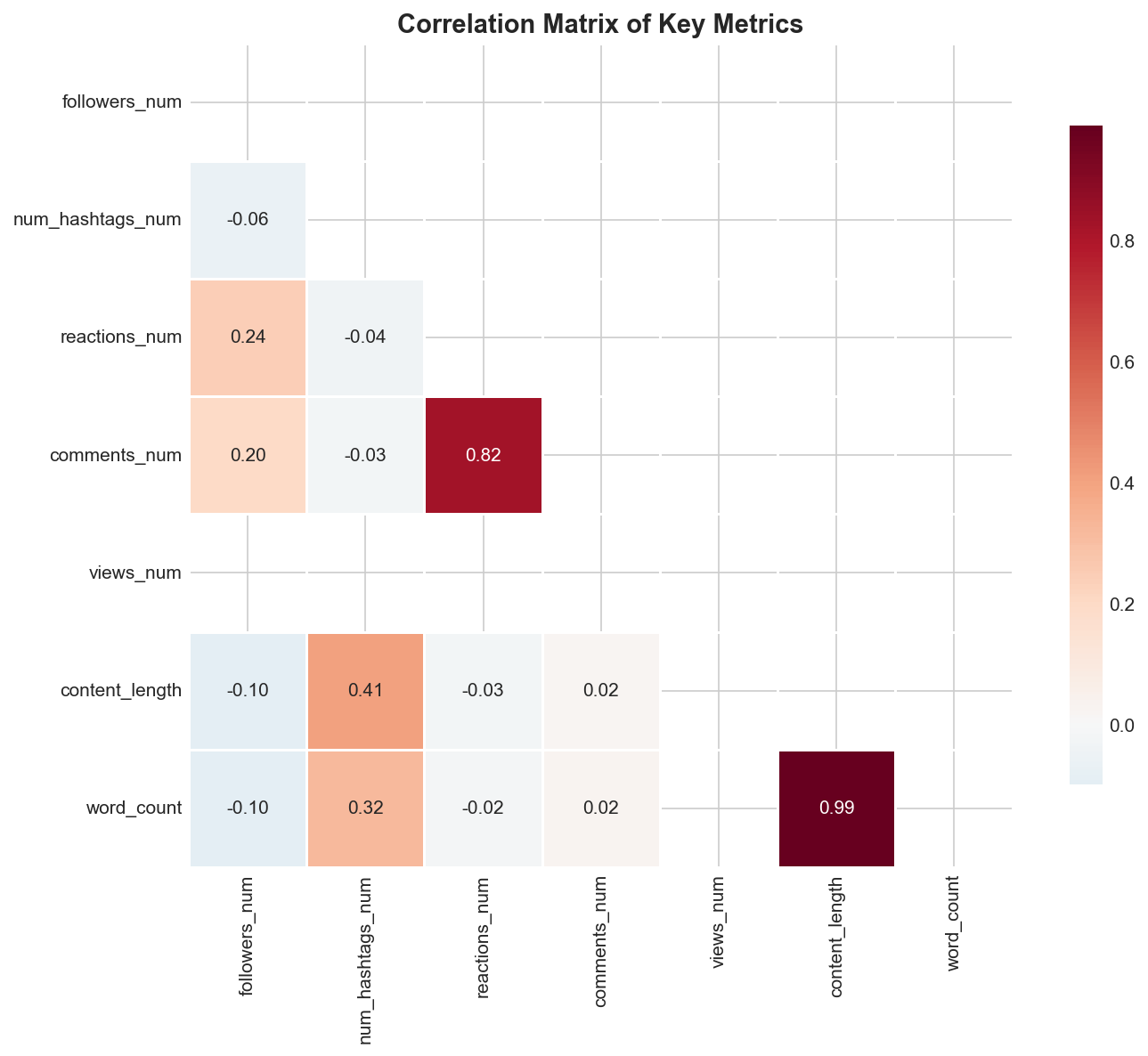
Figure: Correlation Matrix of Key Metrics

9.2 Key Correlation Findings

Strong Correlations
Reactions and Comments (r = 0.823): The strongest correlation in the dataset exists between reactions and comments. This makes intuitive sense - posts that attract reactions also tend to generate discussion. This high correlation suggests that these two metrics could potentially be combined into a single "engagement score" for modeling purposes, reducing dimensionality while preserving signal.

Moderate Correlations
Followers vs Reactions (r = 0.242): A weak positive correlation exists between follower count and reactions. Larger audiences naturally lead to more reactions, but the moderate strength suggests content quality matters more than audience size.
Followers vs Comments (r = 0.195): Similar to reactions, comments show a weak positive correlation with followers. The slightly lower coefficient suggests that comments depend more on content that prompts discussion rather than raw audience size.

Negligible Correlations
Several features show negligible correlation with engagement, which is itself an important finding:
Num Hashtags vs Reactions (r = -0.042): Contrary to popular belief, hashtag count shows almost no correlation with reactions. In fact, the very slight negative correlation suggests that excessive hashtag use might even slightly hurt engagement.
Content Length vs Reactions (r = -0.027): Post length has virtually no impact on engagement, suggesting that both short and long posts can be equally successful if the content is compelling.
Word Count vs Comments (r = 0.025): Similarly, word count shows no meaningful correlation with comments, indicating that prompting discussion depends on content substance rather than length.

9.3 Implications for Modeling
The correlation analysis has several important implications for building engagement prediction models:
- Reactions and comments can potentially be combined into a single target variable due to their strong correlation.
- Follower count should be included as a feature but may benefit from interaction terms or normalization.
- Hashtag count and content length are unlikely to be strong predictors on their own.
- Media type (categorical) and content semantics (from NLP) may be more important predictors than simple numerical features.
- Feature engineering should focus on content quality metrics rather than quantity metrics.

10. Top Performers Analysis
Analyzing the top-performing influencers provides insights into what success looks like on LinkedIn and helps validate that the data captures meaningful variation in performance. This section examines the highest-engagement influencers and their posting patterns.

10.1 Top Influencers by Average Engagement
The following table shows the top 10 influencers ranked by average reactions per post, filtered to include only those with at least 5 posts to ensure statistical reliability.
Rank | Name | Avg Reactions | Total Posts | Followers | Avg Comments
1 | Simon Sinek | 16,641 | 264 | 4.2M | 441
2 | Richard Branson | 5,186 | 975 | 18.3M | 236
3 | Kevin O'Leary | 2,784 | 424 | 2.8M | 193
4 | Ian Bremmer | 2,158 | 590 | 3.7M | 99
5 | Vani Kola | 1,166 | 949 | 1.2M | 46
6 | Quentin M. Allums | 490 | 366 | 66K | 119
7 | Tom Goodwin | 375 | 1,272 | 719K | 67
8 | James Altucher | 338 | 1,125 | 1.3M | 27
9 | Natalie Riso | 248 | 195 | 406K | 22
10 | Tai T. | 242 | 251 | 348K | 21

10.2 Observations from Top Performers
Exceptional Performance: Simon Sinek stands out dramatically with an average of 16,641 reactions per post - over 3x the second-place Richard Branson. His content consistently resonates with his audience, making his posts valuable case studies for content optimization.
Follower Count Not Deterministic: Richard Branson has the most followers (18.3M) but ranks second in engagement. Meanwhile, Quentin M. Allums achieves high engagement (490 avg reactions) with only 66K followers, demonstrating that audience engagement depends on more than audience size.
Posting Frequency Varies: Top performers show varied posting frequencies from 195 posts (Natalie Riso) to 1,272 posts (Tom Goodwin). There's no clear correlation between posting volume and average engagement, suggesting quality matters more than quantity.
Comments vs Reactions Ratio: Simon Sinek also leads in comments with 441 average comments per post, but the reactions-to-comments ratio varies across influencers. Some generate more discussion relative to their reactions, indicating different content styles.

11. Data Gap Risk Assessment
This section provides a comprehensive risk assessment of identified data gaps, categorizing each by severity and analyzing the specific impact on planned system features. Understanding these risks is essential for project planning and setting appropriate expectations.

11.1 Risk Assessment Matrix
Data Gap | Missing % | Severity | Impact on Project
Views data | 100% | HIGH | Cannot optimize for reach/virality
Absolute timestamps | 100%* | HIGH | Cannot recommend posting times
Hashtag followers | 100%** | MEDIUM | Cannot assess hashtag potential
Connections | 24.4% | LOW | Field has limited utility anyway
Media type | 21.3% | MEDIUM | Reduced sample for media analysis
Location | 6.7% | MEDIUM | Limited geographic targeting
Content | 5.9% | LOW | Minimal impact - 94% available
Followers | 0.12% | LOW | Easily imputable

*Timestamps exist but in relative format only (e.g., "2 days ago")
**Column exists but all values are 0

11.2 Detailed Risk Analysis

HIGH Severity Risks
Views Data Gap
The complete absence of views data represents the most significant data gap. Views/impressions are a fundamental metric for understanding post reach and calculating conversion rates (views-to-engagement). Without this data, we cannot: (1) distinguish between posts that reached many people but received low engagement vs posts with limited reach, (2) optimize content for visibility in the LinkedIn feed, (3) calculate impression-based engagement rates for fairer comparisons.
MITIGATION: Focus on engagement optimization rather than reach optimization. Use follower count as a proxy for potential reach. Consider this a limitation in the final system documentation.

Timestamp Format Gap
While time data exists, it's in relative format ("1 week ago") rather than absolute timestamps. This prevents temporal analysis including: (1) optimal posting day of week, (2) optimal posting hour, (3) engagement decay patterns over time, (4) seasonal or trending topic analysis.
MITIGATION: Acknowledge this limitation. For future data collection, prioritize capturing absolute timestamps. Consider using LinkedIn's API for time-sensitive analysis.

MEDIUM Severity Risks
Media Type Gap (21.3%)
About one-fifth of posts lack media type classification. This reduces the sample size for media-based analysis and may introduce bias if certain media types are more likely to have missing values.
MITIGATION: Analyze patterns in missing media types. Consider treating "No Media" as its own category. Ensure models handle missing values appropriately.
Location Gap (6.7%)
Geographic data is missing for some records, limiting geographic targeting features.
MITIGATION: Geographic features may not be critical for content optimization. Consider deprioritizing location-based recommendations.

12. Impact Analysis on Final Project
The TrendPilot system aims to help users create engaging LinkedIn posts. This section evaluates the feasibility and scope of each planned feature based on the data availability and quality findings from this EDA.

12.1 Feature Feasibility Assessment

Content Optimization Features
Data Available | 94.1% of posts have content
Status | FULLY FEASIBLE
Confidence | HIGH

Capabilities enabled by available data:
- Analyze text patterns, structure, and writing style of high-engagement posts
- Build NLP models to suggest content improvements
- Identify keywords, phrases, and topics associated with high engagement
- Recommend optimal content length based on engagement correlations
- Detect sentiment and tone patterns in successful posts

Hashtag Recommendation Features
Data Available | 100% hashtag lists, 0% follower counts
Status | PARTIALLY FEASIBLE
Confidence | MEDIUM

Available capabilities:
- Recommend hashtags based on content topic matching
- Analyze which hashtags correlate with higher engagement
- Suggest optimal number of hashtags based on data patterns
Unavailable due to data gaps:
- Recommend hashtags by reach potential (no follower data)
- Predict hashtag-driven visibility improvements

Media Type Recommendations
Data Available | 78.7% of posts have media type
Status | FULLY FEASIBLE
Confidence | HIGH

Capabilities enabled by available data:
- Recommend optimal media type based on content and goals
- Quantify engagement differences between media types
- Suggest video/image when higher engagement is the goal
- Identify when text-only posts are appropriate

Engagement Prediction Model
ML-Ready Rows | 26,107 (76.8%)
Status | FULLY FEASIBLE
Confidence | HIGH

Model capabilities:
- Predict expected reactions based on content features
- Predict expected comments based on content features
- Provide confidence intervals for predictions
- Identify factors most predictive of engagement
Critical limitation:
- Cannot predict or optimize for views/reach due to 100% missing views data

Posting Time Recommendations
Data Available | Relative time only
Status | NOT FEASIBLE
Confidence | N/A

This feature cannot be implemented with the current data. The relative timestamp format ("2 weeks ago") does not provide the day-of-week or hour-of-day information needed for posting time optimization. This feature should be deprioritized or planned for a future phase with new data collection.

13. Recommendations
Based on the findings of this EDA, the following recommendations are provided for the development of the TrendPilot system and for future data collection efforts.

13.1 Feature Prioritization

Tier 1: Focus Features (Sufficient Data)
These features should be the primary focus of development:
Content Text Analysis: Build NLP models to analyze content patterns, suggest improvements, and predict engagement.
Media Type Recommendations: Recommend optimal media types based on clear engagement differences in the data.
Engagement Prediction: Develop ML models to predict reactions and comments based on content features.
Hashtag Suggestions: Recommend relevant hashtags based on content, even without reach data.

Tier 2: Limited Features (Partial Data)
These features can be implemented with acknowledged limitations:
Engagement Rate Normalization: Use follower count to normalize engagement, acknowledging some missing values.
Content Length Guidance: Provide soft recommendations based on observed patterns, though correlation is weak.

Tier 3: Deprioritized Features (Insufficient Data)
These features should be deprioritized or excluded:
Views/Reach Optimization: Cannot implement - views data is 100% missing.
Posting Time Recommendations: Cannot implement - no absolute timestamps available.
Geographic Targeting: Limited value - location data is sparse and may not impact content strategy.
Hashtag Reach Prediction: Cannot implement - hashtag follower data is all zeros.

13.2 Data Collection Recommendations
For future data collection phases, prioritize the following:
Absolute Timestamps: Capture the exact date and time of each post to enable temporal analysis and posting time recommendations.
Views/Impressions: Ensure views data is captured consistently. This may require different collection methods or API access.
Hashtag Metadata: Collect hashtag follower counts when available to enable reach-based recommendations.
Engagement Over Time: Track how engagement accumulates over time (1 hour, 24 hours, 1 week) to understand decay patterns.
Profile Updates: Capture follower growth over time to understand audience building patterns.

13.3 Model Development Recommendations
Primary Target Variable: Use reactions + comments as the primary engagement metric. Given their strong correlation (r=0.823), consider combining them into a single score or predicting them jointly.
Handle Skewness: Apply log transformation to engagement metrics before modeling. The extreme skewness of raw values will otherwise dominate model training.
Engagement Rate: Consider using engagement rate (reactions/followers) as an alternative target to account for audience size differences.
Feature Engineering: Focus on content-derived features (sentiment, topics, readability) rather than simple counts. Correlation analysis shows counts have limited predictive power.
Missing Value Strategy: For media_type, treat missing as a "No Media" category. For other features, use appropriate imputation or exclusion depending on the modeling approach.
Validation Strategy: Use influencer-stratified cross-validation to ensure models generalize across different posting styles.

14. Conclusion

14.1 Summary of Findings
This exploratory data analysis has provided a comprehensive assessment of the LinkedIn influencer dataset for the TrendPilot project. The dataset comprises 34,012 posts from 69 influential LinkedIn users, offering a substantial foundation for building engagement prediction and content optimization models.
The analysis revealed that the dataset achieves strong data quality for core features, with 95.4% completeness for the features most critical to engagement prediction (content, reactions, comments, media type, hashtags, and followers). This level of completeness is sufficient for developing reliable machine learning models.
However, significant gaps exist that limit certain capabilities. Most notably, views data is completely missing (100%), preventing reach optimization. Additionally, timestamps are stored in relative format, preventing temporal analysis and posting time recommendations. These limitations should be clearly communicated in the final system and addressed in future data collection efforts.

14.2 Data Quality Score
Overall Data Completeness | 86.7%
Core Features Completeness | 95.4%
Quality Assessment | GOOD
Suitability for ML | SUITABLE

14.3 Key Takeaways
- The dataset is suitable for building a LinkedIn post optimization system focused on content analysis, media type recommendations, and engagement prediction.
- Video and image content significantly outperform articles in engagement, suggesting clear recommendations for users seeking maximum impact.
- Reactions and comments are strongly correlated (r=0.823), enabling their combination into a unified engagement metric.
- Hashtag count and content length show negligible correlation with engagement, challenging conventional wisdom.
- Top performers like Simon Sinek achieve exceptional engagement through content quality, not just audience size.
- Future data collection should prioritize absolute timestamps and views data to enable currently infeasible features.

14.4 Next Steps
1. Proceed with feature engineering based on EDA insights
3. Build engagement prediction models using available features
4. Create media type recommendation logic
5. Document limitations for user transparency
6. Plan future data collection to address identified gaps
This EDA provides a solid foundation for the development of TrendPilot. While some features will be limited by data gaps, the available data supports the core goal of helping users create more engaging LinkedIn content through data-driven recommendations.

