**Report**

DBMS EndTerm

Introduction:

The system consists of tables representing various entities such as customers, employees, payments, orders, products, vendors, etc. The system enables customers to purchase products from vendors through orders and payments. The system also includes features such as reviews, photos, shipments, discounts, and guarantees.[Link to GitHub](https://github.com/B1ssultanov/Midterm_DBMS_2course)

ER Diagram:

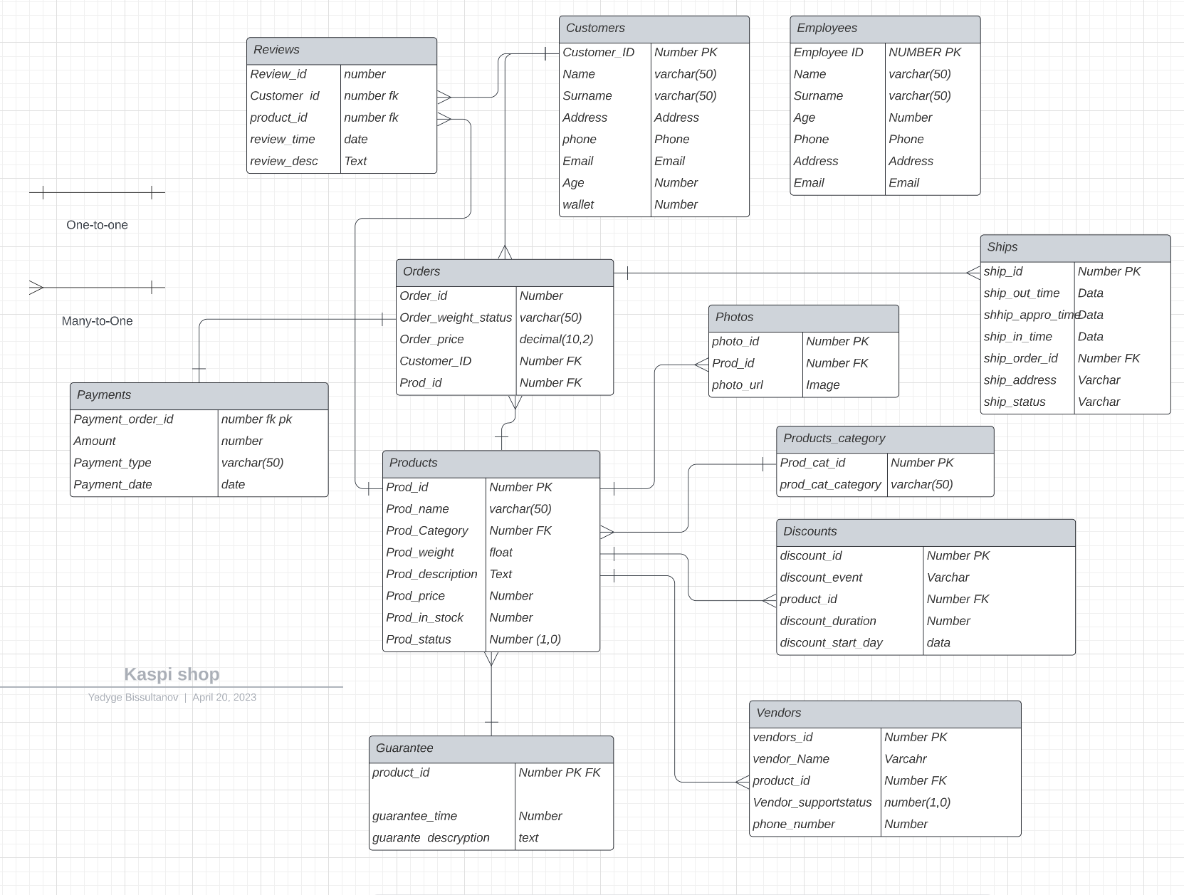

Customers: 3NF

The Customers table is in the third normal form because each row in the table represents a single entity, and there are no repeating groups or fields. All the data is atomic and does not contain any multi-valued attributes.

Employees: 3NF

The Employees table is in the third normal form because each row in the table represents a single entity, and there are no repeating groups or fields. All the data is atomic and does not contain any multi-valued attributes.

Payments: 2NF

The Payments table is in the second normal form because it contains a composite primary key consisting of Payment_order_id and Payment_type. The other fields in the table are dependent on the primary key and contain no transitive dependencies.

Orders: 3NF

The Orders table is in the third normal form because each row in the table represents a single entity, and there are no repeating groups or fields. All the data is atomic and does not contain any multi-valued attributes.

Products: 3NF

The Products table is in the third normal form because each row in the table represents a single entity, and there are no repeating groups or fields. All the data is atomic and does not contain any multi-valued attributes.

Products_category: 3NF

The Products_category table is in the third normal form because each row in the table represents a single entity, and there are no repeating groups or fields. All the data is atomic and does not contain any multi-valued attributes.

Discounts: 3NF

The Discounts table is in the third normal form because each row in the table represents a single entity, and there are no repeating groups or fields. All the data is atomic and does not contain any multi-valued attributes.

Guarantee: 3NF

The Guarantee table is in the third normal form because each row in the table represents a single entity, and there are no repeating groups or fields. All the data is atomic and does not contain any multi-valued attributes.

Vendors: 3NF

The Vendors table is in the third normal form because each row in the table represents a single entity, and there are no repeating groups or fields. All the data is atomic and does not contain any multi-valued attributes.

Reviews: BCNF

The Reviews table is in Boyce-Codd normal form because it has no non-trivial functional dependencies other than candidate keys. The Review_id, Customer_id, and Product_id together form the primary key of the table.

Photos: BCNF

The Photos table is in Boyce-Codd normal form because it has no non-trivial functional dependencies other than candidate keys. The photo_id and Prod_id together form the primary key of the table.

Ships: 3NF

The Ships table is in 3NF because it has no transitive dependencies. All the columns are directly dependent on the primary key (ship_id). There are no repeating groups, and each column has a single value.

Products: 3NF

The Products table is in 3NF because it has no transitive dependencies. All the columns are directly dependent on the primary key (Prod_id). There are no repeating groups, and each column has a single value.

Products_category: 3NF

The Products_category table is in 3NF because it has no transitive dependencies. All the columns are directly dependent on the primary key (Prod_cat_id). There are no repeating groups, and each column has a single value.

Discounts: 3NF

The Discounts table is in 3NF because it has no transitive dependencies. All the columns are directly dependent on the primary key (discount_id). There are no repeating groups, and each column has a single value.

Guarantee: 3NF

The Guarantee table is in 3NF because it has no transitive dependencies. All the columns are directly dependent on the primary key (product_id). There are no repeating groups, and each column has a single value.

Vendors: 3NF

The Vendors table is in 3NF because it has no transitive dependencies. All the columns are directly dependent on the primary key (vendor_id). There are no repeating groups, and each column has a single value.

Overall, the database appears to be well-designed and follows the normal forms. This will ensure data integrity, minimize redundancy, and make it easier to query and maintain the database.

Made By:

Bissultanov Yedyge

Abylay Akhmetov

Ramazan

Rassul

Amirkhan Mamytbekov