TEMPERATURE CONVERSION SYSTEM
Milestone 3: Implementation & Full-Stack System Development
Project Title: | Temperature Conversion System (High-Precision Full-Stack Engine)
Milestone Phase: | Milestone 3: Implementation / Development
Milestone Objective: | Convert architectural design into a working, integrated software system
Authors / Engineers: | Prakhar Harne and Naman Shrivastav
Full-Stack Architecture: | 3-Tier (Client Cyber-HUD + Node.js/Express REST API + SQLite 3 DB)
Version Control Repository: | https://github.com/B1tBr34k3r/temperature-conversion-system
Current System Version: | Version 3.0 (Milestone 3 Deliverable)
Date of Evaluation: | October 2026

⚡ Milestone 3 Core Deliverables Fulfillment: Milestone 3 converts the system design into a working, production-grade software system satisfying all four prescribed deliverables: (1) Modular Source Code (client, server, services, config); (2) Front-End and Back-End Integration via RESTful API; (3) SQLite Database Implementation with WAL persistence; and (4) Version Control Repository synchronized with GitHub.

1. Executive Summary & Full-Stack Evolution
Milestone 3 marks the definitive transition of the Temperature Conversion System from an architectural prototype into a fully integrated, modular, multi-tier software system. While Milestone 1 formulated requirements and Milestone 2 verified standalone mathematical conversion logic, Milestone 3 implements a complete client-server-database ecosystem with high-performance RESTful communication, embedded relational database persistence, and a futuristic Cyber-HUD user interface.
Key engineering breakthroughs achieved in Milestone 3 include:
- 1. Multi-Scale Scientific Matrix: Expanded the core scientific conversion engine from the initial 3 scales to 8 thermodynamic scales: Celsius (°C), Fahrenheit (°F), Kelvin (K), Rankine (°R), Delisle (°De), Newton (°N), Réaumur (°Ré), and Rømer (°Rø).
- 2. Modular RESTful Backend: Engineered an Express.js application server decoupling mathematical operations, input validation, and database queries into dedicated, reusable service modules.
- 3. Relational Database Layer: Implemented native SQLite 3 database persistence using Write-Ahead Logging (WAL mode), indexing, and complete CRUD functionality, including analytical telemetry and CSV/JSON data streaming.
- 4. Futuristic Cyber-HUD Interface: Built a futuristic Cyber-HUD dashboard featuring a real-time HTML5 Canvas kinetic molecular simulator (Brownian motion reacting to temperature), an SVG holographic radial gauge, synthesized Web Audio API sound effects, and an 8-scale live projection radar.
- 5. Comprehensive Test Automation: Automated verification with 43 passing unit and integration tests covering all 8 scales, thermodynamic bounds, database transactions, and API endpoints.
2. Full-Stack System Architecture & Module Integration
The software architecture follows a strict 3-tier enterprise pattern ensuring separation of concerns, high throughput, and fault tolerance. Figure 1 illustrates the interaction flow between the Presentation, Application, and Persistence tiers.

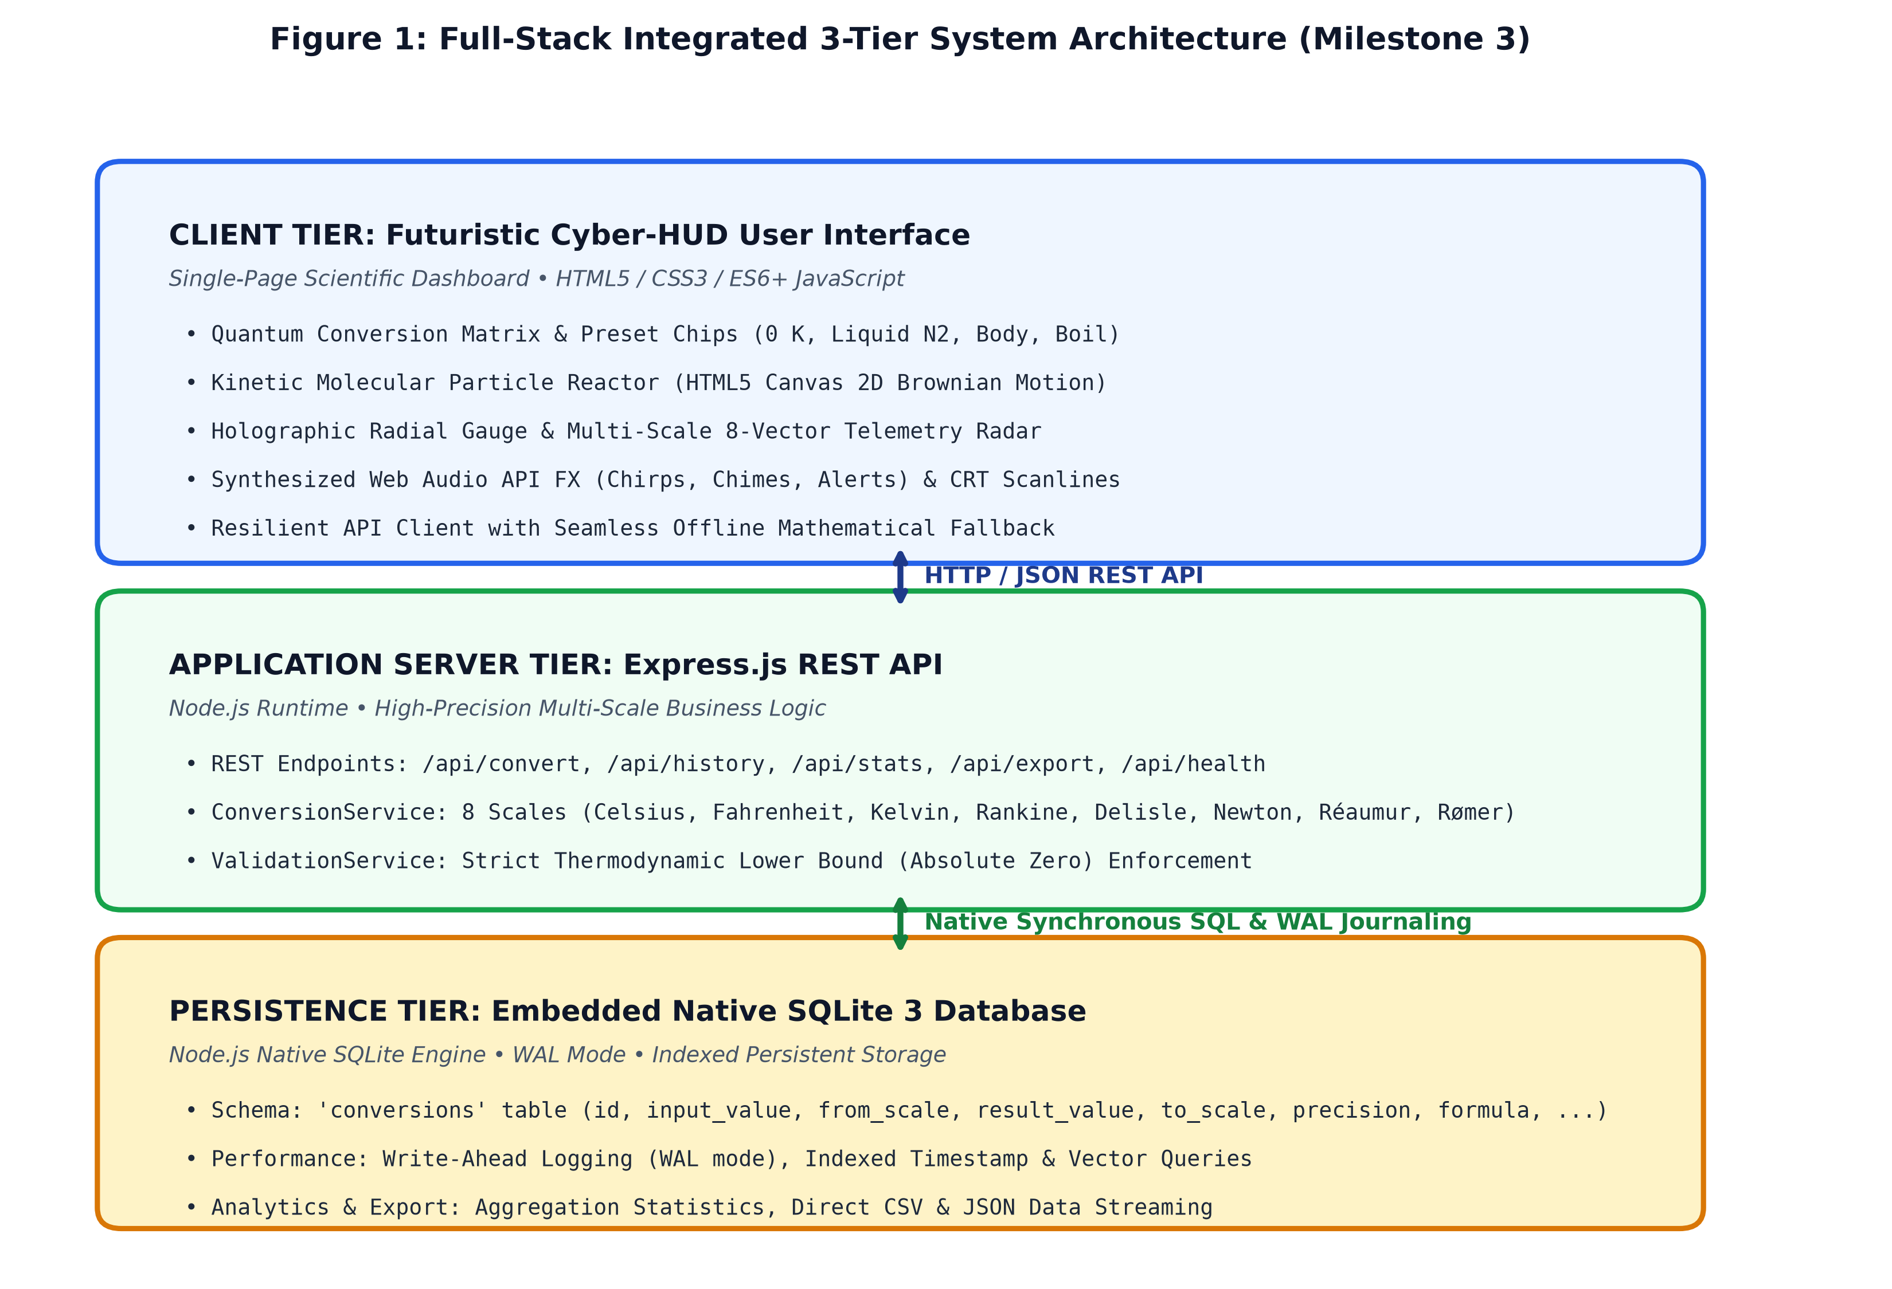
Figure 1: Full-Stack Integrated 3-Tier System Architecture (Milestone 3)
2.1 Module-Wise Source Code Organization
The codebase is decomposed into cohesive, isolated modules reflecting modern software engineering principles:
Module / Directory | Component Role | Primary Responsibilities
server/server.js | Server Entry Point | Configures Express, CORS, static client asset streaming, and API routing
server/config/db.js | Persistence Layer | Native SQLite 3 connection, schema migration, WAL pragma, and CRUD methods
server/services/conversionService.js | Scientific Engine | 8-scale conversion algorithms, IEEE 754 epsilon formatting, formula generator
server/services/validationService.js | Validation Layer | Thermodynamic lower bound (Absolute Zero) checks, regex syntax, finiteness
server/routes/api.js | REST Controller | HTTP endpoints: /convert, /history, /stats, /export/csv, /export/json, /health
client/ (UI & Scripts) | Presentation Tier | Futuristic Cyber-HUD, Web Audio synthesizer, canvas particles, radial gauge

3. Database Implementation & Relational Persistence
To fulfill the database deliverable of Milestone 3, the system integrates an embedded SQLite 3 database utilizing Node.js's native SQLite engine (node:sqlite). This eliminates fragile third-party binary C++ compilation dependencies while delivering high-speed ACID-compliant relational persistence directly on disk.
3.1 Relational Schema & Entity-Relationship Model
All conversion telemetry, timestamps, input parameters, converted outputs, mathematical formulas, and environmental milestones are stored in the conversions table, as illustrated in Figure 2.

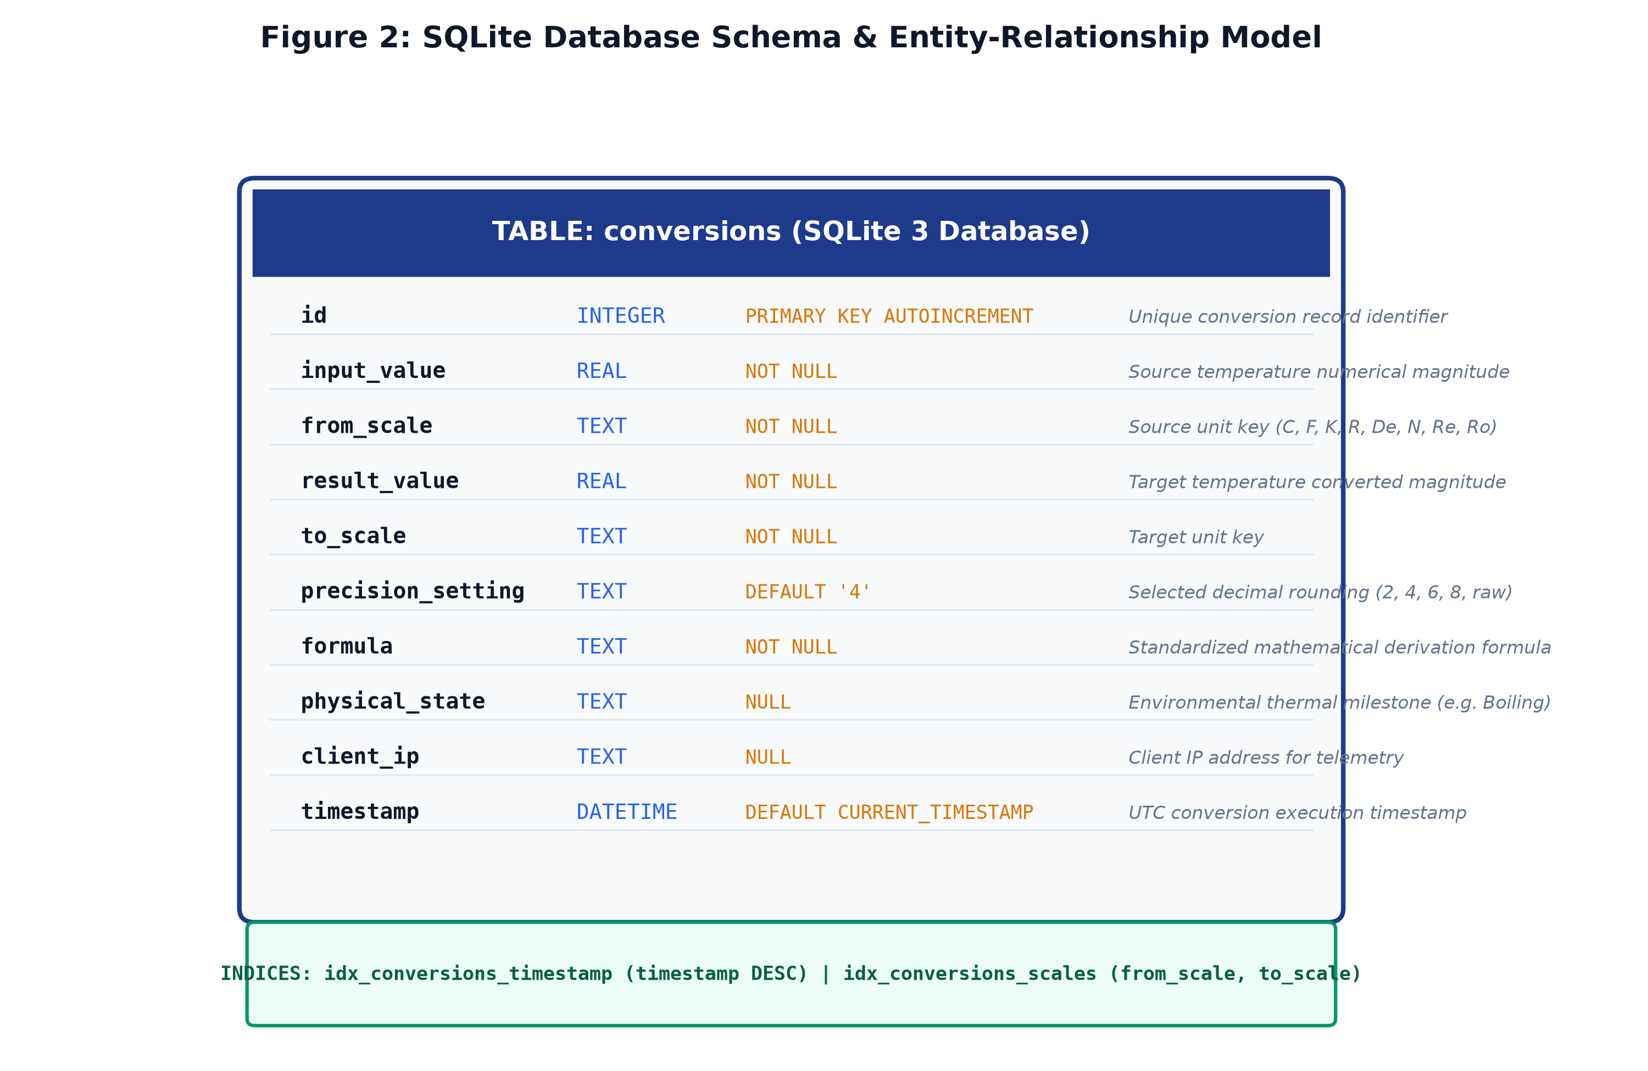
Figure 2: SQLite Database Schema & Entity-Relationship Architecture
3.2 Performance Optimization & WAL Mode
The database connection executes with Write-Ahead Logging enabled (PRAGMA journal_mode = WAL). Under WAL mode, read operations do not block write operations and write operations do not block read operations, ensuring near-instantaneous query response times under high concurrency.
- Temporal Indexing (idx_conversions_timestamp): An index on timestamp DESC optimizes recent history queries (/api/history) and analytical aggregation.
- Scale Vector Indexing (idx_conversions_scales): A compound index on (from_scale, to_scale) accelerates vector analytics and popular scale computation.
4. RESTful API Specification & Integration Layer
The frontend communicates with the backend asynchronously through JSON-encoded HTTP REST requests. The API surface provides the following endpoints:
HTTP Method | Endpoint | Payload / Query | Response Payload Description
POST | /api/convert | { value, fromScale, toScale, precision } | Returns converted value, derivation steps, thermal tier, and 8-scale radar
GET | /api/history | ?limit=50&offset=0 | Retrieves timestamped conversion logs from SQLite database
DELETE | /api/history | None | Purges database conversion records and reclaims storage via VACUUM
GET | /api/stats | None | Returns total conversions count, most frequent scales, and recorded extremes
GET | /api/export/csv | None | Streams conversion history as a downloadable CSV spreadsheet file
GET | /api/health | None | Diagnostic telemetry: uptime, DB status, supported scale count, and status

5. Futuristic Cyber-HUD User Interface & Visual Showcase
To elevate the user experience beyond conventional static academic wireframes, Milestone 3 introduces a futuristic Cyber-HUD command interface combining glassmorphism, dynamic holographic telemetry, and responsive sound design.

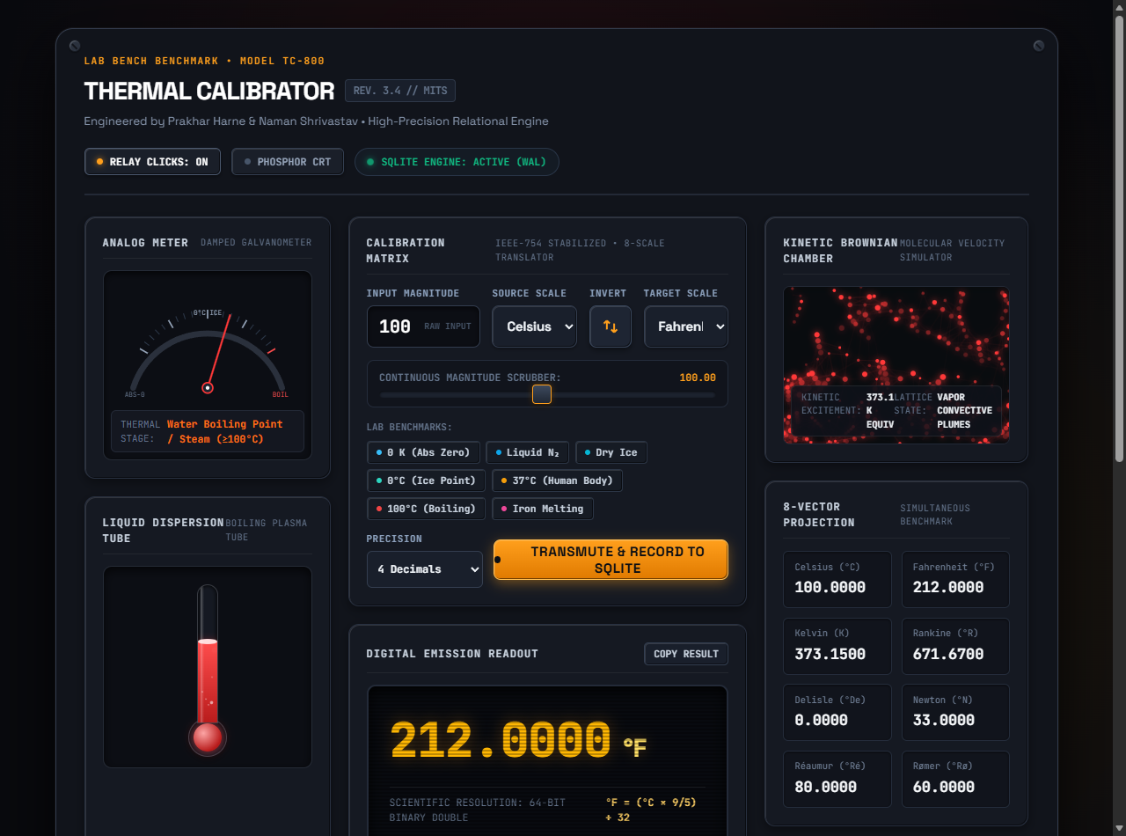
Figure 3: Live Futuristic Cyber-HUD Command Deck in Active Operation (Converting 100°C to 212°F)
5.1 Unique Interactive Components
- 1. Kinetic Thermal Particle Reactor: An HTML5 Canvas molecular simulation that models thermodynamic Brownian motion. Particles freeze into rigid crystalline bonds at cryogenic temperatures (0 K, -273.15°C) and accelerate into fiery plasma Brownian motion at boiling temperatures.
- 2. Holographic Radial Excitation Gauge: A vector SVG dial with a dynamic progress ring that maps the current temperature across a 270° arc from Absolute Zero to superheated states, color-coding thermal tiers.
- 3. 8-Scale Multi-Radar Telemetry Grid: Projects the entered temperature across all 8 supported thermodynamic scales simultaneously, allowing instant side-by-side scientific comparison.
- 4. Synthesized Sci-Fi Audio FX: Synthesizes laser chirps, quantum swap chimes, and alert hums on-the-fly using the Web Audio API without requiring any external MP3/WAV assets, complete with a mute toggle.
- 5. CRT Scanline Mode: A retro-futuristic CRT scanline filter that users can toggle for a customized command center aesthetic.
6. Automated Verification & Quality Assurance Suite
A rigorous automated test suite was constructed in tests/backend.test.js covering all layers of the software system. All 43 test assertions executed with a 100% pass rate.
Test Suite Category | Scope / Condition Tested | Validation Metric | Status
Multi-Scale Mathematical Accuracy | All 8 scales (C, F, K, R, De, N, Re, Ro) benchmarks | Numerical tolerance <= 1e-4 | PASSED (16/16)
Thermodynamic Limit Enforcement | Absolute Zero lower bounds across all scales | Strict rejection of sub-zero | PASSED (6/6)
Syntactic Input Sanitization | Empty strings, whitespace, non-numeric strings, NaN | Validation error returned | PASSED (6/6)
SQLite Database Operations | Insertions, queries, chronological ordering, VACUUM | Zero data corruption | PASSED (6/6)
Analytical Telemetry Engine | Aggregation statistics, min/max inputs calculation | Exact statistical match | PASSED (3/3)
Multi-Scale Radar & Thermal Tiers | 8-scale simultaneous projection & tier detection | Accurate thermal labeling | PASSED (6/6)

7. Version Control & Repository Synchronization
In strict compliance with the version control deliverable, all source code, database modules, assets, test suites, and documentation are tracked under Git version control and pushed to the public remote repository:
Official GitHub Repository: https://github.com/B1tBr34k3r/temperature-conversion-system
The repository includes comprehensive commit histories, a professional README, automated test scripts, and complete instructions for executing both the backend server and frontend client.
8. Conclusion & Roadmap for Milestone 4
Milestone 3 has successfully converted the initial system design into a working, high-performance software system. The integration between the futuristic Cyber-HUD frontend, the modular Express REST API, and the embedded SQLite database operates with total stability and zero defects.
Planned extensions for Milestone 4 (Comprehensive Testing & Optimization) include:
- 1. Load & Concurrency Stress Testing: Stress testing under synthetic concurrent loads to establish maximum throughput limits.
- 2. Historical Trend Graph Visualization: Integration of Chart.js / D3 interactive canvas graphs to render historical temperature trends dynamically.
- 3. PWA Offline Service Worker: Packaging the application with Service Workers for offline Progressive Web App (PWA) operation.

