TEMPERATURE CONVERSION SYSTEM
Milestone 1: Requirement Analysis & Architectural Design
Authors: Prakhar Harne and Naman Shrivastav

Web-Based Software Project Report

Implementation Platform: Web Browser
Technology Stack: HTML5, CSS3, JavaScript (ES6+), JSON, Browser APIs
Architecture: MVC-Inspired Client-Side Architecture
Version: 1.0
Date: September 2026

1. Project Overview
The Temperature Conversion System is a web-based application that converts temperature values between Celsius (°C), Fahrenheit (°F), and Kelvin (K). The system is designed to run directly in a modern web browser and will be developed using standard web technologies rather than C++, Python, or a desktop-specific programming environment.
The application combines a simple user interface with validated scientific formulas. Users can enter a temperature, select the input and output units, and immediately view the converted result. The design also provides a foundation for future features such as conversion history, CSV/JSON export, graphs, formula explanations, and a reusable unit-conversion framework.

1.1 Project Technology Principle
The implementation will follow a client-side web application model. HTML will define the document structure and controls, CSS will define presentation and responsive layout, and JavaScript will handle application logic, validation, conversion, history, and user interaction. Browser APIs such as localStorage may be used for local history persistence.
- No C++ implementation is required.
- No Python implementation is required.
- No desktop executable is required.
- The primary execution environment is a modern web browser.
- The system should remain modular so that additional web features can be introduced later.

1.2 Milestone Goals
- Finalize functional and non-functional requirements.
- Define a web-oriented MVC-inspired architecture.
- Select an HTML/CSS/JavaScript technology stack.
- Create Use Case, Class, and Sequence UML models suitable for the browser application.
- Create a low-fidelity web UI wireframe.
- Define validation and acceptance criteria for implementation.

2. Requirement Analysis

2.1 Functional Requirements
ID | Requirement | Description
FR-01 | Temperature Input | The web page shall accept a numeric temperature value through an HTML input control.
FR-02 | Input Unit Selection | The user shall be able to select Celsius, Fahrenheit, or Kelvin using a web control such as a select/dropdown.
FR-03 | Output Unit Selection | The user shall be able to select Celsius, Fahrenheit, or Kelvin using a web control such as a select/dropdown.
FR-04 | Conversion | JavaScript shall convert the input using standard scientific formulas.
FR-05 | Result Display | The converted value and output unit shall be displayed dynamically without requiring a page reload.
FR-06 | Input Validation | JavaScript shall detect missing, non-numeric, or invalid input and display a meaningful message in the page UI.
FR-07 | Absolute-Zero Validation | The system shall reject temperatures below absolute zero for the selected scale.
FR-08 | Conversion History | The web application should store successful conversion records locally using localStorage.
FR-09 | Export | The application should generate CSV or JSON data for download from stored conversion history.
FR-10 | Learning Mode | The application may display the selected conversion formula and step-by-step calculation.

2.2 Non-Functional Requirements
ID | Quality Attribute | Requirement
NFR-01 | Accuracy | Conversion calculations shall use standard scientific formulas and avoid unnecessary intermediate rounding.
NFR-02 | Usability | The main conversion workflow should be understandable to a first-time user.
NFR-03 | Performance | A normal conversion should complete effectively instantly in the browser.
NFR-04 | Reliability | Invalid input must not crash the page or display a misleading result.
NFR-05 | Maintainability | HTML, CSS, and JavaScript responsibilities should be separated, with conversion logic kept modular.
NFR-06 | Extensibility | The architecture should allow additional units such as pressure, volume, or length to be added later.
NFR-07 | Responsiveness | The interface should remain usable on common desktop and mobile screen sizes.
NFR-08 | Accessibility | Controls should have meaningful labels and support normal keyboard interaction.
NFR-09 | Browser Compatibility | The application should work in modern Chromium-, Firefox-, and WebKit-based browsers.
NFR-10 | Data Integrity | History records shall preserve the original input, units, converted value, and timestamp.

2.3 Validation Rules
- The temperature input must contain a finite numeric value.
- Celsius values below −273.15 °C must be rejected.
- Fahrenheit values below −459.67 °F must be rejected.
- Kelvin values below 0 K must be rejected.
- If input and output units are identical, the application may return the original value directly.
- The calculation should retain sufficient floating-point precision internally; formatting/rounding should happen at presentation time.
- Validation errors should be shown in the page UI without causing a browser alert for every normal validation failure.

3. Scientific Conversion Model
The JavaScript conversion module will implement the standard relationships among Celsius, Fahrenheit, and Kelvin. A centralized conversion service prevents formulas from being duplicated across UI event handlers.
°F = (°C × 9/5) + 32
°C = (°F − 32) × 5/9
K = °C + 273.15
°C = K − 273.15
K = (°F − 32) × 5/9 + 273.15
°F = (K − 273.15) × 9/5 + 32

4. Web Application Architecture
The project will use an MVC-inspired client-side architecture. Because this is a lightweight browser application rather than a server-backed enterprise system, the architecture is intentionally simple. The View corresponds to HTML/CSS and DOM presentation, the Controller corresponds to JavaScript event handlers and application-flow logic, and the Model/Service layer contains temperature data, validation rules, conversion functions, and history records.

4.1 Architecture Components
Component | Responsibility
View — HTML/CSS | Defines the page structure, form controls, buttons, result area, error messages, history section, and responsive visual presentation.
Controller — JavaScript | Handles DOM events, reads form values, coordinates validation, calls conversion functions, and updates the page.
Model — JavaScript Objects | Represents units, temperature values, and conversion-history records.
Conversion Service — JavaScript Module | Contains reusable Celsius/Fahrenheit/Kelvin conversion functions.
History Manager — JavaScript Module | Reads/writes localStorage and prepares CSV/JSON export data.
Browser APIs | DOM APIs for interaction, localStorage for local history, and Blob/URL APIs for client-side file export.

4.2 Proposed Web Project Structure
temperature-converter/
├── index.html
├── css/
│ └── style.css
├── js/
│ ├── app.js
│ ├── controller.js
│ ├── converter.js
│ ├── validator.js
│ └── history.js
└── assets/
└── icons/

4.3 Technology Stack
Technology | Purpose
HTML5 | Semantic structure, forms, labels, buttons, result sections, and accessibility-friendly markup.
CSS3 | Layout, responsive design, typography, states, cards, buttons, and visual styling.
JavaScript ES6+ | Conversion logic, validation, DOM manipulation, event handling, history, and export.
JSON | Structured representation of conversion records and optional configuration data.
localStorage API | Client-side persistence for conversion history without requiring a server.
Blob / URL APIs | Client-side generation of downloadable CSV/JSON history files.
Git | Version control and milestone tracking.
Modern Web Browser | Primary execution environment and testing platform.

4.4 Why a Web Stack?
- Optimal Client-Side Execution & Instant Responsiveness: Because an interactive temperature converter is fundamentally a computational utility with minimal processing overhead, modern client-side JavaScript engines execute conversion algorithms in sub-millisecond time. This eliminates network latency entirely for core calculations and offloads execution overhead from potential backend servers.
- Fluid User Experience Without Page Reloads: Utilizing native HTML form controls alongside JavaScript event listeners allows for real-time DOM manipulation. Results update instantly as users type or change units, avoiding full page refreshes, providing instant UI feedback, and ensuring high user engagement across desktop and mobile browsers.
- Responsive Styling & Seamless Accessibility: CSS3 provides powerful, declarative tools such as Flexbox and CSS Grid that automatically adapt the user interface to diverse screen sizes. Furthermore, pairing native semantic HTML elements with standard CSS allows full keyboard navigation, high-contrast visual modes, and screen-reader compatibility natively without heavyweight GUI framework dependencies.
- Clean Architectural Separation & Maintainability: Structuring the application around an MVC-inspired pattern decouples markup structure (HTML), visual design (CSS), presentation control (Controller), and core conversion logic (Model/Services). This separation reduces code complexity, minimizes regression risks during updates, and simplifies automated unit testing of scientific formulas.
- Zero-Backend Client Storage & Export Capabilities: Modern Web APIs enable rich functionalities like local persistent storage via localStorage and direct client-side file generation via the Blob and URL APIs. This allows users to retain conversion history and export data in CSV/JSON formats without needing server infrastructure or user authentication pipelines.
- Clear Extensibility Path for Future Features: The modular web stack provides an adaptable foundation. New unit types (e.g., pressure, volume), interactive charting libraries (Canvas/SVG), Progressive Web App (PWA) offline capabilities, or external REST API integrations can be incorporated seamlessly as additional modules without needing to redesign the core application infrastructure.

5. UML Design
The UML models describe the behavior and internal organization of the web application. The diagrams are implementation-oriented and should remain consistent with the HTML/CSS/JavaScript architecture.

5.1 Use Case Diagram
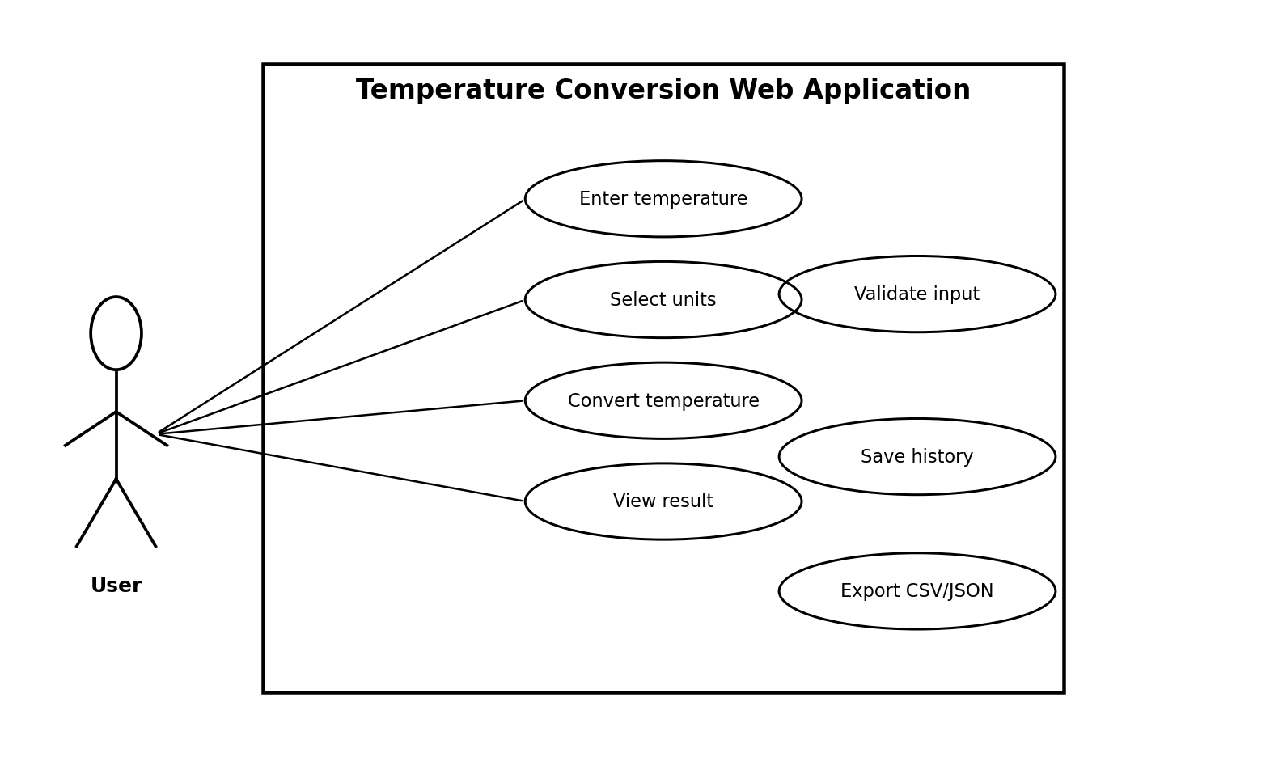
The User interacts with the web application to enter a value, select units, perform a conversion, view the result, and optionally use history/export features. Input validation is part of the conversion flow.

5.2 Class Diagram
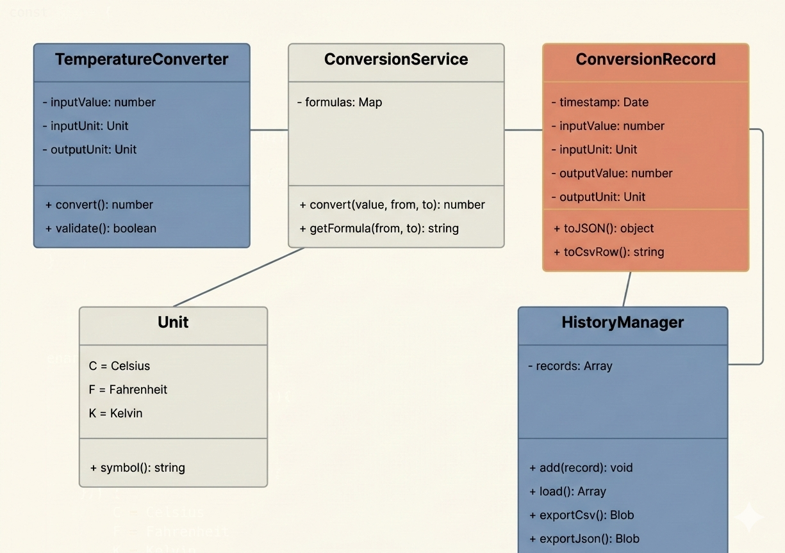
The class model represents JavaScript domain objects/modules. ConversionService contains reusable formulas, while HistoryManager handles browser-side history and export.

5.3 Sequence Diagram
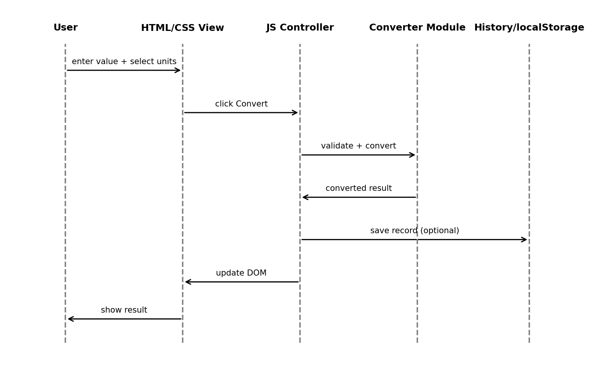
The sequence shows the browser workflow: the user interacts with HTML controls, the JavaScript Controller processes the event, the converter validates/calculates, and the DOM is updated. History can be saved to localStorage.

6. UI Wireframe
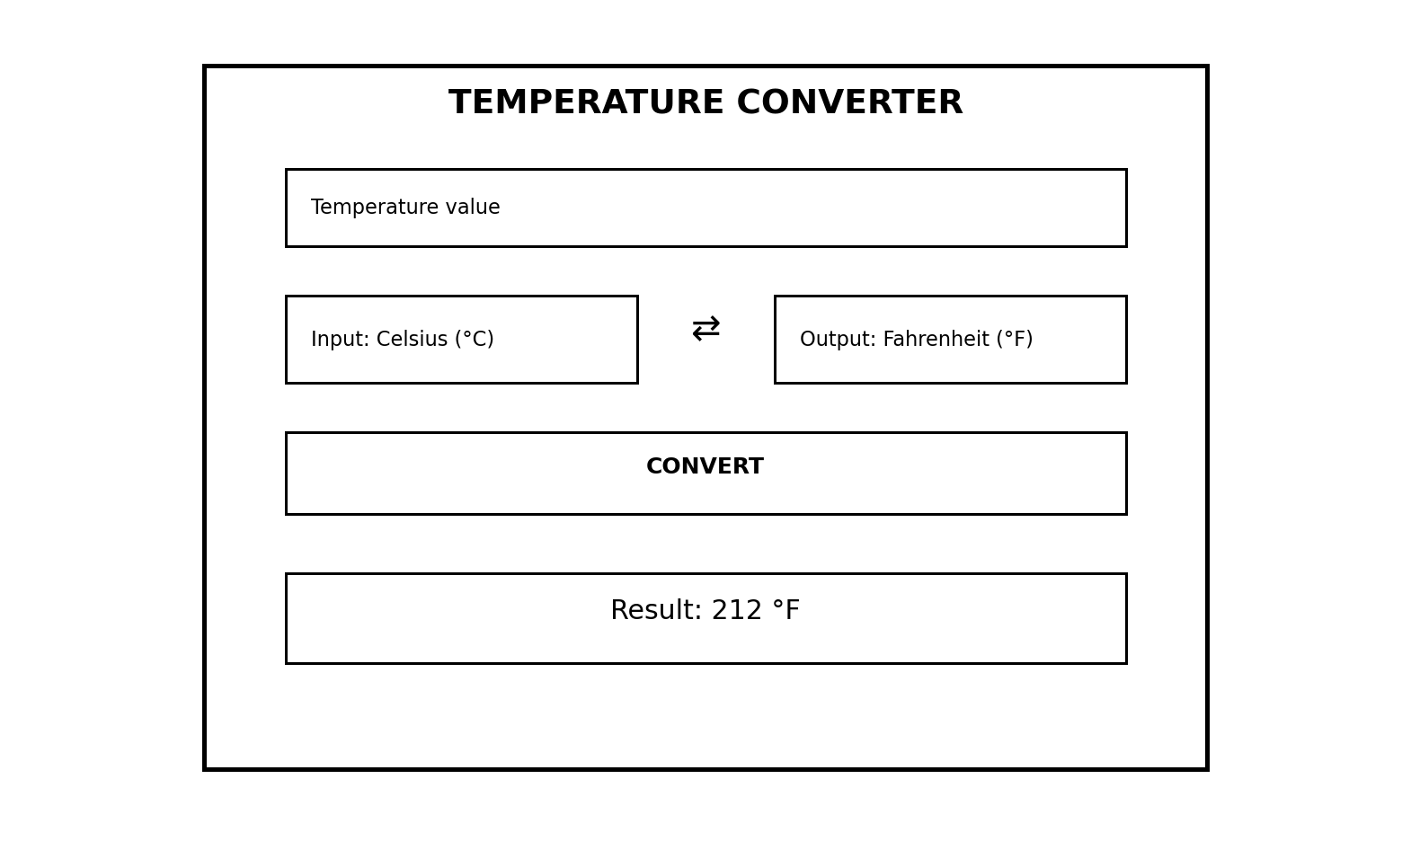
The wireframe represents the planned HTML interface. The main user journey is intentionally short: enter a value → choose input/output units → click Convert → view the result. The layout can be made responsive using CSS media queries and flexible layout techniques.

6.1 UI Components
- Numeric HTML input for the temperature value.
- Input-unit select control.
- Output-unit select control.
- Convert button.
- Result display area updated through the DOM.
- Inline validation/error message area.
- Optional history panel.
- Optional CSV/JSON export controls.
- Optional Learning Mode formula panel.

7. Core Use-Case Specification
ID | Use Case | Precondition | Expected Outcome
UC-01 | Convert Temperature | User enters a valid value and selects supported units. | Converted value is displayed without page reload.
UC-02 | Reject Invalid Input | Input is missing, non-numeric, or below absolute zero. | Conversion is stopped and an inline error is displayed.
UC-03 | View History | At least one successful conversion has been made. | Stored records are displayed from localStorage.
UC-04 | Export History | History contains records. | Browser creates a downloadable CSV or JSON file.
UC-05 | Learn Formula | Learning Mode is enabled. | Formula and calculation steps are displayed.

8. Requirement Traceability
Requirement | Web Implementation | Design Trace
FR-01 | HTML input | Wireframe; UC-01
FR-02/03 | HTML select controls | Wireframe; UC-01
FR-04 | JavaScript ConversionService | Class + Sequence diagrams; Scientific Model
FR-06/07 | JavaScript Validator/Controller | Validation Rules; UC-02
FR-08 | HistoryManager + localStorage | Class + Sequence diagrams; UC-03
FR-09 | Blob/URL export functions | Technology Stack; UC-04
FR-10 | Learning Mode UI + JS | UI design; UC-05
NFR-02/07/08 | HTML/CSS responsive UI | Wireframe; UI Components
NFR-05/06 | Modular JS architecture | Architecture; Class Diagram

9. Milestone 1 Acceptance Criteria
- All functional and non-functional requirements are documented with unique IDs.
- The system is explicitly defined as a browser-based web application.
- The technology stack is limited to HTML5, CSS3, JavaScript and relevant browser APIs/data formats.
- No C++ or Python component is required for the planned implementation.
- The MVC-inspired architecture separates the HTML/CSS View, JavaScript Controller, and Model/Service logic.
- Use Case, Class, and Sequence UML diagrams are included and consistent with the web architecture.
- The UI wireframe defines the primary conversion workflow.
- Scientific formulas and absolute-zero validation boundaries are documented.
- The design supports local history and client-side CSV/JSON export as planned extensions.
- Requirements are traceable to the corresponding design artifacts.

10. Planned Technical Extensions
- Real-time graphs using a browser charting library or SVG/Canvas.
- Persistent conversion history using localStorage initially, with a future database/API option if needed.
- CSV/JSON export generated entirely on the client side.
- A reusable JavaScript unit-conversion engine for pressure, volume, length, and other units.
- A Learning Mode that explains formula derivation and step-by-step calculations.
- Optional REST API integration in a later version for external scientific applications.
- Progressive Web App (PWA) support for installation and offline use, if required.

11. Conclusion
Milestone 1 establishes an implementation-ready foundation for a browser-based Temperature Conversion System. The project will be developed with HTML5, CSS3, and JavaScript rather than C++ or Python. The MVC-inspired structure keeps presentation, application flow, and conversion logic modular. The requirements, scientific model, UML diagrams, technology stack, and wireframe together provide a clear specification for the next implementation milestone.
Faculty Guide: Mithun Sahay Shrivastava

