A PROJECT ON

“GOLD PRICE PREDICTION”
SUBMITTED IN
PARTIAL FULFILLMENT OF THE REQUIREMENT FOR THE COURSE OF
DIPLOMA IN BIG DATA ANALYSIS



SUNBEAM INSTITUTE OF INFORMATION TECHNOLOGY, PUNE
Submitted By:

Jadhav Abhishek (83653)

Harshit Gupta (83943)

Mr.Nitin Kudale Mrs.Manisha Hingne Centre Coordinator Course Coordinator



CERTIFICATE

This is to certify that the project work under the title ‘Gold Price Prediction’ is done by jadhav Abhishek & Harshit Gupta in partial fulfillment of the requirement for award of Diploma in Big Data Analysis Course.

Mr. Aniket P Mrs. Manisha Hingne
Project Guide Course Coordinator

Date:

ACKNOWLEDGEMENT

A project usually falls short of its expectation unless aided and guided by the right persons at the right time. We avail this opportunity to express our deep sense of gratitude towards Mr. Nitin Kudale (Center Coordinator, SIIT, Pune) and Mrs. Manisha Hingne (Course Coordinator, SIIT ,Pune) and Project Guide Mr. Aniket P.
We are deeply indebted and grateful to them for their guidance, encouragement and deep concern for our project. Without their critical evaluation and suggestions at every stage of the project, this project could never have reached its present form.
Last but not the least we thank the entire faculty and the staff members of Sunbeam Institute of Information Technology, Pune for their support.

Jadhav Abhishek
DBDA March 2024 Batch, SIIT Pune

Harshit Gupta
DBDA March 2024 Batch, SIIT Pune

.
TABLE OF CONTENTS

- Introduction
  - Introduction And Objectives
  - Why this problem needs To be Solved?
  - Dataset Information

Problem Definition and Algorithm
  - Problem Definition
  - Algorithm Definition

Experimental Evaluation
  - Methodology/Model
  - Exploratory Data Analysis

Results And Discussion

- GUI

- GitHub link

7.Future Work And Conclusion
  - Future Work
  - Conclusion
    - Introduction

      - Introduction And Objectives:

Gold has long been a cornerstone of investment portfolios, renowned for its stability and hedge against inflation. This report aims to provide a comprehensive analysis of the factors influencing gold prices and to offer predictions based on current data and trends. The gold market is influenced by a multitude of factors, including economic indicators, geopolitical events, monetary policies, and market sentiment. Understanding these elements can help investors make informed decisions about their gold investments.

Why this problem needs To be Solved?

Gold prices are experiencing volatility, driven by several key factors:
- Economic Data: Recent economic indicators have shown mixed signals. While global inflation rates remain high, economic growth has been uneven across different regions.
- Interest Rates: Central banks, particularly the Federal Reserve and the European Central Bank, have maintained a cautious approach with interest rate hikes. This impacts gold prices as higher interest rates often lead to lower gold prices due to the opportunity cost of holding non-yielding assets.
- Geopolitical Tensions: Ongoing geopolitical tensions, including trade disputes and conflicts, have contributed to gold's safe-haven appeal.

Key Influencing Factors:
- Inflation and Economic Growth: Gold is traditionally seen as a hedge against inflation. In periods of high inflation, the demand for gold tends to increase. Conversely, strong economic growth can reduce the attractiveness of gold as an investment.
- Monetary Policy: Central bank policies, particularly interest rate decisions, play a significant role in gold price movements. Lower interest rates generally benefit gold prices as they reduce the opportunity cost of holding gold.
- Geopolitical Events: Conflicts, trade tensions, and political instability often drive investors to gold as a safe-haven asset. Recent global tensions have bolstered gold prices as investors seek stability.
- Currency Movements: The strength of the US dollar has an inverse relationship with gold prices. A stronger dollar makes gold more expensive for foreign investors, potentially decreasing demand.
- Market Sentiment: Investor sentiment and speculative activity also influence gold prices. Trends in gold ETF holdings and futures contracts can provide insights into market expectations.

Dataset Information. gold_rate.csv:
It has seven columns.
Date : Date of data
Open :Opening price of gold
High : Highest price of gold
Low : Lowest price of gold
Close : Closing price of gold
Adj Close : Adjusted price of gold after fees are paid to respective agencies
Volume : Volume of gold traded

Problem Definition and Algorithm:
      - Problem Definition
Gold remains a crucial asset in investment portfolios due to its historical role as a safe-haven and inflation hedge. Current market conditions suggest that gold prices may experience volatility in the short term, influenced by economic data, central bank policies, and geopolitical events. Investors should stay informed about these factors and consider both short-term and long-term trends when making investment decisions.
Given data can be used to predict Closing price of gold with respect to date using machine learning algorithms like Linear regression, polynomial regression, support vector regression

Algorithm Definition
Linear regression: is one of the very basic forms of machine learning where we train a model to predict the behavior of your data based on some variables. In the case of linear regression as you can see the name suggests linear that means the two variables which are on the x-axis and y-axis should be linearly correlated.

Polynomial regression: Polynomial regression is a type of regression analysis used to model the relationship between a dependent variable and one or more independent variables by fitting a polynomial equation to the data. Unlike linear regression, which fits a straight line, polynomial regression can model more complex relationships by fitting curves to the data.

Support Vector Regression: Support Vector Regression (SVR) is a type of regression analysis that is based on the principles of Support Vector Machines (SVM), which are primarily used for classification tasks. SVR is particularly useful for modeling and predicting continuous data where the relationship between variables is complex and non-linear.

Random forest: is a Supervised Machine Learning Algorithm that is used widely in Classification and Regression problems. It builds decision trees on different samples and takes their majority vote for classification and average in case of regression.
One of the most important features of the Random Forest Algorithm is that it can handle the data set containing continuous variables as in the case of regression and categorical variables as in the case of classification. It performs better results for classification problems.
Decision Tree: algorithm belongs to the family of supervised learning algorithms. Unlike other supervised learning algorithms, the decision tree algorithm can be used for solving regression and classification problems too.
The goal of using a Decision Tree is to create a training model that can use to predict the class or value of the target variable by learning simple decision rules inferred from prior data(training data).In Decision Trees, for predicting a class label for a record we start from the root of the tree. We compare the values of the root attribute with the record’s attribute. On the basis of comparison, we follow the branch corresponding to that value and jump to the next node.

XGBoost: or extreme gradient boosting is one of the well-known gradient boosting techniques (ensemble) having enhanced performance and speed in tree- based (sequential decision trees) machine learning algorithms. XGBoost was created by Tianqi Chen and initially maintained by the Distributed (Deep) Machine Learning Community (DMLC) group. It is the most common algorithm used for applied machine learning in competitions and has gained popularity through winning solutions in structured and tabular data. It is open- source software. Earlier only python and R packages were built for XGBoost but now it has extended to Java, Scala, Julia and other languages as well.

Experimental Evaluation:

      - Methodology:

The objective of this project is to predict the weekly sales of wallmart in US. The data set is contained from Kaggle and has 3 csv files namely features, stores and train. The data is merged to obtain one master datafile and then the data preprocessing is carried out.

Loading in raw data
features_df = pd.read_csv("features.csv") stores_df = pd.read_csv("stores.csv") walmart_df = pd.read_csv("train.csv")
master_df =walmart_df.merge(stores_df, how='left').merge(features_df, how='left') print(master_df.shape)
master_df.head()

Preprocessing:
The sales are given for Years 2012-2012 on weekly basis. This data was split to extract information for year, month and week.
master_df['Date'] = pd.to_datetime(master_df['Date'], format='%Y-%m-%d') master_df['Week_Number'] = master_df['Date'].dt.week
master_df['Month'] = master_df['Date'].dt.month master_df["Year"] = master_df["Date"].dt.year

The data had several missing values and needed to be cleaned. The missing values in ‘Markdown1-5’needed to be cleaned. Since the number of missing values were significant, they were not removed but were replaced with zero.

print(master_df.isna().sum()) missing_values = master_df.isna().sum()
master_df['MarkDown1'] = master_df['MarkDown1'].fillna(0) master_df['MarkDown2'] = master_df['MarkDown2'].fillna(0) master_df['MarkDown3'] = master_df['MarkDown3'].fillna(0) master_df['MarkDown4'] = master_df['MarkDown4'].fillna(0) master_df['MarkDown5'] = master_df['MarkDown5'].fillna(0) master_df.isna().sum()

Flow Diagram :

Start
Data Collection
Testing Set

Data Processing

XG Boost

Input

XG Boost Machine

Random forest Regression

Lasso Regression

Ridge Regression

Linear Regression

Training Set

Prediction value

Stop
      - Exploratory Data Analysis
The popularity of each store is plot with the help of a pie chart (fig 2). From the figure we can infer that type A store has the highest popularity followed by type B store and type C store has the least popularity.

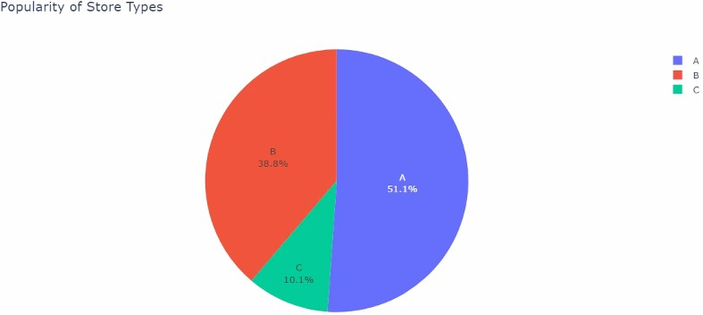

Fig 2: Pie- chart showing store- type wise popularity
The average sale for each store- type is visualized using bar plot (fig 3). From the figure we can infer that type A store has the highest average sales followed by type B store. The type C store has least average sale among the three.
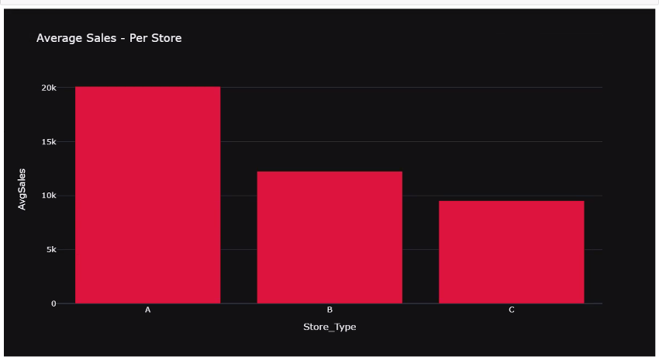

Fig 3: Store- type Vs Average sales

The average sale for each store- type is plotted for each year (fig 4). The plot
shows that Month of January witnessed the lowest sales for 2011 and 2012 while for 2010 the weekly sales are not given in the data From Feburary till October the weekly sales nearly remains constant around 15000 for the 3 years November and December showed the highest sales for 2010 and 2011 while for 2012 the sales data has not been provided
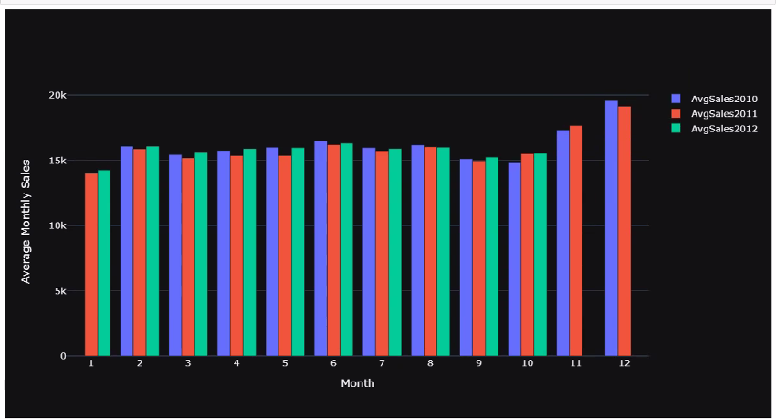
Fig 4: Average monthly sale per year
The average weekly sale per year is plotted using scatter and line plot (fig 5). Month of January witnessed the lowest sales for 2011 and 2012 while for 2010 the weekly sales are not given in the data From Feburary till October the weekly sales nearly remains constant around 15000 for the 3 years November and December showed the highest sales for 2010 and 2011 while for 2012 the sales data has not been provided or any special even.
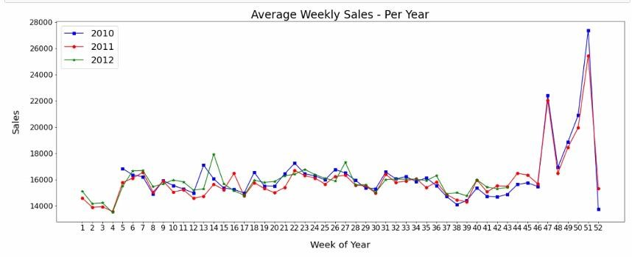
Fig 5: The average weekly sale per year is plotted using scatter and line plot
The average store sales per year is plotted. Month of January witnessed the lowest sales for 2011 and 2012 while for 2010 the weekly sales are not given in the data From Feburary till October the weekly sales nearly remains constant around 15000 for the 3 years November and December showed the highest sales for 2010 and 2011 while for 2012 the sales data has not been provided week of Thanks giving the highest sales in all the 3 years
Average department wise sale per year is plotted for each year. Month of January witnessed the lowest sales for 2011 and 2012 while for 2010 the weekly sales are not given in the data
From Feburary till October the weekly sales nearly remains constant around 15000 for the 3 years November and December showed the highest sales for 2010 and 2011 while for 2012 the sales data has not been provided week of Thanks giving among the 45 stores which have highest average sales
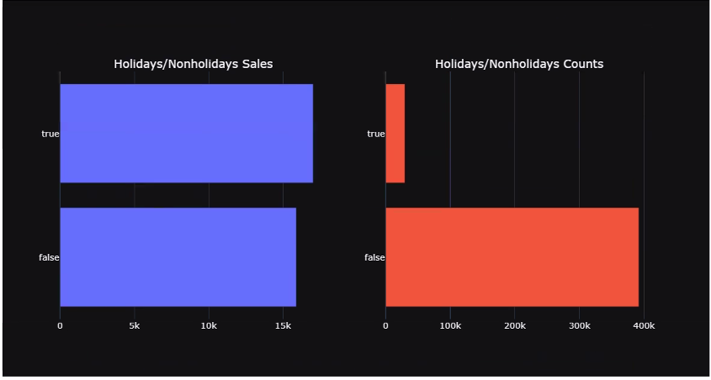
Fig 6: Analysis of sales on holidays and working days

The data is analysed for sales on holidays and other working days. This shows that the sales are comparatively higher on holidays. This information is useful to further improve the store sales. Only 7 percent of the weeks in the data are the holiday weeks Despite being the less peecentage of holiday weeks the sales in the holidays week are on the average higher than in the non-holiday weeks
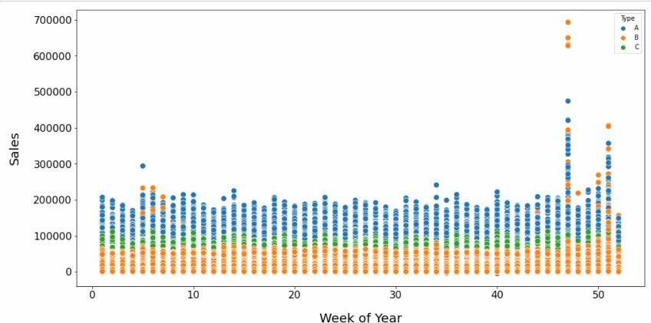

Fig 7: Week of the year vs sales
The sales for each week is plotted for 3 years. This shows only a slight relationship as the weekly sales increased towards the end of the year.

Results and discussion:
Linear regression, Lasso regression, ridge regression, random forest, decision tree and gradient boosting machine algorithm were used to predict the weekly saes of wallmart. Among the given algorithms Gradient Boosting Machine algorithm was the best performing one as it provided the highest R2 score of 0.94.

from xgboost import XGBRegressor

XGBoost_model = XGBRegressor() XGBoost_model.fit(x_train, y_train)

y_prediction = XGBoost_model.predict(x_test)

MAE = mean_absolute_error(y_test, y_prediction) print(f"MAE = {MAE}")

R2 = r2_score(y_test, y_prediction) print(f"R2 = {R2}")
MAE : 1940.99
R2 Score : 0.94

GUI:
GUI is made using Flask framework. Flask is a micro web framework written in Python. It is classified as a microframework because it does not require particular tools or libraries. It has no database abstraction layer, form validation, or any other components where pre-existing third-party libraries provide common functions. However, Flask supports extensions that can add application features as if they were implemented in Flask itself. Extensions exist for object-relational mappers, form validation, upload handling, various open authentication technologies and several common framework related tools

6.GitHubLink:

https://github.com/B2-Abhishek-83653/Project_DBDA_Gold_Price_Prediction

7.Future work And Conclusion 7.1Future Work:
Walmart can analyze the entire store data across US to arrive at an
even more accurate prediction. They can analyze the inventory data as well to optimize their inventory. They can analyze the sales targets and incentives that are given for employees to arrive at achievable sales targets for employees to motivate them better.

7.2 Conclusion:
    - Type 'A' stores are more popular than 'B' and 'C' types

    - Type 'A' stores outclass the 'B' and 'C' types in terms of size and the avergae weekly sales

    - Weekly Sales are effected by the week of year. Holiday weeks witnessed more sales than the non-holiday weeks. Notables are Thanksgiving and Christmas weeks

    - Size of the store is a major contributing factor in the weekly sales

    - Sales are also dependent on the department of the store as different departments showed different levels of weekly sales

    - Among the trained models for predicting the future sales, Gradient Boosting Machine performs the best.

