A PROJECT ON

“GOLD PRICE PREDICTION”
SUBMITTED IN
PARTIAL FULFILLMENT OF THE REQUIREMENT FOR THE COURSE OF
DIPLOMA IN BIG DATA ANALYSIS



SUNBEAM INSTITUTE OF INFORMATION TECHNOLOGY, PUNE
Submitted By:

Jadhav Abhishek (83653)

Harshit Gupta (83943)

Mr.Nitin Kudale Mrs.Manisha Hingne Centre Coordinator Course Coordinator



CERTIFICATE

This is to certify that the project work under the title ‘Gold Price Prediction’ is done by jadhav Abhishek & Harshit Gupta in partial fulfillment of the requirement for award of Diploma in Big Data Analysis Course.

Mr. Aniket P Mrs. Manisha Hingne
Project Guide Course Coordinator

Date:

ACKNOWLEDGEMENT

A project usually falls short of its expectation unless aided and guided by the right persons at the right time. We avail this opportunity to express our deep sense of gratitude towards Mr. Nitin Kudale (Center Coordinator, SIIT, Pune) and Mrs. Manisha Hingne (Course Coordinator, SIIT ,Pune) and Project Guide Mr. Aniket P.
We are deeply indebted and grateful to them for their guidance, encouragement and deep concern for our project. Without their critical evaluation and suggestions at every stage of the project, this project could never have reached its present form.
Last but not the least we thank the entire faculty and the staff members of Sunbeam Institute of Information Technology, Pune for their support.

Jadhav Abhishek
DBDA March 2024 Batch, SIIT Pune

Harshit Gupta
DBDA March 2024 Batch, SIIT Pune

.
TABLE OF CONTENTS

- Introduction
  - Introduction And Objectives
  - Why this problem needs To be Solved?
  - Dataset Information

Problem Definition and Algorithm
  - Problem Definition
  - Algorithm Definition

Experimental Evaluation
  - Methodology/Model
  - Exploratory Data Analysis

Results And Discussion

- GUI

- GitHub link

7.Future Work And Conclusion
  - Future Work
  - Conclusion
    - Introduction

      - Introduction And Objectives:

Gold has long been a cornerstone of investment portfolios, renowned for its stability and hedge against inflation. This report aims to provide a comprehensive analysis of the factors influencing gold prices and to offer predictions based on current data and trends. The gold market is influenced by a multitude of factors, including economic indicators, geopolitical events, monetary policies, and market sentiment. Understanding these elements can help investors make informed decisions about their gold investments.

Why this problem needs To be Solved?

Gold prices are experiencing volatility, driven by several key factors:
- Economic Data: Recent economic indicators have shown mixed signals. While global inflation rates remain high, economic growth has been uneven across different regions.
- Interest Rates: Central banks, particularly the Federal Reserve and the European Central Bank, have maintained a cautious approach with interest rate hikes. This impacts gold prices as higher interest rates often lead to lower gold prices due to the opportunity cost of holding non-yielding assets.
- Geopolitical Tensions: Ongoing geopolitical tensions, including trade disputes and conflicts, have contributed to gold's safe-haven appeal.

Key Influencing Factors:
- Inflation and Economic Growth: Gold is traditionally seen as a hedge against inflation. In periods of high inflation, the demand for gold tends to increase. Conversely, strong economic growth can reduce the attractiveness of gold as an investment.
- Monetary Policy: Central bank policies, particularly interest rate decisions, play a significant role in gold price movements. Lower interest rates generally benefit gold prices as they reduce the opportunity cost of holding gold.
- Geopolitical Events: Conflicts, trade tensions, and political instability often drive investors to gold as a safe-haven asset. Recent global tensions have bolstered gold prices as investors seek stability.
- Currency Movements: The strength of the US dollar has an inverse relationship with gold prices. A stronger dollar makes gold more expensive for foreign investors, potentially decreasing demand.
- Market Sentiment: Investor sentiment and speculative activity also influence gold prices. Trends in gold ETF holdings and futures contracts can provide insights into market expectations.

Dataset Information. gold_rate.csv:
It has seven columns.
Date : Date of data
Open :Opening price of gold
High : Highest price of gold
Low : Lowest price of gold
Close : Closing price of gold
Adj Close : Adjusted price of gold after fees are paid to respective agencies
Volume : Volume of gold traded

Problem Definition and Algorithm:
      - Problem Definition
Gold remains a crucial asset in investment portfolios due to its historical role as a safe-haven and inflation hedge. Current market conditions suggest that gold prices may experience volatility in the short term, influenced by economic data, central bank policies, and geopolitical events. Investors should stay informed about these factors and consider both short-term and long-term trends when making investment decisions.
Given data can be used to predict Closing price of gold with respect to date using machine learning algorithms like Linear regression, polynomial regression, support vector regression, decision tree and XGBoost.

Algorithm Definition
Linear regression: is one of the very basic forms of machine learning where we train a model to predict the behavior of your data based on some variables. In the case of linear regression as you can see the name suggests linear that means the two variables which are on the x-axis and y-axis should be linearly correlated.

Polynomial regression: Polynomial regression is a type of regression analysis used to model the relationship between a dependent variable and one or more independent variables by fitting a polynomial equation to the data. Unlike linear regression, which fits a straight line, polynomial regression can model more complex relationships by fitting curves to the data.

Support Vector Regression: Support Vector Regression (SVR) is a type of regression analysis that is based on the principles of Support Vector Machines (SVM), which are primarily used for classification tasks. SVR is particularly useful for modeling and predicting continuous data where the relationship between variables is complex and non-linear.

Random forest: is a Supervised Machine Learning Algorithm that is used widely in Classification and Regression problems. It builds decision trees on different samples and takes their majority vote for classification and average in case of regression.
One of the most important features of the Random Forest Algorithm is that it can handle the data set containing continuous variables as in the case of regression and categorical variables as in the case of classification. It performs better results for classification problems.

Decision Tree: algorithm belongs to the family of supervised learning algorithms. Unlike other supervised learning algorithms, the decision tree algorithm can be used for solving regression and classification problems too.
The goal of using a Decision Tree is to create a training model that can use to predict the class or value of the target variable by learning simple decision rules inferred from prior data(training data).In Decision Trees, for predicting a class label for a record we start from the root of the tree. We compare the values of the root attribute with the record’s attribute. On the basis of comparison, we follow the branch corresponding to that value and jump to the next node.

XGBoost: or extreme gradient boosting is one of the well-known gradient boosting techniques (ensemble) having enhanced performance and speed in tree- based (sequential decision trees) machine learning algorithms. XGBoost was created by Tianqi Chen and initially maintained by the Distributed (Deep) Machine Learning Community (DMLC) group. It is the most common algorithm used for applied machine learning in competitions and has gained popularity through winning solutions in structured and tabular data. It is open- source software. Earlier only python and R packages were built for XGBoost but now it has extended to Java, Scala, Julia and other languages as well.

Experimental Evaluation:

      - Methodology:

The objective of this project is to predict the daily closing price of gold with respect to date using machine learning algorithms like Linear regression, polynomial regression, support vector regression, decision tree and XGBoost.

Loading in raw data
df=pd.read_csv('../Database/gold_rate.csv')

Preprocessing:
The Gold rate are given for Years 2000-2024 on dailybasis. This data was split to extract information for year, month and week.
df['date_num']=(pd.DatetimeIndex(df['Date']).year%100)*10000\
+pd.DatetimeIndex(df['Date']).month*100 \
+pd.DatetimeIndex(df['Date']).day

The data had several missing values and needed to be cleaned. The missing values in ‘Close’needed to be cleaned. Since the number of missing values were significant, they were not removed but were dropped.

print(df.isna().sum()) missing_values = df.isna().sum()
df=df.dropna()

Flow Diagram :

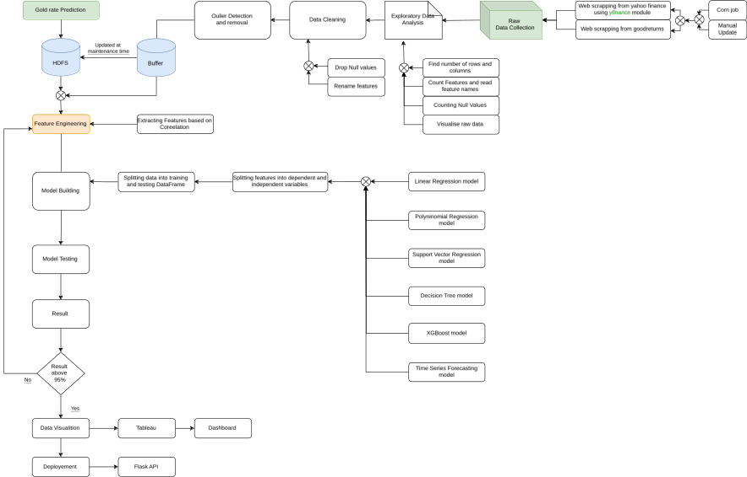
      - Exploratory Data Analysis

Results and discussion:
Linear regression, Lasso regression, ridge regression, random forest, decision tree and gradient boosting machine algorithm were used to predict the daily price of gold. Among the given algorithms Gradient Boosting Machine algorithm was the best performing one as it provided the highest R2 score of 0.94.

from xgboost import XGBRegressor

XGBoost_model = XGBRegressor() XGBoost_model.fit(x_train, y_train)

y_prediction = XGBoost_model.predict(x_test)

MAE = mean_absolute_error(y_test, y_prediction) print(f"MAE = {MAE}")

R2 = r2_score(y_test, y_prediction) print(f"R2 = {R2}")
788.0654801790309
19.115177571343768
0.9974232299471844
{'learning_rate': 0.1, 'max_depth': 8, 'n_estimators': 100}
0.9976473218904447
['xgb_model.pkl']

GUI:
GUI is made using Flask framework. Flask is a micro web framework written in Python. It is classified as a microframework because it does not require particular tools or libraries. It has no database abstraction layer, form validation, or any other components where pre-existing third-party libraries provide common functions. However, Flask supports extensions that can add application features as if they were implemented in Flask itself. Extensions exist for object-relational mappers, form validation, upload handling, various open authentication technologies and several common framework related tools

6.GitHubLink:

https://github.com/B2-Abhishek-83653/Project_DBDA_Gold_Price_Prediction

https://github.com/B2-Harshit-83943/GOLD_PRICE_PREDICTION

7.Future work And Conclusion 7.1Future Work:
Predicting the future price of gold is challenging due to the myriad of factors that influence it. Here are some key factors that could affect gold prices in the future:
- Economic Conditions: Gold is often seen as a safe-haven asset during economic uncertainty. Economic downturns or financial crises might drive up gold prices as investors seek stability.
- Inflation: Gold is traditionally used as a hedge against inflation. If inflation rates rise, demand for gold might increase, pushing up its price.
- Interest Rates: Gold does not yield interest, so its attractiveness tends to decrease when interest rates rise. Conversely, lower interest rates can boost gold prices.
- Geopolitical Events: Political instability or conflicts can lead to increased demand for gold as a safe-haven investment.
- Currency Strength: Gold prices are often inversely related to the strength of the U.S. dollar. A weaker dollar typically boosts gold prices.
- Market Sentiment and Speculation: Investor sentiment and speculative activities can also drive short-term price movements.
- Supply and Demand: Changes in mining output, recycling rates, and central bank gold reserves can impact gold supply and, consequently, its price.
- Technological and Industrial Uses: Advances in technology or changes in industrial applications of gold could affect demand.

7.2 Conclusion:
    - Trend Analysis: Summarize the predicted trends in gold prices based on the ML model’s outputs. For instance, does the model suggest an upward or downward trend.
- Uncertainty and Confidence: Acknowledge the uncertainty in predictions and the potential for model error. Machine learning models provide forecasts based on historical patterns but cannot account for unforeseen events or market shifts.

