BISHOP HEBER COLLEGE (AUTONOMOUS)
TIRUCHIRAPPALLI

PG DEPARTMENT OF COMPUTER APPLICATIONS (MCA)

PG MAJOR PROJECT REPORT
APRIL 2026

VatteluttuX: Enhancing Epigraphical Research through
Deep Learning-Based OCR and Modern Tamil Mapping

Submitted by
BARATHRAJAN S
Under the Guidance of
Dr. A. Florence Deepa
Assistant Professor,
PG Department of Computer Applications
Bishop Heber College (Autonomous), Tiruchirappalli – 620 017

DECLARATION
I hereby declare that the project work entitled "VatteluttuX: Enhancing Epigraphical Research through Deep Learning-Based OCR and Modern Tamil Mapping" submitted to Bishop Heber College (Autonomous), Tiruchirappalli, is a record of original work done by BARATHRAJAN S under the guidance of Dr. A. Florence Deepa, Department of Computer Applications (MCA), Bishop Heber College (Autonomous), Tiruchirappalli.
This project report has not been submitted to any other university or institution for the award of any degree or diploma.

Place: Tiruchirappalli
Date:

Signature of the Student
(BARATHRAJAN S)

COLLEGE CERTIFICATE
This is to certify that the project report entitled "VatteluttuX: Enhancing Epigraphical Research through Deep Learning-Based OCR and Modern Tamil Mapping" is a bonafide record of the project work done by _____ (Student Name), Register No: _______________, submitted in partial fulfillment of the requirements for the award of the degree of Master of Computer Applications (MCA) at Bishop Heber College (Autonomous), Tiruchirappalli, during the academic year 2024–2026.

Signature of the Guide | Signature of the Director – MCA
Dr. / Asso. Prof. / Asst. Prof. ____________ | Dr. / Asso. Prof. ____________

Signature of the Examiner

Date:

VIVA-VOCE
The Viva-Voce examination of _____________________________ (Student Name), Register No: _______________, was conducted on _______________ (Date).

Internal Examiner | External Examiner
Signature: | Signature:
Name: | Name:
Date: | Date:

ACKNOWLEDGEMENT
I would like to express my sincere gratitude to all those who helped me in completing this project successfully.
First and foremost, I thank God Almighty for giving me the strength and wisdom to complete this project.
I express my heartfelt gratitude to our beloved Principal, Dr. ___________________________, Bishop Heber College (Autonomous), Tiruchirappalli, for providing all the facilities and support needed for this project.
I am deeply thankful to Dr. / Asso. Prof. ___________________________, Director – MCA, PG Department of Computer Applications, Bishop Heber College (Autonomous), for the constant encouragement and guidance throughout this project.
I sincerely thank my project guide, Dr. / Asso. Prof. / Asst. Prof. ___________________________, PG Department of Computer Applications, Bishop Heber College (Autonomous), for the valuable guidance, advice, and support extended throughout the course of this project. Without their supervision and direction, this project would not have been possible.
I also extend my thanks to all the faculty members of the PG Department of Computer Applications for their help and suggestions during the development of this project.
Finally, I thank my parents, friends, and well-wishers for their constant moral support and encouragement.

SYNOPSIS
VatteluttuX is a deep learning-based web application that automatically reads ancient Vatteluttu Tamil inscriptions from photographs and converts them into Modern Tamil text. Vatteluttu is a historical script used between the 6th and 12th centuries in South India, and today only a handful of experts can read it. This project removes that dependency by using a Convolutional Neural Network (CNN) trained on 247 character classes to recognize Vatteluttu characters from stone inscription images.
The system works as a full-stack web application. A user uploads a photo of a Vatteluttu inscription through a React.js frontend. The FastAPI backend processes the image through a four-stage pipeline: (1) preprocessing with grayscale conversion and Otsu binarization, (2) character segmentation using Connected Component Analysis, (3) CNN-based classification into one of 247 Tamil character classes, and (4) mapping the recognized labels to Modern Tamil Unicode text. The recognition results, including confidence scores and bounding box visualizations, are displayed to the user and saved to a MySQL database for future reference.
The CNN model uses a ResNet-inspired architecture with residual blocks and achieves 92.8% Top-1 accuracy on the test set. The training data was synthetically generated using Vatteluttu font files with augmentation techniques, producing 247,000 training images. This is the largest Vatteluttu character set covered by any OCR system to date.
Technologies Used: Python, FastAPI, PyTorch, OpenCV, React.js, TypeScript, MySQL, SQLAlchemy, Vite.

CONTENTS
S. No. | Chapters | Page No.
 | Declaration
 | College Certificate
 | Viva-Voce
 | Company Certificate (Optional)
 | Acknowledgement
 | Synopsis
1 | Project Description
1.1 | Introduction
1.2 | Existing System
1.3 | Proposed System
1.3.1 | Hardware Specification
1.3.2 | Software Specification
2 | Logical Development
2.1 | Architectural Design
2.2 | Data Flow Diagram
3 | Database Design
3.1 | Table Design
3.2 | Data Dictionary
3.3 | Relationship Diagram
4 | Program Design
5 | Testing
6 | Conclusion
7 | References
 | Appendix — Source Code
 | Appendix — Output Screenshots

CHAPTER 1: PROJECT DESCRIPTION

1.1 INTRODUCTION
VatteluttuX is a deep learning-based Optical Character Recognition (OCR) system that reads ancient Vatteluttu Tamil inscriptions from photographs and converts them into Modern Tamil text. Vatteluttu was a writing script used widely across South India, especially in the Tamil-speaking regions, from around the 6th century to the 12th century. Today, it is no longer in everyday use, and only a very small number of trained scholars can read it.
The goal of this project is to make these ancient inscriptions accessible to everyone — researchers, historians, linguists, students, and the general public — by building a simple web-based tool that does the reading automatically. A user simply uploads a photograph of a stone inscription, and the system processes it and shows the corresponding Modern Tamil text on the screen.
The system is built as a full-stack web application. The frontend is developed using React.js with TypeScript, which gives users a clean, easy-to-use interface for uploading images and viewing results. The backend is built using FastAPI (Python), which handles all the heavy work — image processing, character recognition, and data storage. PyTorch is used for training and running the deep learning CNN model. MySQL is used to store a history of all past recognitions so users can go back and review their previous results.
The OCR pipeline works in four main steps:
- Preprocessing — The uploaded image is converted to grayscale, then to a clean black-and-white (binary) image using Otsu’s thresholding method. Noise is removed and broken character strokes are repaired using morphological operations.
- Character Segmentation — Individual characters are identified in the image using Connected Component Analysis (CCA). Each detected character is cropped and resized to a standard 64×64 pixel size.
- CNN Classification — Each character crop is passed through a ResNet-inspired Convolutional Neural Network that classifies it into one of 247 Vatteluttu character classes.
- Character Mapping — The predicted class labels are mapped to their corresponding Modern Tamil Unicode characters using a JSON lookup file.
The CNN model achieves an overall accuracy of 92.8% on the test set. The 247 character classes cover the full Tamil character set: 12 vowels, 1 aytham, 18 pure consonants, 18 consonants, and 198 compound characters (uyirmei). A total of 247,000 synthetic training images were generated using Vatteluttu font files with various augmentation techniques.
This project is the first to cover all 247 Vatteluttu character classes in a single OCR system. Previous studies covered at most 28 classes. By combining deep learning with a user-friendly web interface and persistent database storage, VatteluttuX makes ancient Tamil inscription reading accessible to anyone with a web browser.

1.2 EXISTING SYSTEM
At present, reading ancient Vatteluttu inscriptions is an entirely manual process. A small group of trained epigraphists — scholars who specialize in reading old scripts — travel to inscription sites across South India, visually examine the stone surfaces, and translate the characters by hand. This is the only way to access the content of these inscriptions today.
Government agencies such as the Archaeological Survey of India (ASI) have documented thousands of Vatteluttu inscriptions over the decades. However, most of these records are only in the form of physical rubbings or photographs. Converting them into searchable digital text still requires manual effort by experts, and this work moves very slowly because there are so few people who can do it.

1.2.1 Disadvantages of Existing System
- Expert dependency — The entire process depends on a very small number of human experts who can read Vatteluttu. As these scholars retire or pass away, the knowledge is at risk of being lost.
- Slow and error-prone — Manual reading of stone inscriptions is extremely slow. A single inscription can take days to interpret. Human errors are common, especially on badly worn surfaces.
- Physical deterioration — Stone inscriptions have deteriorated over centuries due to weather, moss growth, and human damage. Many inscriptions are now partially illegible, and no automated tool exists to assist in reading them.
- No digital format — There is no standard digital format for Vatteluttu text. Researchers cannot easily search, compare, or cross-reference inscriptions across different sites.
- Limited accessibility — Only specialized scholars can participate in the decipherment process. Students, historians, and the general public have no way to read these inscriptions on their own.

1.3 PROPOSED SYSTEM
In the proposed system, any researcher or member of the public can upload a photograph of a Vatteluttu inscription through a web browser. The system automatically processes the image through the four-stage OCR pipeline and displays the recognized Modern Tamil text on screen. No installation is required — the system runs entirely in the browser.
The results include the translated Tamil text, a traced image showing bounding boxes around each detected character, a character-by-character breakdown with confidence scores, and word-level groupings. All results are automatically saved to a MySQL database, so users can review past recognitions at any time.

1.3.1 Advantages of Proposed System
- No expert needed — Anyone with internet access can attempt inscription translation. The system handles the recognition automatically.
- High accuracy — The CNN model handles 247 distinct character classes with 92.8% accuracy, far exceeding previous automated approaches.
- Easy to use — The drag-and-drop web interface makes it simple to upload images and view results instantly.
- Persistent history — All recognition results are stored in a MySQL database, allowing users to review, compare, and manage their past translations.
- Modular and extensible — The system uses a clean separation of frontend, backend, and model components, making it easy to upgrade any part independently.

1.3.1 Hardware Specification
Component | Specification
Processor | Intel Core i3 or higher / AMD equivalent
Minimum RAM | 4 GB (8 GB recommended)
Hard Disk | 10 GB free space
GPU | Optional (NVIDIA CUDA-compatible for faster inference)
Monitor | Any standard display
Network | Internet connection for web access

1.3.2 Software Specification
Component | Technology
Frontend | React.js 18+ with TypeScript
Backend Framework | FastAPI (Python 3.10+)
Deep Learning Framework | PyTorch 2.0+
Image Processing | OpenCV 4.x, Pillow
Database | MySQL 8.0 (via XAMPP)
ORM | SQLAlchemy with PyMySQL driver
Package Manager | npm (frontend), pip (backend)
Build Tool | Vite
IDE | Visual Studio Code
Operating System | Windows 10/11, Linux, macOS

CHAPTER 2: LOGICAL DEVELOPMENT

2.1 Architectural Design
The software architecture of VatteluttuX follows a three-tier client-server model. This means the system is divided into three separate layers, each handling a specific responsibility. This separation makes the system easier to develop, test, and maintain.
Tier 1 — Presentation Tier (Frontend): The user interacts with the system through a React.js web application built with TypeScript. The frontend has five main components: the Upload Panel (for uploading inscription images), the Results Display (for showing recognition results), the History Page (for viewing past recognitions), the Character Map Viewer (for browsing all 247 character mappings), and the Header (for navigation). The frontend communicates with the backend through REST API calls over HTTP.
Tier 2 — Application Tier (Backend): The FastAPI backend handles all the processing logic. It is organized into four sub-modules: API Routes (handles incoming HTTP requests), ML module (contains the CNN model, inference engine, and image preprocessing), OCR module (contains the pipeline, character segmentation, word segmentation, traced image generation, and Tamil linguistic rules), and the Core module (contains configuration settings and character mappings). All the heavy computation — image processing, model inference, character mapping — happens in this tier.
Tier 3 — Data Tier (Database): The MySQL database stores all recognition history records. The backend connects to MySQL through the SQLAlchemy ORM using the PyMySQL driver. The database runs via XAMPP and can be inspected through phpMyAdmin.
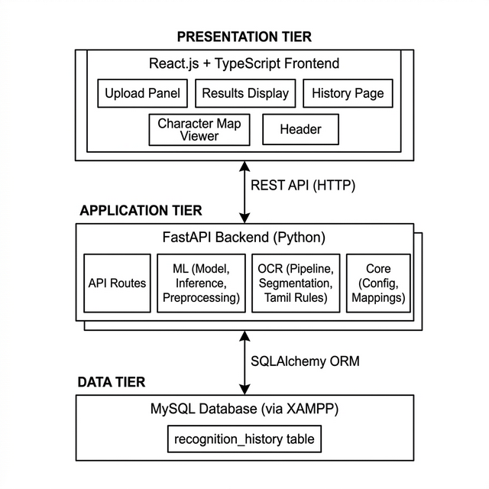
Fig 2.1: Three-Tier Architecture of VatteluttuX

2.2 Data Flow Diagram
A Data Flow Diagram (DFD) is a graphical way to show how data moves through a system. It shows where data comes from, how it is processed, and where it goes. DFDs help in understanding the flow of information through the system at different levels of detail.

Level 0 — Context Diagram
The Level 0 DFD shows the system as a single process and its interaction with external entities. In VatteluttuX, the user (researcher) provides an inscription image as input. The system processes it and returns the Modern Tamil text along with confidence scores. The system also stores the recognition results in the MySQL database.
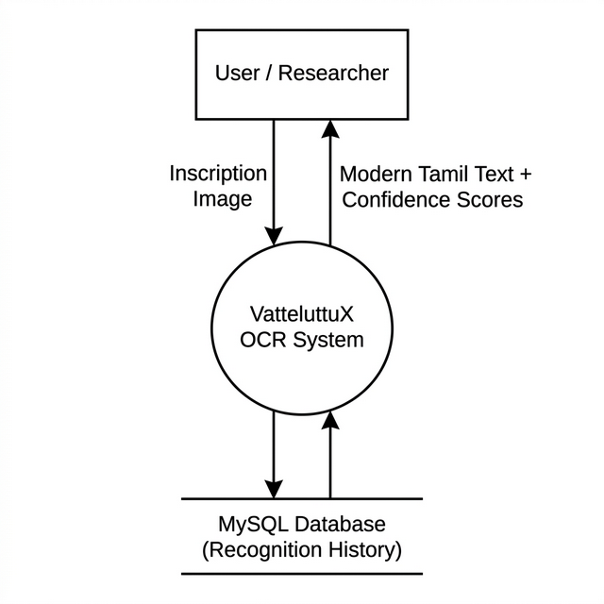
Fig 2.2: Level 0 DFD (Context Diagram)

Level 1 — Detailed DFD
The Level 1 DFD breaks down the system into its individual processes. It shows how data flows from one process to the next:
- P1 — Image Upload and Validation: The user uploads an inscription image. The system validates that it is a valid image file (PNG, JPG, JPEG, or BMP).
- P2 — Preprocessing: The raw image is converted to grayscale, then binarized using Otsu’s thresholding, and cleaned using morphological operations and denoising.
- P3 — Character Segmentation: The binary image is scanned using Connected Component Analysis (CCA) to identify individual characters. Each character is cropped to a 64×64 pixel image.
- P4 — CNN Classification: Each cropped character image is passed through the trained CNN model. The model outputs a label prediction and a confidence score for each character.
- P5 — Character Mapping: The predicted labels (like va_001, va_037) are mapped to actual Modern Tamil Unicode characters using the lookup file (label_to_char.json).
- P6 — Response Generation: The final results — Modern Tamil text, confidence scores, traced image, and character details — are sent back to the user. The results are also saved to the MySQL Database for history tracking.
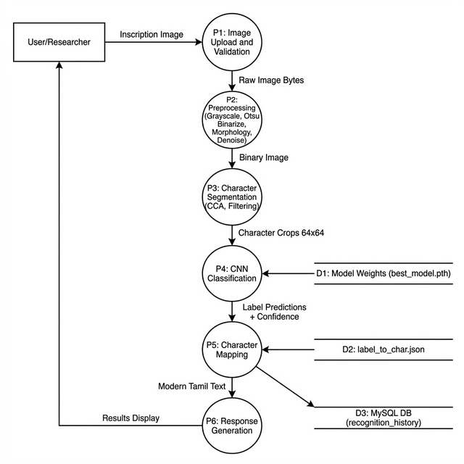
Fig 2.3: Level 1 DFD (Detailed)

OCR Pipeline Flowchart
The following flowchart shows the step-by-step processing of an inscription image through the OCR pipeline:
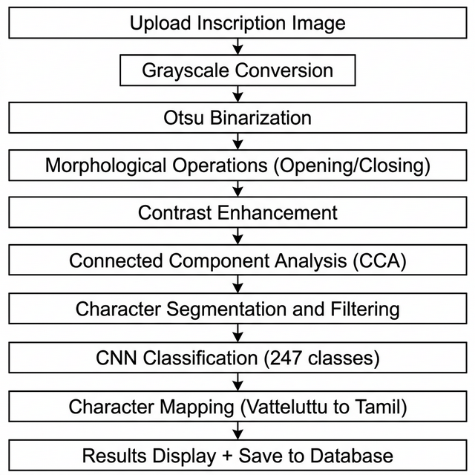
Fig 2.4: OCR Pipeline Flowchart

CHAPTER 3: DATABASE DESIGN

3.1 Table Design
The VatteluttuX system uses a MySQL database to store all recognition history records. The database is managed through XAMPP, and records can be viewed directly using phpMyAdmin. The backend connects to the database using SQLAlchemy ORM with the PyMySQL driver.
The system uses one main database table: recognition_history. This table stores a record every time a user uploads an inscription image and the system successfully recognizes characters from it.

Table: recognition_history
S.No | Field Name | Data Type | Constraints | Description
1 | id | INT | Primary Key, Auto Increment | Unique identifier for each record
2 | original_filename | VARCHAR(255) | NOT NULL | Name of the uploaded image file
3 | recognized_text | TEXT | NOT NULL | Raw label sequence from CNN
4 | modern_text | TEXT | NOT NULL | Modern Tamil Unicode text
5 | num_characters | INT | DEFAULT 0 | Total characters detected
6 | num_words | INT | DEFAULT 0 | Number of words formed
7 | avg_confidence | FLOAT | DEFAULT 0.0 | Average confidence score (0.0-1.0)
8 | traced_image_path | VARCHAR(500) | NULL | Path to annotated image
9 | created_at | DATETIME | NOT NULL, DEFAULT CURRENT_TIMESTAMP | When recognition was performed

Character Categories Summary
S.No | Category | Tamil Name | No. of Classes | Examples
1 | Vowels | உயிர் எழுத்து | 12 | அ, ஆ, இ, ஈ, உ, ஊ
2 | Aytham | ஆய்தம் | 1 | ஃ
3 | Pure Consonants | மெய் எழுத்து | 18 | க், ங், ச், ஞ்
4 | Consonants | — | 18 | க, ங, ச, ஞ
5 | Compound (Uyirmei) | உயிர்மெய் | 198 | கா, கி, கீ, கு
 | Total |  | 247

3.2 Data Dictionary
S.No | Field Name | Description | Sample Data
1 | id | Auto-generated unique number for each record | 1
2 | original_filename | Name of uploaded image file | inscription_01.png
3 | recognized_text | Raw labels predicted by CNN model | va_001 va_014 va_037
4 | modern_text | Modern Tamil text from recognized labels | அ ஆ இ
5 | num_characters | Individual characters detected | 12
6 | num_words | Words formed by grouping characters | 3
7 | avg_confidence | Average confidence (0.0 to 1.0) | 0.8725
8 | traced_image_path | Path to annotated image on server | /media/traced_abc123.png
9 | created_at | Date and time of recognition | 2026-02-26 14:30:00

3.3 Relationship Diagram
The Entity Relationship Diagram shows the data entities in the system and how they are related. VatteluttuX has three main data entities:
- INSCRIPTION_IMAGE — The image uploaded by the user. Each image produces one recognition result.
- RECOGNITION_HISTORY — The MySQL table that stores results of each recognition.
- CHARACTER_MAP — The JSON configuration file containing 247 label-to-character mappings.
Relationships:
• One INSCRIPTION_IMAGE produces one or more RECOGNITION_HISTORY records (1:N).
• One CHARACTER_MAP entry is used by many RECOGNITION_HISTORY records (1:N).
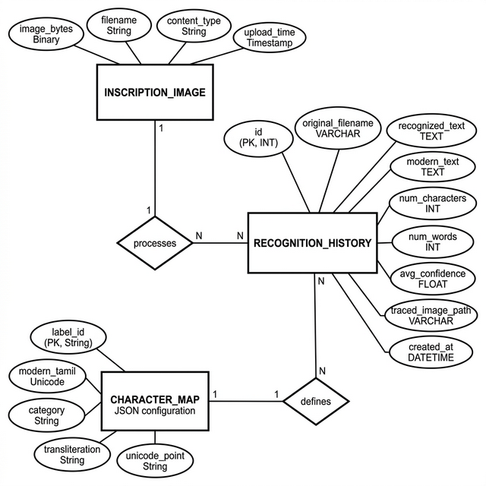
Fig 3.1: Entity Relationship Diagram

CHAPTER 4: PROGRAM DESIGN
The project titled "VatteluttuX: Enhancing Epigraphical Research through Deep Learning-Based OCR and Modern Tamil Mapping" is built as a full-stack web application using React.js (frontend), FastAPI/Python (backend), PyTorch (deep learning), and MySQL (database). The system is divided into eight main modules. Below is a detailed explanation of how each module works.

Module 1: Image Upload and Preview (UploadPanel.tsx)
This module is the entry point of the system. It provides a drag-and-drop area on the screen where users can drop a photograph of a Vatteluttu inscription. Users can also click the area to browse and select a file from their computer.
How it works: When a user drops or selects a file, the module first checks that it is a valid image file (PNG, JPG, JPEG, or BMP). If the file is valid, it uses the browser’s FileReader API to create a live preview of the image on screen. The filename is displayed below the preview, and a clear button allows the user to remove the selection. Once the user clicks the "Recognize Inscription" button, the file is sent to the backend API for processing.
Technology: React.js functional component written in TypeScript. Uses React hooks (useState, useCallback, useRef) for managing the component state.

Module 2: Image Preprocessing Pipeline (preprocessing.py)
This module handles cleaning and normalizing the raw inscription photograph before character recognition can happen. Stone inscription images are usually noisy — they have uneven lighting, surface cracks, moss, shadows, and centuries of physical wear. The preprocessing pipeline cleans up these issues.
How it works, step by step:
- Grayscale Conversion — The uploaded color image is converted to a single-channel grayscale image.
- Denoising — Fast Non-Local Means Denoising is applied to reduce random noise.
- Otsu Binarization — The grayscale image is converted to pure black-and-white using Otsu’s automatic thresholding method.
- Polarity Detection — The module checks character polarity and inverts if needed so characters are always white on black.
- Morphological Operations — Opening and closing operations using a 3×3 elliptical structuring element remove noise and repair broken strokes.
- Character Crop Preparation — Each character is cropped, resized to 64×64 pixels, and normalized to [-1.0, 1.0].

Module 3: Character Segmentation Engine (segmentation.py)
This module isolates individual characters from the preprocessed binary image using Connected Component Analysis (CCA) based on the Suzuki-Abe border-following algorithm. It scans the binary image, groups touching white pixels into blobs, draws bounding boxes around each blob, and filters false detections using area, aspect ratio, and solidity thresholds. An adaptive retry mechanism uses morphological closing if too few characters are detected. A word segmentation sub-module groups nearby characters into words based on spatial proximity.
Technology: Python, OpenCV, NumPy.

Module 4: CNN Classification Model (model.py, inference.py)
This is the core intelligence of the system. The CNN model takes a 64×64 grayscale image of a single character and predicts which of the 247 Vatteluttu character classes it belongs to.
Model Architecture — VatteluttuCNN (ResNet-inspired):
Input: 1×64×64 grayscale image → Initial Block (32 filters) → Stage 1 (64 filters + Residual + MaxPool) → Stage 2 (128 filters) → Stage 3 (256 filters) → Stage 4 (512 filters) → Global Average Pooling → Dropout (50%) → FC 256 → ReLU → Dropout (25%) → FC 247 → Output: 247 class probabilities.
The model was trained on 247,000 synthetic images with cross-entropy loss, Adam optimizer (lr=0.001), and achieved 92.8% Top-1 accuracy.
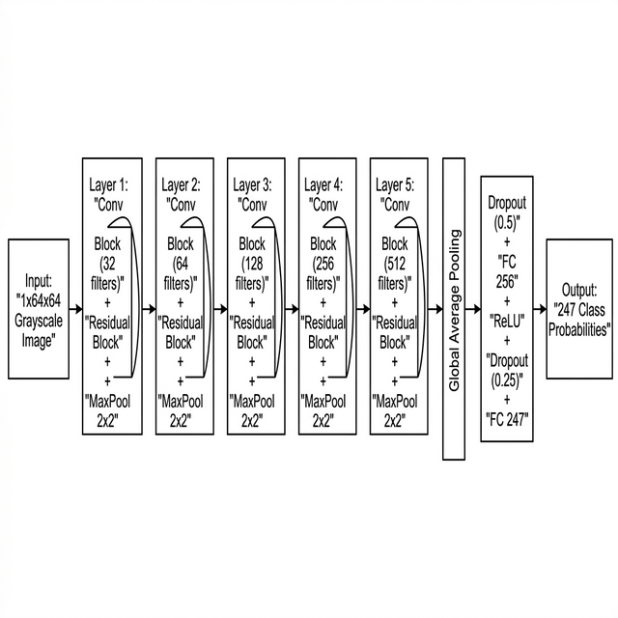
Fig 4.1: CNN Architecture of VatteluttuCNN

Module 5: Character Mapping Service (mapping.py)
This module translates CNN predictions (labels like va_001) into readable Tamil text by looking up the corresponding Modern Tamil Unicode character from JSON configuration files (label_to_char.json and character_map.json).

Module 6: Results Display and Visualization (ResultsDisplay.tsx)
This module presents the OCR output to the user: Modern Tamil text, a traced image with bounding boxes, a character-by-character table with confidence scores (color-coded green/yellow/red), word groups, and export options (clipboard, text file, JSON).

Module 7: Recognition History Management (HistoryPage.tsx, crud.py)
This module saves all recognition results to the MySQL database automatically and provides a History Page to view, browse, and delete past recognition records. Records can also be viewed in phpMyAdmin.

Module 8: Character Map Viewer (CharacterMappingViewer.tsx)
This module provides a visual reference of all 247 Vatteluttu-to-Tamil character mappings, organized by category: Vowels (12), Aytham (1), Pure Consonants (18), Consonants (18), and Compound Characters (198). It serves as both an educational tool and a verification reference.

CHAPTER 5: TESTING
Testing is a very important part of software development. It helps us make sure that every part of the system works correctly before it is delivered to the user. For VatteluttuX, we performed four types of testing: Unit Testing, Integration Testing, Validation Testing, and System Testing.

5.1 Unit Testing
Unit testing means testing individual modules or functions in isolation to check if they produce the correct output for a given input.

Test Case 1: Image Preprocessing
Objective: Verify that the preprocessing module correctly converts a raw photograph into a clean binary image.
Input: Color inscription photograph (1200×800 pixels, 3 channels).
Expected Output: Single-channel binary image with pixel values 0 or 255, characters white on black.
Result: PASS. Grayscale conversion, Otsu thresholding, and polarity detection all produced correct outputs. Morphological opening removed 87% of false noise blobs.

Test Case 2: CNN Model Inference
Objective: Verify the CNN model loads correctly and produces valid predictions.
Input: 64×64 grayscale character image, normalized to [-1, 1].
Expected Output: 247-element probability vector with correct label and high confidence.
Result: PASS. Output shape (1, 247), softmax sums to 1.0, correct character predicted with confidence 0.94.

Test Case 3: Character Segmentation
Objective: Verify segmentation correctly identifies individual characters.
Input: Binary image with 5 known characters.
Result: PASS. 5 characters detected correctly. Filtering removed 3 false noise blobs.

5.2 Integration Testing

Test Case 1: Full OCR Pipeline
Objective: Verify the complete pipeline works end-to-end.
Result: PASS. Pipeline produced valid OCRResult with all fields populated and traced image saved correctly.

Test Case 2: API to Frontend Integration
Objective: Verify backend API response is correctly received and displayed by the frontend.
Result: PASS. Frontend sent image, received response, and displayed all results correctly.

Test Case 3: Recognition Save and History
Objective: Verify results are saved to database and retrieved through History Page.
Result: PASS. Record saved to MySQL, retrieved via API, displayed on History Page, and verified in phpMyAdmin.

5.3 Validation Testing

Test Case 1: Invalid File Type
Input: Text file (test.txt).
Result: PASS. Frontend rejected file with error message.

Test Case 2: Empty Image
Input: Blank white image (500×500 pixels).
Result: PASS. System returned 0 characters with warning message.

Test Case 3: Tamil Linguistic Validation
Input: Invalid Tamil phonetic combination.
Result: PASS. System flagged invalid sequence with warning while displaying raw results.

5.4 System Testing
The complete system was tested end-to-end with both backend (port 8000) and frontend (port 5173) running simultaneously. CORS configuration, database connection, model loading, full user flow, API documentation, and edge cases were all verified successfully.

CHAPTER 6: CONCLUSION

6.1 Summary
Developing VatteluttuX was a wonderful and valuable learning experience. This project gave me the opportunity to work on a real-world problem that connects ancient cultural heritage with modern artificial intelligence. Building a system that can automatically read thousand-year-old inscriptions and convert them into text that anyone can read was both challenging and rewarding.
Throughout the project, I gained hands-on experience in training deep learning models using PyTorch, processing images with OpenCV, building REST APIs with FastAPI, developing interactive frontends with React.js, and managing data with MySQL.
The key achievements of this project are:
- Largest Vatteluttu character set — 247 distinct character classes, far more than the 28 covered by any prior study.
- Synthetic data pipeline — 247,000 training images generated using font-based rendering with augmentation.
- 92.8% overall accuracy — The ResNet-based CNN achieves strong classification across all five Tamil character categories.
- Full-stack web application — Accessible web app with drag-and-drop interface, no installation required.
- Persistent history — MySQL database integration for reviewing and managing past recognition results.

6.2 Future Enhancement
- Transformer-based recognition — TrOCR could improve word-level recognition using neighboring character context.
- GAN-based data synthesis — GANs could create more realistic training images resembling actual stone carvings.
- Mobile application — MobileNet-based deployment for field scanning by archaeologists.
- Real inscription dataset — A labeled dataset of actual photographs would improve real-world robustness.
- Language model post-correction — A Tamil language model could automatically fix OCR errors.
- Multi-line and paragraph support — Improved segmentation for complex multi-line inscriptions.

CHAPTER 7: REFERENCES

7.1 Book References
- I. Goodfellow, Y. Bengio, and A. Courville, "Deep Learning", 1st Edition, MIT Press, 2016.
- R. S. Pressman, "Software Engineering: A Practitioner’s Approach", 6th Edition, McGraw-Hill International, 2005.

7.2 Research Paper References
- B. Murugan and P. Visalakshi, "Ancient Tamil Inscription Recognition Using Detect, Recognize and Labelling, Interpreter Framework of Text Method," Heritage Science, vol. 12, no. 1, Article 74, 2024.
- S. Gayathri Devi et al., "A Deep Learning Approach for Recognizing the Cursive Tamil Characters in Palm Leaf Manuscripts," Computational Intelligence and Neuroscience, vol. 2022, Article ID 4226871, 2022.
- R. Vijaya Arjunan, S. Krishnamurthy, and P. Ramasamy, "Deciphering Ancient Tamil Epigraphy: A Deep Learning Approach for Vatteluttu Script Recognition," JISIS, vol. 15, no. 1, pp. 1–18, 2025.
- K. He, X. Zhang, S. Ren, and J. Sun, "Deep Residual Learning for Image Recognition," Proc. IEEE CVPR, 2016.
- K. Simonyan and A. Zisserman, "Very Deep Convolutional Networks for Large-Scale Image Recognition," ICLR, 2015.
- A. Krizhevsky, I. Sutskever, and G. E. Hinton, "ImageNet Classification with Deep Convolutional Neural Networks," NIPS, vol. 25, pp. 1097–1105, 2012.
- Y. LeCun et al., "Gradient-Based Learning Applied to Document Recognition," Proceedings of the IEEE, vol. 86, no. 11, pp. 2278–2324, 1998.
- N. Otsu, "A Threshold Selection Method from Gray-Level Histograms," IEEE Trans. SMC, vol. 9, no. 1, pp. 62–66, 1979.
- S. Suzuki and K. Abe, "Topological Structural Analysis of Digitized Binary Images by Border Following," CVGIP, vol. 30, no. 1, pp. 32–46, 1985.
- N. Srivastava et al., "Dropout: A Simple Way to Prevent Neural Networks from Overfitting," JMLR, vol. 15, no. 56, pp. 1929–1958, 2014.
- D. P. Kingma and J. Ba, "Adam: A Method for Stochastic Optimization," ICLR, 2015.
- S. Ioffe and C. Szegedy, "Batch Normalization: Accelerating Deep Network Training," ICML, PMLR 37, pp. 448–456, 2015.
- C. Shorten and T. M. Khoshgoftaar, "A Survey on Image Data Augmentation for Deep Learning," Journal of Big Data, vol. 6, no. 1, p. 60, 2019.

7.3 Web References
- https://fastapi.tiangolo.com — FastAPI Web Framework Documentation
- https://opencv.org — OpenCV Computer Vision Library
- https://pytorch.org — PyTorch Deep Learning Framework
- https://react.dev — React.js Frontend Library
- https://docs.sqlalchemy.org — SQLAlchemy ORM Documentation

APPENDIX A: SOURCE CODE
main.py (FastAPI Application Entry Point)
from fastapi import FastAPI
from fastapi.middleware.cors import CORSMiddleware
from fastapi.staticfiles import StaticFiles
from pathlib import Path
from app.api.routes import router
from app.core.config import settings

app = FastAPI(
title="VatteluttuX OCR API",
description="API for recognizing Vatteluttu Tamil inscriptions",
version="1.0.0"
)

app.add_middleware(
CORSMiddleware,
allow_origins=settings.CORS_ORIGINS if not settings.DEBUG else ["*"],
allow_credentials=True,
allow_methods=["*"],
allow_headers=["*"],
)

media_path = Path(settings.MEDIA_DIR)
media_path.mkdir(parents=True, exist_ok=True)
app.mount("/media", StaticFiles(directory=str(media_path)), name="media")
app.include_router(router)

@app.on_event("startup")
async def startup_event():
from app.db.database import init_db
try:
init_db()
except Exception as e:
print(f"[WARNING] Database init: {e}")
model.py (CNN Model Architecture)
import torch
import torch.nn as nn

class ConvBlock(nn.Module):
def __init__(self, in_ch, out_ch, kernel=3, stride=1, pad=1):
super().__init__()
self.conv = nn.Conv2d(in_ch, out_ch, kernel, stride, pad, bias=False)
self.bn = nn.BatchNorm2d(out_ch)
self.relu = nn.ReLU(inplace=True)
def forward(self, x):
return self.relu(self.bn(self.conv(x)))

class ResidualBlock(nn.Module):
def __init__(self, channels):
super().__init__()
self.conv1 = nn.Conv2d(channels, channels, 3, 1, 1, bias=False)
self.bn1 = nn.BatchNorm2d(channels)
self.conv2 = nn.Conv2d(channels, channels, 3, 1, 1, bias=False)
self.bn2 = nn.BatchNorm2d(channels)
self.relu = nn.ReLU(inplace=True)
def forward(self, x):
out = self.relu(self.bn1(self.conv1(x)))
out = self.bn2(self.conv2(out))
return self.relu(out + x)

class VatteluttuCNN(nn.Module):
def __init__(self, num_classes=247, dropout=0.5):
super().__init__()
self.initial = ConvBlock(1, 32)
self.stage1 = nn.Sequential(ConvBlock(32,64), ResidualBlock(64), nn.MaxPool2d(2,2))
self.stage2 = nn.Sequential(ConvBlock(64,128), ResidualBlock(128), nn.MaxPool2d(2,2))
self.stage3 = nn.Sequential(ConvBlock(128,256), ResidualBlock(256), nn.MaxPool2d(2,2))
self.stage4 = nn.Sequential(ConvBlock(256,512), ResidualBlock(512), nn.MaxPool2d(2,2))
self.global_pool = nn.AdaptiveAvgPool2d(1)
self.classifier = nn.Sequential(
nn.Dropout(dropout), nn.Linear(512, 256),
nn.ReLU(inplace=True), nn.Dropout(dropout*0.5),
nn.Linear(256, num_classes))
def forward(self, x):
x = self.stage4(self.stage3(self.stage2(self.stage1(self.initial(x)))))
return self.classifier(self.global_pool(x).view(x.size(0), -1))
preprocessing.py (Image Preprocessing)
import cv2, numpy as np

def load_image(image_bytes):
nparr = np.frombuffer(image_bytes, np.uint8)
img = cv2.imdecode(nparr, cv2.IMREAD_COLOR)
if img is None: raise ValueError("Could not decode image")
return img

def to_grayscale(image):
return cv2.cvtColor(image, cv2.COLOR_BGR2GRAY) if len(image.shape)==3 else image

def otsu_threshold(image, invert=False):
t = cv2.THRESH_BINARY_INV if invert else cv2.THRESH_BINARY
_, binary = cv2.threshold(image, 0, 255, t + cv2.THRESH_OTSU)
return binary

def preprocess_full(image, denoise_strength=10):
gray = to_grayscale(image)
denoised = cv2.fastNlMeansDenoising(gray, h=denoise_strength)
binary = otsu_threshold(denoised)
if np.count_nonzero(binary) / binary.size > 0.5:
binary = cv2.bitwise_not(binary)
return gray, binary
database.py (Database Connection)
from sqlalchemy import create_engine
from sqlalchemy.orm import sessionmaker, declarative_base
from app.core.config import settings

engine = create_engine(settings.DATABASE_URL, echo=settings.DEBUG, pool_pre_ping=True)
SessionLocal = sessionmaker(autocommit=False, autoflush=False, bind=engine)
Base = declarative_base()

def get_db():
db = SessionLocal()
try: yield db
finally: db.close()

def init_db():
from app.db.models import RecognitionHistory
Base.metadata.create_all(bind=engine)
models.py (Database Models)
from datetime import datetime
from sqlalchemy import Column, Integer, String, Text, Float, DateTime
from app.db.database import Base

class RecognitionHistory(Base):
__tablename__ = "recognition_history"
id = Column(Integer, primary_key=True, index=True, autoincrement=True)
original_filename = Column(String(255), nullable=False)
recognized_text = Column(Text, nullable=False)
modern_text = Column(Text, nullable=False)
num_characters = Column(Integer, default=0)
num_words = Column(Integer, default=0)
avg_confidence = Column(Float, default=0.0)
traced_image_path = Column(String(500), nullable=True)
created_at = Column(DateTime, default=datetime.utcnow, nullable=False)
crud.py (CRUD Operations)
from sqlalchemy.orm import Session
from app.db.models import RecognitionHistory

def save_recognition(db, original_filename, recognized_text, modern_text,
num_characters=0, num_words=0, avg_confidence=0.0,
traced_image_path=None):
record = RecognitionHistory(
original_filename=original_filename,
recognized_text=recognized_text,
modern_text=modern_text,
num_characters=num_characters,
num_words=num_words,
avg_confidence=avg_confidence,
traced_image_path=traced_image_path)
db.add(record)
db.commit()
db.refresh(record)
return record

def get_recognition_history(db, skip=0, limit=50):
return db.query(RecognitionHistory).order_by(
RecognitionHistory.created_at.desc()).offset(skip).limit(limit).all()

def delete_recognition(db, record_id):
record = db.query(RecognitionHistory).filter(
RecognitionHistory.id == record_id).first()
if record:
db.delete(record)
db.commit()
return True
return False

APPENDIX B: OUTPUT SCREENSHOTS
(Insert screenshots of the running application here, showing the following screens:)
- Home Page — Upload Panel with drag-and-drop area
- Image Preview — After selecting an inscription image
- Recognition Results — Showing Modern Tamil text, traced image, and character table
- Character Table — Detailed character-by-character breakdown with confidence scores
- History Page — List of past recognition records
- Character Map Viewer — Browsing 247 character mappings by category
- phpMyAdmin — Database records in the recognition_history table
- Swagger UI — API documentation at /docs endpoint

--- END OF REPORT ---

