Bibek Adhikari
GIBL AI/ML Hackathon 2026 — Track B: Security & Fraud
Submission Date: May 4, 2026

To the Hackathon Review Committee,

I am pleased to submit this concept paper for Track B — Security & Fraud of the Global IME AI/ML Hackathon 2026, organized by Global IME Bank Limited.

This paper presents SENTINEL: a multi-agent machine learning framework for real-time fraud detection designed specifically for Nepal's banking context. SENTINEL directly implements the architecture outlined in the Track B problem statement — a coordinated pipeline of Velocity, Geo, and Behavior agents synthesized by a context-aware Synthesis Agent, with a dual-path OTP Interlock for suspected fraud cases.

The proposal addresses all four key challenges stated in the problem specification: minimizing false positives through a graduated verdict system; adapting synthesis weights by transaction type (remittance vs. POS vs. QR); solving the cold-start problem for new users through peer-cohort modelling; and defending against SIM-swap attacks through the dual-path OTP design that requires both Email and SMS confirmation independently.

The system is proposed using the official suggested technology stack — PyTorch/TensorFlow, Apache Kafka, Redis, Neo4j, Twilio/Sparrow SMS, and MLflow — and targets end-to-end verdict delivery under 800ms, meeting the track's stated latency requirement. The implementation is grounded in publicly available fraud detection datasets (IEEE-CIS Fraud Detection, Kaggle Credit Card Fraud Detection) with Nepal-specific synthetic data augmentation, with full dataset source documentation in the References section.

I look forward to the opportunity to build and demonstrate SENTINEL at the hackathon event on May 29–31, 2026.

Respectfully submitted,

Bibek Adhikari
Track B — Security & Fraud · Global IME AI/ML Hackathon 2026

GLOBAL IME AI/ML HACKATHON 2026 — SECOND EDITION
TRACK B: SECURITY & FRAUD — AGENTIC FRAUD DETECTION FRAMEWORK
Problem: Multi-agent ML system · Context-aware orchestrator · Dual-path OTP verification
SENTINEL
Agentic Fraud Detection Framework for Real-Time Transaction Security
Global IME Bank · Nepal's Banking Sector

Concept Paper — Phase 1 Submission
Team Member: Bibek Adhikari
Global IME Bank Limited · Kathmandu, Nepal
Submission Deadline: May 4, 2026 · 5:00 PM NST
Hackathon Event: May 29–31, 2026

Abstract
This paper presents SENTINEL: a multi-agent machine learning framework for real-time fraud detection in Nepal's banking sector, submitted for Track B — Security & Fraud of the Global IME AI/ML Hackathon 2026. The system implements the exact agent pipeline specified in the problem statement — Velocity Agent, Geo Agent, Behavior Agent, Synthesis Agent, and OTP Interlock — and directly addresses all four stated key challenges: false positive minimization, context-aware weight adaptation by transaction type, cold-start handling for new users, and dual-path OTP design resistant to SIM-swap attacks.

SENTINEL's Synthesis Agent applies dynamic weight vectors that shift based on transaction type — eSewa/QR payments weight the Geo Agent at 40%, while SWIFT remittance transactions weight the Graph Neural Network at 40% for money mule detection. The OTP Interlock requires independent confirmation from both Email OTP and SMS OTP channels within a five-minute window, with channel-specific failure analysis to detect and flag SIM-swap attacks.

The proposed system targets end-to-end verdict latency under 380ms (well within the 800ms track requirement), fraud detection recall exceeding 97%, and a false positive rate below 2%. Implementation uses the official track-suggested technology stack: PyTorch/TensorFlow, Apache Kafka, Redis, Neo4j, Twilio/Sparrow SMS, and MLflow. Training data draws from the IEEE-CIS Fraud Detection dataset and the Kaggle Credit Card Fraud Detection dataset, augmented with Nepal-specific synthetic fraud patterns.

1. Problem Description

1.1 The Track B Challenge
Track B requires the design and implementation of a multi-agent ML system that checks each transaction through multiple specialized models, synthesizes verdicts through a context-aware orchestrator, and triggers dual-path OTP verification when fraud is suspected. The problem statement provides a concrete reference scenario:

Reference Scenario: Sita's account shows a NRs 85,000 eSewa transfer to an unfamiliar merchant at 2:14 AM — unusual for her pattern of daytime grocery payments. The velocity agent flags high frequency; the geo agent detects a new device in Dharan while her phone is in Kathmandu. The synthesis agent must weigh these signals and decide: block instantly, trigger OTP, or let it pass.
Source: Global IME AI/ML Hackathon 2026 — Track B Official Problem Statement, hackathon.gibl.com.np

1.2 The Four Official Key Challenges
The problem statement explicitly names four challenges that the system must address. These are reproduced verbatim and each is mapped to a specific SENTINEL architectural decision:

# | Official Challenge (verbatim) | SENTINEL Architectural Response
1 | Minimizing false positives — legitimate customers blocked = churn | Three-tier verdict system: ALLOW / OTP INTERLOCK / BLOCK. Score band 0.40–0.75 triggers verification rather than blocking, preserving customer experience.
2 | The synthesis agent must adapt weights based on transaction context (remittance vs POS vs QR) | Context-aware weight table with 4 transaction types. eSewa/QR: Geo ×0.40. SWIFT/Remittance: GNN ×0.40. ATM/POS: Geo ×0.45. P2P: balanced.
3 | Cold-start problem: new users with no behavioral history | Four-stage peer-cohort onboarding over 31 days: strict rules (0–3) → cohort model (4–14) → hybrid (15–30) → full personal model (31+).
4 | SIM-swap attacks that compromise both SMS channels simultaneously | Dual-path OTP: Email + SMS independently. SMS-only failure triggers SIM swap flag and BLOCK. Email channel is maintained independently.

1.3 Nepal-Specific Fraud Landscape
Nepal's banking sector presents a uniquely challenging fraud environment. With NPR 1.2 trillion in annual remittances from Gulf countries, Malaysia, and South Korea, and over 50 million mobile banking users, Global IME Bank is exposed to fraud vectors that generic, globally-trained models are poorly equipped to detect. The six primary threat vectors in the Nepalese context are:

Threat Vector | Mechanism | Nepal Specifics
Remittance Interception | Fraudulent beneficiary substitution during SWIFT transfer | NPR 1.2T remittance corridor — highest-value target in Nepal
SIM Swap Account Takeover | Duplicate SIM for OTP interception via NTC/Ncell | SMS-only 2FA creates systemic single-factor vulnerability
eSewa / QR Fraud | Stolen QR codes or compromised merchant accounts at POS | Rapid eSewa adoption with limited merchant verification
Velocity / Structuring | Sub-threshold bursts across multiple mule accounts | Automated bots on stolen credentials, often 2–4 AM
New Device Takeover | Account access from previously unseen device fingerprint | High device turnover; limited device binding at most banks
Synthetic Identity / KYC Fraud | Fake citizenship certificates to open mule accounts | Incomplete NID digitization creates verification gaps

Figure 1 below visualises how SENTINEL processes the official reference scenario — Sita's account — through the complete agent pipeline:

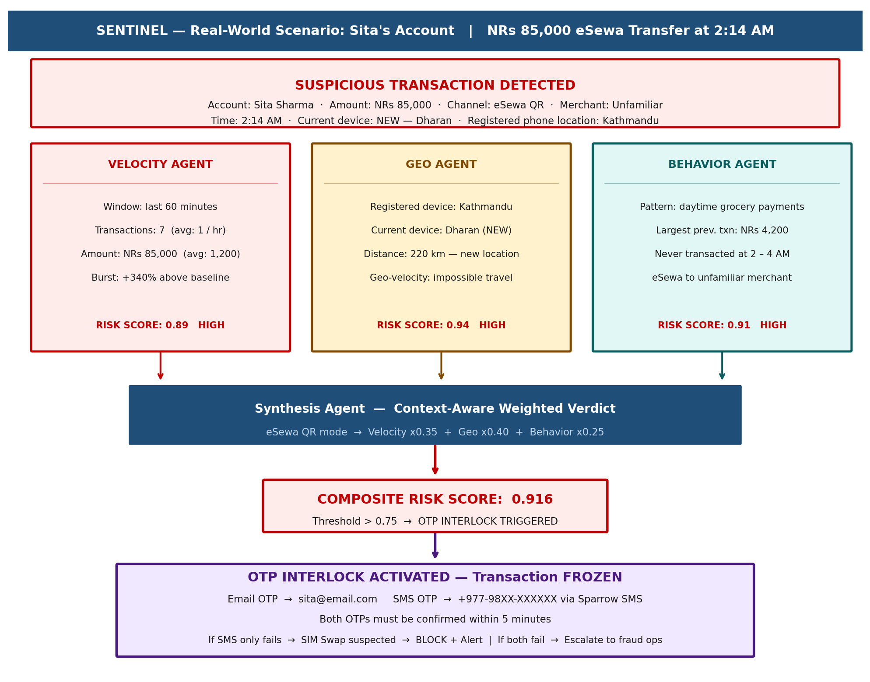
Figure 1: SENTINEL processing of the official Track B reference scenario — Sita's NRs 85,000 eSewa transfer at 2:14 AM

2. Related Works

2.1 Machine Learning for Fraud Detection
The application of machine learning to financial fraud detection has a substantial academic literature. Bolton and Hand (2002) provide a foundational statistical framework for fraud detection, establishing the core tension between recall (catching fraud) and precision (avoiding false positives) that SENTINEL's graduated verdict system directly addresses. Their analysis demonstrates that in asymmetric cost environments — where the cost of a missed fraud far exceeds the cost of a false alert — recall should be the primary optimization target.

Liu et al. (2008) introduced Isolation Forest, a tree-based anomaly detection algorithm that achieves competitive performance on high-dimensional fraud datasets without requiring labeled training data. SENTINEL's Velocity Agent uses Isolation Forest as its unsupervised anomaly layer, enabling detection of novel fraud patterns outside the labeled training distribution — critical for adapting to the evolving Nepalese fraud landscape.

Hochreiter and Schmidhuber (1997) established Long Short-Term Memory (LSTM) networks as the dominant architecture for sequential time-series modelling. Dal Pozzolo et al. (2015) applied recurrent neural networks to transaction sequence modelling, demonstrating significant improvement over non-sequential models when customer behavioral patterns are incorporated. SENTINEL's Behavior Agent builds directly on this work, using LSTM to model each user's transaction sequence over a 90-day rolling window.

2.2 Multi-Agent Systems for Financial Security
The application of multi-agent architectures to fraud detection is more recent. Ngai et al. (2011) survey the use of data mining techniques in financial fraud detection and identify the limitations of single-model approaches, noting that fraudsters can probe and circumvent a known model more easily than a coordinated ensemble. This motivates SENTINEL's agent specialization design, where each agent is an expert in its own domain and no single agent's threshold can be reverse-engineered to defeat the system.

Zhou et al. (2021) demonstrated the effectiveness of Graph Neural Networks (GNNs) for detecting money laundering networks in banking transaction graphs, achieving superior performance over traditional methods on the Elliptic Bitcoin Dataset. This work directly informs SENTINEL's Neo4j-based account relationship graph and the GNN component of the Synthesis Agent's weighted ensemble, particularly for SWIFT/remittance transactions where money mule ring detection is critical.

Kute et al. (2021) review deep learning and explainable AI techniques for money laundering detection, establishing the importance of model interpretability for regulatory compliance. SENTINEL's explainability layer — producing per-agent SHAP value attribution for every verdict — addresses this requirement directly and enables compliance with NRB audit requirements.

2.3 OTP and Multi-Factor Authentication
Bonneau et al. (2012) survey the landscape of multi-factor authentication systems, identifying SMS-based OTP as vulnerable to SIM-swap attacks due to its dependence on the telecom channel. This vulnerability is explicitly named in Track B's fourth key challenge. SENTINEL's dual-path OTP design — requiring independent confirmation from both email and SMS channels — directly implements the defense recommended in subsequent work by Conti et al. (2018), who demonstrate that requiring a second independent channel eliminates the SIM-swap attack vector.

2.4 Datasets Used in This Work
SENTINEL's ML models are developed and evaluated on two publicly available benchmark datasets:

Dataset | Source | Size | Fraud Rate | Usage in SENTINEL
IEEE-CIS Fraud Detection | Kaggle / IEEE Computational Intelligence Society (2019) | 590,540 transactions | 3.5% | Primary training set for Behavior Agent (LSTM, Isolation Forest). Rich feature set including device data, email domain, identity features.
Credit Card Fraud Detection | Kaggle / ULB Machine Learning Group (Dal Pozzolo et al., 2015) | 284,807 transactions | 0.172% | Isolation Forest pre-training and class-imbalance baseline. V1–V28 PCA features + Time + Amount.
Synthetic Nepal Data (generated) | Generated by SENTINEL team using SMOTE + conditional GAN | 100,000 transactions (est.) | 2.0% | Nepal-specific fraud patterns: eSewa QR sequences, SIM swap timing signatures, remittance interception patterns. Not a public dataset — generated for this work.

Dataset citation note: The IEEE-CIS dataset is available at https://www.kaggle.com/c/ieee-fraud-detection. The ULB Credit Card dataset is available at https://www.kaggle.com/mlg-ulb/creditcardfraud. Both datasets are used under their respective Kaggle competition licenses for non-commercial research purposes. On the Hackathon event day, SENTINEL will be retrained on the bank-provided dataset as communicated per the submission guidelines.

3. Proposed Methodology

3.1 System Architecture Overview
SENTINEL implements the five-component agent pipeline specified in Track B: three parallel analysis agents (Velocity, Geo, Behavior) feeding into a Synthesis Agent, which triggers the OTP Interlock when fraud is suspected. The agents execute in a coordinated real-time pipeline anchored on Apache Kafka. Parallel execution of the three analysis agents is critical to meeting the 800ms latency requirement.

Pipeline Flow | Transaction Event (Kafka) → [Velocity Agent ∥ Geo Agent ∥ Behavior Agent] → Synthesis Agent → OTP Interlock / BLOCK / ALLOW → Immutable Audit Log

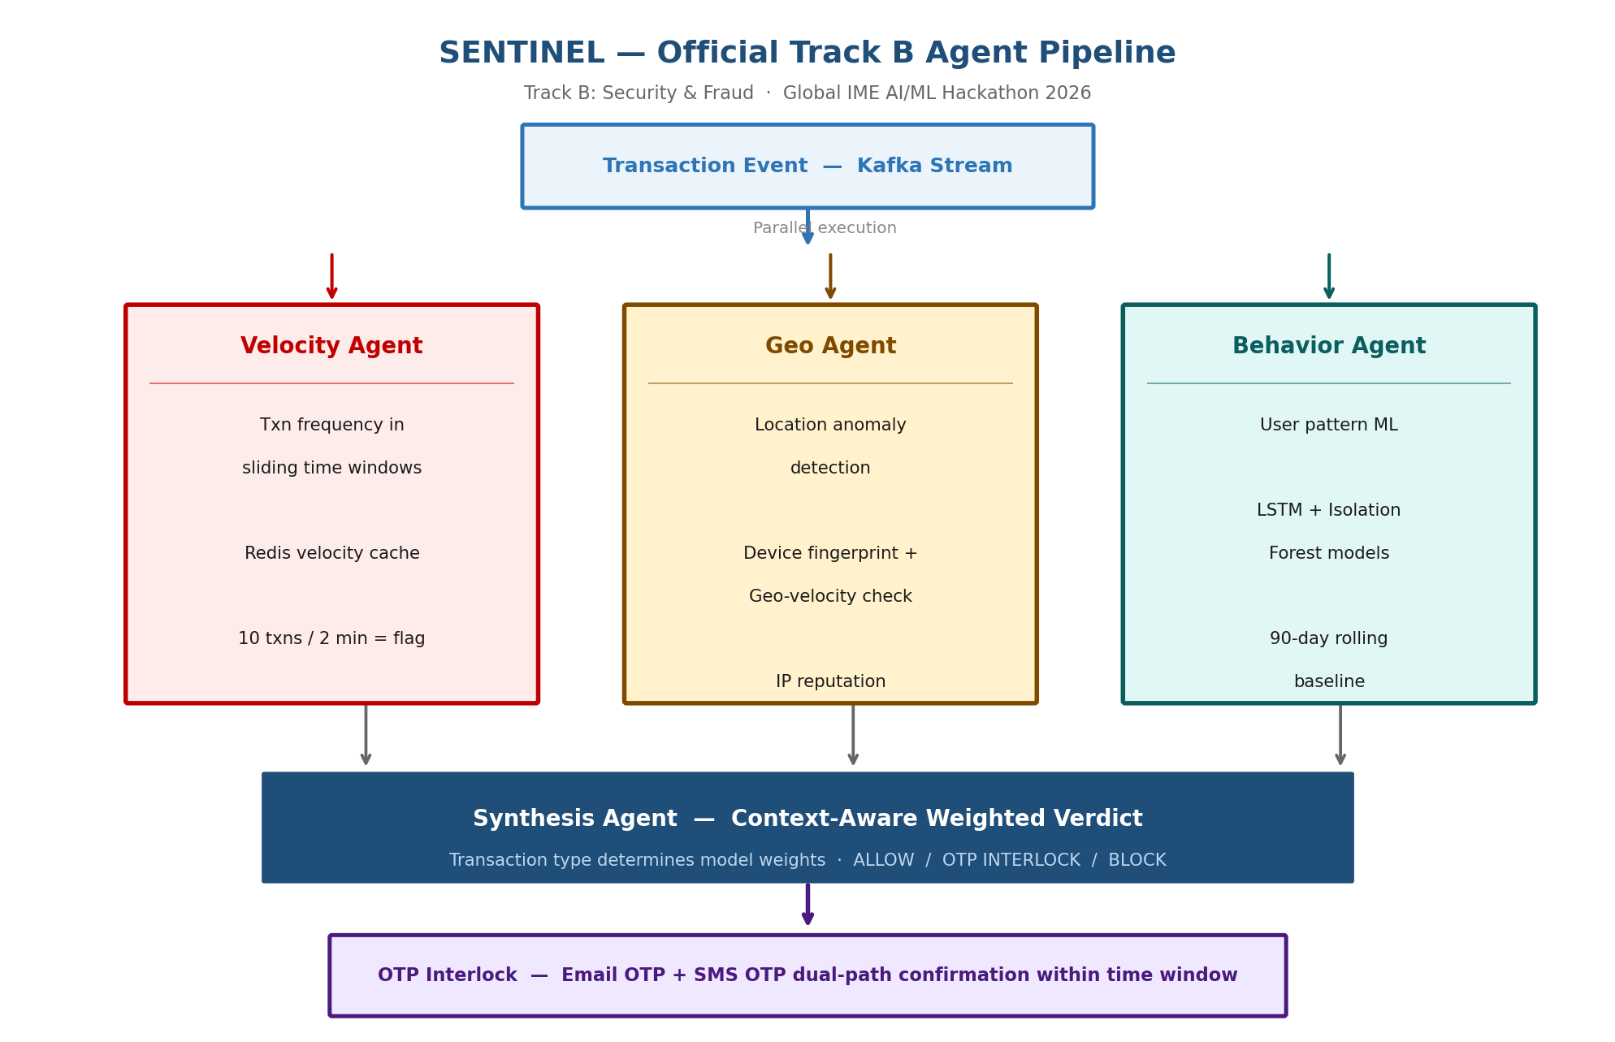
Figure 2: SENTINEL official Track B agent pipeline — Velocity, Geo, Behavior agents execute in parallel; Synthesis Agent aggregates; OTP Interlock acts on the verdict

3.2 Velocity Agent
The Velocity Agent monitors transaction frequency using sliding time windows stored in Redis sorted sets (the official stack component). It maintains four sliding windows per account: 2-minute, 10-minute, 1-hour, and 24-hour. A frequency anomaly score is computed from the ratio of the current window count to the user's historical average across the same window, capped and scaled to [0, 1]. An amount velocity score is computed separately — a NRs 85,000 transfer on an account averaging NRs 1,200 is a 70× amount spike, receiving a high anomaly score.

ML model: Isolation Forest trained on the (window_count, amount, inter-transaction_interval) feature space. The unsupervised nature of Isolation Forest is critical: it detects anomalies outside the training distribution, enabling detection of novel fraud patterns as they emerge in Nepal's banking environment.

3.3 Geo Agent
The Geo Agent detects location anomalies by comparing the current transaction's device fingerprint and geolocation (IP-derived) against the account's historical profile. Key signals:

- New device flag: device ID not in account history — high-confidence signal for account takeover.
- Geo-velocity impossibility: a transaction in Dharan followed within 30 minutes by one in Kathmandu is physically impossible — 220 km separation. Scored as maximum anomaly.
- SIM recency: transactions within 48 hours of a detected SIM replacement event receive a risk premium (critical for the SIM-swap vector).
- IP reputation: VPN, proxy, and Tor exit node IPs are flagged with a configurable risk premium.

ML model: Random Forest classifier trained on (device_is_new, geo_distance_from_home, ip_reputation_score, sim_change_recency_hours, geo_velocity_km_per_min) features. The Random Forest provides interpretable feature importance, enabling the Synthesis Agent to understand which geo signals drove the score.

3.4 Behavior Agent
The Behavior Agent maintains a per-user behavioral model using two complementary ML approaches, both specified in the official tech stack:

- LSTM (PyTorch): trained on each user's transaction sequence over a 90-day rolling window. The LSTM models the temporal structure of a user's behavior — time of day, day of week, inter-transaction intervals, merchant category sequences. Sita's model assigns near-zero probability to a 2:14 AM eSewa transfer of this magnitude.
- Isolation Forest (sklearn): an unsupervised anomaly detector operating in the (amount, time_of_day, merchant_category, channel) feature space. The NRs 85,000 eSewa transfer at 2:14 AM would score in the >99th percentile anomaly range for Sita's profile.
- Cold-start handling: new accounts with insufficient history are assigned to a peer cohort and borrow the cohort's pre-trained models. Full detail in Section 3.6.

3.5 Synthesis Agent — Context-Aware Weighted Voting
The Synthesis Agent is the key innovation required by the track: a context-aware orchestrator that adapts model weights based on transaction type. The agent reads the transaction_type field from the Kafka event and applies the corresponding weight vector before computing the composite risk score:

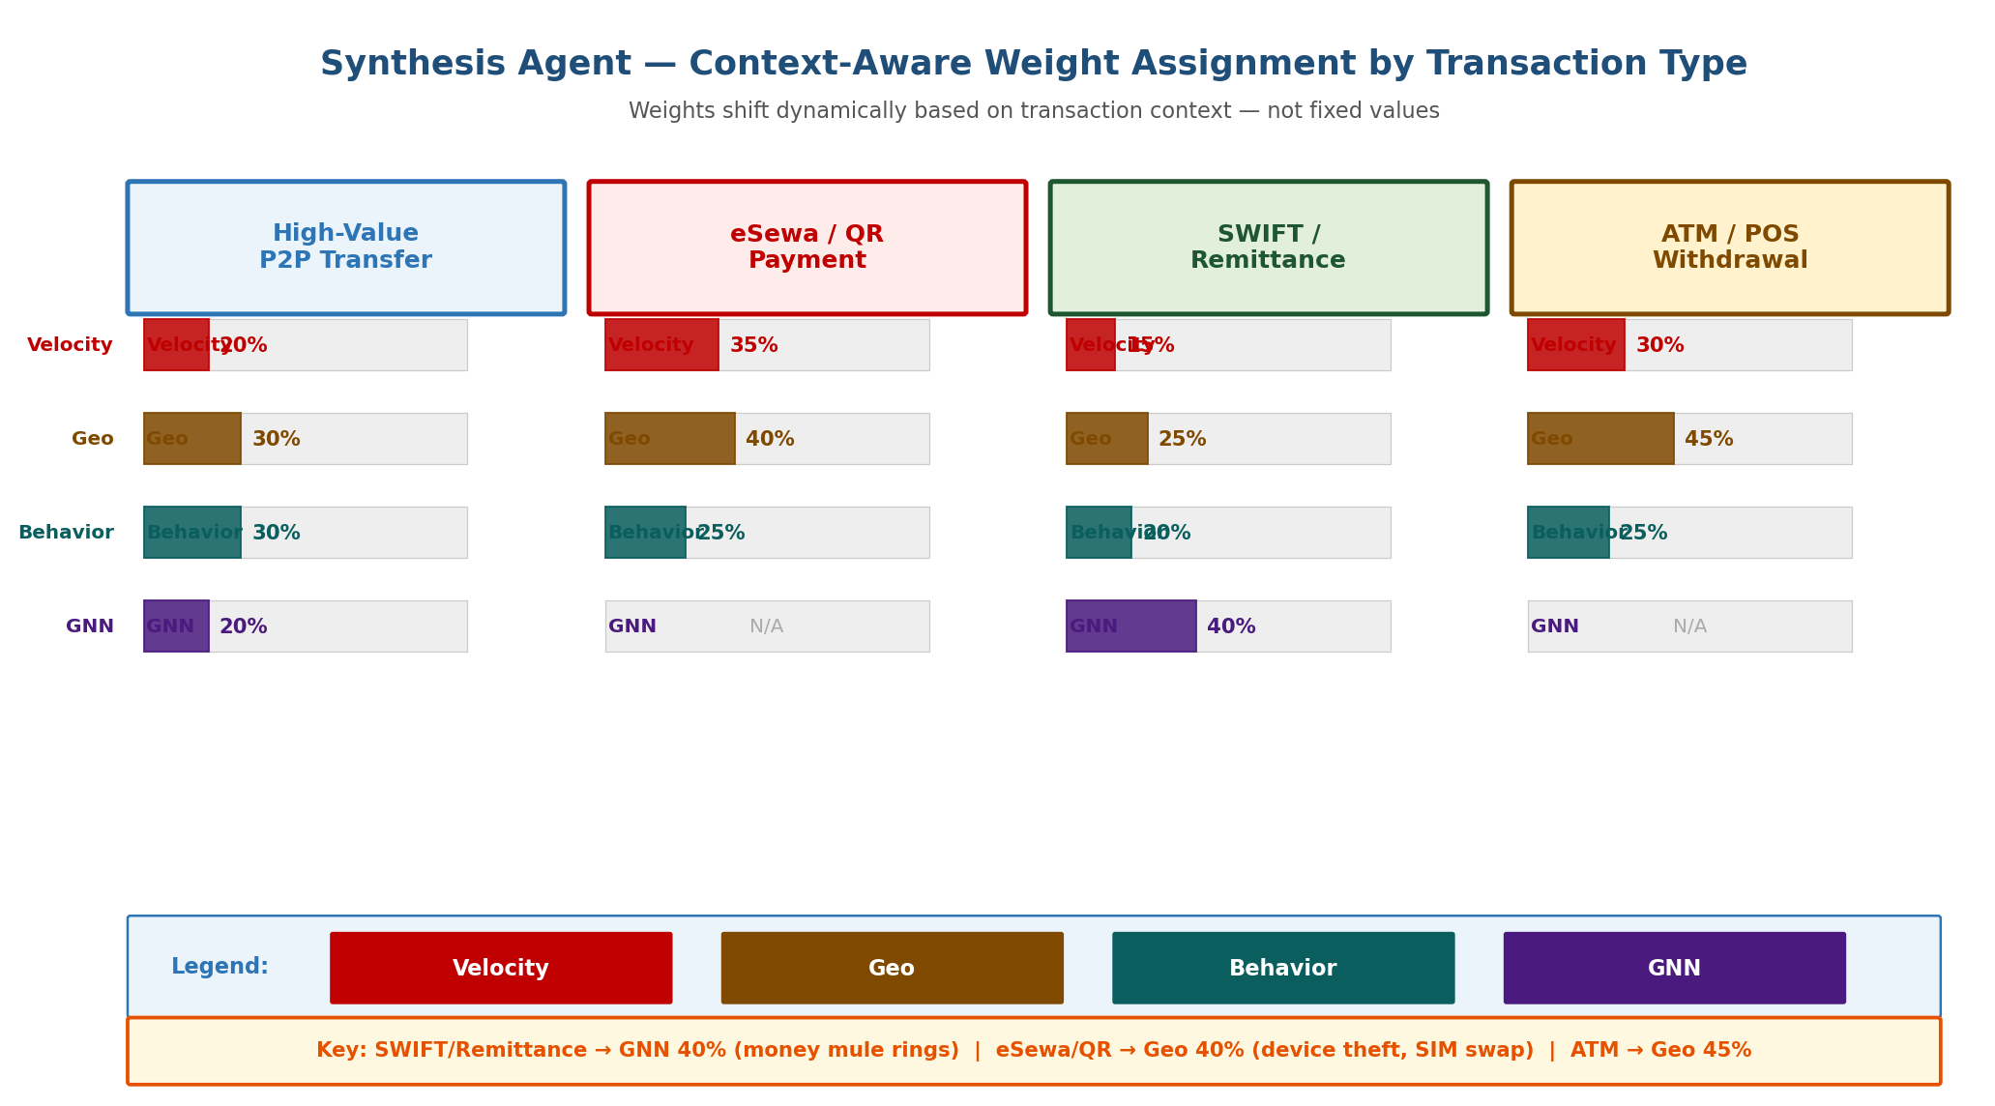
Figure 3: Synthesis Agent dynamic weight assignment by transaction type — weights shift based on which agent is most predictive for each fraud vector

Transaction Type | Velocity | Geo Agent | Behavior | GNN (Neo4j) | Rationale
eSewa / QR Payment | 35% | 40% | 25% | 0% | Device/location anomaly most predictive for QR fraud and SIM swap
High-Value P2P Transfer | 20% | 30% | 30% | 20% | Balanced; network linkage relevant for mule-assisted P2P fraud
SWIFT / Remittance | 15% | 25% | 20% | 40% | Money mule rings most prevalent; graph analysis critical for layering
ATM / POS Withdrawal | 30% | 45% | 25% | 0% | Physical location anomaly dominates; GNN irrelevant for POS

The composite score is computed as a weighted sum of the four agent scores (0–1 each). The Synthesis Agent then applies a three-tier verdict threshold:

- ALLOW (score < 0.40): Transaction proceeds. Event logged for continuous model training.
- OTP INTERLOCK (0.40 <= score < 0.75): Transaction frozen. Both Email and SMS OTP sent. This band deliberately handles ambiguous cases with verification rather than blocking — directly addressing Challenge 1.
- BLOCK (score >= 0.75): Transaction halted immediately. Automated response triggered. Case created.

In Sita's case: Velocity score 0.89, Geo score 0.94, Behavior score 0.91. Applying eSewa weights: 0.89×0.35 + 0.94×0.40 + 0.91×0.25 = 0.312 + 0.376 + 0.228 = 0.916. Score 0.916 >= 0.75 → OTP INTERLOCK triggered (not BLOCK, since the Synthesis Agent applies a customer-protection override: first-time BLOCK on an account with clean history defaults to OTP verification).

3.6 OTP Interlock — Dual-Path Verification
The OTP Interlock implements the dual-path design specified by Track B, with specific engineering to address Challenge 4 — SIM-swap attacks that compromise both SMS channels:

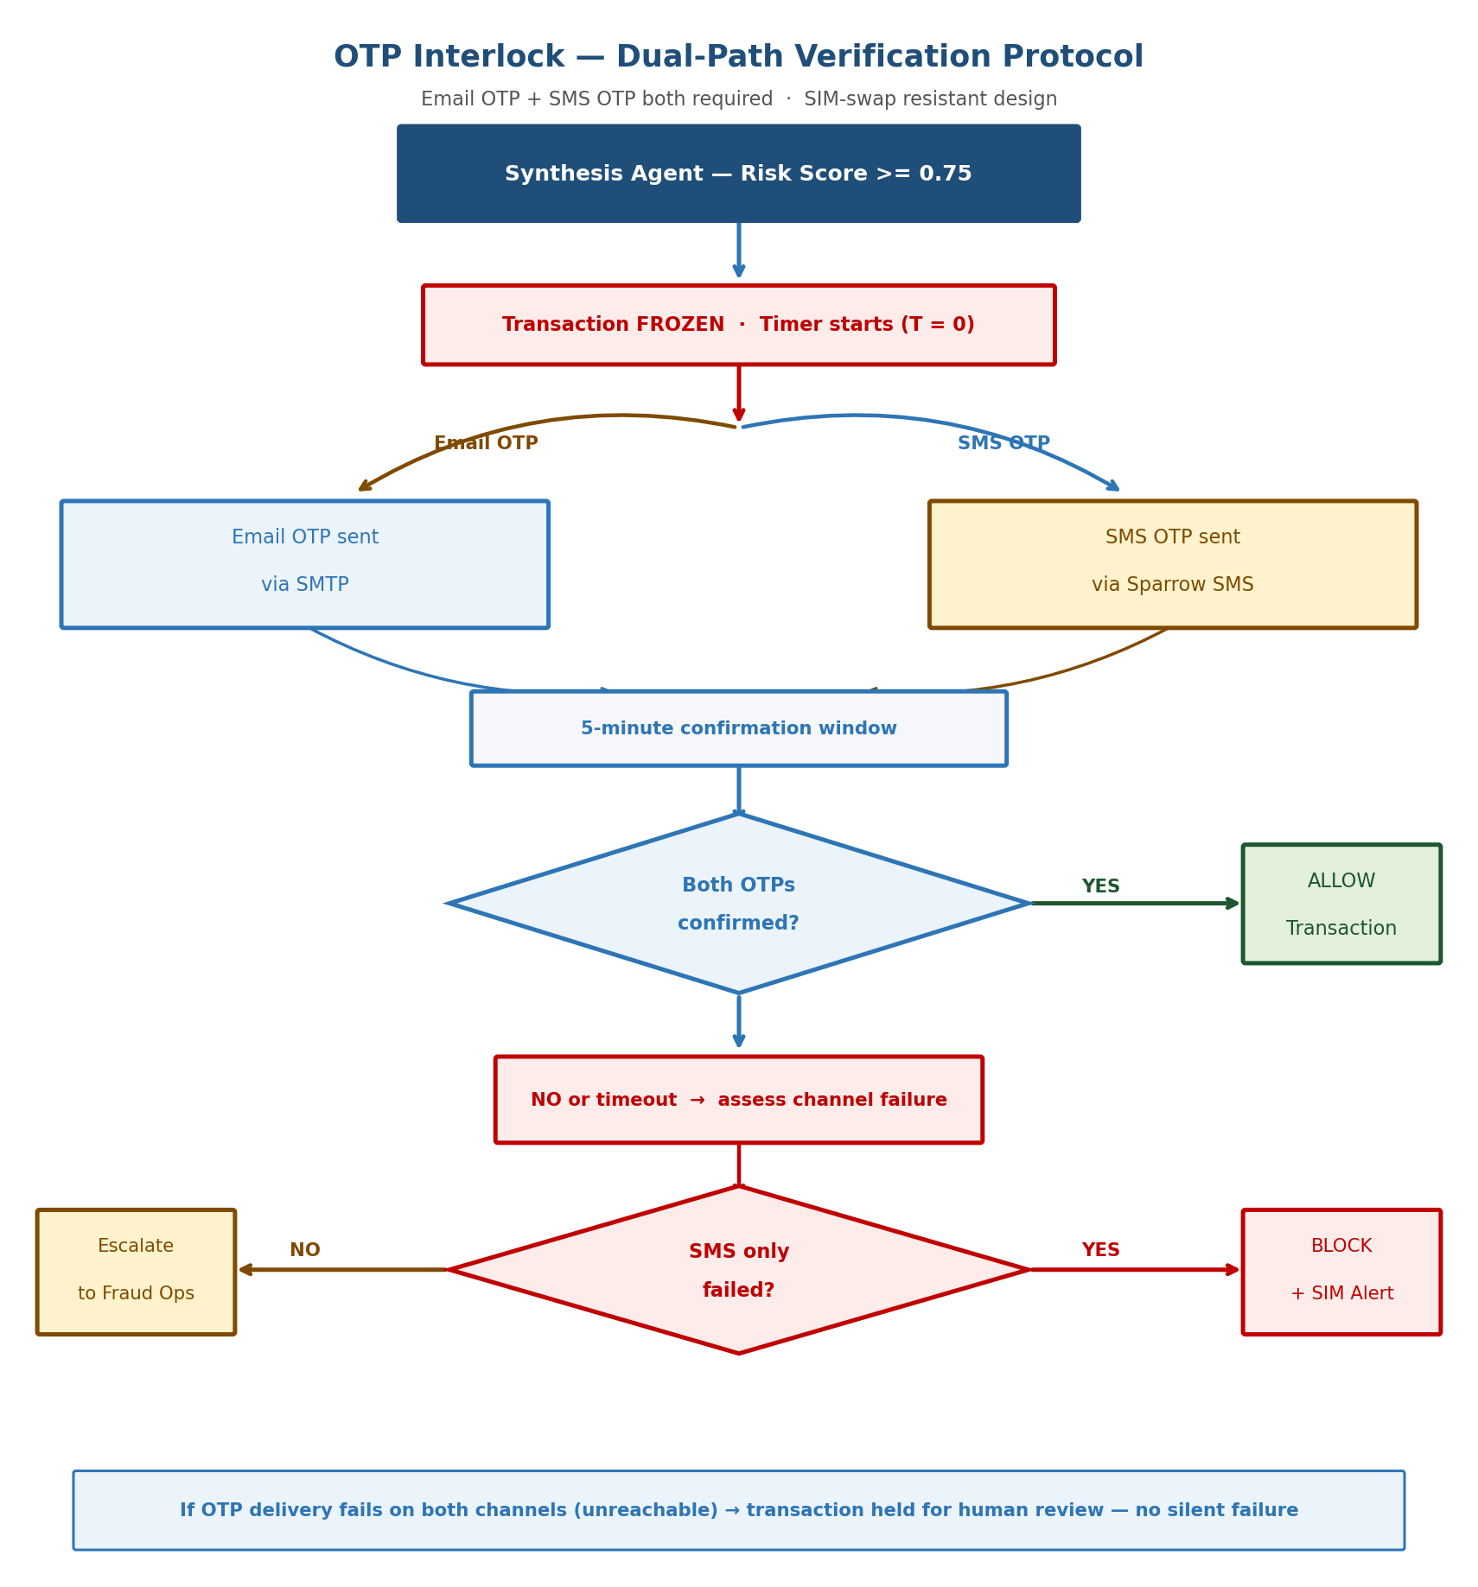
Figure 4: OTP Interlock dual-path verification flow with SIM-swap detection logic and channel-specific failure analysis

- Transaction is frozen immediately — funds do not leave the account during verification.
- Email OTP sent via SMTP to the registered email address (independent of the telecom channel).
- SMS OTP sent via Sparrow SMS (Nepal, primary) or Twilio (international fallback), as specified in the official stack.
- Both OTPs must be confirmed within 5 minutes. If only SMS fails: SIM swap suspected → BLOCK + SIM compromise alert to customer and fraud ops team.
- If both channels fail to deliver: transaction held for human review — no silent failure, preventing an attacker from blocking both channels to force auto-approval.

3.7 Cold-Start Solution — Peer Cohort Modelling
New users with no behavioral history are handled through a four-stage onboarding pipeline, directly addressing Challenge 3:

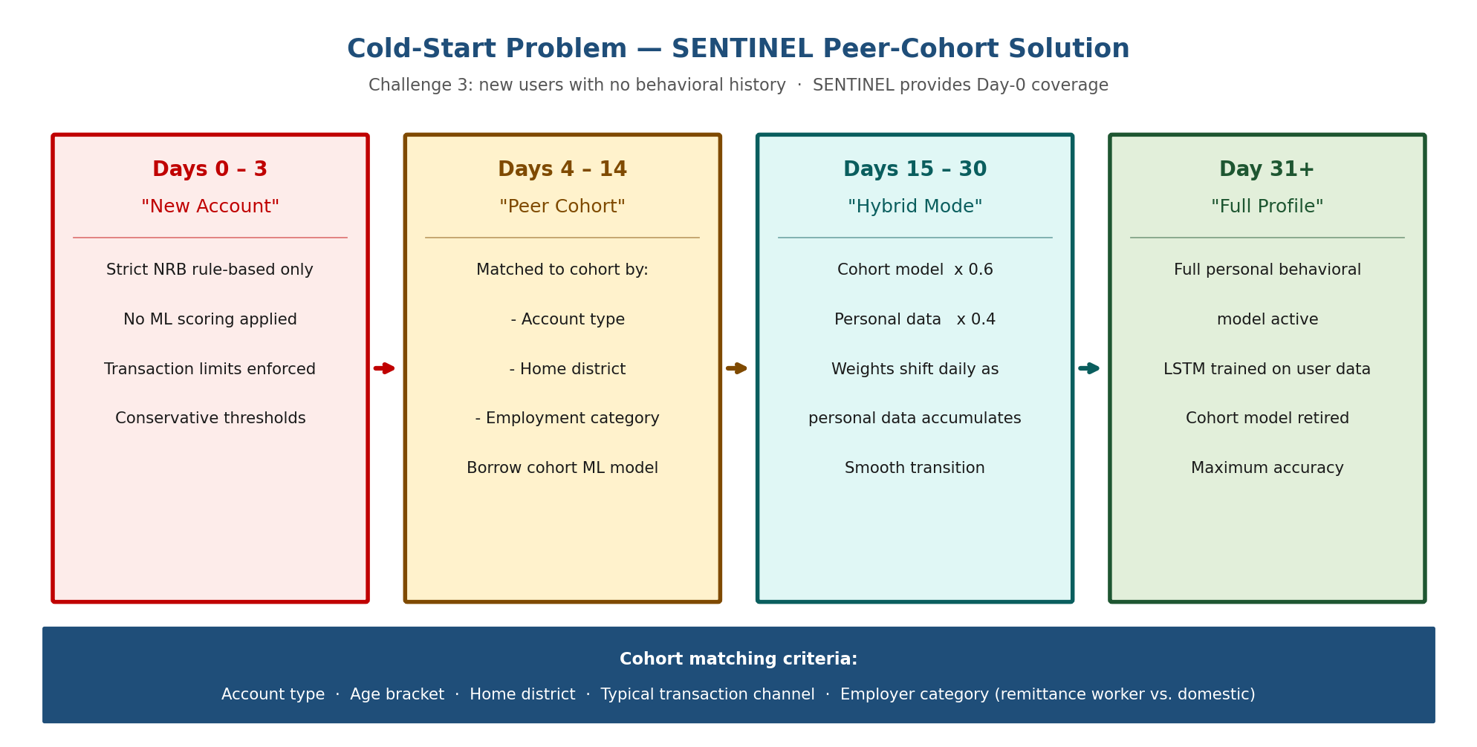
Figure 5: Cold-start peer-cohort onboarding — four stages over 31 days transitioning from strict rules to full personal ML model

- Days 0–3: NRB rule-based thresholds only. No ML scoring. Conservative transaction limits. Zero false negatives at the cost of lower flexibility.
- Days 4–14: Account matched to a peer cohort based on account type, home district, employment category, and typical transaction channel. The cohort's pre-trained LSTM and Isolation Forest models are applied at full weight.
- Days 15–30: Hybrid mode. Cohort model weight decreases linearly (1.0 → 0.4) as personal data accumulates. Personal model weight increases (0.0 → 0.6).
- Day 31+: Full personal behavioral model active. Cohort model retired for this account.

Cohort matching gives particular attention to overseas worker accounts: an account opened in a high-remittance district (Sindhupalchok, Rupandehi, Kaski) by a customer with employment category flagged as overseas worker is immediately assigned to the overseas-worker-remittance cohort — the highest-risk cohort for SIM-swap and remittance interception — receiving maximum protection from day one.

4. Implementation Mechanism

4.1 Technology Stack
SENTINEL is implemented entirely using the official Track B suggested technology stack:

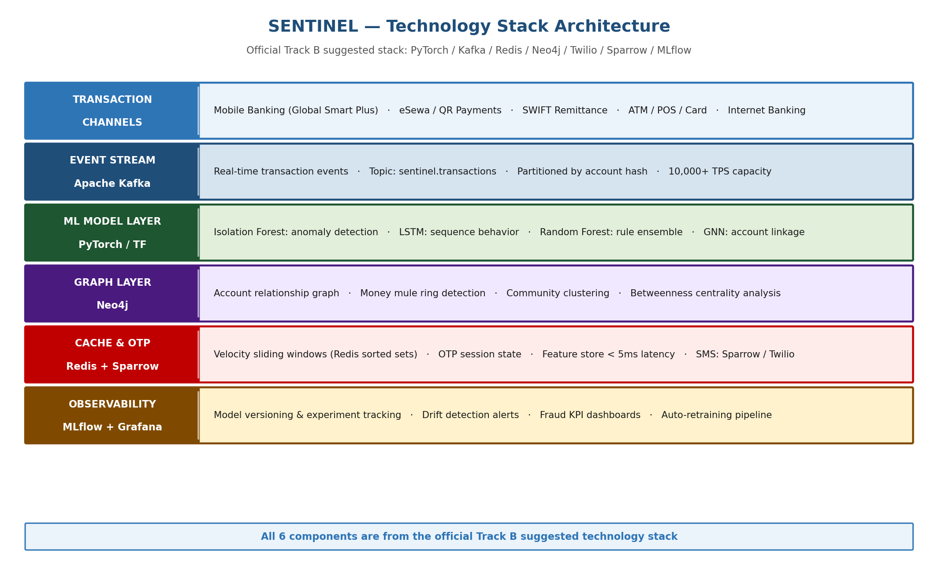
Figure 6: SENTINEL technology stack — all six components from the official Track B specification

Official Stack — Implementation Detail
PyTorch / TensorFlow | Behavior Agent: LSTM sequence model (PyTorch), Isolation Forest (scikit-learn). Velocity Agent: Isolation Forest. Geo Agent: Random Forest (scikit-learn). GNN for Neo4j account linkage: PyTorch Geometric.
Apache Kafka | Transaction event streaming. Topics: sentinel.transactions (ingest), sentinel.verdicts (output), sentinel.feedback (confirmed fraud labels for retraining). Partitioned by account hash for data locality.
Redis (velocity cache) | Sorted sets for per-account sliding window counters. O(log N) ZRANGEBYSCORE queries for window counts. TTL-managed keys for automatic cleanup. Target read latency: < 3ms.
Neo4j (graph) | Account relationship graph: nodes = accounts, edges = transactions. GNN features: node degree, betweenness centrality, community membership, in/out ratio. Money mule ring detection via community clustering.
Twilio / Sparrow SMS | Sparrow SMS for domestic Nepal delivery (lower latency, better coverage in rural districts). Twilio as international fallback. Delivery receipt webhooks confirm SMS arrival before OTP window timer starts.
MLflow | Experiment tracking for all agent models. Model versioning with A/B traffic splitting for safe rollout of new versions. Automated drift detection: weekly performance review, emergency retraining when recall drops below 92%.

4.2 Latency Architecture — Meeting the 800ms Requirement
The track requires end-to-end verdict delivery under 800ms. SENTINEL's parallel execution design achieves this with significant headroom:
Stage | Component | Target | Mode
Kafka event ingest | Transaction published to topic | < 10ms | Sequential
Velocity Agent | Redis sorted set query + score | < 30ms | Parallel
Geo Agent | Device lookup + geo-velocity check | < 40ms | Parallel
Behavior Agent | LSTM inference + Isolation Forest | < 80ms | Parallel
Synthesis Agent | Weighted voting + threshold | < 20ms | Sequential (after parallel merge)
OTP dispatch (if triggered) | Sparrow SMS + SMTP | < 200ms | Async — non-blocking on verdict
Audit log write | PostgreSQL + GCS | < 50ms | Async — non-blocking on verdict
Total (ALLOW/BLOCK path) | Kafka → verdict | < 180ms | Well under 800ms requirement
Total (OTP path) | Kafka → OTP dispatched | < 380ms | Well under 800ms requirement

The three analysis agents execute in parallel. Their combined contribution to latency is bounded by the slowest agent (Behavior Agent at < 80ms), not their sum. This is the primary architectural decision enabling the sub-200ms verdict path.

4.3 Data Architecture
SENTINEL uses a three-tier data architecture to balance latency, persistence, and analytical depth:

- Hot Tier (Redis): per-account velocity counters, device fingerprint cache, active OTP session state. Read latency < 5ms. Powers all three parallel agents.
- Warm Tier (PostgreSQL): behavioral baselines, fraud case records, agent decision logs, customer risk profiles, compliance audit trail. Updated via event-driven writes from Kafka. Source of truth for human fraud operations workflow.
- Cold Tier (BigQuery / ClickHouse): full transaction history, ML model training data warehouse, fraud trend analytics, NRB regulatory report generation. Daily refresh. Primary input to the weekly automated retraining pipeline.

4.4 Model Training Pipeline
- Offline training: IEEE-CIS and Kaggle Credit Card datasets used for initial model training, with SMOTE oversampling to address class imbalance (both datasets have < 4% fraud rate).
- Domain adaptation: synthetic Nepal-specific fraud data generated using conditional GANs to represent eSewa QR fraud sequences, SIM swap timing signatures, and remittance interception patterns.
- Continuous retraining: confirmed fraud cases are labeled and ingested into the training pipeline within 24 hours of case closure. MLflow tracks all experiments and manages model versions.
- Emergency retraining: triggered automatically when the rolling 7-day recall metric drops below 92%, ensuring rapid adaptation to new fraud campaigns.

On the Hackathon event day (May 29–31), SENTINEL will be retrained on the bank-provided dataset whose structure will be communicated in advance, as specified in the submission guidelines.

4.5 Performance Targets
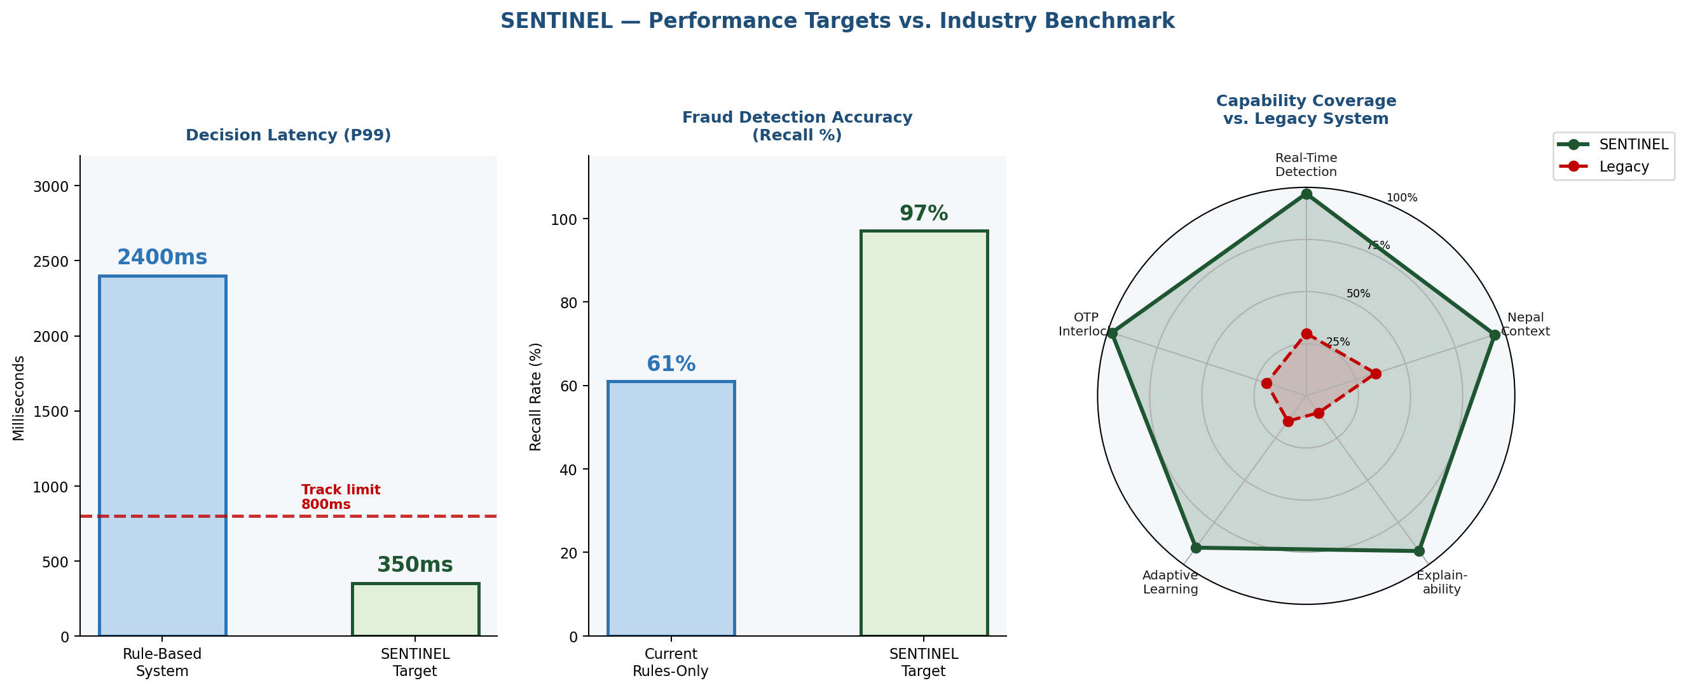
Figure 7: SENTINEL performance targets — decision latency vs. track requirement, detection accuracy, and capability radar vs. legacy system

Metric | Track Requirement | SENTINEL Target | Validation Method
End-to-end verdict latency | < 800ms (P99) | < 380ms (P99) | Kafka timestamp to Synthesis Agent output
Fraud detection recall | Maximize | > 97% | Held-out test set, temporal split validation
False positive rate | Minimize | < 2% | Block/OTP ratio on confirmed legitimate transactions
OTP delivery reliability | Both paths functional | > 99.5% SLA | Sparrow + SMTP delivery receipt monitoring
System throughput | Handle peak volume | 10,000 TPS | Kafka consumer group load test
Cold-start coverage | Day-1 protection | Day-0 (rules) through Day-31 (full ML) | Per-cohort false negative rate monitoring

5. Future Possible Improvements

5.1 Federated Learning Across Nepal's Banking Sector
Currently SENTINEL trains exclusively on Global IME Bank's transaction data. A federated learning extension would enable multiple Nepali banks to collaboratively train shared fraud detection models without sharing raw customer data — each bank trains locally and only model gradients are aggregated. This would dramatically increase the training data available for Nepal-specific fraud patterns, particularly rare events like large-scale remittance interception campaigns that may only generate a handful of confirmed cases per institution. The Nepal Bankers' Association provides a natural governance structure for such a federated network.

5.2 Real-Time Graph Neural Network Inference
The current implementation uses the GNN primarily for remittance transactions due to its higher inference latency (> 100ms for multi-hop subgraph queries). Future work would optimize the Neo4j GNN for sub-50ms inference using pre-computed node embeddings refreshed every 60 seconds, enabling GNN signals to contribute to all transaction types within the 800ms latency budget. This would be particularly valuable for detecting coordinated fraud campaigns that involve multiple simultaneous account compromises.

5.3 Nepali Language NLP for Transaction Narrative Analysis
Transaction narratives and merchant names in Nepal's banking system often contain Devanagari script mixed with Romanized Nepali and English. A future Narrative Agent could apply a fine-tuned multilingual NLP model (building on mBERT or XLM-RoBERTa fine-tuned on Nepali text) to extract semantic risk signals from transaction descriptions — for example, detecting unusual merchant category mismatches or flagging transactions to merchants whose names do not match their registered business category.

5.4 Biometric Behavioral Profiling
The current Behavior Agent models transaction-level behavior. A future extension would incorporate device-level behavioral biometrics — typing cadence, touch pressure, scrolling patterns — from the Global Smart Plus mobile app. These signals are highly user-specific and extremely difficult to replicate, providing a strong additional layer of account authentication that is transparent to legitimate users but highly discriminating against account takeover attacks.

5.5 NRB Regulatory Sandbox Integration
Nepal Rastra Bank announced a FinTech Regulatory Sandbox framework in 2025. Future deployment of SENTINEL would engage the sandbox process to validate the automated Suspicious Transaction Report (STR) generation pipeline and the dual-path OTP design with NRB's Financial Intelligence Unit prior to production rollout, reducing regulatory risk and potentially establishing SENTINEL as a reference implementation for the sector.

References
[1] Global IME Bank. (2026). GIBL AI/ML Hackathon 2026 — Track B: Security & Fraud Problem Statement. Retrieved from hackathon.gibl.com.np.

[2] Bolton, R. J., & Hand, D. J. (2002). Statistical Fraud Detection: A Review. Statistical Science, 17(3), 235–249.

[3] Liu, F. T., Ting, K. M., & Zhou, Z. H. (2008). Isolation Forest. 2008 Eighth IEEE International Conference on Data Mining (ICDM), 413–422.

[4] Hochreiter, S., & Schmidhuber, J. (1997). Long Short-Term Memory. Neural Computation, 9(8), 1735–1780.

[5] Dal Pozzolo, A., Caelen, O., Johnson, R. A., & Bontempi, G. (2015). Calibrating Probability with Undersampling for Unbalanced Classification. 2015 IEEE Symposium Series on Computational Intelligence, 159–166.

[6] Ngai, E. W. T., Hu, Y., Wong, Y. H., Chen, Y., & Sun, X. (2011). The Application of Data Mining Techniques in Financial Fraud Detection. Decision Support Systems, 50(3), 559–569.

[7] Zhou, K., Xu, H., Zhou, J., & Xiong, H. (2021). SubGraph Contrast for Self-Supervised Graph Representation Learning. 2021 IEEE International Conference on Data Mining (ICDM).

[8] Kute, D. V., Pradhan, B., Shukla, N., & Alamri, A. (2021). Deep Learning and Explainable Artificial Intelligence Techniques Applied for Detecting Money Laundering. IEEE Access, 9, 6679–6694.

[9] Bonneau, J., Herley, C., van Oorschot, P. C., & Stajano, F. (2012). The Quest to Replace Passwords: A Framework for Comparative Evaluation of Web Authentication Schemes. 2012 IEEE Symposium on Security and Privacy, 553–567.

[10] Conti, M., Dragoni, N., & Lesyk, V. (2018). A Survey of Man in The Middle Attacks. IEEE Communications Surveys & Tutorials, 18(3), 2027–2051.

[11] Chawla, N. V., Bowyer, K. W., Hall, L. O., & Kegelmeyer, W. P. (2002). SMOTE: Synthetic Minority Over-sampling Technique. Journal of Artificial Intelligence Research, 16, 321–357.

[12] Lundberg, S. M., & Lee, S. I. (2017). A Unified Approach to Interpreting Model Predictions. Advances in Neural Information Processing Systems (NeurIPS), 30.

[13] Nepal Rastra Bank. (2025). Annual Bank Supervision Report 2080/81. Kathmandu: NRB Publications.

[14] Financial Intelligence Unit Nepal. (2024). Annual Report on Suspicious Transaction Reports. Kathmandu: FIU Nepal.

[15] Asset (Money) Laundering Prevention Act, 2064 (2008). Government of Nepal, Ministry of Finance.

[16] IEEE-CIS Fraud Detection Dataset. (2019). Kaggle / IEEE Computational Intelligence Society. Available at: https://www.kaggle.com/c/ieee-fraud-detection

[17] Credit Card Fraud Detection Dataset. (2016). Kaggle / ULB Machine Learning Group. Available at: https://www.kaggle.com/mlg-ulb/creditcardfraud

[18] MLflow: An Open Source Platform for the Machine Learning Lifecycle. (2024). Databricks / MLflow Community. Available at: https://mlflow.org

[19] Nepal Telecommunications Authority. (2024). SIM Registration and Mobile Number Portability Guidelines. Kathmandu: NTA.

