Adventurers of the Uncharted v1
Yet another minimal way to play Old-School RPGs

Table of Contents
What is this? 1
Build a PC 2
1. Choose a Species 2
2. Choose a Class 2
3. Roll for Hit Points 2
4. Roll for or Choose a Background 2
5. Roll for or Choose a Feat 2
6. Choose an Armor 2
7. Choose your Weapons 3
8. Number of Attacks 3
9. Purchase Equipment 3
10. Languages 3
11. Choose a Name and Description 3
Adventuring 4
Advantage and Disadvantage 4
Stealth & Stunts 4
Saving throws and Skill checks 4
Dangers 4
Light 4
Time 4
Movement 4
Encounters 5
1. Surprise 5
2. Initiative 5
3. Diplomacy 5
4. Attack 5
5. Damage 5
6. Morale 5
7. Rest and bandages 5
Experience 5
Magic 6
Turn Undead 6
Casting Spells 6
Cleric Spell List 6
Wizard Spell List 7

What is this?

I started off consolidating Searchers of the Unknown and the various additions people had made for it. Overtime I kept tweaking it and it eventually turned into something that I no longer feel comfortable calling a version of Searchers of the Unknown. So this is Adventurers of the Uncharted. A minimalist fantasy adventure game in the old-school style (with some modern stuff taped on). Have fun!
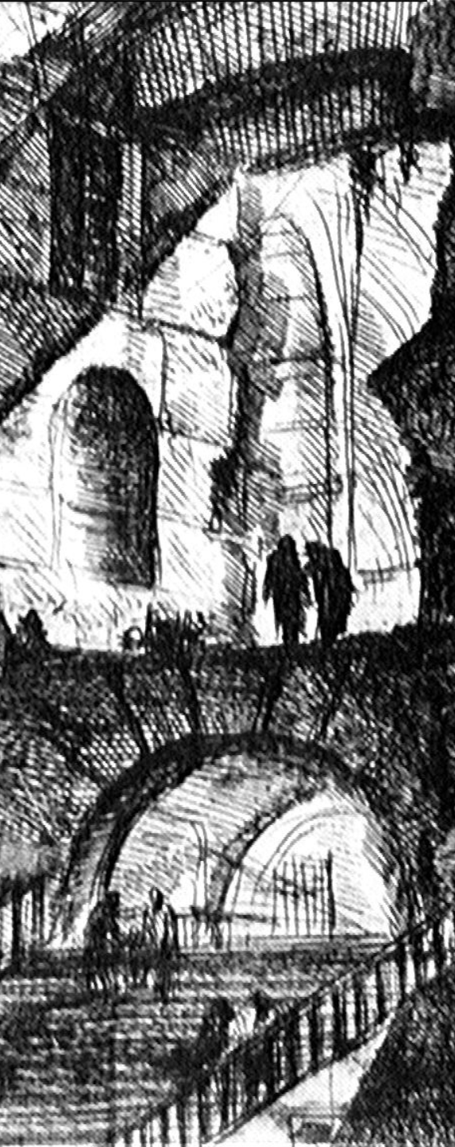

Build a PC

1. Choose a Species
 | Dwarves | Short, cunning, and see well in dim light.
 | Elves | Slim, wise, and see well in dim light.
 | Halflings | Small, nimble, and stealthy.
 | Humans | Tall, proud, and quick learners.

2. Choose a Class
 |  |  | Hit Dice (HD)
 | Clerics | Powerful, devout, and cast magic spells. | 1d6
 | Fighters | Strong, athletic, and superior in combat. | 1d8
 | Thieves | Quick, subtle, and deadly in stealth. | 1d6
 | Wizards | Uncanny, shrewd, and cast magic spells. | 1d4

3. Roll for Hit Points
Use the Hit Dice (HD) for your class. So, 1d6 for a Cleric starting at level 1, 1d8 for a Fighter, etc.

4. Roll for or Choose a Background
The DM may allow you to make checks related to this background at advantage.
d8 | Background
1 | Blacksmith
2 | Farmer
3 | Hunter
4 | Miner
5 | Mason
6 | Sailor
7 | Tailor
8 | Woodcutter
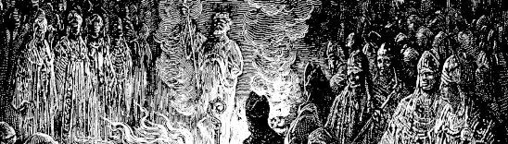

5. Roll for or Choose a Feat
A feat represents a unique characteristic that separates you from others. Each feat has an effect that benefits your character. Each character only has one feat.
d8 | Feat | Effect
1 | Animal Handling | You have advantage on skill checks when dealing with domesticated animals.
2 | Avenger | You have advantage on attack rolls on monsters who have dropped one of your allies to 0 hp.
3 | Berserker | You have advantage on attack rolls when you are reduced to 1 hp.
4 | Light sleeper | You may make a skill check at disadvantage to notice approaching monsters while sleeping.
5 | Linguist | You know 2 additional languages of your choosing.
6 | Mountaineer | You have advantage on stunt checks to climb sheer surfaces.
7 | Navigator | You have advantage on skill checks to find your way when lost.
8 | Survivor | You have advantage on saving throws related to extreme weather.

6. Choose an Armor
This determines your PC’s armor class (AC), movement rate (MV), and encounter movement rate (EM).
 | Clerics | Can wear any armor.
 | Fighters | Can wear any armor.
 | Thieves | Can wear leather armor.
 | Wizards | May not cast spells while wearing armor or using shields.
 | Dwarves | Have a maximum MV of 90 and a maximum EM of 30 even when wearing no armor.
 | Halflings | Have a maximum MV of 90 and a maximum EM of 30 even when wearing no armor.

Armor | AC | MV | EM
No armor | 10 | 120’ | 40’
Leather armor | 12 | 90’ | 30’
Chainmail | 14 | 60’ | 20’
Plate mail | 16 | 30’ | 10’
Shield | +1 | -10’ | --

7. Choose your Weapons
 | Clerics | Choose two weapons, or one weapon and a shield. May use only a sling, mace, or hammer.
 | Fighters | Choose three weapons, or two weapons and a shield. May use any weapon.
 | Thieves | Choose two weapons, or one weapon and a shield. May use only a bow, dagger, sling, or sword.
 | Wizards | Choose two weapons. May use only a dagger, sling, or staff (2 handed weapon that deals 1d6 damage).
 | Dwarves | Cannot use two handed weapons or longbows.
 | Elves | Can use 1-handed swords and bows regardless of class but must have one hand free when casting.
 | Halflings | Cannot use two handed weapons or longbows.

Weapon | Description | D
Small weapons | Easily concealable (dagger, sling, ...) | 1d4
Range weapons | Bow, crossbow... | 1d6
Melee weapons | Mace, sword, hammer,... | 1d8
2-handed weapons | 2-Handed sword, polearm, ... | 1d10
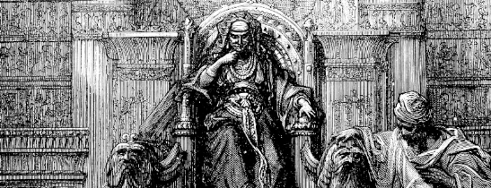

8. Number of Attacks
(AT) is 1 at start. Depending on your class the number of attacks per round goes up as you level. In addition when certain classes kill a monster they may immediately may another attack on a number of monsters depending on their class. This is called a Cleave attack.
 |  | AT | Cleave
 | Clerics | 1 per round | Equal to half your level, rounded down.
 | Fighters | Rises to 2 at level 5,  3 at level 9, and so on | Equal to your level
 | Thieves | 1 per round | Equal to half your level, rounded down.
 | Wizards | 1 per round | 0

9. Purchase Equipment
Roll 1d6 and multiply that by 10. That is your starting gold pieces (gp). Use that to buy equipment from the table below.
Equipment | GP
Backpack | 5
Flask of Oil | 2
Flint & Steel | 3
Hammer (Small) | 2
Holy Symbol | 25
Holy Water, Vial | 25
Iron Spikes (12) | 1
Lantern | 10
Mirror (small) | 5
Pole, 10’ | 1
Rations, 1 Person/Week | 5
Rope, 50’ | 1
Sack | 1
Thieves Tools | 25
Torches (6) | 1
Waterskin | 1

10. Languages
In addition to common, you know various languages depending on your race.
 | Dwarves | Can speak Dwarf, Common, Gnomish, Goblin, Orcish, and Kobold.
 | Elves | Can speak Common, Elvish, Gnoll, Hobgoblin, and Orcish.
 | Halflings | Can speak Dwarf, Elf, Common, Gnomish, Goblin, Orcish, and Kobold.
 | Humans | Can speak Common and two other languages of their choosing.

11. Choose a Name and Description
Imagine what they were before becoming an adventurer. Your PC is ready.

Example of character sheet: Wayland the Elf Fighter (AC 14 MV 60 HD 3 hp 14 #AT 1 D 1d10 with a voulgue). Languages: Common, Elvish, Gnoll, Hobgoblin, and Orcish. Equipment: Backpack, 2 Rations, Rope, 2 Waterskin.

Adventuring

Advantage and Disadvantage
If a rule calls for advantage or disadvantage then 2d20 is rolled. If there is advantage then the higher of the two numbers is used. If there is disadvantage then the lower of the two numbers is used. The GM can also decide if a character or monster has advantage or disadvantage based on the circumstances.

Stealth & Stunts
Sneaking a monster, hiding in shadows, moving silently, picking locks, climbing, or swimming are easier with a lighter armor. For each such an action, roll 1d20 over the character’s AC - level. So a 4th level adventurer with a leather armor and a shield must roll 9 or higher to climb a cliff.
 | Thieves | Thieves make stealth checks with advantage.
 | Halflings | Sneak up on monsters and hide in shadows with advantage.
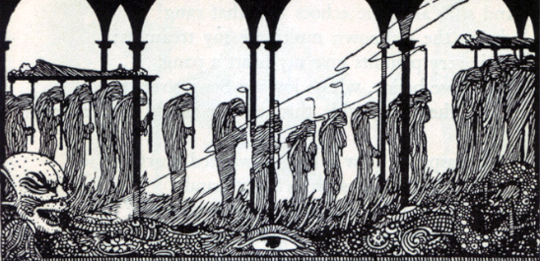

Saving throws and Skill checks
When such a roll is needed for any reason, roll 1d20 + the character’s level. If the result is over 15 you succeed. This saving throw rule applies to every other action which isn’t covered by the “stealth & stunts” rule, but fits the common adventurer’s skills like searching for secrets doors. Failed skill checks may be made again but take twice as long and may draw unwanted attention.
 | Dwarves | - Make saving throws against magic and poison with advantage.  - Note slanting passages, traps, shifting walls and new construction underground with advantage.
 | Halflings | Make saving throws against magic and poison with advantage.

Dangers
If something could kill a man, like a fall, a fire or a trap, it does 1d8 points of damage. If it could kill a horse, 2d8. If it could kill an ogre, 4d8. Etc.

Light
Torches give off a 30’ radius of light. Some species have darkvision allowing them to see up to 60’ in the dark. Monsters are assumed to have darkvision as well in most cases. Creatures that can not see their target have disadvantage to hit.
 | Dwarves | Darkvision
 | Elves | Darkvision
 | Halflings | Normal vision
 | Humans | Normal vision

Time
While adventuring time is measured in turns of 10 minutes. During encounters time is measured in rounds of 10 seconds.

Movement
While adventuring movement is measured in feet per turn (10 minutes). This is the MV column on the armor table. So an unarmored character can move 120’ per turn. Adventuring movement assumes a slower exploration pace is being used to map, move quietly, and navigate dark conditions. During an encounter the Encounter Movement (EM) is used. So an unarmored adventurer can move 40’ per round. Encounter moment assumes the character is moving in short bursts of sprinting. Shields reduce MV by the amount given on the armor table. Characters attempting to stealth during encounters move at half speed.
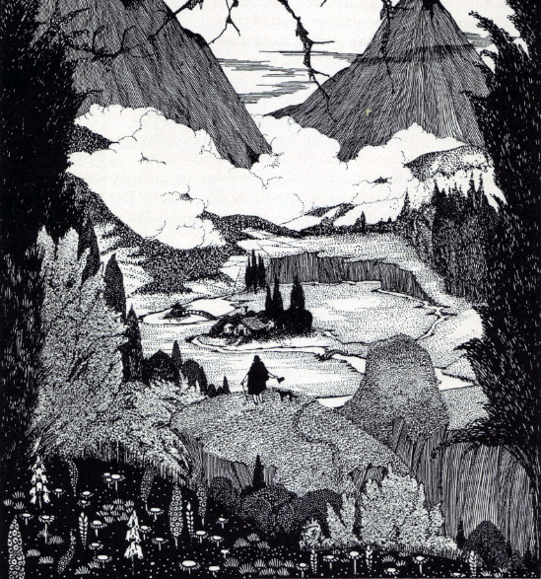

Encounters

1. Surprise
If it is not obvious from the circumstances the GM will roll 1d6 to determine if either side is surprised. If it is a 1 the players are surprised. If it is a 6 the monsters are surprised. A surprised side will not act the first round.

2. Initiative
Each side rolls 1d6. The higher side wins and goes first. Then the other side goes. Initiative is rerolled each round.

3. Diplomacy
An adventurer can attempt to use their words to avoid violence. After telling the GM what they say, the player rolls 1d20 + the character’s level. If the result is over 15 you succeed. The GM may choose to give the player advantage or disadvantage depending on how convincing their argument is.
 | Humans | Make diplomacy checks with advantage.

4. Attack
Roll 1d20 then add your attack modifier. If the result is over your opponent’s AC, it’s a hit. A natural 20 is a critical hit and results in 2 damage (D) dice rolled. A natural 1 is a critical miss and may result in a negative consequence and the GM’s discretion.
 |  | Attack Modifier
 | Clerics | Equal to your level divided by 2, rounded up.
 | Fighters | Equal to your level.
 | Thieves | Equal to your level divided by 2, rounded up.
 | Wizards | Equal to your level divided by 3, rounded up.
In addition to the modifiers afforded by class there are various factors afforded by one’s species:
 | Dwarves | - Gain a +1 bonus to hit Goblins, Orcs and Hobgoblins.  - Ogres, Trolls, and Giants have a -4 penalty to hit a dwarf.
 | Elves | - Gain a +1 bonus to hit with bows, swords.  - Immune to Ghoul paralysis.
 | Halflings | - Gain a +3 bonus to hit with missile weapons.  - Human sized humanoid opponents have a -2 penalty to hit.  - Giant sized humanoid opponents have a -4 penalty to hit.

5. Damage
When you hit an opponent, roll the damage (D) dice. Subtract the result from your opponents hit points (hp). If you are using a shield you may splinter it to avoid all damage from a hit, destroying the shield in the process. At or below 0, monsters are dead, and PC’s are knocked out. Monsters could kill them easily, but they won’t. Instead, they keep them as prisoners. This is just more pulp-like.
 | Thieves | Roll 2 damage (D) dice if they have successfully used stealth to remain undetected by their target.

6. Morale
If outnumbered, after the first death, and when reduced to one-half number of hit points, monsters checks for morale. The GM rolls 1d10. If the result is over the monster’s hit dice, it will withdraw or surrender to get a better position.

7. Rest and bandages
After combat, all hit points (hp) are restored back their initial score. After all, hit points reflect the capacity to escape or stand hits. If a PC has been sent below 0 hp, they may needs a longer rest, or even healing magic like a potion of healing), because they are wounded.

Experience

PCs start at level 1 (1 Hit Dice). Players get 100 experience points per monster’s hit dice and 1 experience point per gold piece found, split equally between the party.
 | Humans | Receive 10% additional experience points.
The number of experience points needed to level up is the experience multiplier x the current level.
 |  | Experience Multiplier
 | Clerics | 1,000
 | Fighters | 2,000
 | Thieves | 1,000
 | Wizards | 4,000
Gaining a new level means better rolls for fight, save and actions, and more hit points. The player rolls the hit dice and adds the result to their maximum hit points. Characters can only gain 1 level per session.

Magic

Turn Undead
Instead of attacking, a cleric may attempt to turn undead. Roll 1d20 under the cleric’s level + 4; and add or subtract the undead monster's HD if it is greater or lower than the cleric's level. So a 7th level cleric must roll under 17 to turn a 1 HD skeleton (7th level plus 4 equals 11; cleric is 6 HD higher than a 1 HD skeleton). Each turning attempt effects all undead within a 20' radius.
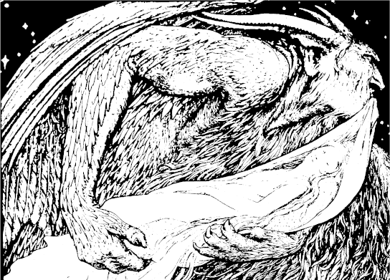

Casting Spells
 | Clerics | - May cast a total number of spells per day equal to their level minus one; with a maximum spell level equal to 1⁄2 of their level. Thus a first level cleric cannot cast spells, and a third level cleric can cast 2 level 1 spells/day.  - Can cast any spells from the cleric list appropriate for their level.
 | Wizards | - May cast a total number of spells per day equal to their level; with a maximum spell level equal to 1⁄2 of their level (rounded up). Thus a 1st level wizard can cast 1 level 1 spell per day, and a 3 rd level wizard can cast either 3 level 1 spells/day, or 1 second level spells and 1 first level spell/day.  - Must choose spells before each adventure.  - Knows Detect Magic and 1 spell at level 1.  - Learns 1 additional spell each time they level.  - Can also learn spells from scrolls and books.  - May spend a turn to cast Detect Magic for free by making a skill check.

Spell durations are measured in 10 minute (turns) or 10 second blocks of time (rounds).

Cleric Spell List
Level | Spell | Range | Effect
1 | Cure Light Wounds | Touch | Heals 1d6 hp
1 | Detect Evil | 120’ | Detects evil thought/intent for 6 turns
1 | Detect Magic | 60’ | Detect magic for 2 turns
1 | Light | 120’ | Lights a 30' radius for 12 turns
1 | Protection from evil | 0’ | Enchanted monsters can't attack, +1 on saves and +1 penalty to hit for evil opponents for 12 turns
2 | Bless | 60’ | Allies gain +1 to hit/morale for 6 turns
2 | Find Traps | 30’ | Find normal and magic traps for 2 turns
2 | Hold Person | 120’ | Holds 1-4 for 6 turns +1 turn/caster level if the target fails a saving throw
3 | Continual Light | 120’ | Lights a 30’ radius until dispelled
3 | Cure Disease | Touch | Negates disease in target
3 | Remove Curse | Touch | Negates curse in target
4 | Cure Serious Wounds | Touch | Heals 2d6 hp
4 | Neutralize Poison | Touch | Negates poison in a creature
4 | Protection from Evil, 10’ Radius | 10’ | See Prot. From Evil
5 | Dispel Evil | 30’ | Dispel any evil sending or spell
5 | Quest | 30’ | Target is given a task it must complete if it fails its saving throw
5 | Raise Dead | Sight | Target is brought back to life provided it has not been dead longer than 12 days. For each level above 10 that amount increases by 4 days. So a 12th Level cleric can raise a dead target within 20 days.

Wizard Spell List
Level | Spell | Range | Effect
1 | Charm Person | 120’ | Makes victim enamored of caster for 1-20 days minus HD (minimum 1 day) if the target fails a saving throw
1 | Detect Magic | 60’ | Detect magic for 2 turns
1 | Light | 120’ | Lights a 30' radius for 6 + caster level turns
1 | Magic Missile | 150’ | One 1d4+1 damage missile per 3 caster levels ( ex - a 4th level wizards makes 2 missiles).
1 | Sleep | 250’ | Puts 2-8 HD (max 4 HD creature)to sleep 2-8 rounds
1 | Shield | Touch | AC15 protection (AC17 vs missiles) with AC10 MV for 2 turns, immune to magic missiles
2 | Detect Invisibility | 10’/Level | See invisible 5 rounds/level
2 | Invisibility | 240’ | Target Invisible (-4 penalty to be hit) until attacking
2 | Detect Thoughts | 60’ | Hear the thoughts of others for 12 turns
2 | Web | 10’ | Create sticky mass 10' radius , giants break through in 1 round, humans take 2-8 turns.
3 | Dispel Magic | 60’ | Remove all magic 60' radius
3 | Fireball | 240’ | 1d6/level damage 20' radius
3 | Invisibility, 10’ Radius | 240’ | See Invisibility
3 | Lightning Bolt | 240’ | 5'x60 bolt 1d6/level damage
4 | Charm Monster | 120’ | As charm person but any creature
4 | Dimension Door | 10’ | Target is transported up to 360’
4 | Minor Globe of Invulnerability | 0’ | 10' radius sphere around caster prevents all 1-3 rd level spells (except casters own) 1 round/level
4 | Polymorph | 60’ | Target assumes form of creature of caster’s choosing receiving its attributes but retaining its original mind. If cast on self, effect lasts 6 turns + caster level. Otherwise the effect remains until dispelled
5 | Animate Dead | Sight | Create skeletons or zombies from corpses. Creates 1d6 animated dead for each caster level above 8
5 | Conjure Elemental | 240’ | Conjure 1 water, fire, air, or earth elemental per day. Elemental remains until dispelled but will attack conjurer that is not focusing on controlling it
5 | Teleport | 10’ | Transport target to a location the caster knows. 75% chance of failure if caster only has indirect knowledge of location
5 | Wall of Stone | 60’ | Conjure 2’ thick wall of stone with maximum area of 1,000 square feet
6 | Death Spell | 240’ | Within 60’ radius kills 2d8 creatures of 7HD or less
6 | Project Image | 240’ | Project image of caster for 6 turns. Spells cast appear to originate from image
6 | Reincarnation | Sight | Bring target back to life but in a new form
6 | Stone to Flesh | 120’ | Can be used to reverse petrification
