Project Requirements for DiscoPlanet

Vision
The project DiscoPlanet is aimed to create an adventure game. Also, it is supposed to entertain its users. This game will be a small adventure game, which will set place in a non-realistic future. The player will have to discover a planet (maybe multiple) in order to find several items, to unlock his path throughout the story line.

Goals
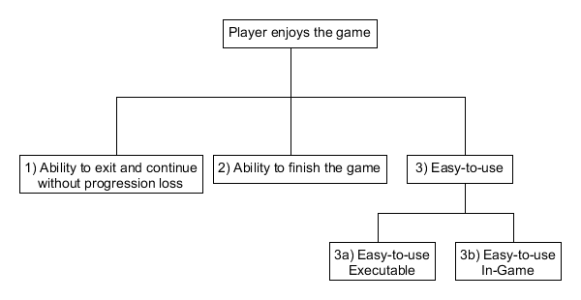

System context

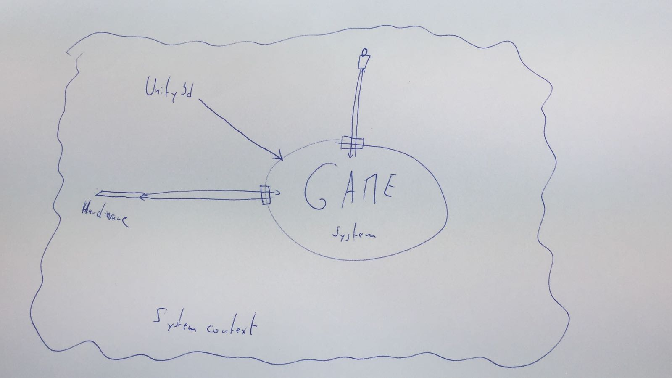

Legend and additional information:

P: Priority (in number: 1; 2; 3 or as symbols ⬇ ➔ ⬆)
S: Stability
C: Complexity (when high might need to divide smaller tasks)

R: {P+S+C} ‘calculated’ risk (number or symbol) ⬆  ➔  ⬇

FR = Functional Requirements / NR = Non-Functional Requirements

Project Leader: Prof. Dr. Jürgen Eckerle
Team: Flückiger, Quentin & Graf, Benjamin

Table

No. |  | Short Description | Status | P | S | C | R | Source | Date | Goal
1 | FR | Planet discovery
 | 1.1 | Discover the planet. | Planned | ⬆ | ⬇ | ⬆ |  | Team | 2018-02-21 | 2
 | 1.2 | Discover other planets. | Planned | ⬇ | ⬇ | ⬆ |  | Team | 2018-02-21 | 2
 | 1.3 | Progression memory | Planned | ⬆ | ⬇ | ➔ | ➔ | Project Leader | 2018-02-21 | 1
2 | FR | Reason for discovery
 | 2.1 | Reason for discovery | Planned | ⬆ | ⬇ | ➔ | ➔ | Project Leader | 2018-02-21 | 2
3 | FR | Obstacles hindering the discovery
 | 3.1 | Intelligent Agent | Planned | ⬆ | ➔ | ⬆ |  | Project Leader | 2018-02-21 | 2
 | 3.2 | Environment | Planned | ⬆ | ➔ | ➔ |  | Team | 2018-02-21 | 2
4 | FR | Gathering
 | 4.1 | Gathering items | Planned | ⬇ | ⬇ | ⬇ | ⬇ | Team | 2018-02-21 | 2
5 | NR | Execution
 | 5.1 | Loading times | Planned | ⬇ | ⬇ | ➔ |  | Team | 2018-03-20 | 1
 | 5.2 | Light weight | Planned | ⬇ | ⬇ | ➔ |  | Team | 2018-03-20 | 3a
 | 5.3 | Simple controls | Planned | ⬇ | ⬇ | ⬇ | ⬇ | Team | 2018-05-23 | 3b

Description

1 Planet discovery P S C R
1. 1 Discover the planet P ⬆ S ⬇ C ⬆ R 
When playing, the user shall be able to discover the planet in its entirety.
1. 2 Discover other planets P ⬇ S ⬇ C ⬆ R 
As the team we want to have multiple planets.
1. 3 Progression memory P ⬆ S ⬇ C ➔ R ➔
As the project leader I want the program to remember the progression of my game so that if the player comes back the game is in the same state as he left.

2 Reason for discovery P S C R
2.1 Reason for discovery P ⬆ S ⬇ C ➔ R ➔
When playing, the game should provide the user with a reason to discover the planet.

3 Obstacles hindering the discovery P S C R
3.1 Intelligent Agents P ⬆ S ➔ C ⬆ R 
As the project leader, I want the game to have intelligent agents, which make the progress of the player a little bit harder, so he has a bigger feeling of accomplishment when he succeeds.
3.2 Environment P ⬆ S ➔ C ➔ R 
As the team, we want the world to have non-living obstacles, which the player has to overcome to succeed, so that the game is a bit more engaging for the player.

4 Gathering P S C R
4.1 Gathering Items P ⬇ V ⬇ K ⬇ R ⬇
As the team, we want the player to be able to gather items, which he can use at a later point in time, so he can unlock previously inaccessible areas.

5 Execution P S C R
5.1 Loading times P ⬇ V ⬇ K ➔ R 
As the team, we want the player to be able to load the game in a reasonable amount of time (short).
5.2 Light weight P ⬇ V ⬇ K ➔ R 
As the team, we want the final game folder to be compact and user-friendly.
5.3 Simple controls P ⬇ V ⬇ K ⬇ R ⬇
As the team, we want the final game to have simple, widely used, intuitive controls.

Stakeholder Descriptions

Product owner / Project leader
Prof. Dr. Jürgen Eckerle

Interests:
- The project owner wants to satisfy the users
- The game should be windows runnable

Development team
Team members are:
- Flückiger Quentin
- Graf Benjamin

Interests:
- The development team wants to develop an interesting game for the users.

User
Everyone who wants to play the game.

Interests:
- Spending an enjoyable time playing the game.

