# 28928429_10214234633933570_1364126048_oProject 1 documentation

# Planning document

## Requirements

Goal is, that the player

* Can discover the planet.
  + More / solar system …
* Has a reason to do so.
* Has obstacles, hindering him in the discovery.
  + Smart obstacles.
* Can collect stuff.

## Features

Items on this list marked with a star, are explained further down to give a better understanding of the idea.

* The size of the planet influences jumping (gravity).
* Resource ‘nodes’ for material gathering
* Partially destructible world, to gain access to hidden areas
* Crouching
* Cliff grapple\* / ladder
* Being able to discover a star
* Fixed / moving camera\*
* Story\*
* Objectives on the planet with the possible need to revisit ‘older’ planets
* Map\*
* Options\*
* Controls\*
* Assets\*

## Cliff grapple

In order to prevent accidental falls, this feature aims to enable the player to grapple onto the cliff when stepped off it. This also helps the player to get to higher grounds, even if he can’t directly jump there.

## Camera

The camera is always perpendicular to the centre of the planet and encloses the player and a portion of the area he’s in. He is not able to see the entire planet, nor any caves, if he is located on the surface.

Also the camera is fix at the beginning, and only moves, if the player reaches a certain limit on the screen (e.g. the outer quarters on each side). Then the camera pans in that direction, faster than the player moves, until the player is a bit behind the centre again. At this point, the camera is fixed again.

## Story

We want the player to have a reason to discover the planet, so the game should tell a certain story for the player to follow and play along.

## Map

The player has some sort of map, he can open. This can be done either with a functionality, e.g. pressing the ‘M’ key, to open it, or through the use of an item, which he has to use.

On the map, the player is able to see the areas, he has discovered. Everything else is greyed/blacked out.

## Options

If you launch the game, you will be able to go to the start screen, on which you’ll be presented with the following options. The click on play will open a dialog to continue a previously saved game, or to start off a new adventure.

* Play
  + New
  + Load
* Settings
* FAQ
* Leave

If you pause the game (e.g. through the ‘Esc’ key), you’ll be presented with the following options. The Settings option will open another dialog with the corresponding possibilities.

* Resume
* Save
* Settings
  + Sound
  + Music
  + Key binding
  + Language
* Leave

## Controls

For the controls we’re using the standard keys. Meaning that for moving we use WASD and the space bar for jumping, the mouse to aim and use the items from the inventory, and shift, if we implement the crouch feature.

Also the support of a gamepad is aspired to be implemented.

## Assets

As discussed with the project leader, we are free to use any assets we find, since it would be too much work, to create those ourselves for this project.

We need the following assets. They are ordered by importance in the sub-categories.

* Visual
  + Terrain
  + Character and enemies
  + Weapons / tools
  + Background / foreground
  + Space
* Acoustic
  + Background music and sounds
  + Effect sounds

# Planning fulfilment

## Cliff grapple

We did not implement this feature because we soon realised that it would be too much work to do it properly. We would have needed to create fitting animations, terrain and controls.

Without it, we opted for simpler controls but a more difficult map making, since we had to be sure, that the player can reach the desired areas.

## Camera

Since our world turned out to be flat and the default camera is perpendicular to the ‘ground’ (i.e. down), the camera is always in a natural view to the player.

There are one or two places, where the player can see a cave underneath, although the entrance is further away. Also the player sees all caves on screen, even those he has not been into yet, because to do it as we wanted to, means to have a complicated way of detecting, where the player is, and depending on that unlock certain areas or not. We also could have solved it with a dynamic lighting, but after looking at different games which were in development for years and they still don’t manage to do it properly, we decided to scrap that idea too.

In addition to that we went for a slightly different approach on the camera movement. This came to be because we felt it was more natural to have it this way and preferred it over our first idea. The current camera is fixed on the player and moves along the player through the world. The other version would be more fitted to put the focus on one set of obstacles, and after completion on the next set.

## Story

Both of us are bad writers. That is why we don’t have a lot of story. We do have some story elements which are presented to the player upon entering the level for the first time. After that there are small things the player has to do to progress in the story, until he reaches the end. But what these things are, the player has to figure out by himself.

## Map

To have a map means to know what is around you. We wanted the game to be harder and the player to pay more attention to where he goes.

However, if the map would only contain already explored areas, this could be subject to be implemented in a future update of the game.

## ‘Options’

We do have implemented the principle options we wanted. They function as one would expect:

Play enables the selection of continuing the previously saved game, if there is one, or start a new one. Back goes one layer back. Quit exits the game. Options opens up the possibility to set the volume of the background and the effects respectively.

We did not add any FAQs, since we don’t have any questions, which would be asked frequently.

## Controls

So far we only use four different keys. Two to control the character left and right (either with A/D or the arrow keys), one to jump (the spacebar) and one to interact with objects (E).

Since we don’t have an active combat system, we don’t need the mouse to aim. Also the inventory is handled passively through the PlayerPrefs given by Unity. Also we did not implement the crouch, since we’ve decided to make a fluffy ball our character. The gamepad too is not yet supported.

## Assets

We used several given assets from the Unity Asset Store[[1]](#footnote-1) and Google. Some were modified, some were not. For a detailed list, see the sources.md file.

# Project requirements

## Vision

The project DiscoPlanet is aimed to create an adventure game. Also, it is supposed to entertain its users. This game will be a small adventure game, which will set place in a non-realistic future. The player will have to discover a planet (maybe multiple) in order to find several items, to unlock his path throughout the story line.

## Goals

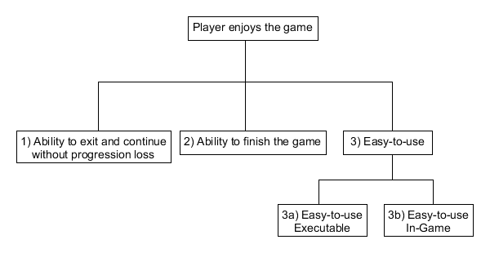

## System context

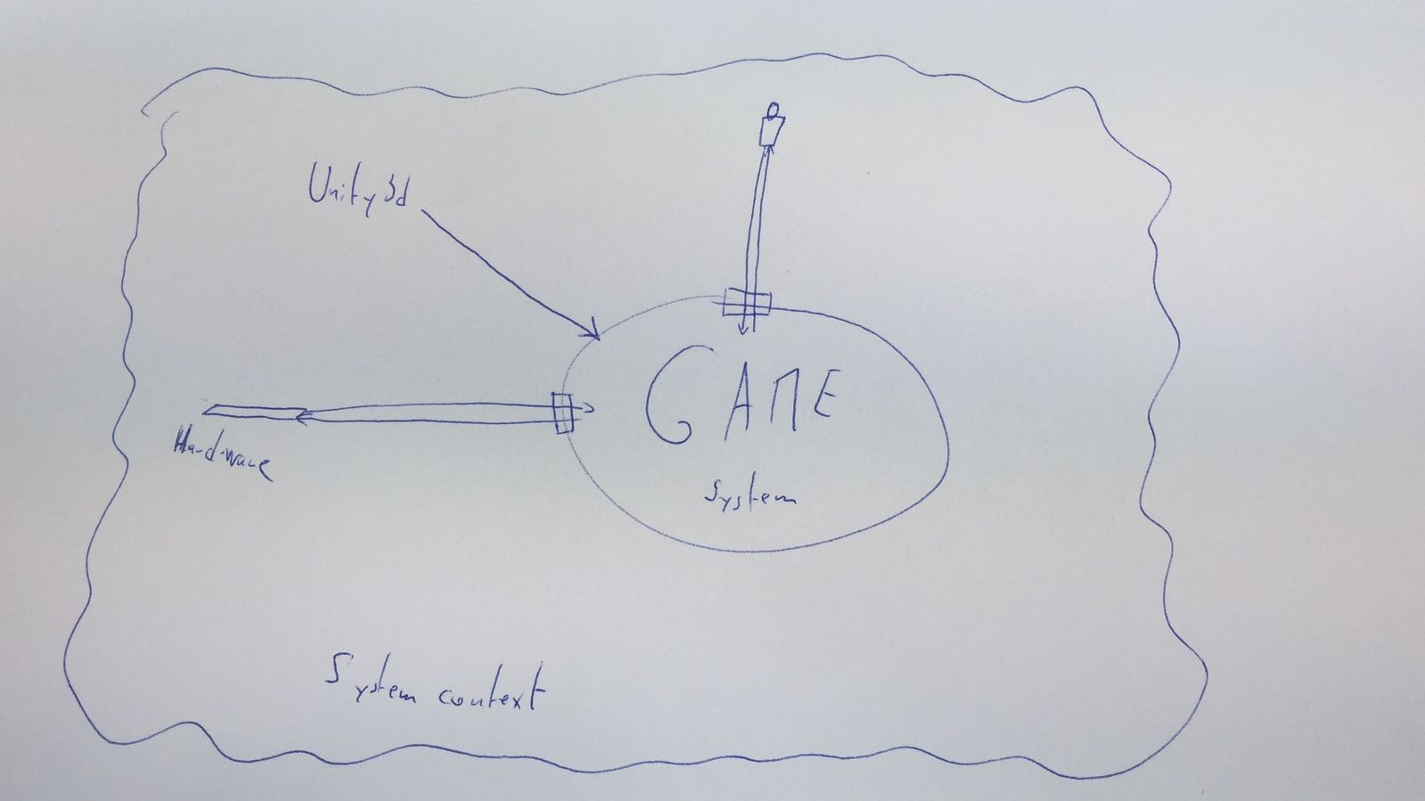

## Legend and additional information:

P: Priority (in number: 1; 2; 3 or as symbols 🡻 ➔ ⬆)

S: Stability

C: Complexity (when high might need to divide smaller tasks)

R: {P+S+C} ‘calculated’ risk (number or symbol) ⬆ 🡽 ➔ 🡾 🡻

FR = Functional Requirements / NR = Non-Functional Requirements

[Project Leader](#_Product_owner_/): Prof. Dr. Jürgen Eckerle

[Team](#_Development_team): Flückiger, Quentin & Graf, Benjamin

## Table

|  |  |  |  |  |  |  |  |  |  |  |
| --- | --- | --- | --- | --- | --- | --- | --- | --- | --- | --- |
| **No.** | | **Short Description** | **Status** | **P** | **S** | **C** | **R** | **Source** | **Date** | **Goal** |
| 1 | FR | [Planet discovery](#_1_Planet_discovery) |  | | | | | | | |
|  | 1.1 | Discover the planet. | Done | ⬆ | 🡻 | ⬆ | 🡽 | [Team](#_Development_team) | 2018-02-21 | 2 |
| 1.2 | Discover other planets. | Done | 🡻 | 🡻 | ⬆ | 🡾 | [Team](#_Development_team) | 2018-02-21 | 2 |
| 1.3 | Progression memory | Done | ⬆ | 🡻 | ➔ | ➔ | [Project Leader](#_Product_owner_/) | 2018-02-21 | 1 |
| 2 | FR | [Reason for discovery](#_2_Reason_for) |  | | | | | | | |
|  | 2.1 | Reason for discovery | Done | ⬆ | 🡻 | ➔ | ➔ | [Project Leader](#_Product_owner_/) | 2018-02-21 | 2 |
| 3 | FR | [Obstacles hindering the discovery](#_3_Obstacles_hindering) |  | | | | | | | |
|  | 3.1 | Intelligent Agent | Done | ⬆ | ➔ | ⬆ | 🡽 | [Project Leader](#_Product_owner_/) | 2018-02-21 | 2 |
| 3.2 | Environment | Done | ⬆ | ➔ | ➔ | 🡽 | [Team](#_Development_team) | 2018-02-21 | 2 |
| 4 | FR | [Gathering](#_4_Gathering_) |  | | | | | | | |
|  | 4.1 | Gathering items | Done | 🡻 | 🡻 | 🡻 | 🡻 | [Team](#_Development_team) | 2018-02-21 | 2 |
| 5 | NR | [Execution](#_5_Execution_) |  | | | | | | | |
|  | 5.1 | Loading times | Done | 🡻 | 🡻 | ➔ | 🡾 | [Team](#_Development_team) | 2018-03-20 | 1 |
|  | 5.2 | Light weight | Done | 🡻 | 🡻 | ➔ | 🡾 | [Team](#_Development_team) | 2018-03-20 | 3a |
|  | 5.3 | Simple controls | Done | 🡻 | 🡻 | 🡻 | 🡻 | [Team](#_Development_team) | 2018-05-23 | 3b |

## Description

#### 1 Planet discovery P S C R

1.1 **Discover the planet** ⬆ 🡻 ⬆ 🡽

When playing, the user shall be able to discover the planet in its entirety.

1.2 **Discover other planets** 🡻 🡻 ⬆ 🡾

As the team we want to have multiple planets.

1.3 **Progression memory** ⬆ 🡻 ➔ ➔

As the project leader I want the program to remember the progression of my game so that if the player comes back the game is in the same state as he left.

#### 2 Reason for discovery P S C R

2.1 **Reason for discovery** ⬆ 🡻 ➔ ➔

When playing, the game should provide the user with a reason to discover the planet.

#### 3 Obstacles hindering the discovery P S C R

3.1 **Intelligent Agents** ⬆ ➔ ⬆ 🡽

As the project leader, I want the game to have intelligent agents, which make the progress of the player a little bit harder, so he has a bigger feeling of accomplishment when he succeeds.

3.2 **Environment** ⬆ ➔ ➔ 🡽

As the team, we want the world to have non-living obstacles, which the player has to overcome to succeed, so that the game is a bit more engaging for the player.

#### 4 Gathering P S C R

4.1 **Gathering Items** 🡻 🡻 🡻 🡻

As the team, we want the player to be able to gather items, which he can use at a later point in time, so he can unlock previously inaccessible areas.

#### 5 Execution P S C R

5.1 **Loading times** 🡻 🡻 ➔ 🡾

As the team, we want the player to be able to load the game in a reasonable amount of time (short).

5.2 **Light weight** 🡻 🡻 ➔ 🡾

As the team, we want the final game folder to be compact and user-friendly.

5.3 **Simple controls** 🡻 🡻 🡻 🡻

As the team, we want the final game to have simple, widely used, intuitive controls.

## Stakeholder Descriptions

### Project leader

Prof. Dr. [Jürgen Eckerle](mailto:erj1@bfh.ch)

Interests:

* The project owner wants to satisfy the users
* The game should be windows runnable

### Product owner / Development team

Team members are:

* [Flückiger Quentin](mailto:flucq1@bfh.ch)
* [Graf Benjamin](mailto:grafb6@bfh.ch)

Interests:

* The development team wants to develop an interesting game for the users.

### User

Everyone who wants to play the game.

Interests:

* Spending an enjoyable time playing the game.

# Conclusion

First and foremost it was a very interesting project, to see what it takes to create a game. Since we used Unity, there were a bunch of things taken care of by the game engine, otherwise we definitely would not have been able to do this much.

Despite all the things, Unity took care of, there were plenty of things we had to do and learn. And because of that learning process, everything takes at least three times as much time, as we would have expected. We noticed that especially in the beginning. Towards the end of the project we could estimate the required time a lot better, both because we already knew how to implement the things we wanted, but also because we already had some experience on how much effort it is, to actually implement it. This in addition to procrastination lead to the fact that we had to do one or two night shifts.

Overall the experience was very pleasant, and we hope we are able to use the learned knowledge in the future for other projects.

1. [assetstore.unity.com](https://assetstore.unity.com/) [↑](#footnote-ref-1)