# DiscoPlanet

## Requirements

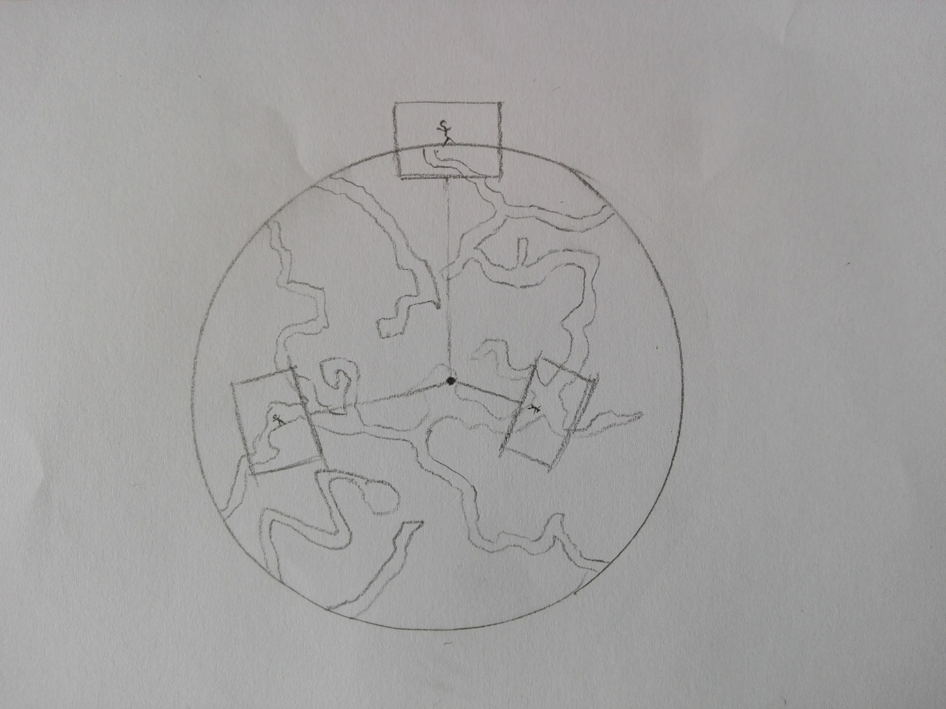

Goal is, that the player

* Can discover the planet.
  + More / solar system …
* Has a reason to do so.
* Has obstacles, hindering him in the discovery.
  + Smart obstacles.
* Can collect stuff.

## Features

Items on this list marked with a star, are explained further down, to give a better understanding of the idea.

* The size of the planet influences jumping (gravity).
* Resource ‘nodes’ for material gathering
* Partially destructible world, to gain access to hidden areas
* Crouching[1]
* Cliff grapple* / ladder
* Being able to discover a star
* Fixed / moving camera*
* Story*
* Objectives on the planet with the possible need to revisit ‘older’ planets
* Map*
* Options*
* Controls*
* Assets*

### Cliff grapple

In order to prevent accidental falls, this feature aims to enable the player to grapple onto the cliff when stepped off it. This also helps the player to get to higher grounds, even if he can’t directly jump there.

### Camera

The camera is always perpendicular to the centre of the planet and encloses the player and a portion of the area he’s in. He is not able to see the entire planet, nor any caves, if he is located on the surface.

Also the camera is fix at the beginning, and only moves, if the player reaches a certain limit on the screen (e.g. the outer quarters on each side). Then the camera pans in that direction, faster than the player moves, until the player is a bit behind the centre again. At this point, the camera is fixed again.

### Story

TBA

### Map

The player has some sort of map, he can open. This can be done either with a functionality, e.g. pressing the ‘M’ key, to open it, or through the use of an item, which he has to use.

On the map, the player is able to see the areas, he has discovered. Everything else is greyed/blacked out.

### Options

If you launch the game, you’ll be able to go the start screen, on which you’ll be presented with the following options. The press on play will open a dialog to continue a previously saved game, or to start off a new adventure.

* Play
  + New
  + Load
* Settings
* FAQ
* Leave

If you pause the game (e.g. through the ‘Esc’ key), you’ll be presented with the following options. The Settings option will open another dialog with the corresponding possibilities.

* Resume
* Save
* Settings
  + Sound
  + Music
  + Key binding[2]
  + Language[3]
* Leave

### Controls

For the controls we’re using the standard keys. Meaning that for moving we use WASD and the space bar for jumping, the mouse to aim and use the items from the inventory, and shift, if we implement the crouch feature.

Also the support of a gamepad is aspired to be implemented, but is also fluffy.

### Assets

As discussed with the project leader, we are free to use any assets we find, since it would be too much work, to create those ourselves for this project.

We need the following assets. They are ordered by importance in the sub-categories.

* Acoustic
  + Background music and sounds
  + Effect sounds
* Visual
  + Terrain
  + Character and enemies
  + Weapons / tools
  + Background / foreground

1. Fluffly
2. Fluffly
3. Superfluffy