

Requirement & Design Specification

**SafeDriver Certification Manager**

**Version: 1.0**

**Group 3**

**HE181827 – Hoàng Văn Đức**

**HE186392 – Nguyễn Hoàng Sơn**

**HE186897 – Nguyễn Bảo Long**

# Table of content

**Table of content 2**

I. Overview 3

1. User Requirements 3

1.1 Actors 4

1.2 Use Cases 4

a. Diagram(s) 4

b. Descriptions 4

2. Overall Functionalities 5

2.1 Screens Flow 5

2.2 Screen Descriptions 5

2.3 Screen Authorization 7

3. Database design 8

a. Database Schema 8

b. Table Descriptions 8

4. Package Diagram 9

II. Design Specifications 9

1. Common 9

1.1 Login 10

1.2 Dashboard 10

1.3 Profile 11

1.4 Register 12

1.5 Change password 13

2. Student 13

2.1. View list of participating courses 13

2.2. View notifications 15

2.3. Register courses 16

3. Teacher 17

3.1. Manage Exams 17

3.2. Manage Results 18

3.3. Manage Courses 18

3.4. Manage Registrations 19

4. Traffic Police 20

4.1. View List Exam 20

4.2. Update Exam 21

4.3. View List Certificate 21

4.4. Certificate Issuance 22

5. Admin 22

5.1. List User 22

5.1. Add User 23

5.1. Statistics 23

**III. Appendix 24**

1. Assumptions & Dependencies 24

2. Limitations & Exclusions 24

3. Business Rules 24

# I. Overview

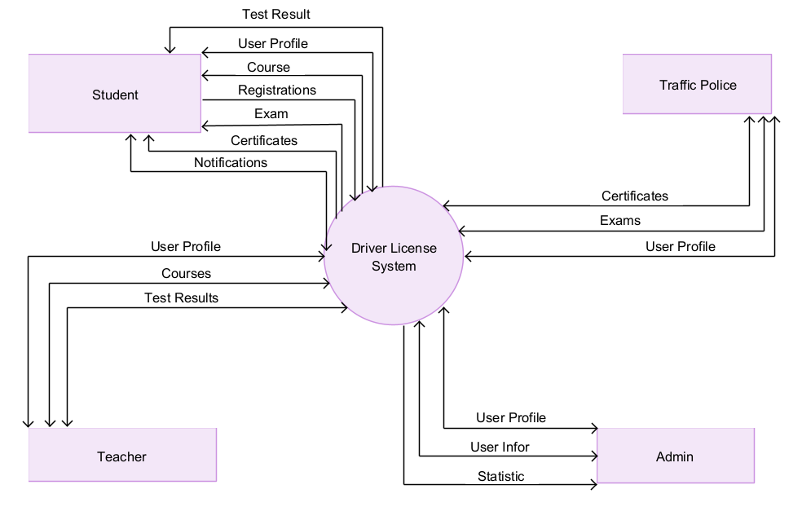

SafeDriver Certification Manager is a simple tool that makes signing up for safe driving exams easy. Students can register for courses and exams, teachers can manage courses and record exam results, and traffic police can monitor exam sessions and approve certificates. This system helps everyone follow the process clearly and improves road safety.

## 1. User Requirements

### 1.1 Actors

|  |  |  |
| --- | --- | --- |
| **#** | **Actor** | **Description** |
| 1 | Admin | Admins manage user accounts and view statistical data to monitor overall system performance. |
| 2 | Teacher | Teachers create and manage courses, verify student registrations, record exam results, and collaborate with traffic police to organize and supervise examinations, ensuring that all processes adhere to the necessary standards. |
| 3 | Student | Students register for courses, update their personal details, take in exams, and receive safe driving certifications upon successfully passing the required examinations. |
| 4 | Traffic police | Traffic Police oversee exam processes, create exams, verify that the examinations are conducted in accordance with safety regulations, and approve the issuance of safe driving certifications to qualified students. |

### 1.2 Use Cases

#### a. Diagram(s)

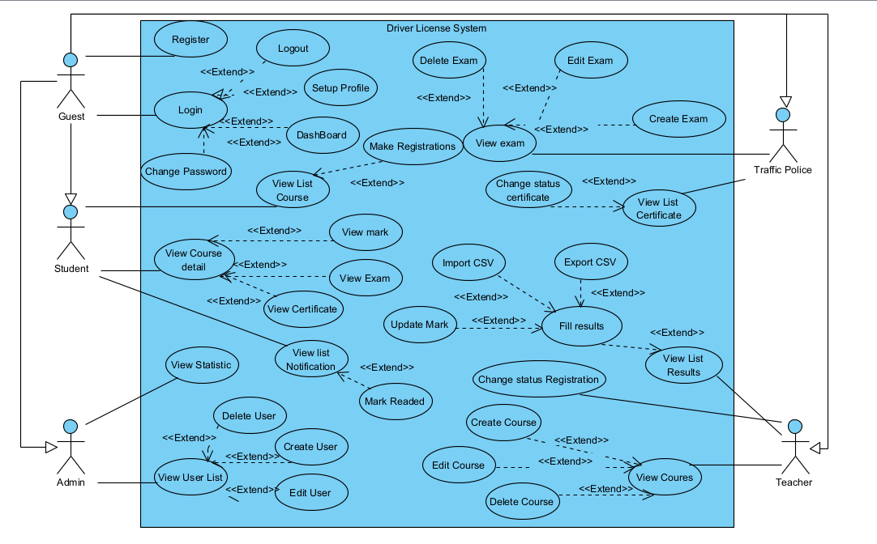

#### b. Descriptions

|  |  |  |  |
| --- | --- | --- | --- |
| **ID** | **Feature** | **Use Case** | **Use Case Description** |
| 01 | Admin | Manage Accounts | Add, edit, delete, view account information. |
| 02 | View Statistic | View Statistic |
| 03 | Teacher | Manage Courses | Add, edit, delete, view courses information. |
| 04 | Manage Results | Add , Edit, view, import csv, export csv results information. |
| 05 | Manage Registration | Edit, view registrations. |
| 06 | Traffic police | Manage Exam | Add, edit, delete, view exam information. |
| 07 | Manage certificate | Edit, View certificate information. |
| 08 | Student | View exam and mark, certificate | View exam, mark, certificate |
| 09 | Manage Notification | View, edit notifications. |
| 10 | Register course | Add, Edit registrations. |
| 11 | Mange courses | View list course, course detail |

## 2. Overall Functionalities

### 2.1 Screens Flow

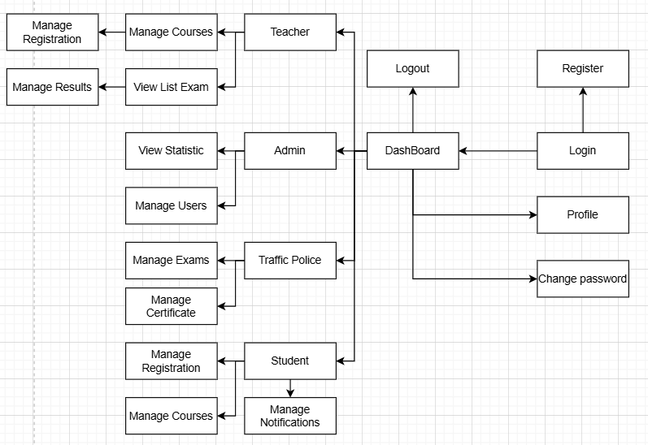

### 2.2 Screen Descriptions

|  |  |  |  |
| --- | --- | --- | --- |
| **#** | **Feature** | **Screen** | **Description** |
| 1 | Common | Login | This page allows User to enter username and password to login |
| 2 | Common | Register | This page allows new users to create an account. |
| 3 | Common | Profile | Users can view and update their personal information. |
| 4 | Common | Change password | Allows users to change their login password |
| 5 | Common | Dashboard | The main interface displaying an overview of the system |
| 6 | Teacher | Manage Courses | Teachers can manage courses, including creating, updating, and deleting courses |
| 7 | Teacher | Manage Registration | Teachers can manage student course registrations. (Approve or Reject) |
| 8 | Teacher | View List Exam | Teachers can view the list of exams |
| 9 | Teacher | Manage Results | Teachers can enter grades and manage student exam results. |
| 10 | Student | View list of participating courses | Student can view the list of participating courses, view exam schedule and mark, view their certificates |
| 11 | Student | View notifications | Student can view the list of notifications, mark the unread notifications as read |
| 12 | Student | Register courses | Student can view the list of active courses, register courses or cancel a register |
| 13 | Police | View List Exam | Allows police to view a list of scheduled exams along with relevant details. |
| 14 | Police | View List Certificates | Enables police to review a list of issued certificates and their statuses. |
| 15 | Police | Manage Exam | Permits police to add and update exam information and scheduling. |
| 16 | Police | Manage Certificates | Allows police to manage certificate records, including verification. |
| 17 | Admin | Manage Users | Empowers admins to control user accounts, assign roles, and update profile information. |
| 18 | Admin | Statistics | Provides admins with comprehensive system statistics and performance analytics. |

### 2.3 Screen Authorization

|  |  |  |  |  |  |
| --- | --- | --- | --- | --- | --- |
| **#** | **Screen** | **Admin** | **Student** | **Teacher** | **Traffic Police** |
| 1 | Login | X | X | X | X |
| 2 | Dashboard | X | X | X | X |
| 3 | Profile | X | X | X | X |
| 4 | Register | X | X | X | X |
| 5 | Change password | X | X | X | X |
| 6 | Manager courses |  |  | X |  |
| 7 | View list exam | X |  | X | X |
| 8 | Manage Results |  |  | X |  |
| 9 | Manage Registrations |  |  | X |  |
| 10 | View list of participating courses |  | X |  |  |
| 11 | View notifications |  | X |  |  |
| 12 | Register courses |  | X |  |  |
| 13 | Statistic | X |  |  |  |
| 14 | Manage Certificate |  |  |  | X |
| 15 | Manage User | X |  |  |  |

### 

## 3. Database design

#### a. Database Schema

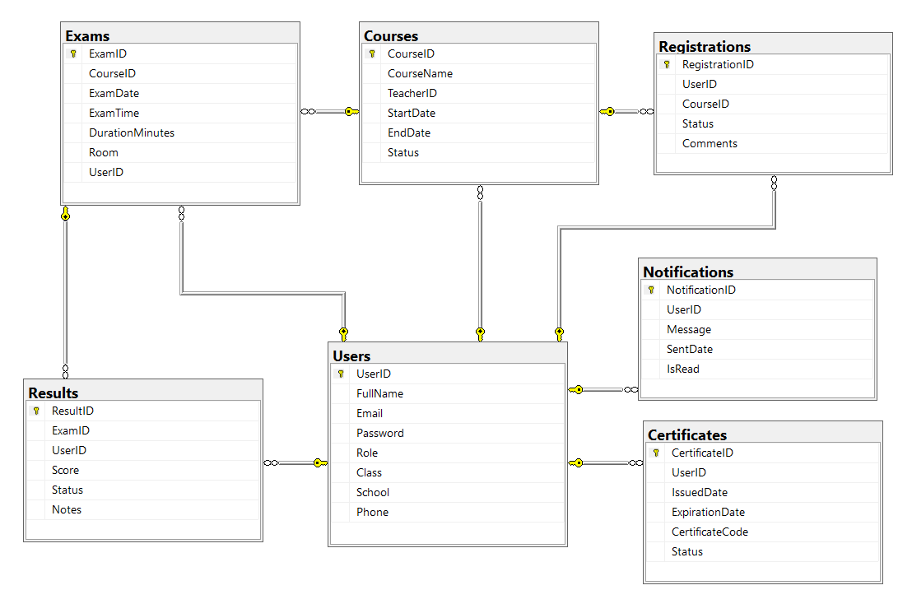

#### b. Table Descriptions

| **No** | **Table** | **Description** |
| --- | --- | --- |
| 01 | Users | * Manages user accounts with fields for UserID, FullName, Email, Password, Role, Class, School, Phone, etc. * Primary keys: UserID |
| 02 | Courses | * Manages courses with fields for CourseID, CourseName, TeacherID, StartDate, EndDate, Status, etc. * Primary keys: CourseID * Foreign keys: TeacherID (references Users) |
| 03 | Registrations | * Manages course/exam registrations with fields for RegistrationID, UserID, CourseID, Status, Comments, etc. * Primary keys: RegistrationID * Foreign keys: UserID (references Users), CourseID (references Courses) |
| 04 | Exams | * Stores exam information with fields for ExamID, CourseID, ExamDate, ExamTime, DurationMinutes, Room, UserID (invigilator), etc. * Primary keys: ExamID * Foreign keys: CourseID (references Courses), UserID (references Users) |
| 05 | Results | * Stores exam results with fields for ResultID, ExamID, UserID, Score, Status, Notes, etc. * Primary keys: ResultID * Foreign keys: ExamID (references Exams), UserID (references Users) |
| 06 | Certificates | * Manages certificates with fields for CertificateID, UserID, IssuedDate, ExpirationDate, CertificateCode, Status, etc. * Primary keys: CertificateID * Foreign keys: UserID (references Users) |
| 07 | Notifications | * Stores notifications with fields for NotificationID, UserID, Message, SentDate, IsRead, etc. * Primary keys: NotificationID * Foreign keys: UserID (references Users) |

## 4. Package Diagram

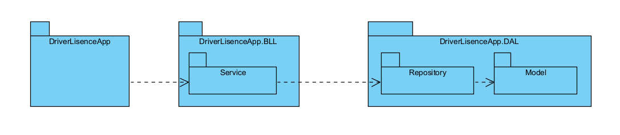

# II. Design Specifications

## 1. Common

### 1.1 Login

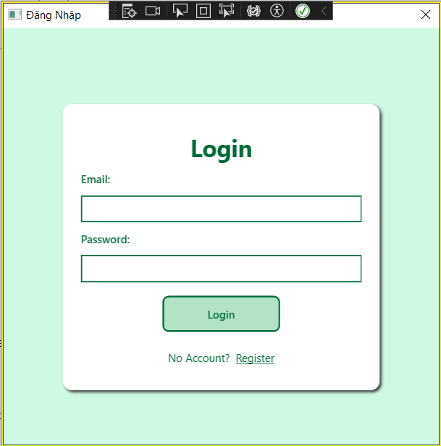

### 1.2 Dashboard

After login successfully, user can view dashboard with button appeared by role

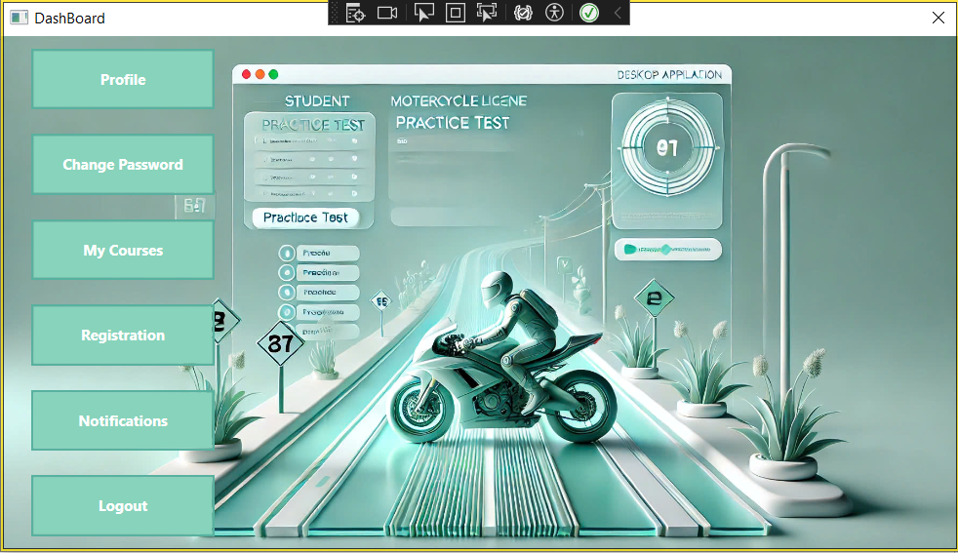

### 1.3 Profile

### User can update profile

### 

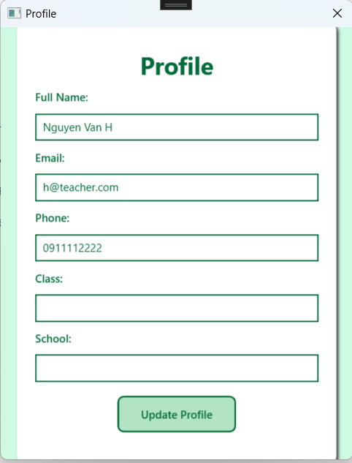

### 1.4 Register

User can register an accounts

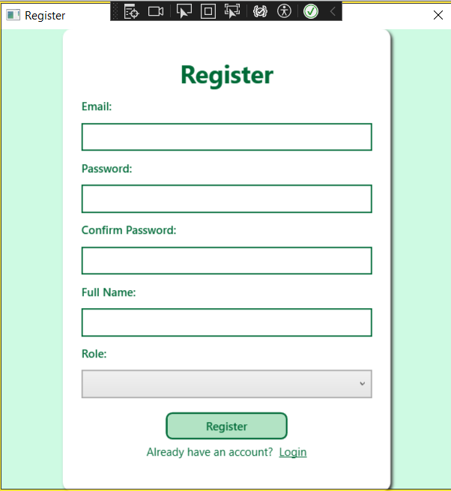

### 

### 1.5 Change password

User can change password

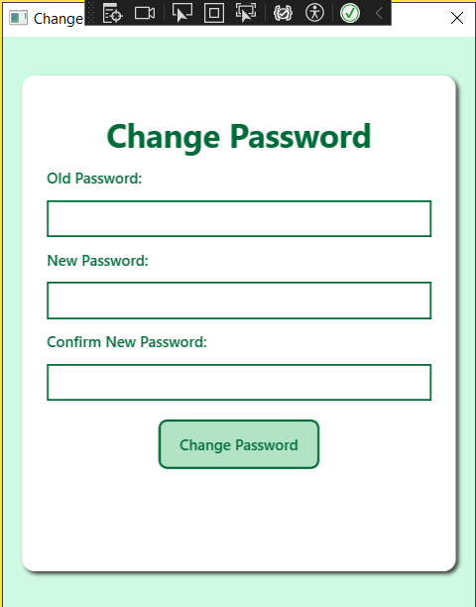

## 2. Student

### 2.1. View list of participating courses

Student can view the list of participating courses

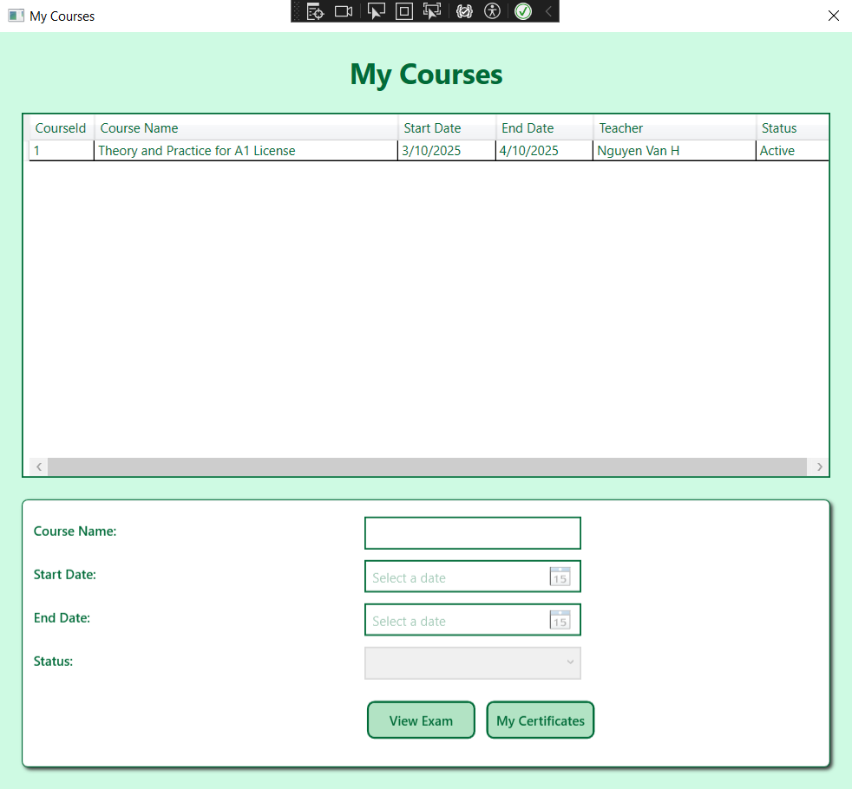

Student can view exam schedule and mark

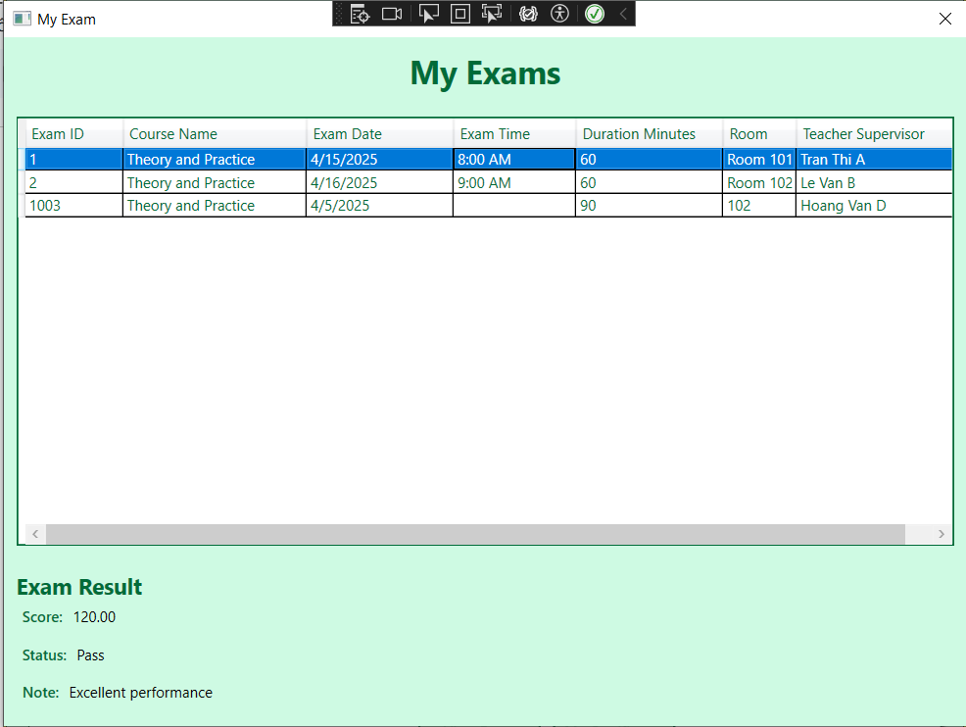

Student can view their certificates

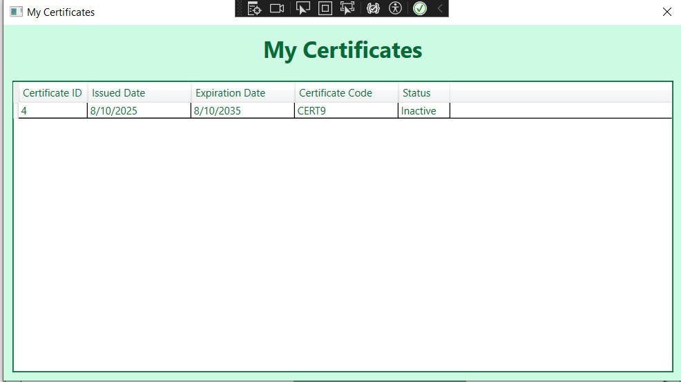

### 2.2. View notifications

Student can view the list of notifications, mark the unread notifications as readed

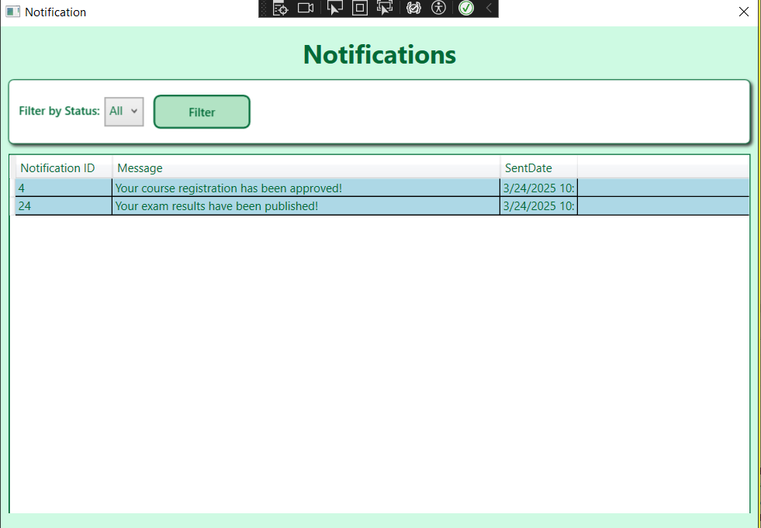

### 2.3. Register courses

Student can view the list of active course, register courses or cancel a register

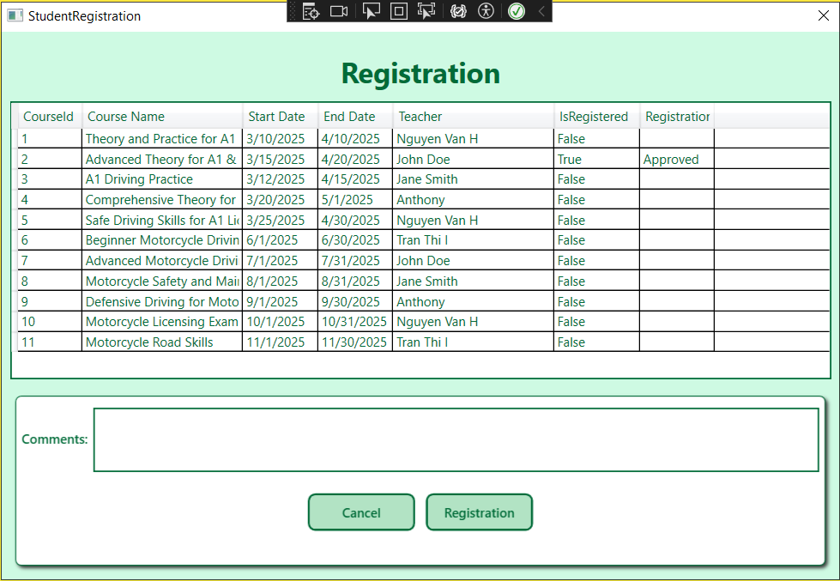

## 3. Teacher

### 3.1. Manage Exams

* Teachers manage their exam

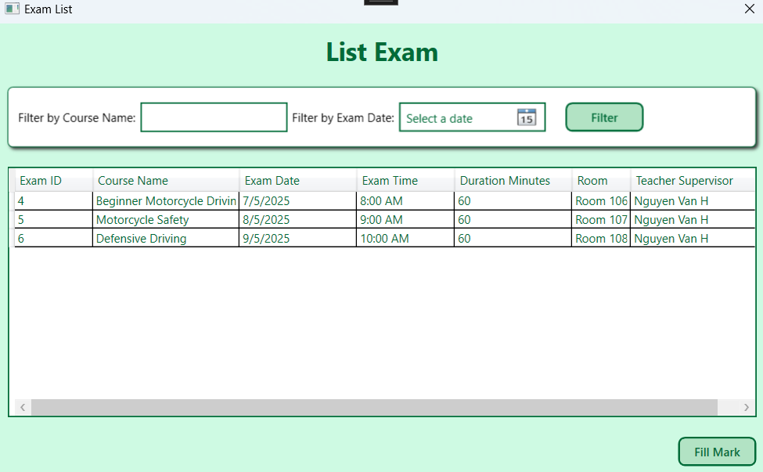

### 3.2. Manage Results

* Teachers can import result from file csv, export to file csv, change result after import if need

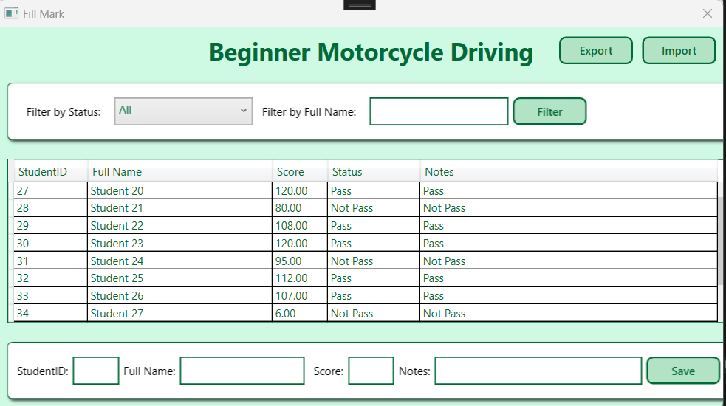

### 3.3. Manage Courses

* Teacher can manage their courses

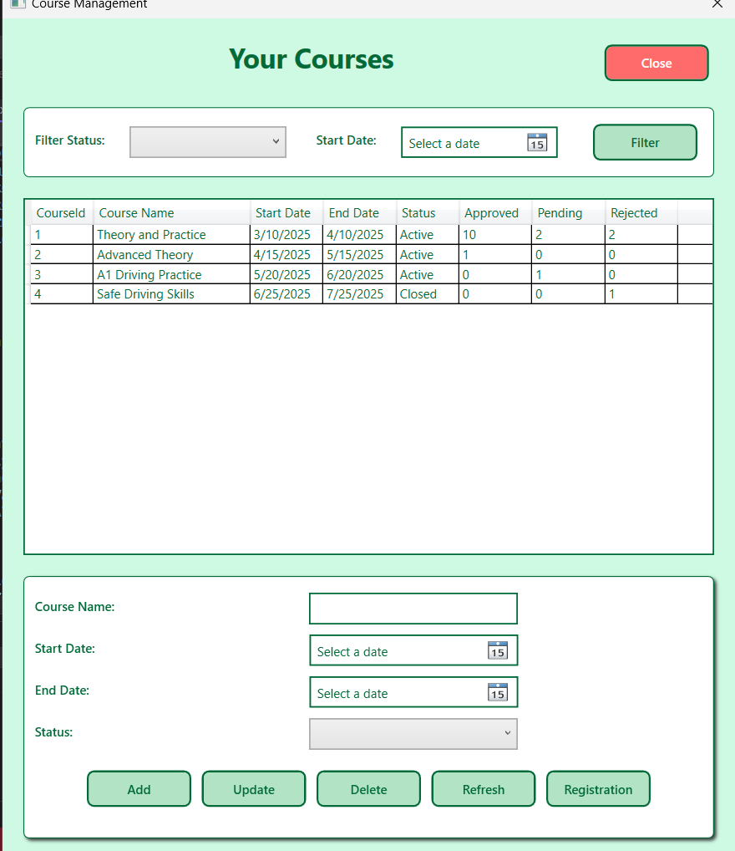

### 3.4. Manage Registrations

* Teacher can approve/reject request join in their courses

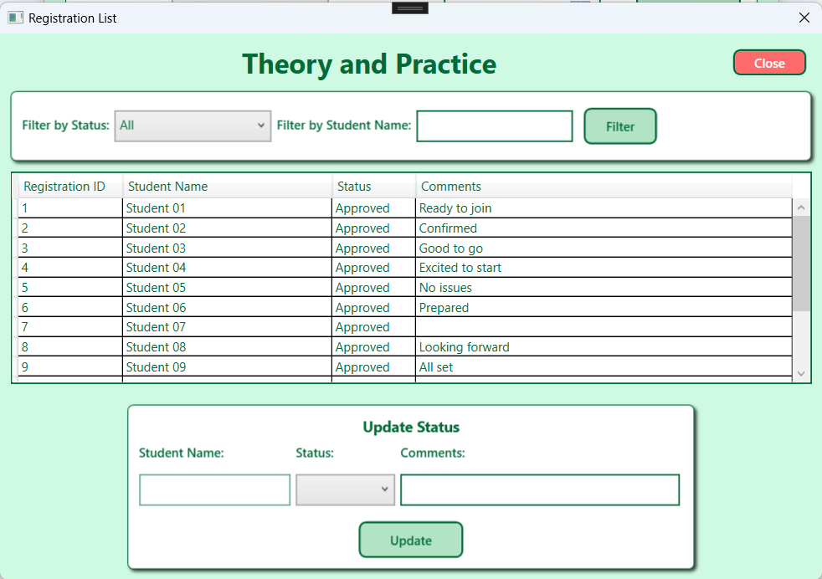

## 4. Traffic Police

### 4.1. View List Exam

Traffic Police can view list all exam

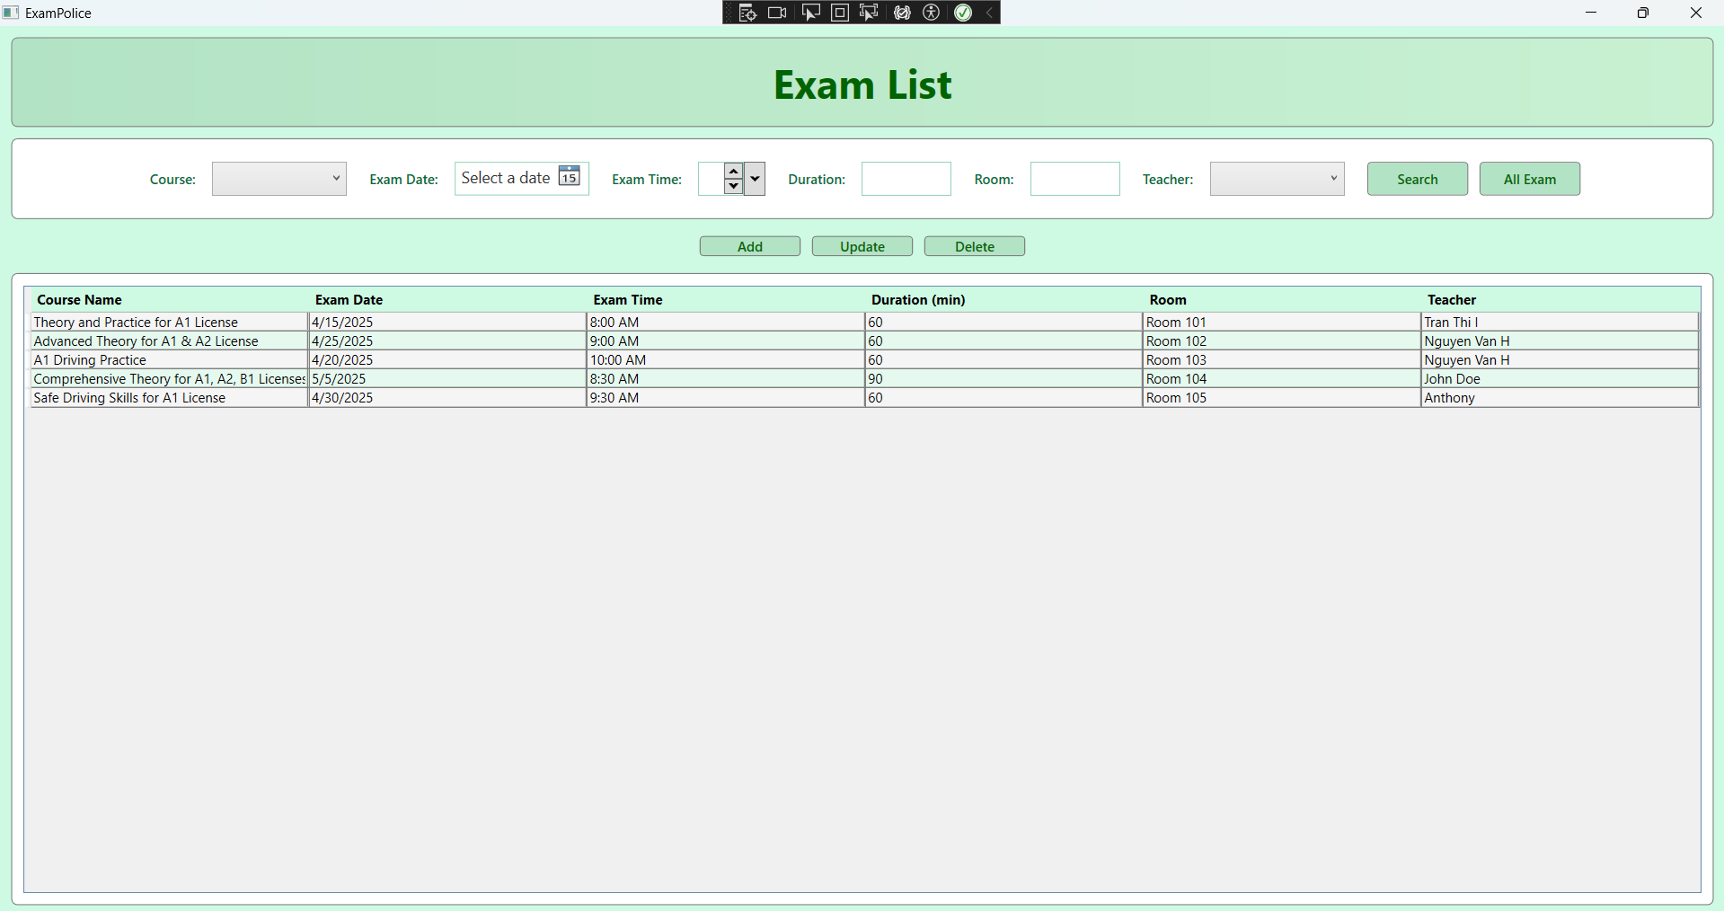

### 

### 4.2. Update Exam

Traffic Police can update and add exam

## 

### 4.3. View List Certificate

Traffic Police can view list certificate

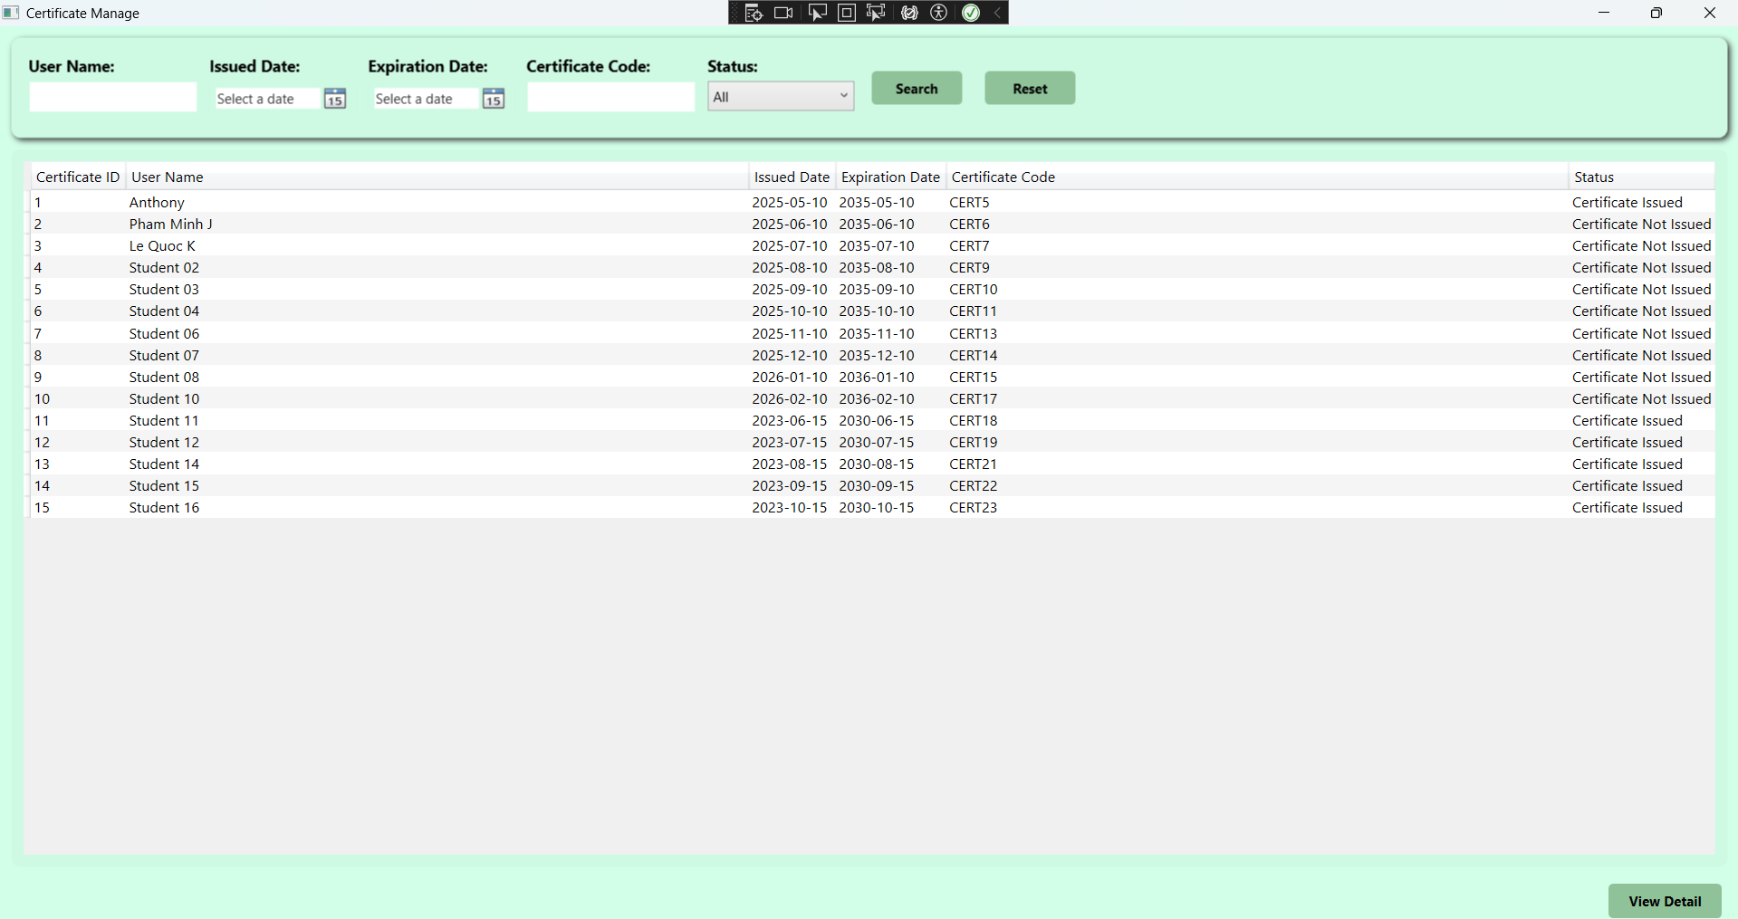

### 4.4. Certificate Issuance

Traffic Police can view list certificate

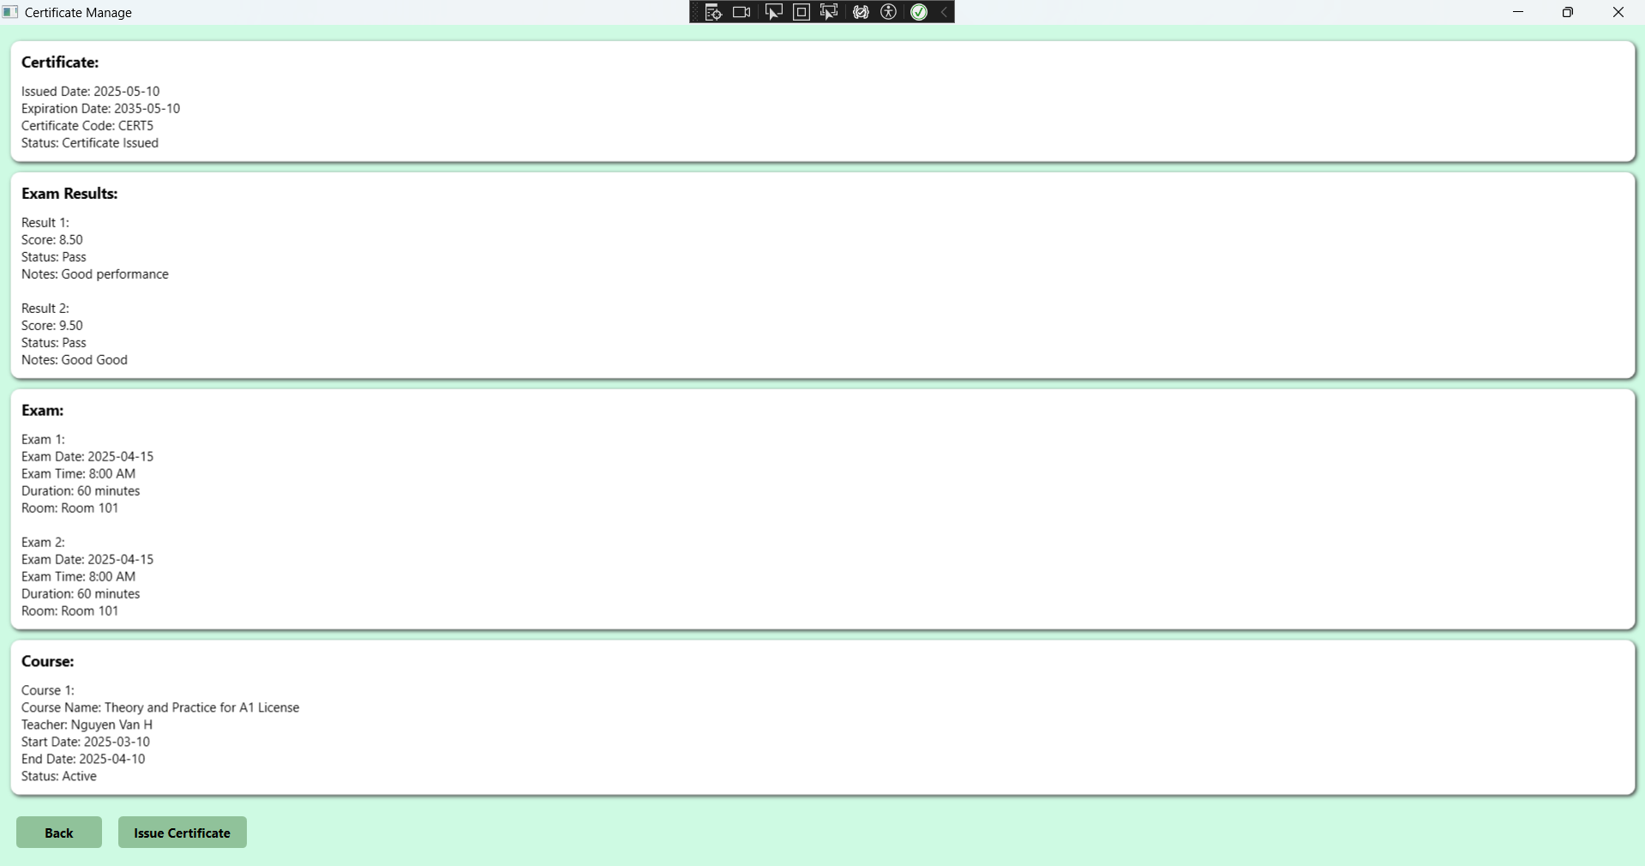

## 5. Admin

### 5.1. List User

Admin can view list user

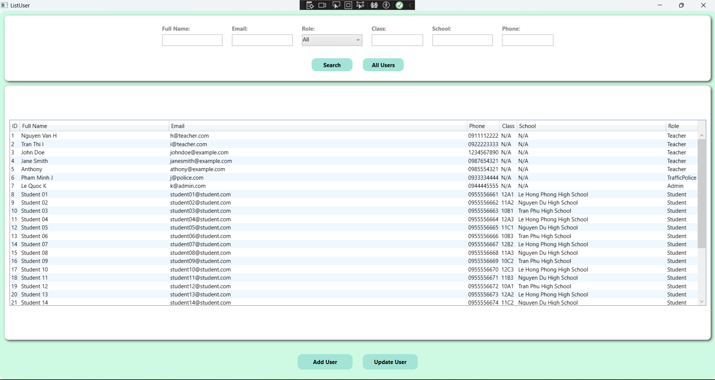

### 5.1. Add User

### 

Admin can add user

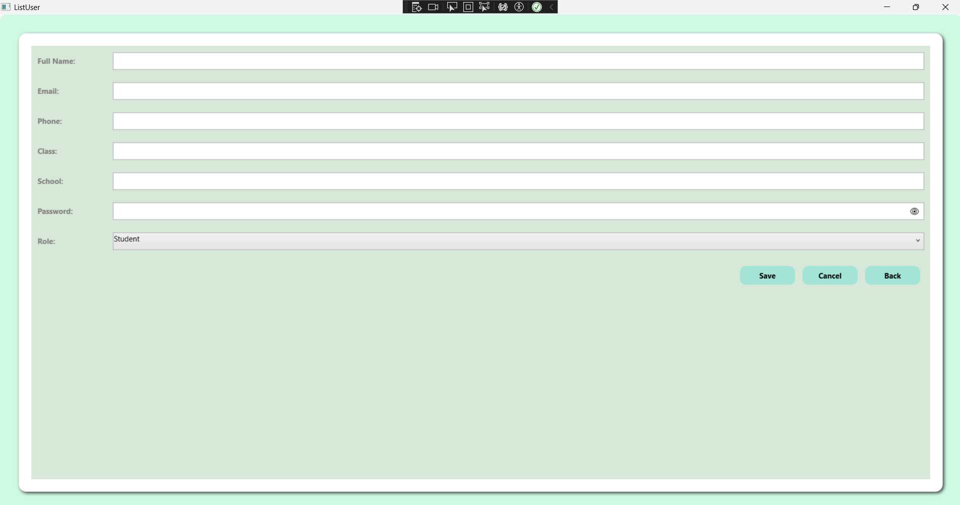

### 5.1. Statistics

Admin can view report about system

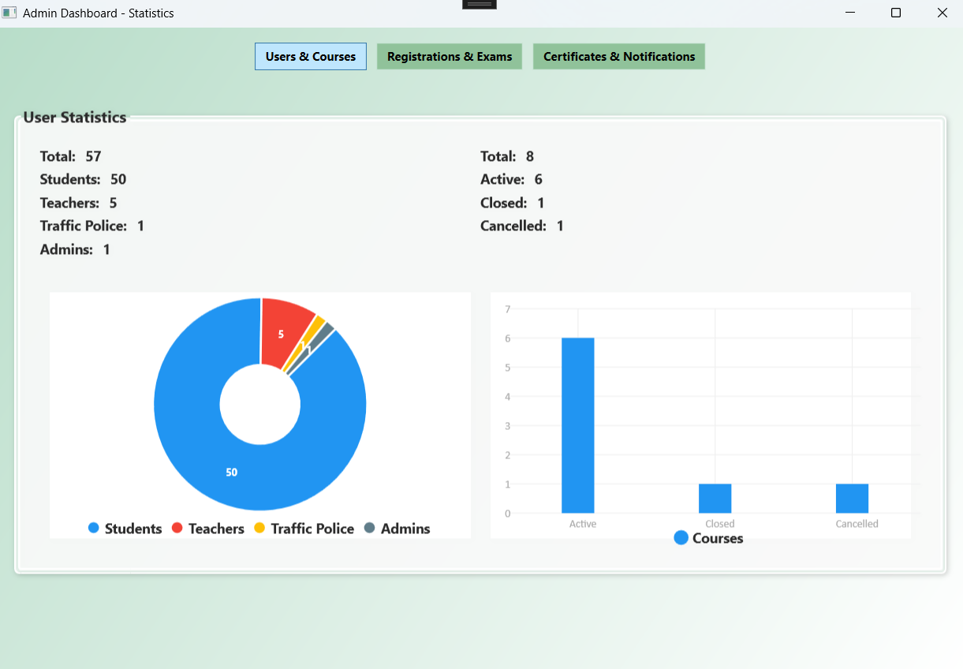

# III. Appendix

## 1. Assumptions & Dependencies

**AS-1:** The system will be used within the organization’s internal network by driving school administrators, teachers, and traffic police.

**DE-1:** Users are expected to have basic knowledge of using Windows desktop applications.

## 2. Limitations & Exclusions

**L-E :** The system will not support mobile platforms in the current version..

## 3. Business Rules

## 

**BR-1: Default Admin Account**

* The system includes a pre-configured Admin account for full system management.
* Default credentials: email is “admin@gmail.com” and password is “123”.

**BR-2: Default Teacher Account**

* The system includes a pre-configured Teacher account for managing courses and recording exam results.
* Default credentials: email “teacher@gmail.com” and password is “123”.

**BR-3: Default Traffic Police Account**

* The system includes a pre-configured Traffic Police account for supervising exams and approving certifications.
* Default credentials: MemberID is “police@gmail.com” and password is “123”.

**BR-4: Default Student Account**

* The system includes a pre-configured Student account for registering in courses and taking exams.
* Default credentials: MemberID is “Student” and password is “@student123”.