**Aim:** Design a web page which includes text, graphics, sound, video, and animation create your Institute website, Department Website and Tutorial website for specific subject**.**

**SOURCE CODE**

**index.html**

<!DOCTYPE html>

<html>

<head>

<title>Department Selection</title>

</head>

<body>

<h1>Select Department</h1>

<button onclick="location.href='civ.html'">CIV</button>

<button onclick="location.href='csb.html'">CSB</button>

<button onclick="location.href='csd.html'">CSD</button>

<button onclick="location.href='cse.html'">CSE</button>

<button onclick="location.href='csm.html'">CSM</button>

<button onclick="location.href='cst.html'">CST</button>

<button onclick="location.href='ece.html'">ECE</button>

<button onclick="location.href='eee.html'">EEE</button>

<button onclick="location.href='mec.html'">MEC</button>

</body>

</html>

**cst.html**

<!DOCTYPE html>

<html>

<head>

<title>CST Selection</title>

</head>

<body>

<h1>Select Year</h1>

<button onclick="location.href='year1.html'">1st Year</button>

<button onclick="location.href='year2.html'">2nd Year</button>

<button onclick="location.href='year3.html'">3rd Year</button>

<button onclick="location.href='year4.html'">4th Year</button>

</body>

</html>

**year1.html**

<!DOCTYPE html>

<html>

<head>

<title>1st Year</title>

</head>

<body>

<h1>Select Semester</h1>

<button onclick="location.href='year1sem1.html'">1st Sem</button>

<button onclick="location.href='year1sem2.html'">2nd Sem</button>

</body>

</html>

**year1sem1.html**

<!DOCTYPE html>

<html>

<head>

<title>1st Year 1st Sem</title>

</head>

<body>

<h1>Subjects - 1st Year 1st Sem</h1>

<ul>

<li><a href="https://gprec.ac.in/scheme-2020/GPREC-9X-SCHEME-2020%20CSE-CST%20STRUCTURE_SYLLABUS.pdf">Engineering Mathematics-I</a></li>

<li><a href="https://gprec.ac.in/scheme-2020/GPREC-9X-SCHEME-2020%20CSE-CST%20STRUCTURE_SYLLABUS.pdf">Applied Physics</a></li>

<li><a href="https://gprec.ac.in/scheme-2020/GPREC-9X-SCHEME-2020%20CSE-CST%20STRUCTURE_SYLLABUS.pdf">Elements of Electrical Engineering</a></li>

<li><a href="https://gprec.ac.in/scheme-2020/GPREC-9X-SCHEME-2020%20CSE-CST%20STRUCTURE_SYLLABUS.pdf">Electronic Devices and Circuits</a></li>

<li><a href="https://gprec.ac.in/scheme-2020/GPREC-9X-SCHEME-2020%20CSE-CST%20STRUCTURE_SYLLABUS.pdf">Programming for Problem Solving</a></li>

</ul>

</body>

</html>

**year1sem2.html**

<!DOCTYPE html>

<html>

<head>

<title>1st Year 2nd Sem</title>

</head>

<body>

<h1>Subjects - 1st Year 2nd Sem</h1>

<ul>

<li><a href="https://gprec.ac.in/scheme-2020/GPREC-9X-SCHEME-2020%20CSE-CST%20STRUCTURE_SYLLABUS.pdf">Engineering Mathematics-II</a></li>

<li><a href="https://gprec.ac.in/scheme-2020/GPREC-9X-SCHEME-2020%20CSE-CST%20STRUCTURE_SYLLABUS.pdf">Probability & Statistical Methods</a></li>

<li><a href="https://gprec.ac.in/scheme-2020/GPREC-9X-SCHEME-2020%20CSE-CST%20STRUCTURE_SYLLABUS.pdf">English</a></li>

<li><a href="https://gprec.ac.in/scheme-2020/GPREC-9X-SCHEME-2020%20CSE-CST%20STRUCTURE_SYLLABUS.pdf">Engineering Drawing</a></li>

<li><a href="https://gprec.ac.in/scheme-2020/GPREC-9X-SCHEME-2020%20CSE-CST%20STRUCTURE_SYLLABUS.pdf">Data Structures</a></li>

</ul>

</body>

</html>

**year2sem1.html**

<!DOCTYPE html>

<html>

<head>

<title>2nd Year 1st Sem</title>

</head>

<body>

<h1>Subjects - 2nd Year 1st Sem</h1>

<ul>

<li><a href="https://www.gprec.ac.in/scheme-2020/S-20-CST-Syllabus.pdf">Managerial Economics & Financial Accountancy</a></li>

<li><a href="https://www.gprec.ac.in/scheme-2020/S-20-CST-Syllabus.pdf">Switching Theory & Logic Design</a></li>

<li><a href="https://www.gprec.ac.in/scheme-2020/S-20-CST-Syllabus.pdf">Advanced Data Structures</a></li>

<li><a href="https://www.gprec.ac.in/scheme-2020/S-20-CST-Syllabus.pdf">Database Systems</a></li>

<li><a href="https://www.gprec.ac.in/scheme-2020/S-20-CST-Syllabus.pdf">Object Oriented Programming through Java</a></li>

</ul>

</body>

</html>

**year2sem2.html**

<!DOCTYPE html>

<html>

<head>

<title>2nd Year 2nd Sem</title>

</head>

<body>

<h1>Subjects - 2nd Year 2nd Sem</h1>

<ul>

<li><a href="https://www.gprec.ac.in/scheme-2020/S-20-CST-Syllabus.pdf">Operating Systems</a></li>

<li><a href="https://www.gprec.ac.in/scheme-2020/S-20-CST-Syllabus.pdf">Software Engineering & Applications</a></li>

<li><a href="https://www.gprec.ac.in/scheme-2020/S-20-CST-Syllabus.pdf">Computer Organization</a></li>

<li><a href="https://www.gprec.ac.in/scheme-2020/S-20-CST-Syllabus.pdf">Design and Analysis of Algorithms</a></li>

<li><a href="https://www.gprec.ac.in/scheme-2020/S-20-CST-Syllabus.pdf">Discrete Structures</a></li>

<li><a href="https://www.gprec.ac.in/scheme-2020/S-20-CST-Syllabus.pdf">Python Programming</a></li>

</ul>

</body>

</html>

**year3sem1.html**

<!DOCTYPE html>

<html>

<head>

<title>3rd Year 1st Sem</title>

</head>

<body>

<h1>Subjects - 3rd Year 1st Sem</h1>

<ul>

<li><a href="toc.mp4">Theory of Computation (Video)</a></li>

<li><a href="cn.mp4">Computer Networks (Video)</a></li>

<li><a href="ai.mp4">Artificial Intelligence (Video)</a></li>

<li><a href="pe.mp4">Professional Elective - I (Video)</a></li>

<li><a href="ooad.mp4">Professional Ethics (Video)</a></li>

</ul>

</body

**year3sem2.html**

<!DOCTYPE html>

<html>

<head>

<title>3rd Year 2nd Sem</title>

</head>

<body>

<h1>Subjects - 3rd Year 2nd Sem</h1>

<ul>

<li><a href="toc.mp3">Language Processors (Audio)</a></li>

<li><a href="cn.mp3">Big Data Technologies (Audio)</a></li>

<li><a href="ai.mp3">Foundations of Machine Learning (Audio)</a></li>

<li><a href="pe.mp3">Microprocessors and Microcontrollers - II (Audio)</a></li>

<li><a href="ooad.mp3">Professional Elective - II (Audio)</a></li>

</ul>

</body>

</html>

**year4sem1.html**

<!DOCTYPE html>

<html>

<head>

<title>4th Year 1st Sem</title>

</head>

<body>

<h1>Subjects - 4th Year 1st Sem</h1>

<ul>

<li><a href="https://www.geeksforgeeks.org/compiler-design/">Compiler Design</a></li>

<li><a href="https://www.geeksforgeeks.org/distributed-systems/">Distributed Systems</a></li>

<li><a href="https://www.geeksforgeeks.org/machine-learning/">Machine Learning</a></li>

<li><a href="https://www.geeksforgeeks.org/professional-ethics/">Professional Elective - III</a></li>

<li><a href="https://www.geeksforgeeks.org/professional-ethics/">Professional Elective - IV</a></li>

</ul>

</body>

</html>

**year4sem2.html**

<!DOCTYPE html>

<html>

<head>

<title>4th Year 2nd Sem</title>

</head>

<body>

<h1>Subjects - 4th Year 2nd Sem</h1>

<ul>

<li><a href="https://www.geeksforgeeks.org/cloud-computing/">Cloud Computing</a></li>

<li><a href="https://www.geeksforgeeks.org/cyber-security/">Cyber Security</a></li>

<li><a href="https://www.geeksforgeeks.org/blockchain/">Blockchain Technologies</a></li>

<li><a href="https://www.geeksforgeeks.org/professional-elective-v/">Professional Elective - V</a></li>

<li><a href="https://www.geeksforgeeks.org/professional-elective-vi/">Professional Elective - VI</a></li> </ul>

</body>

</html>

**OUTPUT:**

**home.html**

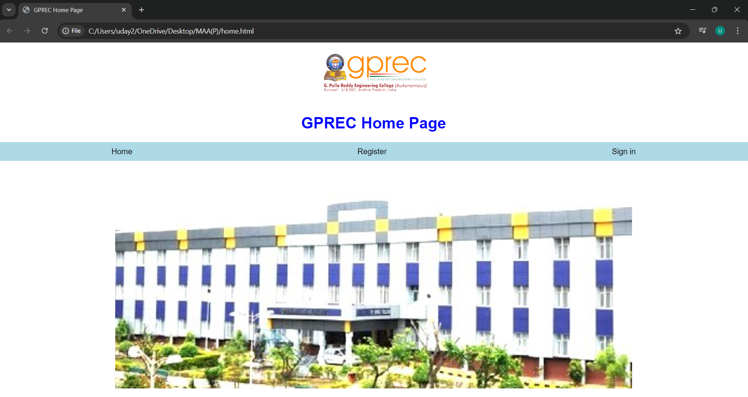

**index.html**

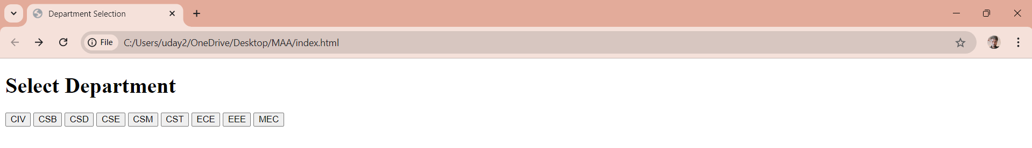

**cst.html**

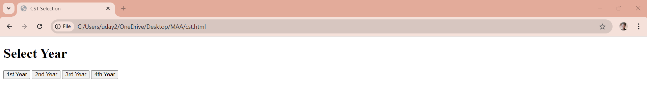

**year1.html**

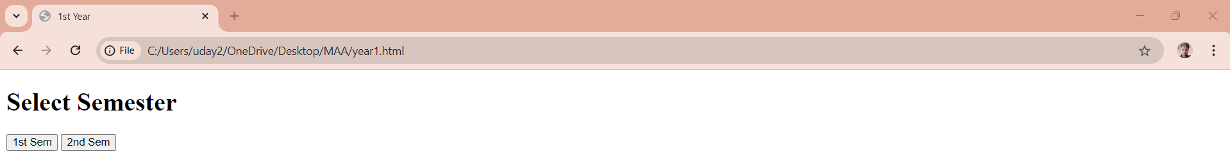

**year1sem1.html**

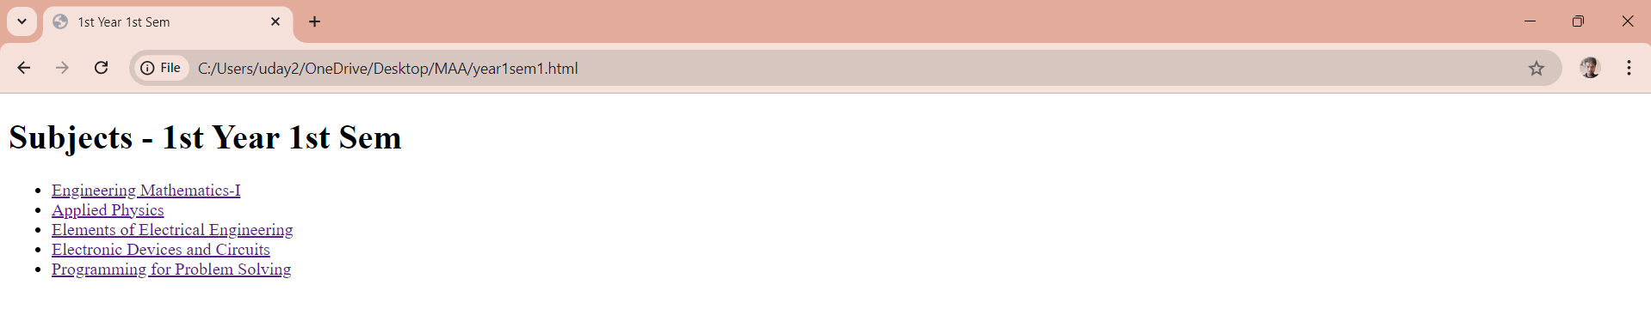

**On clicking Applied Physics Output:**

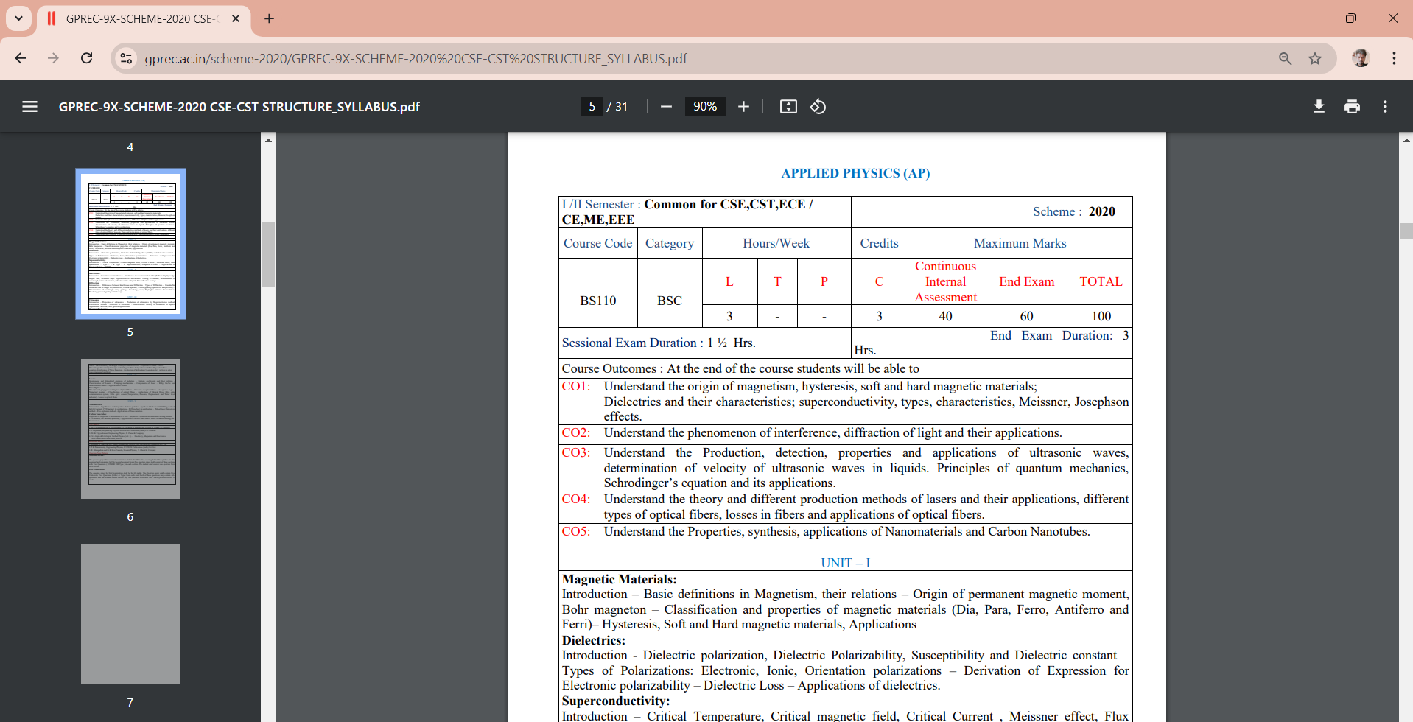

**Similarly, Video Output for Third Year Sem1 TOC Subject**

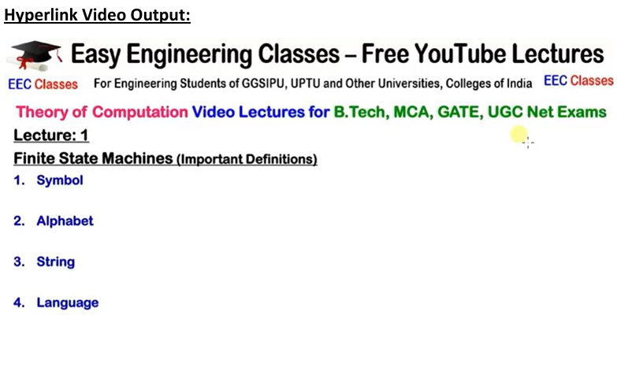

**Similarly, Audio Output for Third Year Sem2 BDT Subject**

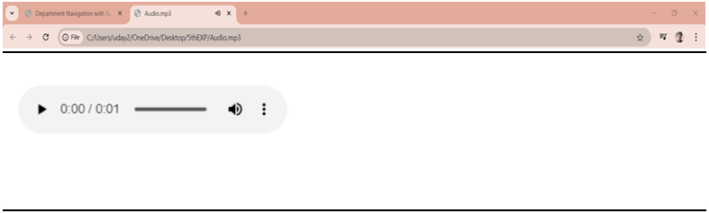

**Similarly, Audio Output for Fourth Year Sem1 CD Subject**

