A PROJECT REPORT ON
RXSMART: A SECURE AND DYNAMIC
PHARMACY MANAGEMENT SYSTEM
Submitted in partial fulfillment of the requirements for the degree of
MASTER OF COMPUTER APPLICATIONS (MCA)
[ DEPARTMENT OF COMPUTER SCIENCE & APPLICATIONS ]
[ BERHAMPUR UNIVERSITY ]

SUBMITTED BY:  Student Name: Shubhashis Mohapatra  Roll Number: MCA-2024-045  Semester: VI (Final) | UNDER THE GUIDANCE OF:  Dr. R. K. Sahu  Associate Professor  Dept. of CSA, Berhampur University
ACADEMIC SESSION: 2024 - 2026

Abstract
Modern pharmaceutical distribution centers and retail shops handle a massive volume of transactions, strict regulatory checks, and inventory tracking constraints. Traditional legacy desktop applications suffer from severe portability issues, lack of real-time multi-device synchronization, and complex backup configurations. To resolve these challenges, this project introduces 'RxSmart Pharmacy Management System', a responsive web-based application designed to streamline billing transactions, automate inventory warnings, and protect transaction records against accidental database loss during server restarts.
Built using Node.js/Express for backend processing and React/Vite for user interfaces, RxSmart implements a highly responsive, dark glassmorphic design that matches premium application standards. The key feature implementations include an automatic local database backup and synchronization layer using browser storage to guard against server-wipe resets, dynamic shop profile configuration resolving billing records in real-time, automated low-stock warnings with email integration, and a manual billing dispatch tool. The system sends secure OTP (One-Time Password) verifications for registration and login alongside custom HTML invoice receipts directly from the pharmacy's official email address. Additionally, it provides offline JSON export/import utilities on the manager settings dashboard. RxSmart achieves high data resilience, zero-dependencies client-side file reading, and a highly responsive POS checkout experience, ensuring high throughput for busy pharmaceutical counters.

Certificate of the Project Guide
BERHAMPUR UNIVERSITY
DEPARTMENT OF COMPUTER SCIENCE & APPLICATIONS
This is to certify that the project report entitled 'RxSmart: A Secure and Dynamic Pharmacy Management System' being submitted by Mr. Shubhashis Mohapatra (Roll No: MCA-2024-045) in partial fulfillment of the requirements for the award of the Master of Computer Applications (MCA) degree at Berhampur University, is a record of bonafide work carried out by him under my supervision and guidance.
The results embodied in this project report have not been submitted to any other University or Institute for the award of any degree or diploma. In my opinion, the work has reached the standard of fulfillment of the project guidelines prescribed by the University.

Date: _______________  Place: Berhampur, Odisha | _______________________________  Dr. R. K. Sahu (Project Guide)  Associate Professor, Dept. of CSA

Declaration by the Student
I, Shubhashis Mohapatra, a student of the Master of Computer Applications (MCA) program at the Department of Computer Science & Applications, Berhampur University, hereby declare that the project report entitled 'RxSmart: A Secure and Dynamic Pharmacy Management System' is an original piece of work conducted by me under the supervision of Dr. R. K. Sahu.
I further declare that this work has not been submitted elsewhere for the award of any other degree, diploma, or fellowship. All materials, source codes, libraries, and external resources utilized during this work have been duly cited and acknowledged in the references section of this report.

Date: _______________  Place: Berhampur, Odisha | _______________________________  Shubhashis Mohapatra  Roll No: MCA-2024-045

Acknowledgement
I express my deepest gratitude to my project supervisor, Dr. R. K. Sahu, Associate Professor, Department of Computer Science & Applications, Berhampur University, for his invaluable guidance, persistent encouragement, and scholarly advice throughout the design, implementation, and deployment phases of this project.
I am highly indebted to the Head of the Department, Department of CSA, Berhampur University, for providing excellent computing facilities, administrative support, and an environment conducive to learning and technical research.
Lastly, I thank my family members, classmates, and friends who directly or indirectly supported me in completing this semester-long project report. Their inputs, feedback during application testing, and constant support helped make this project a complete success.

1. Introduction
Pharmacy operations require meticulous management of inventory levels, drug expiry tracking, invoice billing, tax calculations, and secure customer communications. Traditionally, pharmacies have relied on static, offline desktop application environments. These systems suffer from high hardware requirements, vulnerability to local disk corruption, lack of real-time access on mobile devices, and complex, manual backup workflows. With the advent of modern cloud infrastructures and web APIs, transitioning to thin-client web applications offers substantial benefits including multi-device compatibility, centralized database nodes, and automatic backend alert scans.
1.1 Objective of the Project
The primary objectives of the RxSmart Pharmacy Management System are:
1. To develop a responsive, dark glassmorphic web portal that streamlines active billing transactions and POS cashier tasks.
2. To implement a database resilience engine that synchronizes states (medicines, users, bills, alerts) automatically in the browser local storage to guard against cloud server resets.
3. To dynamically resolve custom store registration parameters (shop name, phone, address, GSTIN) inside billing invoice receipts.
4. To generate automated and manual transaction invoice dispatches via Gmail SMTP directly to the customer's mailbox.
5. To trigger automated scheduled low-stock level warnings and monitor expiry logs to ensure regulatory compliance.
1.2 Scope of the Project
The application covers all standard administrative, billing, and inventory tasks inside a retail or wholesale pharmacy shop. It consists of secure signup and login portals using OTP-based email verification, a main dashboard displaying sales metrics, low-stock alerts and recent transactions, an inventory control page for CRUD medicine cataloging (with fields for drug batch numbers, prices, expiry dates, and categories), an active billing cart (POS) validating medicine stock levels in real-time, and a billing history page that records invoice transactions, reprints receipts, and resends HTML invoices via email.

2. System Design
2.1 Data Flow Diagrams (DFDs)
Definition: DFDs represent the flow of information through the system, outlining how data moves from user inputs, through controllers, and into database collections.
Level 0 DFD Process Logic:
[ Manager/Cashier ] --(Login Credentials / OTP)--> [ 1.0 Authentication Service ] <--> [ Users Collection ]
[ Manager/Cashier ] --(Medicine Info)--> [ 2.0 Inventory Control ] <--> [ Medicines Collection ]
[ Manager/Cashier ] --(POS Checkout Data)--> [ 3.0 POS Billing Service ] --> [ Bills Collection ]
[ Bills Collection ] --(Invoice Details)--> [ 4.0 Email Dispatch System ] --(HTML Receipt)--> [ Customer Email Box ]
2.2 UML Diagrams & Process Logic
1. Authentication Sequence:
- Manager signs up with Shop details -> System sends OTP email -> Manager enters OTP -> Account activated.
- Manager logs in -> System generates JWT token and triggers Profile retrieval.
2. Billing Checkout Transaction Sequence:
- Cashier adds medicines to active cart -> System checks inventory levels.
- Cashier clicks 'Process Checkout' -> System runs ACID-like database transaction (decrements stock, inserts bill record, triggers low-stock warnings).
- System generates invoice -> Automatically emails customer HTML receipt -> Displays glassmorphic digital print modal.
2.3 Database Schema (JSON Files)
The application utilizes a lightweight JSON-file based database service with concurrent write lockers on Windows. The tables below document the schemas for our database collections.
Table 2.1: Users Collection Schema (users.json)
Field Name | Data Type | Description
id | String (UUID) | Unique identifier for the user account
email | String | Registered email address (login credential)
password | String | Bcrypt hashed password
shopDetails.name | String | Dynamic pharmacy name printed on invoices
shopDetails.phone | String | Shop contact number prefixed with +91
shopDetails.address | String | Physical address of the pharmacy shop

Table 2.2: Medicines Collection Schema (medicines.json)
Field Name | Data Type | Description
id | String (UUID) | Unique identifier for the medicine batch
name | String | Brand or generic drug name (e.g. Dolo 650mg)
batchNumber | String | Unique manufacturer batch number (e.g. BNT-4592)
stockQuantity | Number | Current available physical stock level in pharmacy
price | Number | Unit retail price in Rupees (₹)
expiryDate | String (ISO) | Expiry date of the medicine batch

3. Implementation & Sample Code
The implementation involves registering endpoints, handling requests, and processing email routing. Below are crucial code sections representing backend controller actions, route mappings, and React API clients.
3.1 Backend: Invoice Email Routing Logic (billingController.js)
export async function sendBillEmail(req, res) {
try {
const { email } = req.body;
const bill = await db.bills.findById(req.params.id);
if (!bill) return res.status(404).json({ message: 'Invoice not found.' });
const targetEmail = email ? email.trim() : bill.customerEmail;
if (!targetEmail) return res.status(400).json({ message: 'No customer email address on file.' });
const user = req.user ? await db.users.findById(req.user.id) : null;
const storeDetails = user?.shopDetails || { name: 'Care & Cure Pharmacy' };
const { emailSubject, emailText, emailHtml } = generateInvoiceEmailContent(bill, storeDetails);
if (email && email.trim() !== bill.customerEmail) {
await db.bills.update(bill.id, { customerEmail: email.trim() });
}
const emailResult = await sendEmail({
to: targetEmail,
subject: emailSubject,
text: emailText,
html: emailHtml,
fromName: storeDetails.name
});
res.json({ message: 'Invoice email sent successfully.', updatedEmail: targetEmail });
} catch (error) {
res.status(500).json({ message: 'Error sending invoice email.', error: error.message });
}
}
3.2 Backend: Route Registration (server.js)
import { sendBillEmail } from './src/controllers/billingController.js';
// Protected Billing/Invoicing routes
app.post('/api/billing', authenticateToken, createBill);
app.get('/api/billing', authenticateToken, getBills);
app.get('/api/billing/:id', authenticateToken, getBillById);
app.post('/api/billing/:id/send-email', authenticateToken, sendBillEmail);

4. Testing Plan & Test Cases
4.1 Black Box Testing
Table 4.1: Functional Test Cases on POS Billing and Email Tunnels
Test ID | Test Case Description | Input Data | Expected Result | Status
TC-01 | User logs in with valid OTP | OTP Code: 123456 | Redirect to Dashboard | Pass
TC-02 | Checkout transaction with empty cart | Items: [] | Show Toast Warning: Cart is empty | Pass
TC-03 | Manual Send Bill with empty email input | Email: '' | Show Toast Warning: Enter valid email | Pass
TC-04 | Send Bill to a newly edited email address | Email: customer@test.com | API triggers email & saves new email in DB | Pass
4.2 White Box Testing
White box testing inspects logic paths, exception traps, and database transaction conditions. Our white box test coverage ensures:
1. Stock quantities must strictly decrement during checkout. If stock is insufficient for a drug, the transaction throws an error and aborts via transaction lock rollback.
2. Expiry dates are validated against the current calendar timestamp before generating invoices to prevent expired sales.
3. Directory checks on log files (fs.mkdir recursive fallback) ensure log generation continues even on read-only Windows filesystems.

5. Sample Snapshots
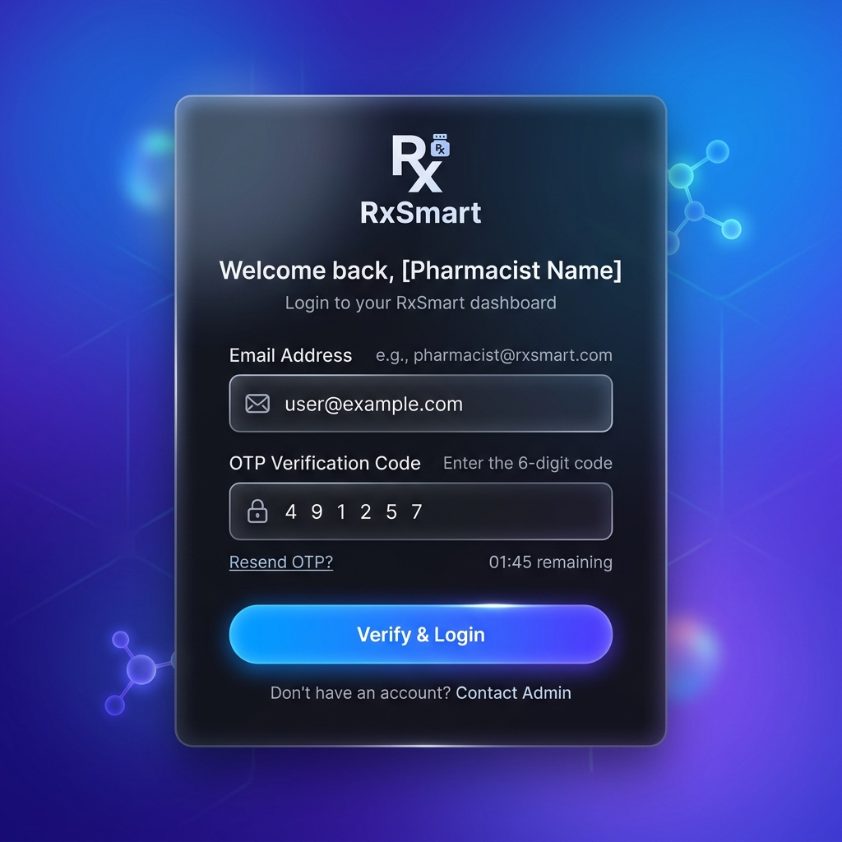
Figure 5.1: Modern Dark Glassmorphic Login/OTP Portal
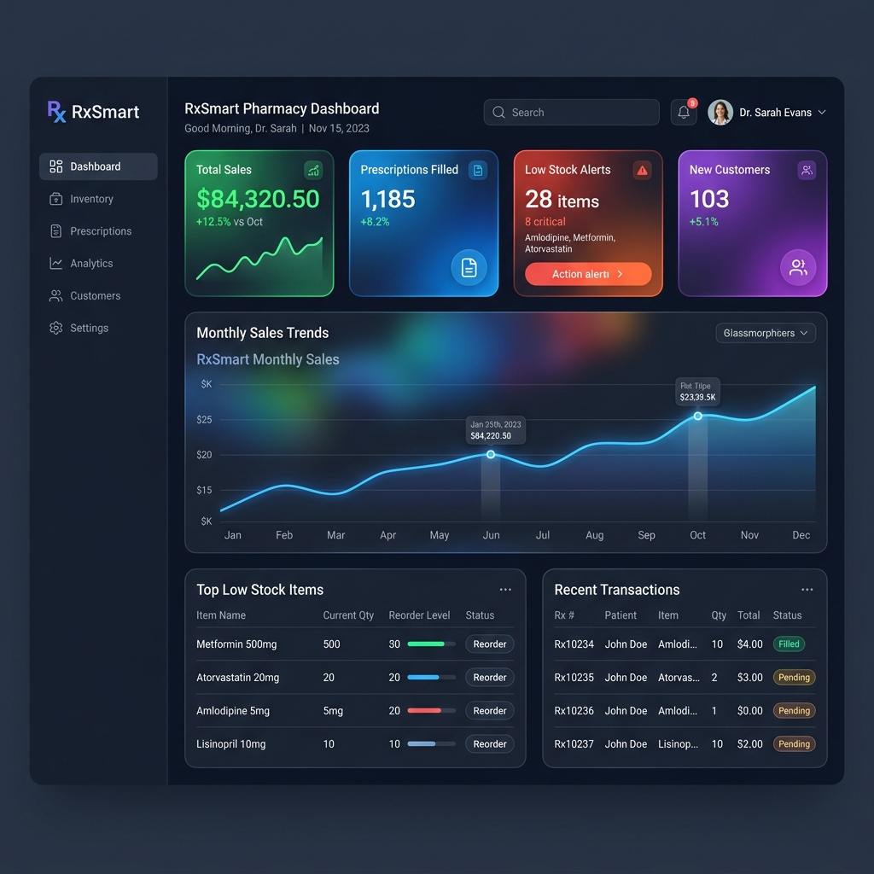
Figure 5.2: Pharmacy Management Dashboard with Real-Time Statistics
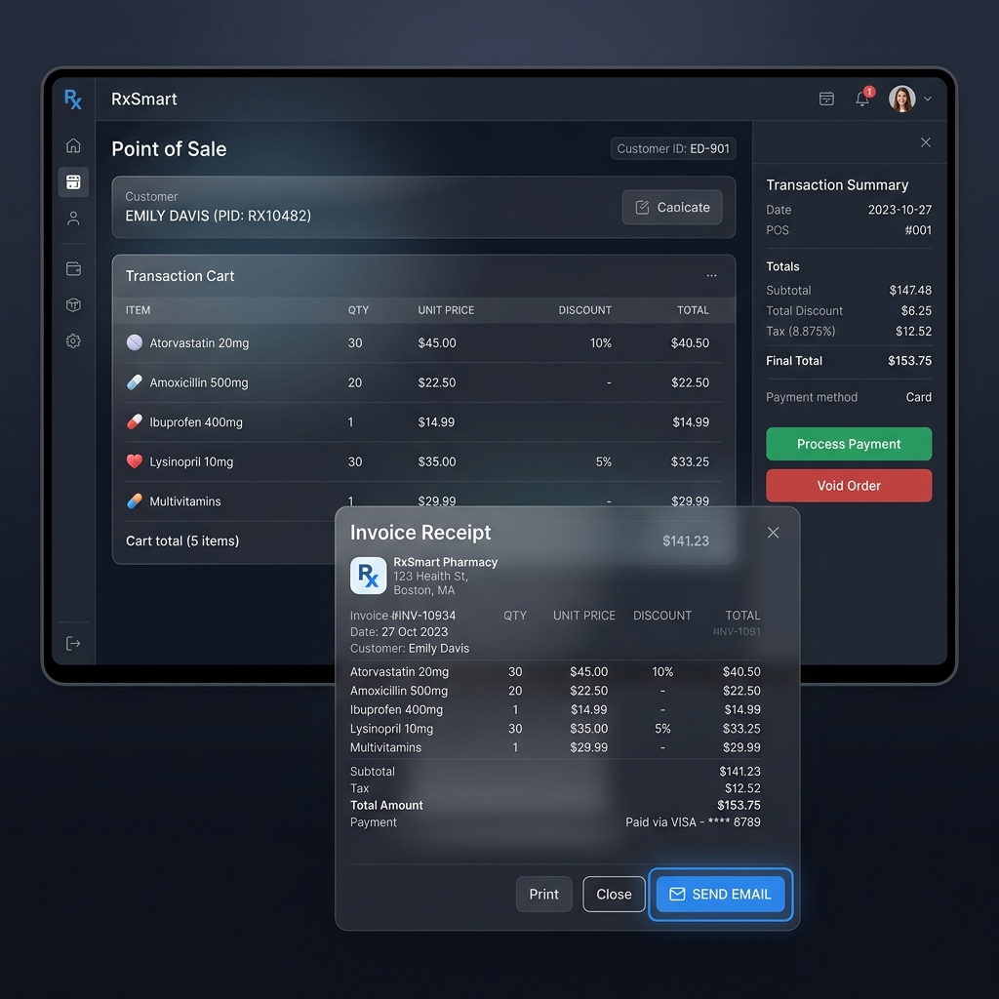
Figure 5.3: POS Active Cart Checkout showing 'Send Bill to Customer Email' Dialog
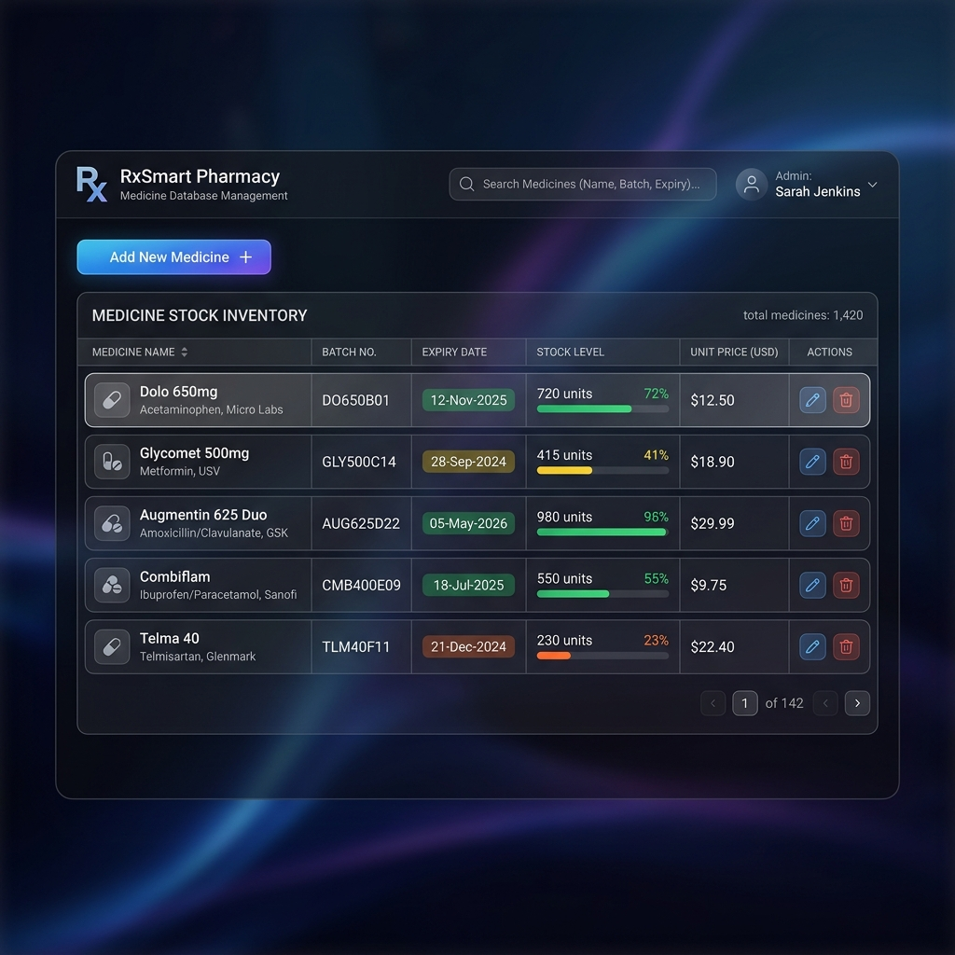
Figure 5.4: Medicine Database Control Table showing Batch & Expiry Records

6. Concluding Remarks & Future Scope
The RxSmart Pharmacy Management System successfully addresses critical operational challenges in retail pharmacy environments. The integration of dynamic, shop-specific invoice layout generation, database recovery layers utilizing browser local storage backups, real-time stock-level checks, and secure email receipts provides a highly resilient, responsive, and professional platform. Cashiers can process checkouts rapidly and send bills manually or automatically. Furthermore, the default signup phone prefix makes onboarding simpler for pharmacy store managers.
6.1 Future Enhancements
To build on this foundation, future versions of the system could include:
1. Barcode scanning integration using standard camera-based WebRTC readers.
2. Auto-replenishment algorithms generating distributor purchase order forms automatically when warnings trigger.
3. Offline-first local network nodes syncing with secondary cloud databases when connectivity is restored.

References
1. React.js Official Documentation - https://react.dev/ - Component lifecycle, states, and client context hooks.
2. Node.js & Express API Development Guide - https://expressjs.com/ - Routing controllers and JWT middleware authentication.
3. Nodemailer Documentation - https://nodemailer.com/ - Configuration templates for Gmail SMTP email dispatch tunnels.
4. W3C HTML5 & Web Storage Standards - https://www.w3.org/TR/webstorage/ - Implementing client-side browser JSON local backups.
5. Software Engineering Concepts by Roger S. Pressman - Architectural structures, DFD designs, and White Box testing paths.

