Nikko Rush

9/23/13

Calculator Design Document

Contents

Calculator Project 2

Controls: 2

Programming: 2

Results: 2

Features: 2

Layout: 2

Error handling 3

Display: 3

What you need to know: 3

# Calculator Project

## Controls:

## Need buttons for number input and for special operations like sqrt(), abs(), and trigonometric functions.

## Text box to display the answer and for the user to directly enter equations into the calculator

## Programming:

## The program will hold the values the user enters in a list of elements, numbers will be stored as doubles and the operators (+,-,*,/) will be part of a class called Operator. Each equation will be stored as a list of elements and operated on according to the rules of math.

## Results:

## Results are printed to the text box, clearing out anything that is already there

## Features:

* Allows the user to perform mathematical operations on numbers, and some basic algebraic manipulation on equations with variables.

## Layout:

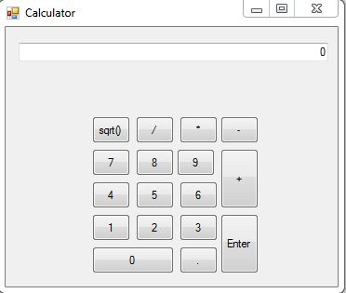

* Similar to that except form better sized to buttons and more common mathematic functions added in.

## Error handling:

* Errors will be printed to the same output window as the results are and also logged to a text file with a more detailed explanation of the error

## Display:

* I will display each number and operator as it is entered by the user

## What I need to know:

* I don’t think that there is anything else that I will need to know for this.