PoC
Kindly refer to the below RD for you to create a PoC for the purpose of evaluating your skills around AI/ML & coding. Make the solution for both the use cases mentioned below. If not both, try to come up with at least one -
Case -1 :
Write a program in a programming language of your choice (please specify) that performs the following actions:
- To read the PDF documents included in the Zip file (Case-1).
- Extract the required information from the PDF into an excel file/JSON containing two different sheets (Attribute Set-1, Attribute Set-2 [below is the definition])
- The program should be able to save the spreadsheet with an auto name (Attributes_MPN_MFR Name) into the "Document" folder.
Component Datasheet-1:
Part Number : SBC50-4-14-2
Attribute Set-1:
- Capacitance
- Voltage
- Current
Attribute Set-2:
- Length
- Width
- Height
Component Datasheet-2:
Part Number : 91864A002
Attribute Set-1:
- Head Type
- Material
- RoHS Compliance
Attribute Set-2:
- Length
- Head Diameter
Case -2 :
Write a program in a programming language of your choice (please specify) that performs the following actions:
- Request that the user enter an Input (MPN).
- Entered MPN should be only from the below given TableA

TableA (you can save it as new excelFile)
MPN | MANUFACTURER NAME | Material | RoHS
91864A028 | MCMASTER CARR SUPPLY | ? | ?
90044A249 | MCMASTER CARR SUPPLY | ? | ?
91251A107 | MCMASTER CARR SUPPLY | ? | ?
91251A105 | MCMASTER CARR SUPPLY | ? | ?

- The program should search the MPN on the website at https://www.mcmaster.com/.
- After the page has loaded, click on the “Product Detail”. (Click on Red box)

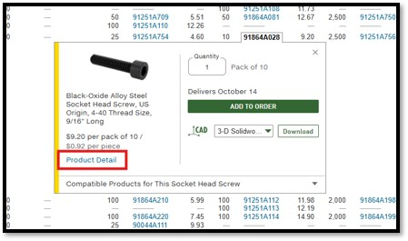

- After product detail page is loaded get the corresponding "Material" and "RoHS Compliance" status from there and then update the specific MPN’s Material & RoHS column value in above TableA.
- Save the complete Excel table with these two values filled in.
- The spreadsheet should be saved in the "Document" folder.

Requirements:
Your program should be able to handle different input data and provide accurate results.
You are allowed to use any libraries or frameworks that you deem necessary.
Please provide clear instructions on how to run your program and any assumptions made during the development process.

Evaluation Criteria:
Correctness and accuracy of the results.
Efficiency and performance of the code.
Code readability and organization.
Handling of edge cases and error scenarios.

