SCHOOL OF COMPUTER SCIENCE AND ARTIFICIAL INTELLIGENCE |  |  |  |  | DEPARTMENT OF COMPUTER SCIENCE ENGINEERING
Program Name: B. Tech |  |  |  | Assignment Type: Lab |  |  | Academic Year:2025-2026
Course Coordinator Name |  |  |  | Venkataramana Veeramsetty
Instructor(s) Name |  |  |  | Dr. V. Venkataramana (Co-ordinator)  Dr. T. Sampath Kumar  Dr. Pramoda Patro  Dr. Brij Kishor Tiwari  Dr.J.Ravichander  Dr. Mohammand Ali Shaik  Dr. Anirodh Kumar  Mr. S.Naresh Kumar  Dr. RAJESH VELPULA  Mr. Kundhan Kumar  Ms. Ch.Rajitha  Mr. M Prakash  Mr. B.Raju  Intern 1 (Dharma teja)  Intern 2 (Sai Prasad)  Intern 3 (Sowmya)  NS_2 ( Mounika)
Course Code |  |  | 24CS002PC215 | Course Title |  | AI Assisted Coding
Year/Sem |  |  | II/I | Regulation |  | R24
Date and Day  of Assignment |  |  | Week6 - Thursday | Time(s)
Duration |  |  | 2 Hours | Applicable to  Batches
AssignmentNumber:12.1(Present assignment number)/24(Total number of assignments)
 | Q.No. | Question |  |  |  |  |  | Expected Time  to complete
 | 1 | Lab 12: Algorithms with AI Assistance – Sorting, Searching, and Optimizing Algorithms  Lab Objectives:  - Apply AI-assisted programming to implement and optimize sorting and searching algorithms.  - Compare different algorithms in terms of efficiency and use cases.  - Understand how AI tools can suggest optimized code and complexity improvements.  Task 1: Implementing Bubble Sort with AI Comments  - Task: Write a Python implementation of Bubble Sort.  - Instructions:  - Students implement Bubble Sort normally.  - Ask AI to generate inline comments explaining key logic (like swapping, passes, and termination).  - Request AI to provide time complexity analysis.  - Expected Output:  - A Bubble Sort implementation with AI-generated explanatory comments and complexity analysis.  WITH OUT INLNE COMMENTS:  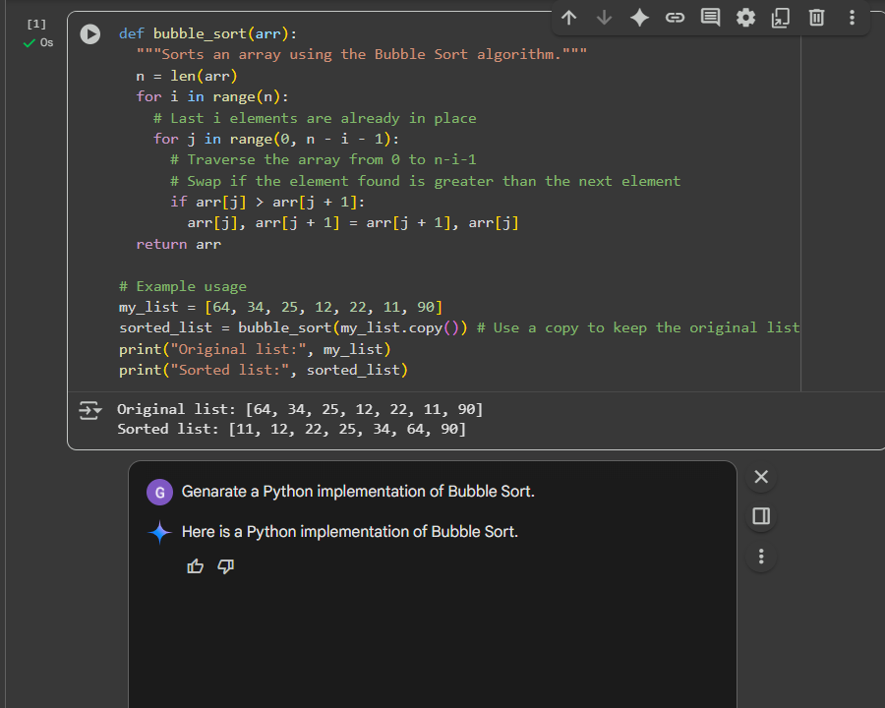  WITH INLINE COMMENTS:  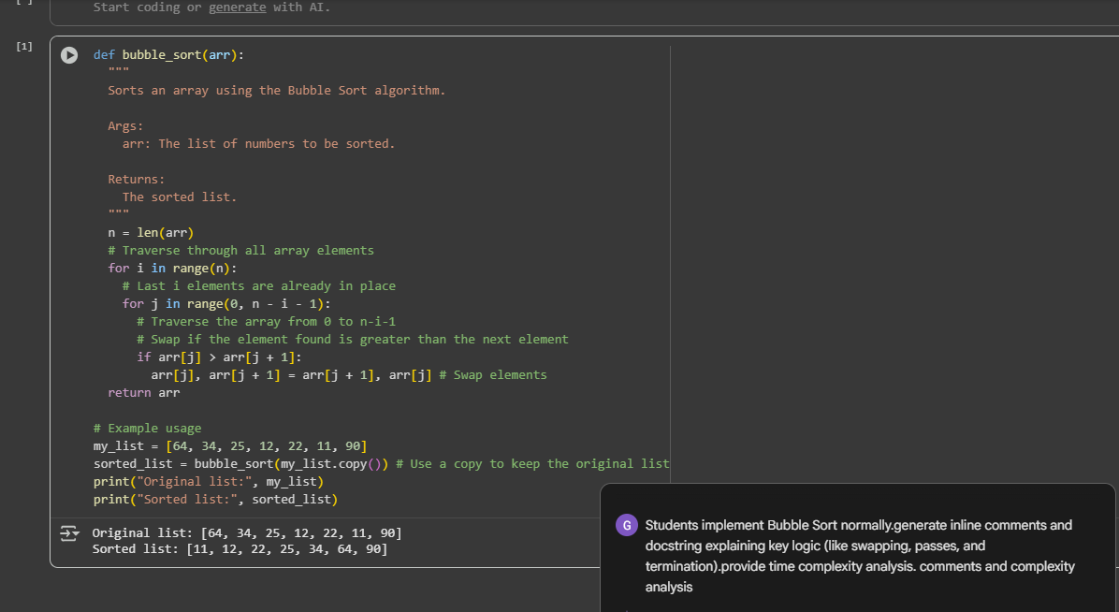  EXPLANATION:  - def bubble_sort(arr):: Defines a function called bubble_sort that takes a list arr as input.  - n = len(arr): Gets the length of the input list and stores it in variable n.  - for i in range(n):: This is the outer loop that iterates through the entire list. In each pass, the largest unsorted element "bubbles up" to its correct position at the end of the list. The range n ensures that the outer loop runs n times.  - for j in range(0, n - i - 1):: This is the inner loop that performs the comparisons and swaps within the unsorted portion of the list.  - n - i - 1 is used as the upper bound of the range because after each pass of the outer loop (i), the last i elements are already sorted and don't need to be compared.  - if arr[j] > arr[j + 1]:: This condition checks if the current element (arr[j]) is greater than the next element (arr[j + 1]).  - arr[j], arr[j + 1] = arr[j + 1], arr[j]: If the condition in the if statement is true, this line swaps the positions of the two elements.  - return arr: After the loops complete, the function returns the sorted list.  Task 2: Optimizing Bubble Sort → Insertion Sort  - Task: Provide Bubble Sort code to AI and ask it to suggest a more efficient algorithm for partially sorted arrays.  - Instructions:  - Students implement Bubble Sort first.  - Ask AI to suggest an alternative (Insertion Sort).  - Compare performance on nearly sorted input.  - Expected Output:  - Two codes (Bubble Sort + Insertion Sort).  - AI explanation of why Insertion Sort is more efficient for partially sorted data.  CODE:      EXPLANATION:  - for i in range(1, len(arr)):: This outer loop starts from the second element of the list (index 1) and iterates through the end of the list. The first element is considered already sorted.  - key = arr[i]: The current element being considered for insertion into the sorted portion is stored in the key variable.  - j = i - 1: This initializes an index j to the last element of the sorted portion of the array (which is just before the key).  - while j >= 0 and key < arr[j]:: This inner while loop compares the key with elements in the sorted portion of the array, moving backward from right to left.  - j >= 0: Ensures that the loop doesn't go out of bounds.  - key < arr[j]: Checks if the key is smaller than the current element in the sorted portion.  - arr[j + 1] = arr[j]: If the key is smaller, the current element arr[j] is shifted one position to the right to make space for the key.  - j -= 1: The index j is decremented to move to the next element on the left in the sorted portion.  - arr[j + 1] = key: Once the while loop finishes (either j becomes less than 0 or key is no longer smaller than arr[j]), the key is inserted into its correct position in the sorted portion of the array.  Task 3: Binary Search vs Linear Search  - Task: Implement both Linear Search and Binary Search.  - Instructions:  - Use AI to generate docstrings and performance notes.  - Test both algorithms on sorted and unsorted data.  - Ask AI to explain when Binary Search is preferable.  - Expected Output:  - Two implementations with docstrings.  - A student observation table comparing performance (Linear vs Binary Search).  Without inline comments:  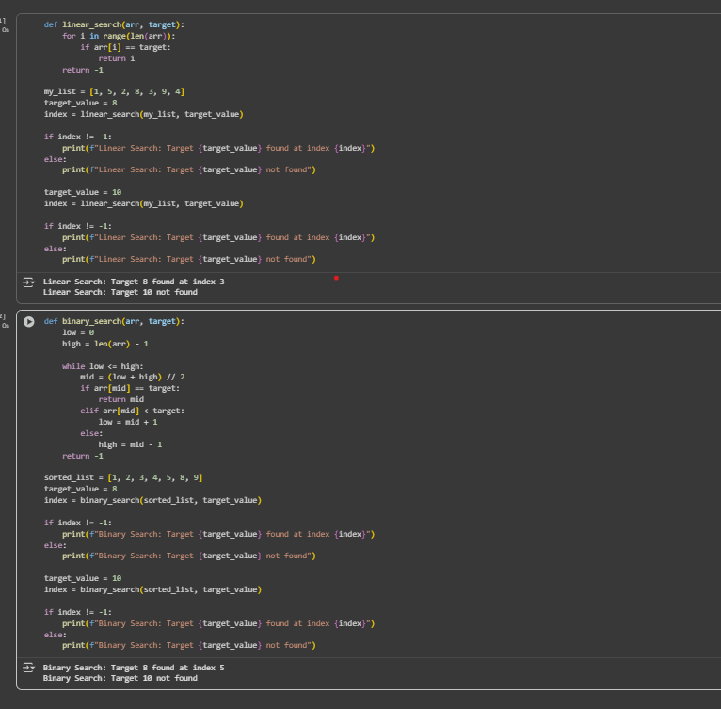  Linear Search and Binary Search :  Inline comments:  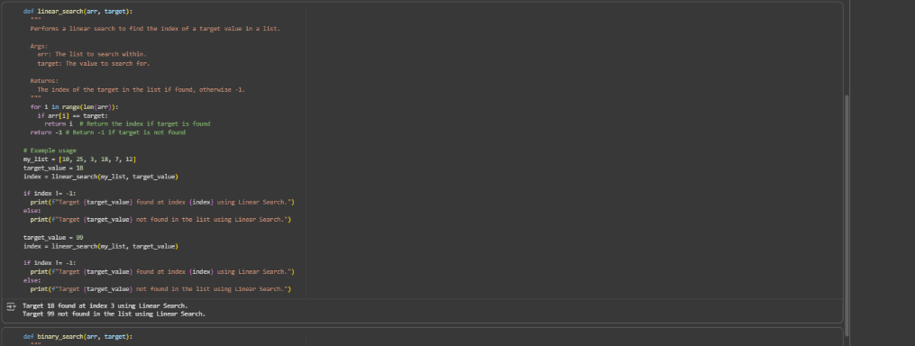  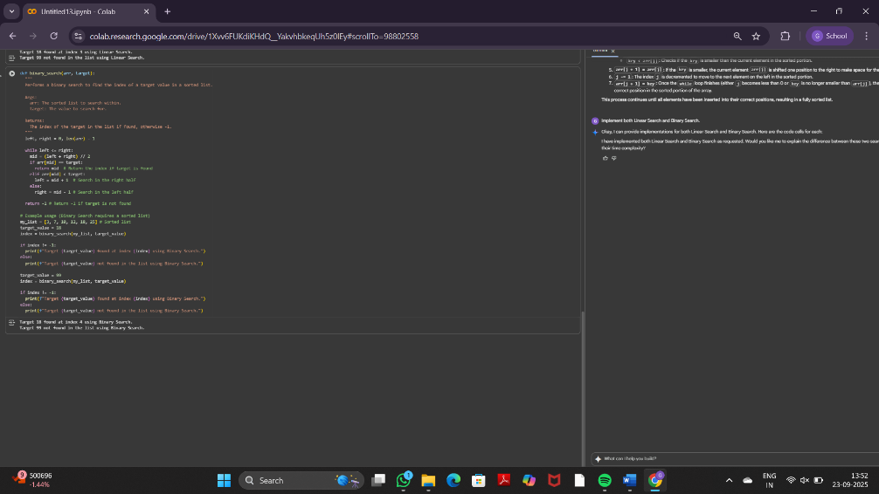  EXPLANATION:  - Insertion Sort: Builds the final sorted array one element at a time by inserting each element into its correct position within the already sorted portion.  - Bubble Sort: Repeatedly steps through the list, compares adjacent elements, and swaps them if they are in the wrong order. This process is repeated until the list is sorted.  The core reason Insertion Sort is better for partially sorted arrays is its adaptive nature. If an array is already mostly sorted, Insertion Sort requires fewer comparisons and shifts because elements are already close to their final positions. In contrast, Bubble Sort will still perform many comparisons and swaps even on a nearly sorted array because it repeatedly traverses the entire unsorted portion in each pass.  The markdown also mentions the time complexity:  - Insertion Sort: Has a best-case time complexity of O(n) when the array is already sorted. For partially sorted arrays, its performance is closer to this best case.  - Bubble Sort: Has a best-case time complexity of O(n) only if an optimization is used to stop early when no swaps occur. Without this optimization, its best-case is still O(n^2). Its average and worst-case time complexity is O(n^2).  Therefore, for partially sorted arrays, Insertion Sort's ability to quickly place elements that are already close to their correct positions makes it significantly faster than Bubble Sort. |  |  |  |  |  | Week6 - Thursday
Task 4: Quick Sort and Merge Sort Comparison
- Task: Implement Quick Sort and Merge Sort using recursion.
- Instructions:
  - Provide AI with partially completed functions for recursion.
  - Ask AI to complete the missing logic and add docstrings.
  - Compare both algorithms on random, sorted, and reverse-sorted lists.
- Expected Output:
  - Working Quick Sort and Merge Sort implementations.
  - AI-generated explanation of average, best, and worst-case complexities.
Prompt 1:
Code:
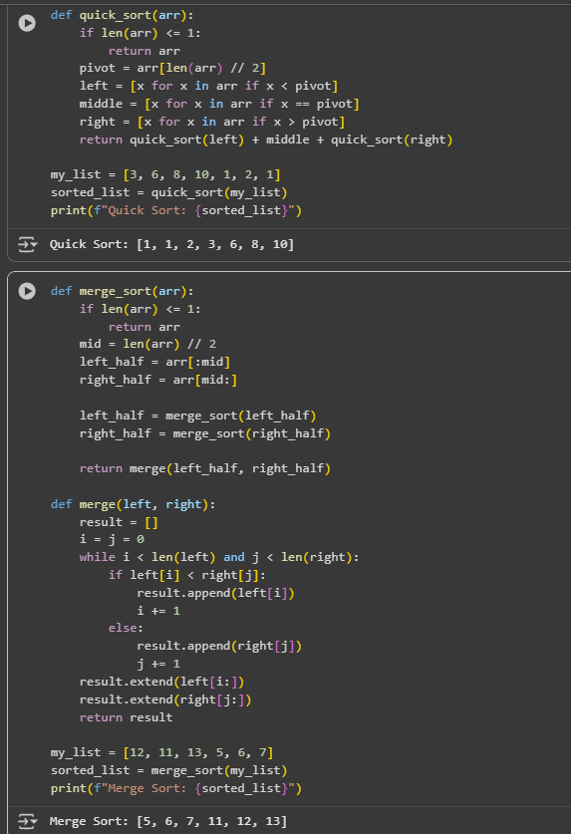
Prompt 2:

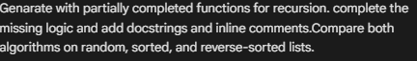
Code:
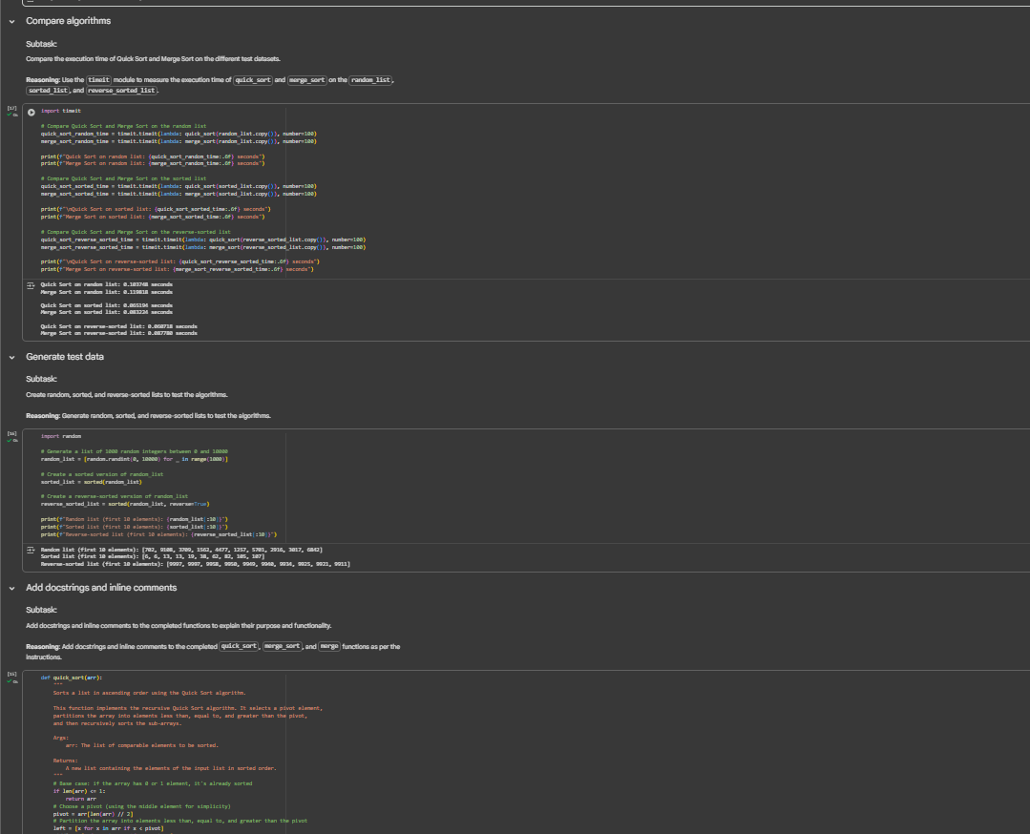
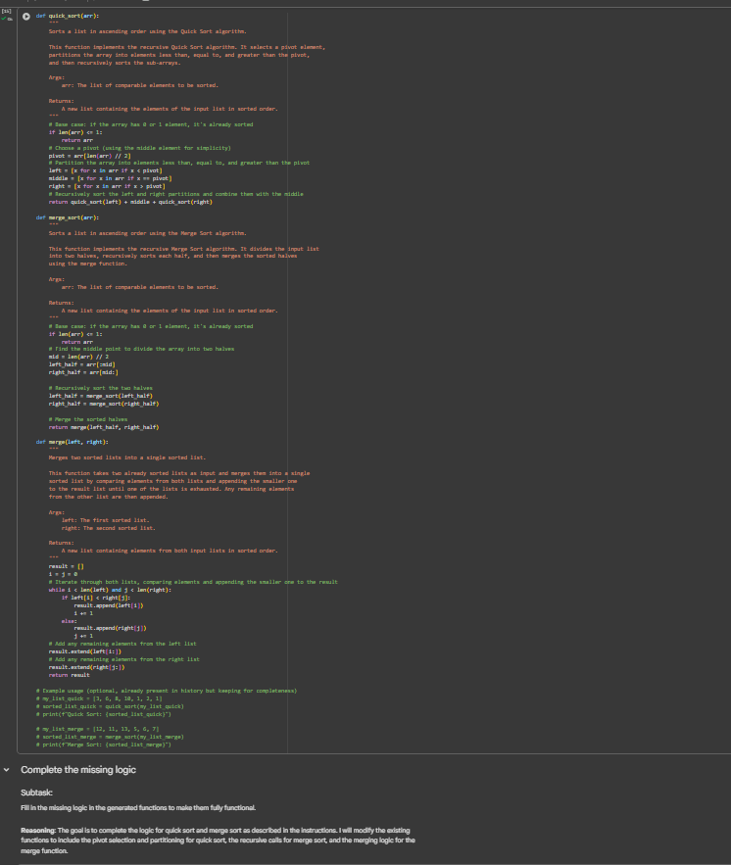

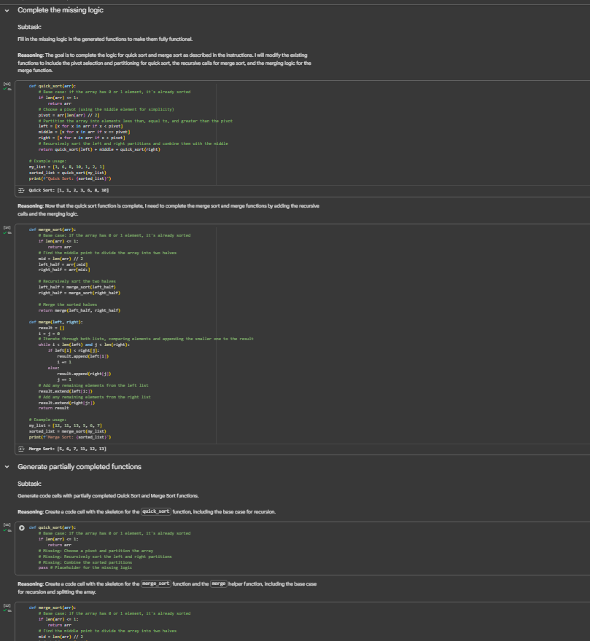
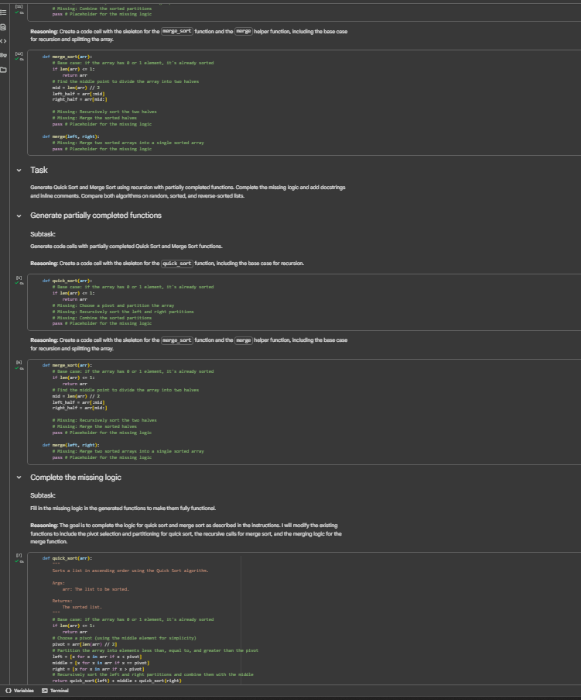
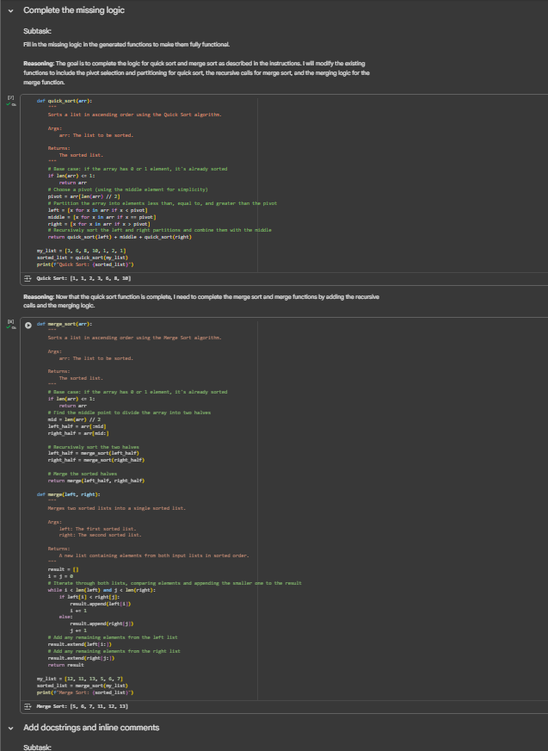
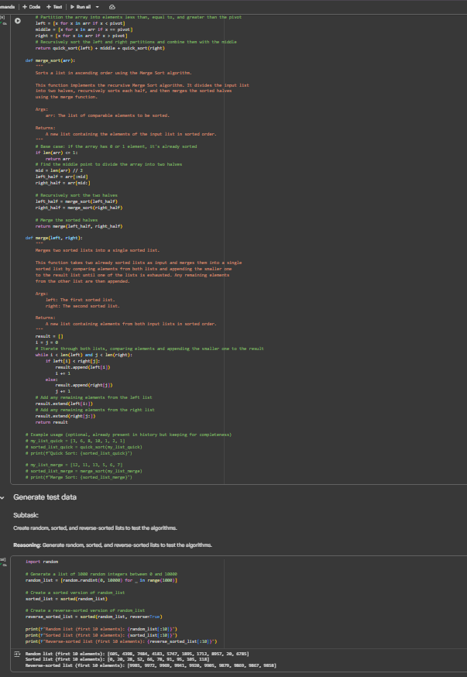
Task 5: AI-Suggested Algorithm Optimization
- Task: Give AI a naive algorithm (e.g., O(n²) duplicate search).
- Instructions:
  - Students write a brute force duplicate-finder.
  - Ask AI to optimize it (e.g., by using sets/dictionaries with O(n) time).
  - Compare execution times with large input sizes.
- Expected Output:
  - Two versions of the same algorithm (brute force + optimized).
  - AI explanation of how complexity was improved.
Prompt:

Code:
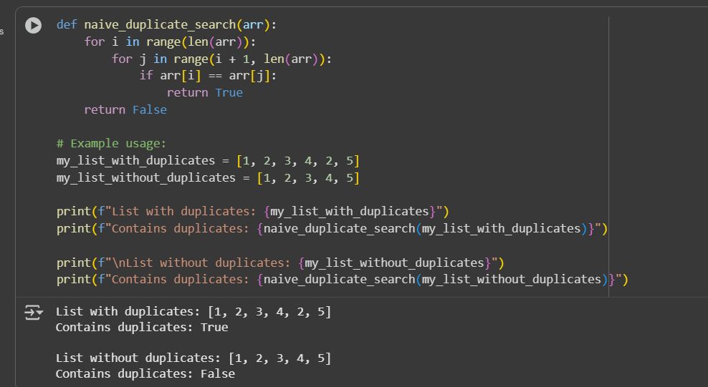

Prompt 2 :
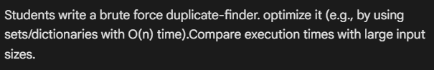
Code:
