ASSIGNMENT-19
Name-BandiSreesaicharan
Batch-03
2403a54088
Task 1: Translate a Simple Program (Python → JavaScript)
PROMPT:
Write a Python function print_numbers() that prints the first 10 natural numbers using a loop.
Then translate the same function into JavaScript as printNumbers(), and show how to call the function in both languages to display numbers 1 to 10.
CODE and OUTPUT:
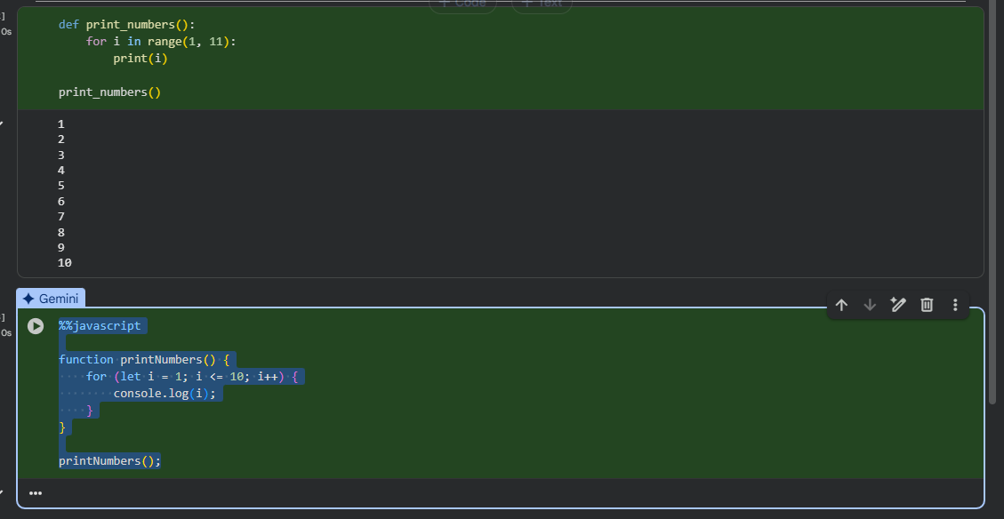
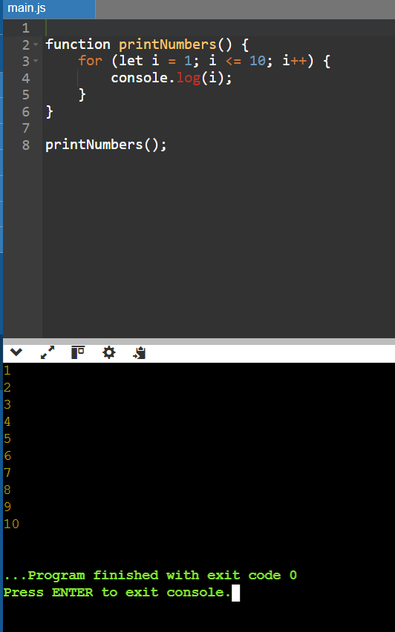
Task 2: Convert Conditional Statements (Java → Python)
PROMPT:
Write a Java method checkNumber(int num) that checks whether a number is positive, negative, or zero. Then translate it into a Python function check_number(num) that does the same. Call both versions with inputs -5, 0, and 7, and display the corresponding outputs.
CODE AND OUTPUT:
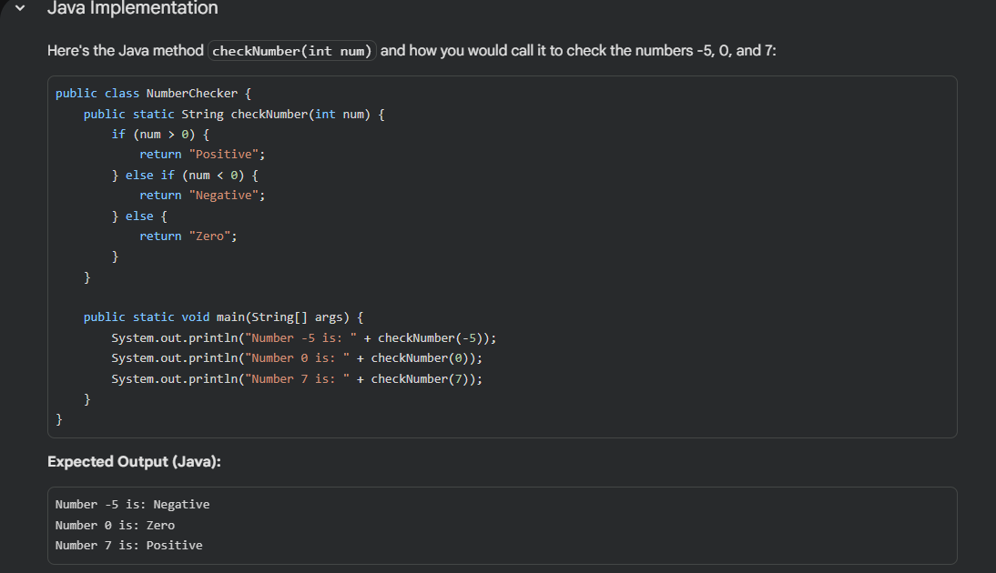
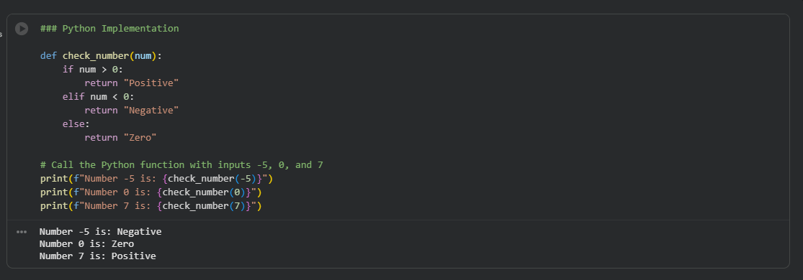
Task 3: Translate Recursive Function (Python → C++)
PROMPT:
ChatGPT said: Write a Python function factorial(n) that calculates the factorial of a number using recursion. Then translate it into a C++ function int factorial(int n) with the same logic. Call both functions with inputs 5 and 0, and display the outputs (Factorial = 120 and Factorial = 1).
CODE and OUTPUT:
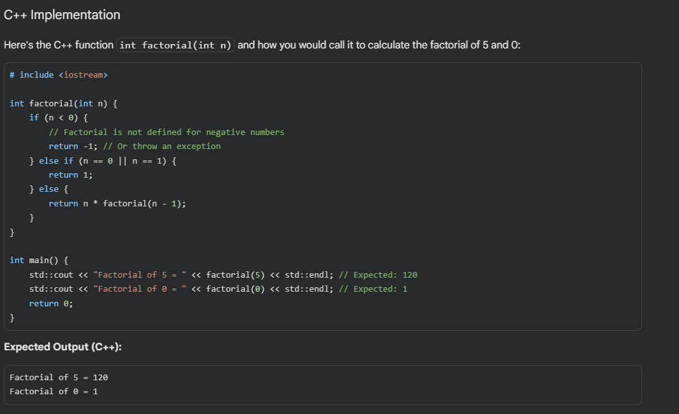
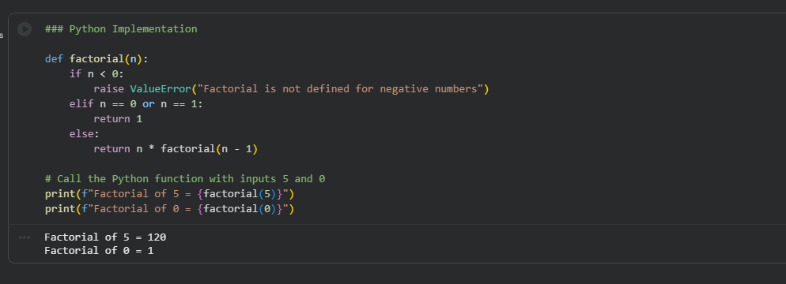
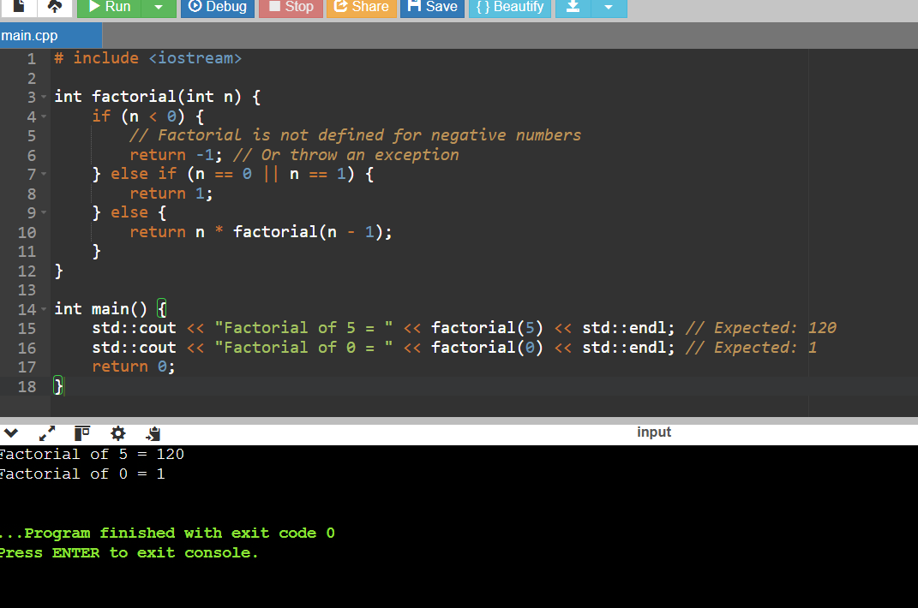
Task 4: Data Structures with Functions (JavaScript → Python)
PROMPT:
Write a JavaScript function printStudents(students) that takes an array of student names and prints each name. Then translate it into a Python function print_students(students) using a list.
CODE AND OUTPUT:
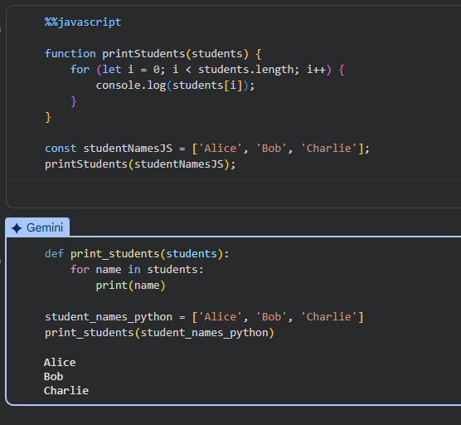
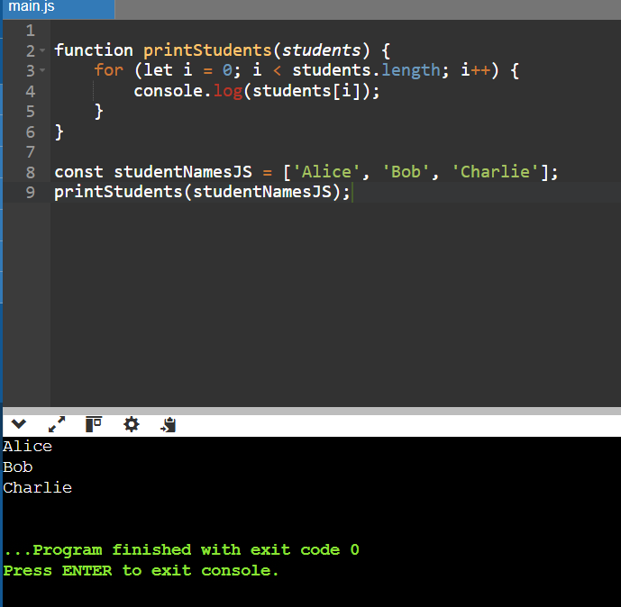

Task 5: Class & Object Translation (Python → Java)
PROMPT:
Write a Python class Car with attributes brand, model, and year, and a method display_details() that prints the car details. Then translate it into a Java class Car with the same attributes and a method displayDetails()
CODE AND OUTPUT:
