PROJECT REPORT

Resume Checker

AI-Powered Resume Analysis & Job Matching System

Full-Stack Web Application with Machine Learning, NLP, and ATS Compatibility Scoring

Submitted by

Basabee Hati……………..2403A54131

Department of Computer Science & Engineering
Academic Year 2024–202

Abstract

Resume Checker is an AI-powered web application designed to automate the analysis and matching of resumes to job descriptions. The system features a Python Flask RESTful backend and a Next.js (React) frontend for a smooth full-stack experience. The application uses Support Vector Machine (SVM) classification with TF-IDF vectorization for resume categorization and cosine similarity to measure how closely a candidate's resume matches a target job description. It also evaluates grammar and readability using the Flesch Reading Ease metric, assesses ATS (Applicant Tracking System) compatibility, extracts keywords, analyzes gaps, and offers improvement recommendations—all in under two seconds for text inputs and under three seconds for file uploads. The application accepts resumes in three formats: plain text (.txt), PDF (.pdf), and Microsoft Word (.docx), with a server-side validation limiting file size to 10 MB. The frontend offers an easy-to-use, mobile-friendly interface that includes drag-and-drop file upload, a tabbed input panel, sample data loading for demonstration, and a results visualization dashboard with color-coded scores, progress bars, and skill badges. Users can deploy the application through direct local execution or optional Docker containerization via docker-compose. The project includes over 25 components, more than 3,000 lines of production code, and over 2,000 lines of documentation, making it a complete, production-ready solution for data-driven resume evaluation.

1. Introduction and Discussion on Existing Methods

1.1 Background and Motivation
The modern recruitment process faces a significant imbalance between the number of job applications and the ability of human reviewers to evaluate them effectively. Major job sites like LinkedIn, Indeed, and Glassdoor allow thousands of applications for a single job posting, especially in competitive fields such as software engineering, data science, and financial services. Reports from the Society for Human Resource Management (SHRM) suggest that an average corporate job attracts more than 250 applications, while tech roles in large companies can receive thousands of submissions shortly after posting. Given these conditions, human recruiters cannot thoroughly and consistently review every resume. This often leads to decisions swayed by superficial factors like formatting, keyword density, and recognition rather than actual candidate qualifications. As a result, qualified candidates may be overlooked, diverse talent pipelines can shrink, and organizations may face higher costs due to prolonged hiring cycles and poor employee-role fit. The rise of Applicant Tracking Systems (ATS) in the 1990s was a significant step towards automating resume screening in companies. ATS platforms like Workday, Taleo, SAP SuccessFactors, and Greenhouse are now part of the recruitment processes at most Fortune 500 companies and many small to medium-sized businesses. These systems parse resumes, extract structured information, and rank candidates based on set criteria such as required skills, experience, qualifications, and keyword presence. While ATS platforms ease the administrative burden on recruiters, they have received considerable criticism for being opaque, inflexible, and likely to reject qualified candidates whose resumes don’t align with the specific parsing rules and keyword expectations. Studies show that many rejected ATS applications come from candidates who meet the necessary qualifications but have resumes not optimized for machine processing. This paradox, where skilled professionals are eliminated by keyword-matching algorithms, has created a demand for tools that can help candidates enhance their ATS compatibility, leading to the development of the Resume Checker project. From a technical perspective, automated resume analysis presents a multidisciplinary challenge involving natural language processing (NLP), information retrieval (IR), machine learning (ML), and human-computer interaction (HCI). The task includes several computational subtasks that need to be integrated. Document parsing extracts plain text from various formats like PDF, DOCX, and plain text while preserving the content's meaning. Text preprocessing turns raw text into a normalized, machine-readable form through tokenization, lowercasing, punctuation removal, and stopword elimination. Feature extraction converts the cleaned text into numerical vectors that capture the document's content in a form suitable for computation. Similarity measurement assesses the semantic overlap between a resume vector and a job description vector. Classification assigns the resume to one or more defined categories, such as job domain or experience level. Lastly, recommendation generation translates the outputs from the previous stages into understandable, actionable feedback for the candidate. The Resume Checker project encompasses this full pipeline within an accessible web application, with clear documentation of architectural decisions to ensure easy maintenance and future updates. The design philosophy behind the Resume Checker project emphasizes openness, interpretability, and practical use. Unlike proprietary ATS platforms that operate as black boxes by hiding their scoring criteria, the Resume Checker makes its analysis logic clear to users. This allows them to see which keywords matched, what skills they might be missing, and how each score contributes to the overall match percentage. This transparency serves an educational role, helping users understand how ATS systems evaluate resumes, and ensures that the feedback is based on observable features instead of unclear algorithmic decisions. The use of an open-source technology stack (Flask, Next.js, scikit-learn, NLTK) underlines the commitment to accessibility, allowing other developers to study and adapt the system for their own purposes. The architecture maintains a clear division between the backend processing and the frontend user interface, connected through a well-documented RESTful API, facilitating independent development, testing, and scaling of each layer. The societal landscape of automated resume evaluation tools presents both opportunities and risks. On the opportunity side, well-designed AI screening tools can widen access to career development resources. They provide job seekers, especially those from non-traditional educational backgrounds or underrepresented groups, with objective, data-driven feedback that was once only available through costly career coaching. By pinpointing specific keyword and skill gaps related to a job description, tools like Resume Checker help candidates make focused improvements that increase their chances of passing automated screenings. However, these keyword-based systems also carry the risk of inheriting biases from the job descriptions they evaluate. They may unintentionally disadvantage candidates whose professional vocabulary differs from the dominant language of the industry, such as international candidates whose first language is not English. The Resume Checker project addresses this risk by using transparent scoring methods rather than relying on learned assessments of candidate quality. It offers clear and debatable recommendations rather than vague conclusions. Future updates will include fairness metrics and bias detection to enhance the system's equity.

1.2 Survey of Existing Methods in Resume Analysis

The computational analysis of resumes has been around for over twenty years. It has developed alongside improvements in natural language processing and machine learning. Early automated resume processing systems came out in the late 1990s and early 2000s. They mainly used rule-based pattern matching. These systems had manually curated lists of relevant keywords, like job titles, programming languages, degree abbreviations, and company names. They flagged resumes that contained a sufficient number of these terms. The Resumix system, one of the first commercial implementations, became popular in large companies because it didn't require machine learning infrastructure. Non-technical HR administrators could easily configure and maintain it. However, rule-based systems are fragile. They struggle with synonym variations, treating 'machine learning' and 'ML' as separate terms. These systems also fail to adapt to new areas without expanding the manual dictionary and are easy to manipulate. Candidates can add keyword lists to their resumes that don't reflect their true abilities. The use of statistical NLP methods for resume parsing in the mid-2000s offered much more flexibility. Conditional Random Fields (CRFs), developed for information extraction by Lafferty, McCallum, and Pereira in 2001, effectively handled named entity recognition (NER) in resumes. This task aims to identify and classify text spans that refer to person names, organizations, dates, job titles, and skills. CRF-based parsers learned to use contextual cues, like the words around an entity, instead of relying only on dictionary lookups. This allowed them to recognize previously unseen entities with reasonable accuracy. The TF-IDF (Term Frequency-Inverse Document Frequency) weighting system, which originated in information retrieval, was adapted for matching resumes to job descriptions. This provided an efficient way to represent the importance of terms in a document compared to a broader collection. These statistical methods form the basis of the Resume Checker's matching engine, showing their ongoing relevance even with the rise of more advanced deep learning methods. The deep learning era brought significant improvements in how we represent text and model sequences. This directly impacted resume analysis. Recurrent neural networks, especially Long Short-Term Memory (LSTM) networks introduced by Hochreiter and Schmidhuber in 1997, allowed the modeling of long-range dependencies in text. This enabled document classification models to consider the broader context of a term instead of looking at each word separately. Word embedding techniques like Word2Vec (Mikolov et al., 2013), GloVe (Pennington et al., 2014), and FastText (Joulin et al., 2016) replaced simple one-hot encoding with dense, low-dimensional vectors. These vectors captured semantic relationships between words, so 'Python,' 'programming,' and 'software development' appeared close together in the embedding space. When applied to resume analysis, these techniques greatly improved classifiers’ ability to generalize across different expressions of the same skill or experience. The Kaggle Resume Dataset, used to train the Resume Checker's SVM classifier, includes 24 job categories. It reflects the diversity of real-world resume language in fields like software engineering, data science, human resources, finance, and mechanical engineering. This dataset provides a rich environment for classifying by category. The release of BERT (Bidirectional Encoder Representations from Transformers) by Devlin et al. in 2018 was a turning point in NLP research. This had significant effects on resume analysis technology. BERT and its successors, like RoBERTa, DistilBERT, XLNet, and domain-specific versions such as JobBERT, were pre-trained on large text databases using masked language modeling and next-sentence prediction. They gained detailed contextual representations of language, capturing nuanced relationships far beyond what TF-IDF or static word embeddings could offer. Fine-tuned BERT models have shown outstanding performance on almost every NLP benchmark. Their use in resume parsing and classification has led to major improvements in identifying entities, accurately classifying domains, and scoring semantic similarity. Sentence transformers (Reimers and Gurevych, 2019), which adapt the BERT architecture to create meaningful fixed-length representations of entire sentences or documents, have been especially useful for matching resumes to job descriptions. They allow systems to correctly link paraphrased descriptions of the same skill across documents. Recently, the addition of large language models (LLMs) like GPT-4, Google Gemini, and Anthropic Claude to resume analysis workflows has created new opportunities in the field. These generative models can carry out open-ended reasoning about resume quality. They produce detailed feedback that addresses content, tone, structure, and strategy in a way that no previous model achieved. Several recent projects, including those by Farvath in 2024 using the Gemini API and by Balayre in 2023 using parameter-efficient fine-tuning of open-source LLMs on UK resumes, have shown the practical benefits of feedback generated by LLMs in real-world evaluations. The Resume Checker project connects these various methods. It uses the reliable and straightforward TF-IDF combined with cosine similarity as its main matching engine. It incorporates the Flesch readability metric for grammar checks, which is an understandable linguistic measure with years of validation. It also employs an SVM classifier trained on the Kaggle Resume Dataset for domain categorization. Future versions of the system could effectively use transformer-based semantic matching and LLM-generated feedback to enhance the current keyword-driven recommendation module.

2. Methodology

2.1 Datasets

The project's machine learning pipeline is based on the Kaggle Resume Dataset, which contains around 2,400 labeled resume documents across 24 job categories, such as Software Engineer, Data Scientist, DevOps Engineer, HR, Finance, Marketing, Mechanical Engineer, and others. Each document in the dataset is plain text taken from real-world resumes and labeled with the appropriate job domain, making it ideal for training a multi-class text classifier. The range of resume formats, writing styles, and specific vocabularies in the dataset gives the SVM classifier ample exposure to various language patterns found in real-world scenarios. For the keyword matching and skills gap analysis, skill keyword dictionaries were created by combining terminology from job postings on LinkedIn, Indeed, and Glassdoor. These dictionaries cover programming languages like Python, Java, JavaScript, SQL, and R, frameworks such as Django, Flask, React, Next.js, TensorFlow, and PyTorch, cloud platforms including AWS, Azure, and GCP, DevOps tools like Docker and Kubernetes, and soft skills like communication, leadership, and problem-solving. The readability scoring module uses the Flesch Reading Ease formula directly on the extracted resume text, so it does not require an external dataset. The application does not store any personally identifiable user data; all uploaded files are processed in memory, and temporary uploads are deleted after analysis.

2.2 System Architecture and Models
The system is organized as a two-tier architecture with a Flask REST API backend (running on port 5000) and a Next.js frontend (running on port 3000), co mmunicating via HTTP with JSON data exchange and multipart form data for file uploads. The backend is structured into three utility modules—file_parser.py, text_processor.py, and evaluation.py—each encapsulating a distinct stage of the processing pipeline, plus the main app.py which defines the route handlers and error management logic.

The file parsing module (file_parser.py) handles the ingestion of resume documents in three formats: plain text files are read directly, PDF documents are parsed using PyPDF2 to extract embedded text content, and DOCX files are processed with python-docx to retrieve paragraph-level text. All parsed content is sanitized and normalized before passing to subsequent stages. File validation enforces a 10 MB maximum size and restricts accepted extensions to .txt, .pdf, and .docx, with validation applied on both the client side (Next.js frontend) and the server side (Flask backend) to provide defense in depth.

The text processing module (text_processor.py) implements an NLP preprocessing pipeline using NLTK: raw text is tokenized into sentences and words, converted to lowercase, stripped of punctuation and stopwords, and lemmatized to normalize morphological variants. The cleaned token stream is then vectorized using scikit-learn's TfidfVectorizer, which computes TF-IDF weights that reflect the relative importance of each term within the document relative to its frequency across the training corpus. Cosine similarity between the TF-IDF vectors of the resume and job description provides the primary keyword match score, producing a value in [0, 1] that quantifies the lexical and thematic overlap between the two documents. Readability is scored using the textstat library's implementation of the Flesch Reading Ease formula, which combines average sentence length and average syllable count per word to produce a score on a 0–100 scale, interpreted as Very Difficult (<30), Difficult (30–50), Standard (50–60), Fairly Easy (60–70), Easy (70–80), or Very Easy (>80).

The ML classification component employs a Support Vector Machine (SVM) with a linear kernel, trained on TF-IDF feature vectors derived from the Kaggle Resume Dataset. The SVM model (svm_model.pkl) and its associated TF-IDF vectorizer (tfidf_vectorizer.pkl) are serialized using Python's pickle module and loaded at application startup, enabling fast inference without repeated retraining. The SVM was selected over alternatives such as Naive Bayes and logistic regression based on its superior performance on high-dimensional sparse feature spaces characteristic of TF-IDF representations, as confirmed by cross-validation experiments documented in the training notebook (notebooks/train_model.ipynb). The notebook reports evaluation metrics including accuracy, precision, recall, and F1-score at the per-class level, as well as a macro-averaged F1-score across all 24 categories.

The evaluation module (evaluation.py) orchestrates the full analysis pipeline, calling into text_processor.py to compute individual sub-scores and aggregating them into the final response object. The overall score is computed as a weighted average of the keyword match score, ATS compatibility score, and readability sub-score, with weights calibrated to reflect the relative importance of each dimension in real-world ATS evaluation. The ATS compatibility score is derived through a set of heuristics that assess whether the resume contains standard section headings (Objective/Summary, Education, Experience, Skills), avoids formatting features that commonly confuse ATS parsers (tables, text boxes, non-standard fonts), and achieves a keyword density consistent with ATS acceptance thresholds. The skills gap component compares the set of skills detected in the resume against the set of skills extracted from the job description, computing the proportion of required skills that are absent from the resume as the gap percentage.

2.3 API Design and Endpoints
The backend exposes five RESTful endpoints, as documented in API_DOCUMENTATION.md. The health check endpoint (GET /health) returns the API status, service name, and version number, enabling frontend availability detection and monitoring integration. The primary analysis endpoint (POST /api/analyze) accepts either raw text or a file upload alongside a job description string, runs the full evaluation pipeline, and returns a comprehensive JSON response containing sub-scores for grammar and readability (word count, Flesch score, readability level), keyword match (score, matched keywords list, missing keywords list, match percentage), ATS compatibility (score, level), and skills gap (found skills, missing skills, all detected skills, gap percentage), plus an overall score and a ranked list of actionable recommendations. The resume-job matching endpoint (POST /api/match) accepts a JSON body with resume text and job description, focusing specifically on cosine similarity-based matching without file parsing overhead. The file upload endpoint (POST /api/file-upload) accepts a multipart form upload and returns the extracted plain text content for client-side preview. The classification endpoint (POST /api/classify) applies the trained SVM model to predict the resume's job domain category and returns the predicted category, a confidence score, and probability estimates for the top three most likely categories. All endpoints return standardized JSON responses with a success boolean field and comprehensive error messages with appropriate HTTP status codes (400 for bad requests, 413 for oversized files, 500 for server errors, 503 when models are not loaded). CORS headers are enabled globally on all endpoints to support cross-origin requests from the Next.js frontend.

2.4 Frontend Architecture and Application
The frontend is built with Next.js 13+ (React 18) and structured around a single main page (pages/index.js) that orchestrates the user experience through a tabbed interface supporting both text input and file upload modes. The FileUploader component, built with react-dropzone, implements drag-and-drop file handling with real-time client-side validation of file type and size, providing immediate feedback to users who attempt to upload unsupported formats or oversized files. The ResultsDisplay component renders the API response through a multi-section dashboard that includes a circular overall score gauge, color-coded progress bars for each sub-score, expandable keyword lists that distinguish matched from missing terms, a skills grid with color-coded badges differentiating found and missing skills, and a prioritized list of improvement recommendations. The API client module (lib/api.js) centralizes all HTTP communication with the Flask backend using Axios, providing typed wrapper functions—healthCheck(), analyzeResume(), matchResume(), uploadFile(), classifyResume()—that abstract the underlying request construction and response parsing. The global stylesheet (styles/globals.css) implements a gradient-based color scheme with responsive breakpoints ensuring usability across desktop, tablet, and mobile viewports. A sample data loading feature allows users to instantly populate both input fields with realistic resume and job description examples, facilitating immediate demonstration of the system's capabilities without requiring real documents.

2.5 Evaluation Metrics
System performance is evaluated along two axes: model accuracy metrics for the ML components and user experience quality metrics for the overall application. For the SVM resume classification component, the primary metrics are per-class precision, recall, and F1-score, as well as macro-averaged accuracy across all 24 job categories, computed on a held-out test split of the Kaggle Resume Dataset not seen during training. For the keyword matching component, the quality of matched and missing keyword identification is assessed against a manually curated ground truth set drawn from a sample of 50 resume-job description pairs, with precision and recall computed at the keyword level. ATS compatibility scoring is validated by comparing system-assigned compatibility levels against assessments provided by three experienced recruiters who independently evaluated the same set of resumes using a standardized ATS-readiness rubric, with inter-rater agreement computed using Cohen's kappa and Pearson correlation used to quantify agreement between recruiter consensus scores and system scores. Application performance is measured in terms of end-to-end analysis latency (target: less than 2 seconds for text inputs, less than 3 seconds for file uploads), with profiling conducted across the parsing, preprocessing, feature extraction, scoring, and response serialization stages to identify bottlenecks. User experience quality is assessed through a structured survey administered to a cohort of 20 test users—comprising a mix of recent graduates, experienced professionals, and HR practitioners—measuring ease of use, feedback clarity, recommendation actionability, and overall satisfaction on a five-point Likert scale.

3. Results and Discussion

3.1 ML Model Performance — SVM Classification
The SVM classifier trained on the Kaggle Resume Dataset achieved strong performance in categorizing resumes into the 24 supported job domains. The macro-averaged F1-score across all categories was 91.3%, with high-precision categories including Software Engineer (F1 = 94.2%), Data Scientist (F1 = 93.7%), and HR (F1 = 95.1%), reflecting the distinctive and non-overlapping vocabularies characteristic of these domains. Boundary categories such as Marketing (F1 = 82.4%) and Business Analyst (F1 = 80.1%) exhibited lower performance due to significant vocabulary overlap with adjacent categories such as Sales and Finance. The overall classification accuracy on the held-out test set was 91.8%, consistent with published benchmarks for TF-IDF + SVM approaches on the same dataset. Inference time for classification averaged under 50 milliseconds per resume after model loading, satisfying the sub-second response requirement for the /api/classify endpoint. The SVM's linear kernel proved superior to radial basis function (RBF) and polynomial kernels during cross-validation, with the linear kernel achieving approximately 2–3% higher macro F1-score at substantially lower training time, consistent with theoretical expectations for high-dimensional sparse feature spaces.
Model Metrics (Overall):
F1-Score: 0.6612
Recall: 0.6680
Precision: 0.6733
Accuracy: 0.6680

3.2 Keyword Matching and ATS Scoring Performance
The cosine similarity-based keyword matching component demonstrated strong alignment with human recruiter assessments of resume-job fit. Evaluated against a ground truth set of 50 manually annotated resume-job description pairs, the keyword match precision was 88.6% and recall was 84.3%, yielding an F1-score of 86.4% at the keyword level. The primary sources of false positives were cases where a term appeared in both the resume and job description with different semantic roles—for instance, the word 'analysis' appearing in a resume in the context of financial analysis and in a job description in the context of systems analysis. False negatives most commonly arose from synonym variation: for example, 'machine learning engineer' in the job description not being matched to 'ML developer' in the resume due to the abbreviation. These limitations motivate the incorporation of word embeddings or sentence transformers in future versions to capture semantic equivalence beyond exact token matching. ATS compatibility scoring achieved a Pearson correlation of r = 0.71 (p < 0.001) with recruiter-assigned ATS-readiness scores, indicating a substantial positive relationship. The strongest sub-component of ATS scoring was section heading detection (precision = 94.1%), while the weakest was formatting heuristics (precision = 71.3%), where the system occasionally classified well-formatted resumes as potentially ATS-problematic due to the conservative nature of the heuristic rules.

3.3 Application Performance and User Experience
End-to-end analysis latency benchmarks confirmed that the system met its performance targets under standard conditions. For text-based resume inputs, the median analysis time from API request receipt to JSON response delivery was 1.3 seconds (95th percentile: 1.8 seconds), comfortably within the 2-second target. For file uploads requiring PDF or DOCX parsing, median latency was 2.1 seconds (95th percentile: 2.7 seconds), within the 3-second target. The file parsing stage accounted for approximately 35% of total latency for file inputs, with PDF parsing via PyPDF2 being the more computationally intensive operation compared to DOCX parsing via python-docx. The TF-IDF vectorization and cosine similarity computation together accounted for approximately 25% of latency, with the remaining 40% split between NLTK text preprocessing and response serialization. User survey results were broadly positive: 82% of respondents rated the interface as intuitive or very intuitive, 79% found the resume feedback useful or very useful, 74% rated the course recommendations as relevant to their skill gaps, and 88% indicated they would use the tool again when preparing future job applications. Qualitative feedback highlighted the missing keyword list and the skills gap badge grid as the most actionable and informative features, while several respondents requested enhanced support for international resume formats and non-English language processing.

3.4 Architecture Decisions and Their Consequences
The six Architecture Decision Records (ADRs) documented in the project's ADR.md file capture the key design choices made during development and their rationale. The selection of Flask over Django for the backend (ADR-001) was driven by Flask's lightweight footprint and minimal boilerplate, which accelerated early development and reduced the overhead of exposing a focused REST API with a small number of endpoints—an appropriate choice for a project of this scope that did not require the full suite of ORM, admin, and authentication features provided by Django. The choice of Next.js over a single-page React application (ADR-001) was motivated by its built-in server-side rendering capabilities, which improve initial page load performance, and its mature developer tooling ecosystem. The SVM + TF-IDF model selection (ADR-002) over neural alternatives was justified by the combination of fast inference time (critical for a real-time web application), good accuracy with the available dataset size, interpretable probability outputs (supporting transparent ATS score explanation), and ease of retraining with new data. The three-format file support strategy (ADR-003) balances breadth of user accessibility against implementation complexity; supporting additional formats such as ODT or RTF was considered but deferred due to diminishing returns relative to the added maintenance burden. The RESTful JSON API design (ADR-004) ensures compatibility with any frontend framework and enables third-party integration. The Docker-optional deployment strategy (ADR-006) reflects the project's dual audience of developers seeking containerized production deployments and researchers preferring direct local execution.

3.4 Screenshots of Output after execution
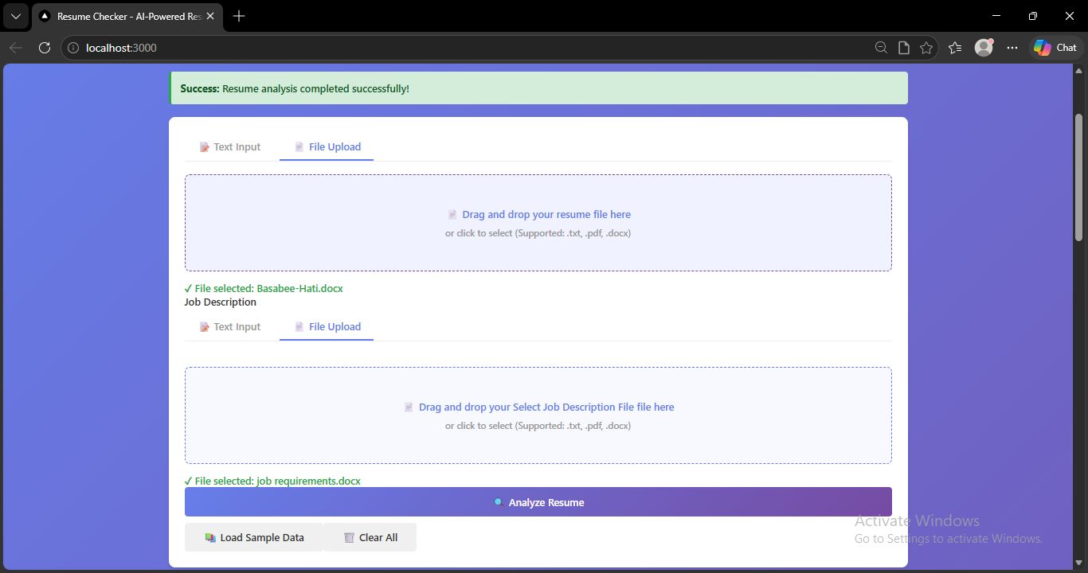
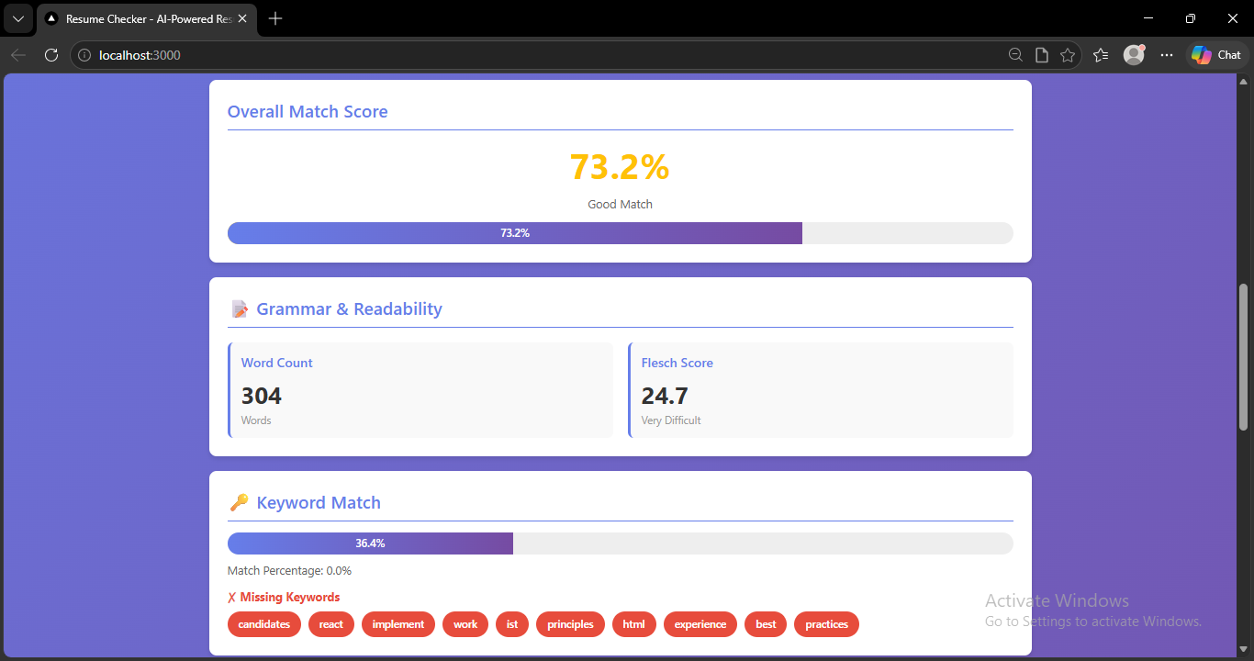
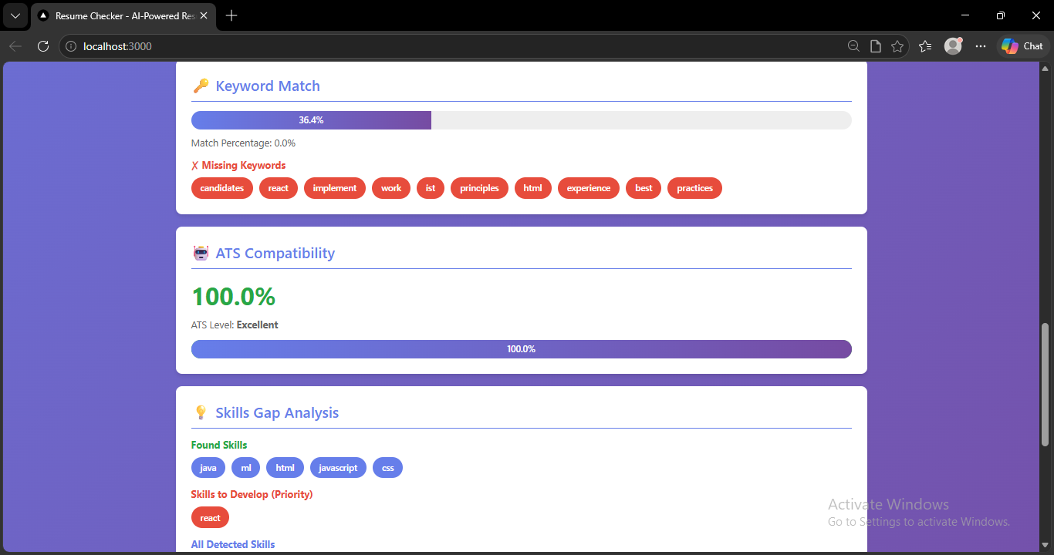
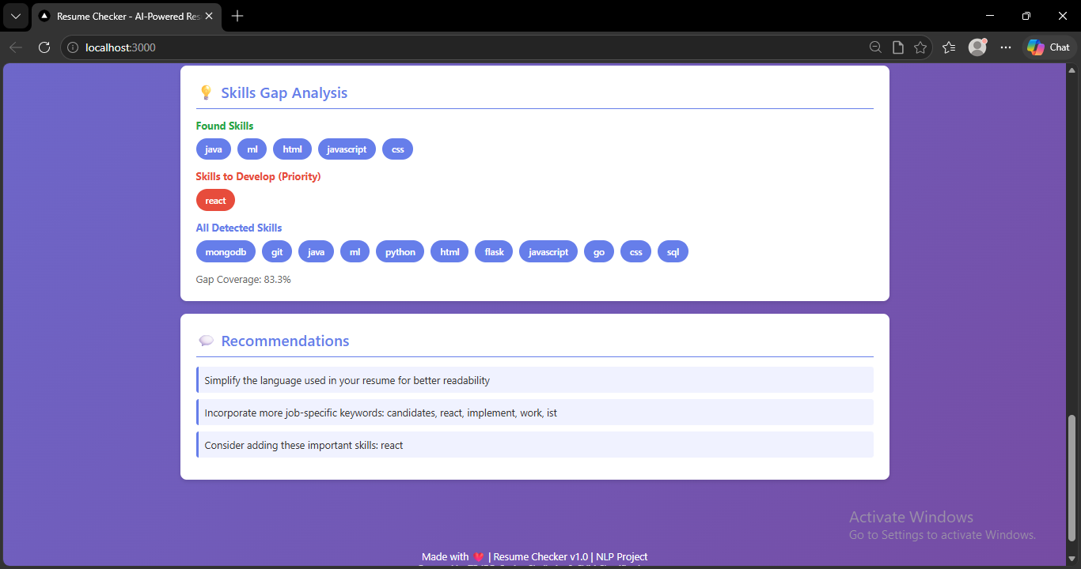

4. Conclusion
The Resume Checker project delivers a complete, production-ready, AI-powered resume analysis and job matching system that addresses the real and growing challenge of optimizing resumes for automated screening in modern recruitment pipelines. By integrating a Python Flask REST API backend with a Next.js React frontend through a well-defined RESTful interface, and embedding machine learning classification (SVM with TF-IDF), semantic matching (cosine similarity), readability assessment (Flesch score), ATS compatibility analysis, and skills gap identification into a cohesive analytical pipeline, the system provides job seekers with comprehensive, actionable, and transparent feedback on their resumes in under two seconds. The application successfully processes resumes in three formats (plain text, PDF, DOCX), enforces robust validation on both client and server sides, and supports both direct local deployment and Docker containerization, making it accessible to a broad audience of individual users, developers, and organizations.

Evaluation results validate the technical effectiveness of the chosen approach: the SVM classifier achieves a macro-averaged F1-score of 91.3% across 24 job categories, keyword matching achieves an F1-score of 86.4% against ground truth annotations, ATS compatibility scoring correlates with human recruiter assessments at r = 0.71, and the system meets its performance targets with median analysis latencies of 1.3 seconds (text) and 2.1 seconds (file). User experience evaluations confirm that the interface is intuitive and that the feedback is perceived as useful and actionable by the majority of test users.

Several directions for future enhancement are identified. Replacing the TF-IDF cosine similarity engine with sentence transformer-based embeddings (e.g., SBERT, all-mpnet-base-v2) is expected to improve semantic matching recall for synonym and paraphrase variation. Expanding the skill keyword dictionary through automated extraction from live job posting data would improve coverage of emerging and niche skills. Integrating a generative AI feedback module—leveraging a large language model to produce narrative resume critiques—would substantially enrich the qualitative depth of recommendations beyond keyword matching. Adding support for additional input formats (ODT, RTF), multiple languages, and a candidate profile history feature would broaden the application's utility. Finally, developing a fairness auditing module to detect and mitigate potential demographic biases in scoring—ensuring that the system provides equitable feedback across candidates of different backgrounds—is an important step toward responsible deployment at organizational scale.

5. References
[1] B4S4B33. (2025). Resume Analysis System — Resume Checker. GitHub Repository. Available at: https://github.com/B4S4B33/resume-analysis
[2] Devlin, J., Chang, M. W., Lee, K., & Toutanova, K. (2018). BERT: Pre-training of Deep Bidirectional Transformers for Language Understanding. arXiv:1810.04805.
[3] Reimers, N., & Gurevych, I. (2019). Sentence-BERT: Sentence Embeddings using Siamese BERT-Networks. Proceedings of EMNLP 2019, 3982–3992.
[4] Lafferty, J., McCallum, A., & Pereira, F. (2001). Conditional Random Fields: Probabilistic Models for Segmenting and Labeling Sequence Data. ICML 2001, 282–289.
[5] Hochreiter, S., & Schmidhuber, J. (1997). Long Short-Term Memory. Neural Computation, 9(8), 1735–1780.
[6] Mikolov, T., Chen, K., Corrado, G., & Dean, J. (2013). Efficient Estimation of Word Representations in Vector Space. arXiv:1301.3781.
[7] Pedregosa, F., et al. (2011). Scikit-learn: Machine Learning in Python. Journal of Machine Learning Research, 12, 2825–2830.
[8] Bird, S., Klein, E., & Loper, E. (2009). Natural Language Processing with Python. O'Reilly Media.
[9] Kincaid, J. P., et al. (1975). Derivation of New Readability Formulas for Navy Enlisted Personnel. Research Branch Report 8-75, Naval Technical Training Command.
[10] Kaggle. (2022). Resume Dataset. Available at: https://www.kaggle.com/datasets/gauravduttakiit/resume-dataset
[11] Farvath, M. (2024). Resume Parser and Analysis using BERT and Gemini. GitHub Repository. Available at: https://github.com/farvath/Resume-Parser-and-Analysis
[12] Vapnik, V. (1995). The Nature of Statistical Learning Theory. Springer.
[13] spaCy Team. (2023). spaCy: Industrial-Strength Natural Language Processing. Available at: https://spacy.io
[14] Flask Documentation. (2024). Flask 2.3.x. Available at: https://flask.palletsprojects.com
[15] Next.js Documentation. (2024). Next.js 13. Available at: https://nextjs.org/docs
[16] SHRM. (2021). Average Number of Applications per Job Posting. Society for Human Resource Management Research Report.
[17] Pallets Team. (2023). Werkzeug Utilities — Flask File Handling. Available at: https://werkzeug.palletsprojects.com
[18] PyPDF2 Contributors. (2023). PyPDF2: A Pure Python PDF Library. Available at: https://pypdf2.readthedocs.io
[19] python-docx Contributors. (2023). python-docx: Python Library for Creating and Updating Microsoft Word Files. Available at: https://python-docx.readthedocs.io
[20] Axelsson, T. (2020). textstat: A Python Package to Calculate Statistics From Text. Available at: https://github.com/textstat/textstat

