# Some visualisations obtained from this code

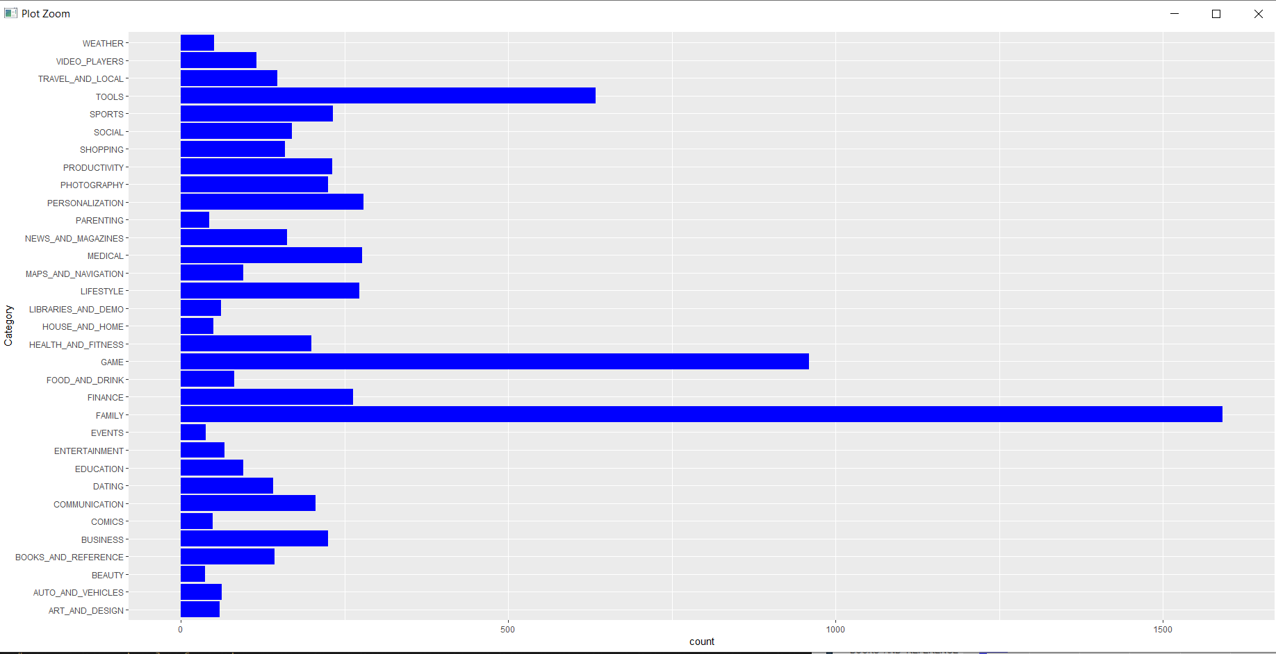

*1.* Bar plot for variable ‘Category’ versus count from ‘googleplay’ data set.

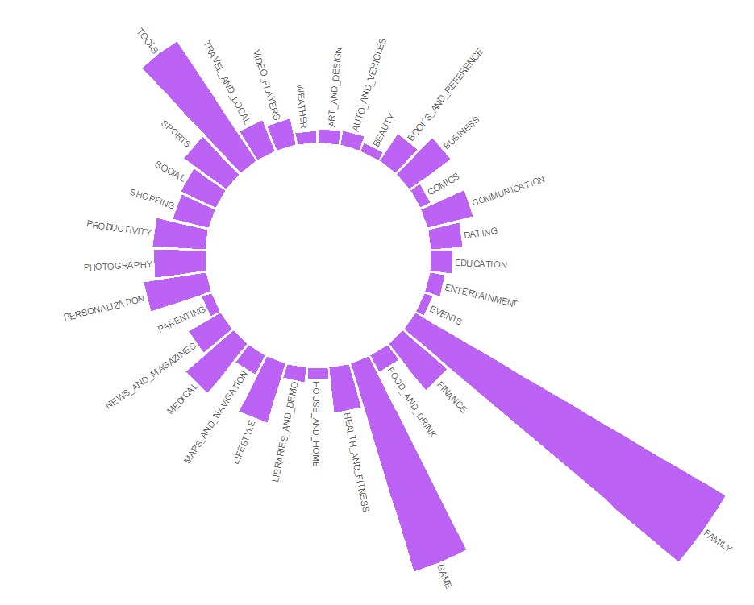

*2.* Circular plot for variable ‘Category’ (categorical variable) with frequencies for each category from ‘googleplay’ data set.

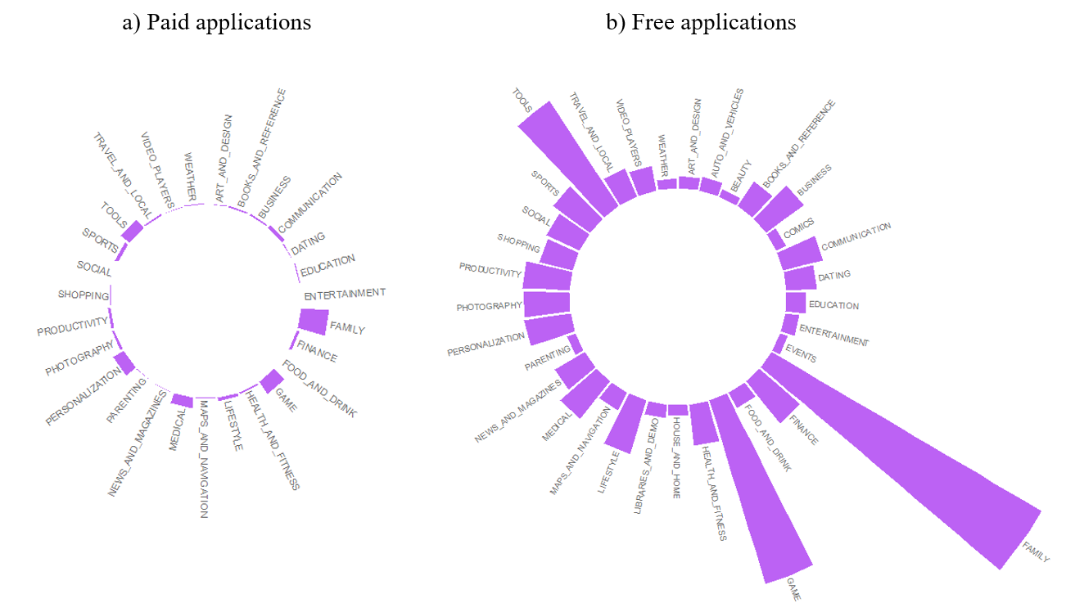

*3*. Circular plot for a) paid applications and b)free applications. Arrows indicate those categories with high frequency, except ‘FAMILY’, ‘GAME’ and ‘TOOLS’.

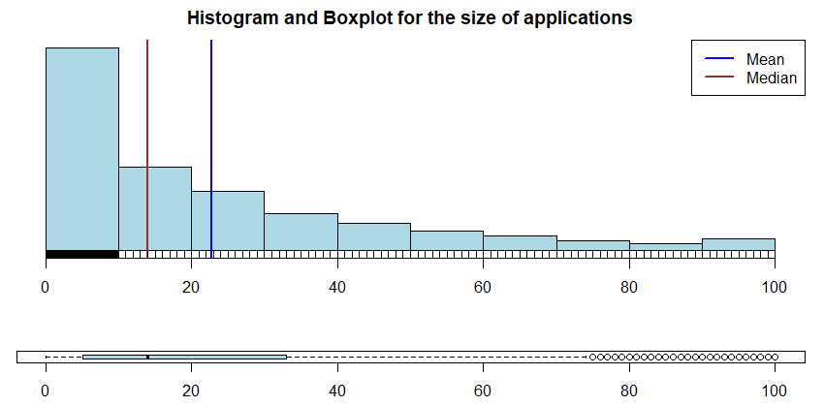

*4.* Histogram and boxplot for the size of the application.

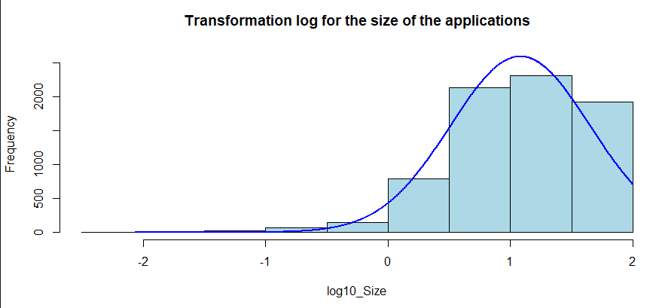

*5.* Logarithmic transformation for the size of the applications.

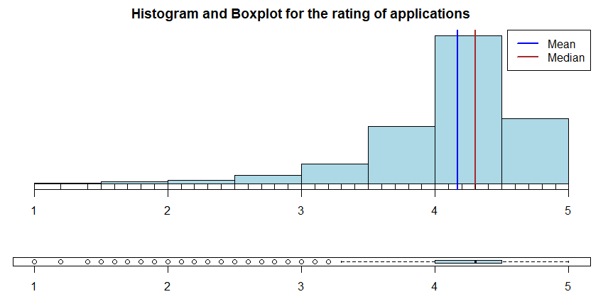

*6.* Histogram and boxplot for the rating of the application.

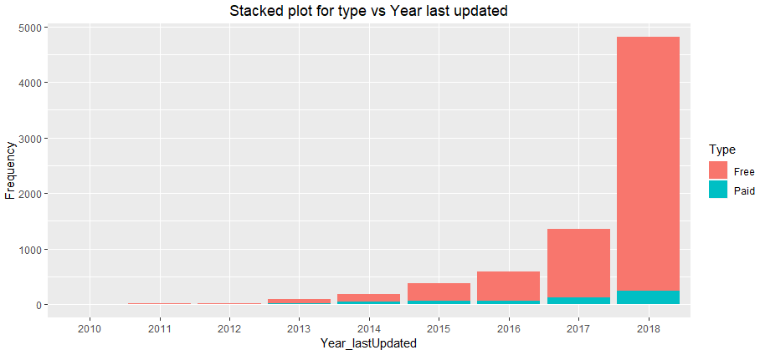

*7.* A stacked plot for ‘Year_lastUpdated’ versus ‘Type’.

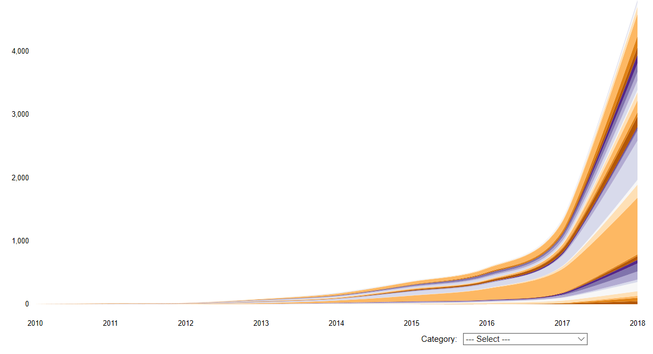

8. A stream graph that shows the frequency of each ‘Category’ according to year.

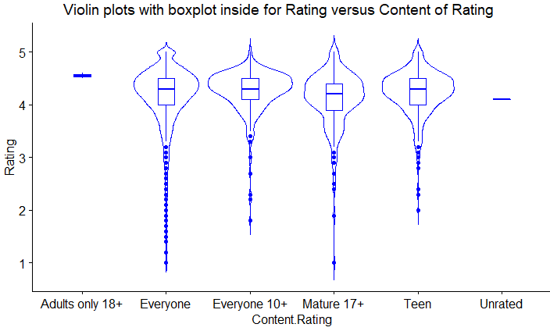

*8.* Violin plot with boxplot inside for ‘Rating’ and ‘Content.Rating’ variables.

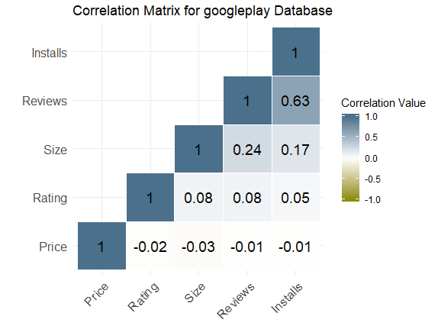

*9.* A correlation matrix between numeric variables from the dataset.

a) 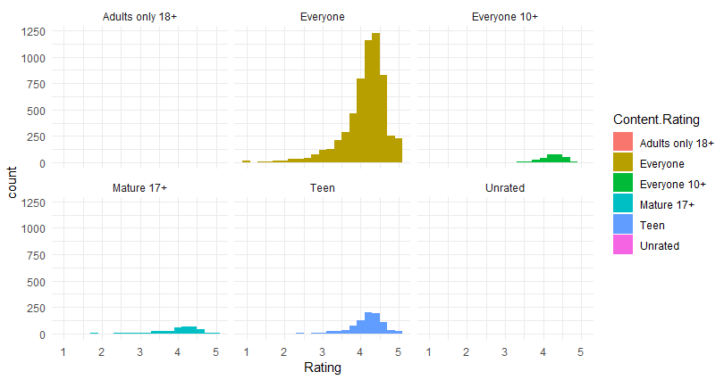

b) 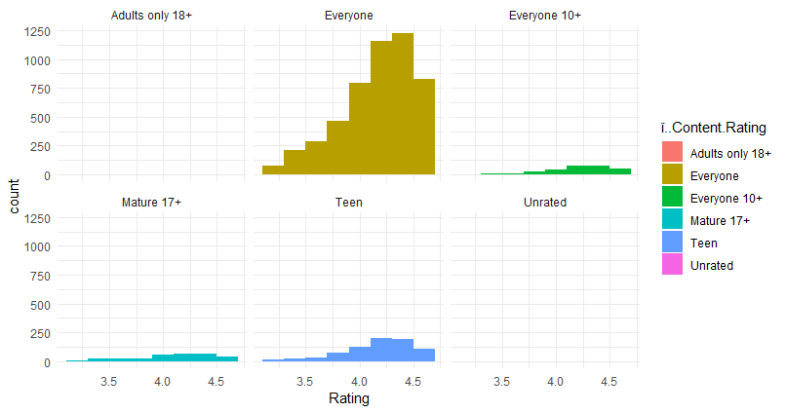

*10*. Comparison between histograms with and without outliers. a) Content.Rating vs rating with outliers, b) Content.Rating vs rating without outliers.