# Some outputs

1. NewstalkZB

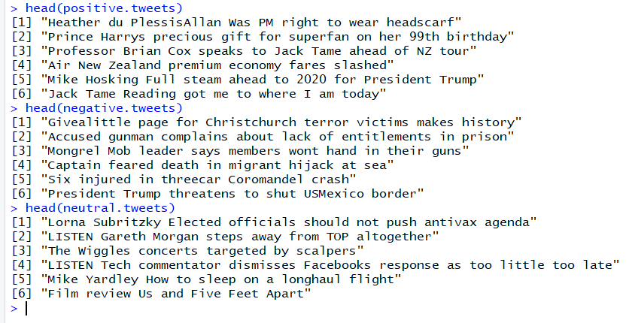

1. Nzherald

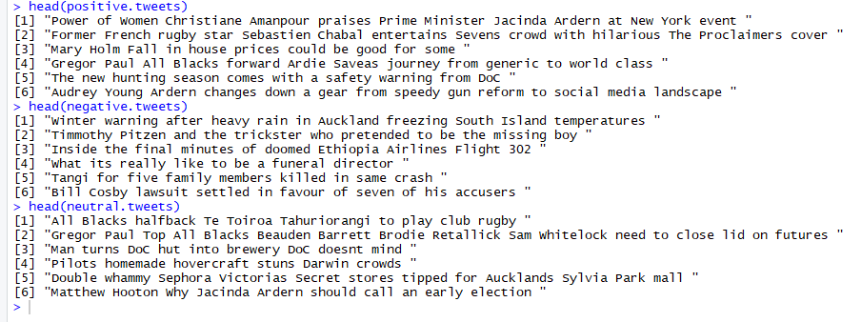

1. NZStuff

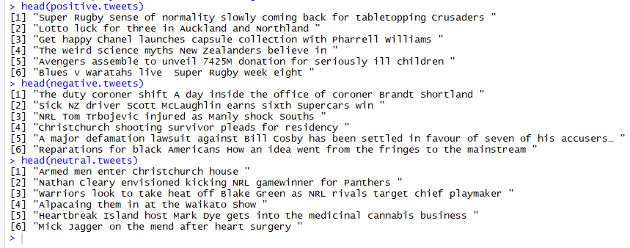

1. A sample of positive, negative and neutral tweets obtained from a) NewstalkZB, b) nzherald and c) NZStuff tweets.
2. NewstalkZB b) nzherald c) NZStuff

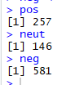 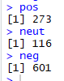 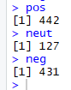

2. The total number of positive, neutral and negative tweets for a) NewstalkZB, b) nzherald and c) NZStuff.

1. 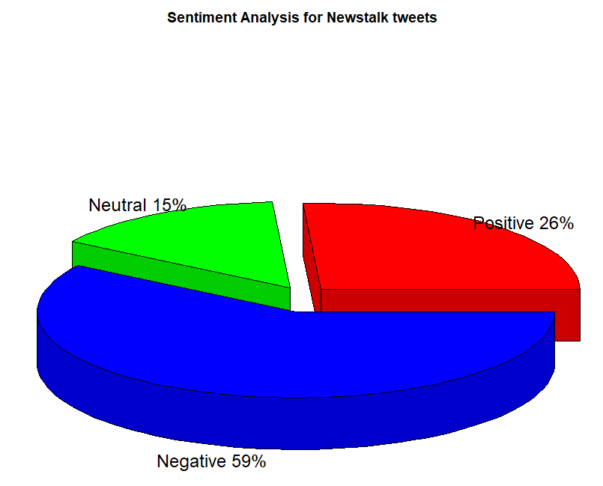 b)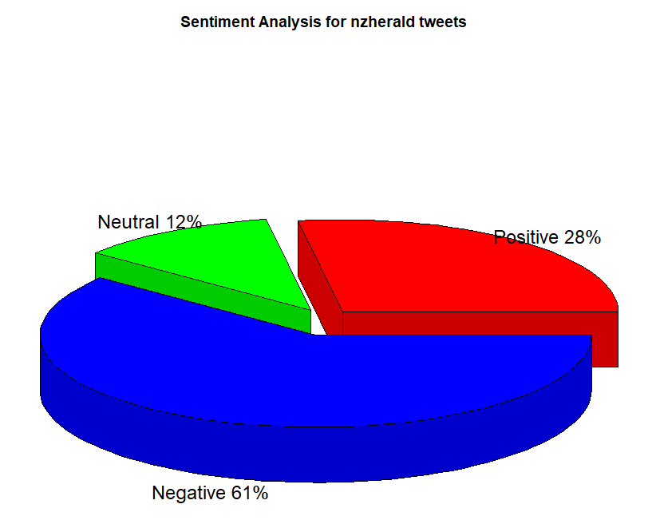
2. 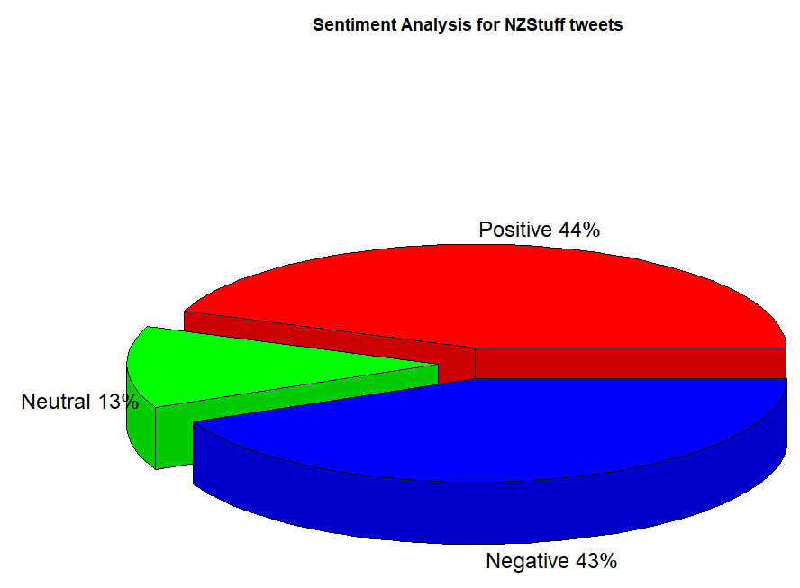

3. Pie chart representations with their respective percentages for sentiment analysis for a) Newstalk, b) nzherald and c) NZStuff tweets.

a) Newstalk b) nzherald c) NZStuff

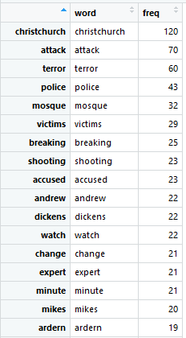 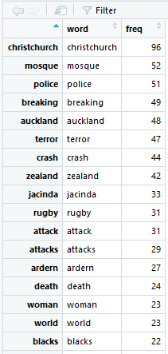 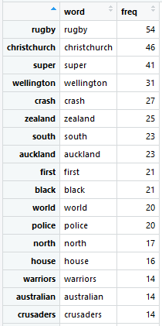

4. A sample of data frames obtained that represent each word and its frequency for a) Newstalk, b) nzherald and c) NZStuff tweets.

1. Newstalk b) nzherald c) NZStuff

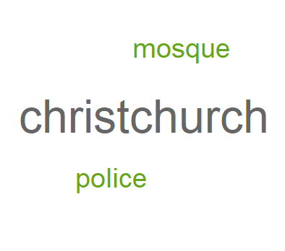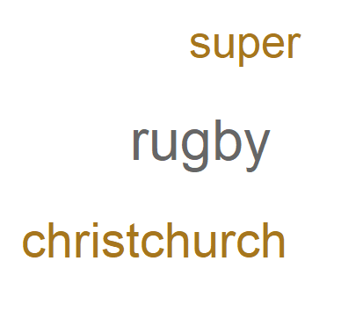

5. Word Cloud with a minimum frequency of 50 for a) Newstalk, b) nzherald and c) NZStuff tweets.

a) Newstalk



b) nzherald



c) NZStuff



6. Number of positive and negative sentiment obtained from a concatenation based on the frequency of words from a) Newstalk, b) nzherald, and c) NZStuff tweets.

Positive words Negative words

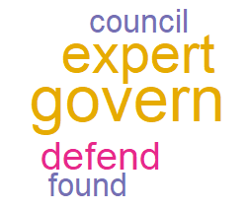 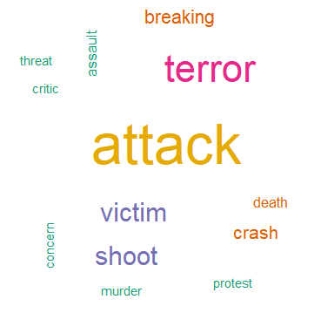

a) Newstalk

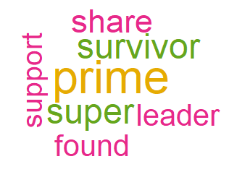 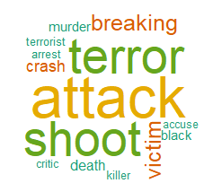

b) nzherald

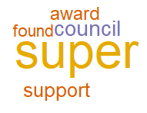 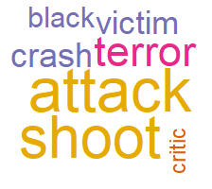

c) NZStuff

7. Word Cloud for positive and negative sentiment words with a frequency equals to 10 for a) Newstalk, b) nzherald and c) NZStuff.

1. Newstalk

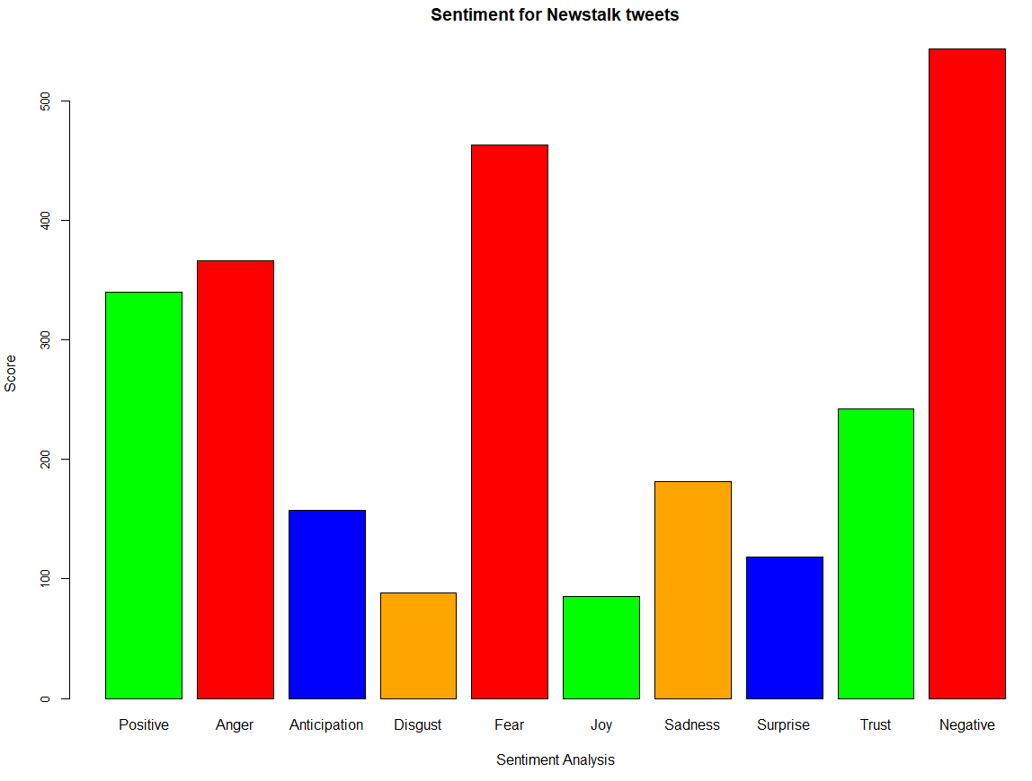

b) nzherald

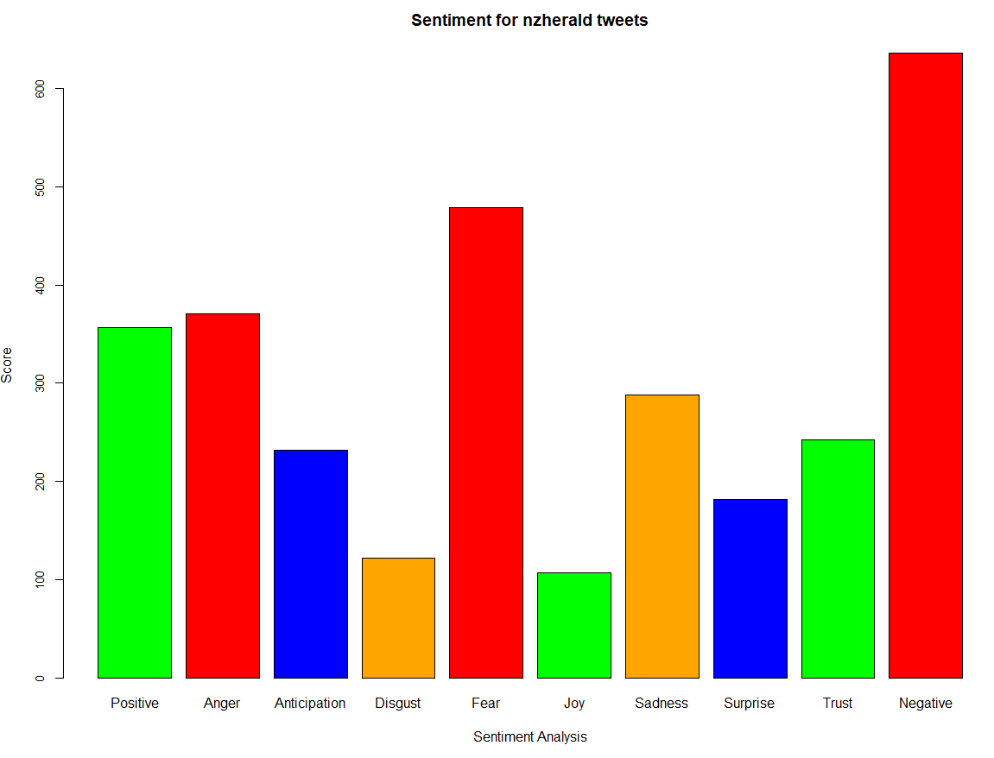

c) NZStuff

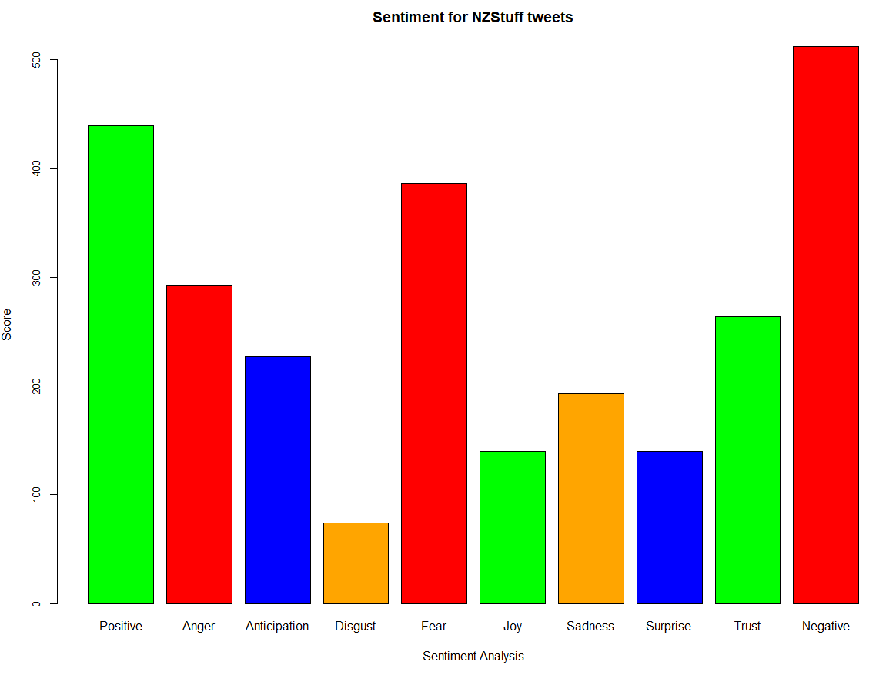

8. Bar charts that represent the frequency of each emotion from a) Newstalk, b) nzherald and c) NZStuff tweets.