Bilal ‘Bel’ Abdul Hak

1990 Macroeconomic Analysis

Argentina Report

# Argentina 1990 Macroeconomy Report

## Brief

This report analyzes and addresses the macroeconomic situation of Argentina in the year 1990 using an aggregate supply and aggregate demand (AD-AS) model. The AD-AS model is used to gauge whether the economy is performing at its potential, in addition to identifying causes of and remedies to the contemporary[1] state of the economy. The results found that a combination of diminished aggregate supply and unrestricted aggregate demand caused a decline in output but a substantial rise in inflation. The analysis concludes with a policy recommendation of improved and consistent contractionary fiscal policies.

## Assumptions

The analysis operates under a few key assumptions:

1. The long-run real GDP growth rate and equilibrium inflation are estimated through an arithmetic average of the preceding 5 years (1985-1989).
   1. This also means that the economy’s potential output in this analysis is the estimated long-run real GDP growth rate.
2. Instead of using the traditional GDP and CPI levels, the analysis uses their rates in the AD-AS model to better capture business cycles.
3. The slopes of the AD-AS model are not calculated through empirical data and statistical methods; rather, they assumed to be -1000 and 1000 respectively.

Despite the simplicity of these assumptions, the resulting AD-AS model yields valuable insights for the state of the economy.

## Data Retrieval and Preparation Summary

Data was obtained from two sources: the World Bank and the Central Bank of the Argentine Republic. The former contains Argentina’s GDP growth and unemployment rates, while the latter has the country’s inflation rates. To make both datasets tidy and mergeable, the monthly inflation rate dataset was annualized by calculating the mean inflation rate for every year. After filtering for the years 1970-1990, the results were as the preview showcases below:

## Analysis

By calculating the average of the previous five years, the estimates for the GDP growth rate (Y*) and inflation rate are approximately -0.92% and 727.76% respectively. Below is Figure 1, showcasing this in an AD-AS model at point A.

Figure 1

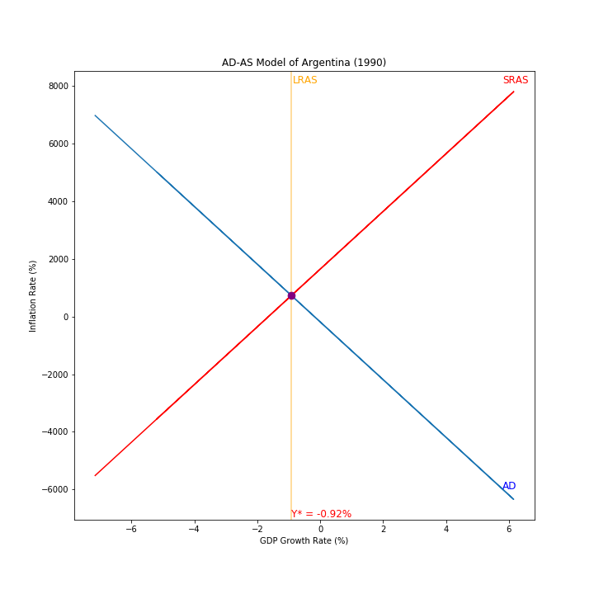

Point A

Subject to the assumptions, the scale of the slopes of both aggregate demand (AD) and aggregate supply (AS) indicate that either complementary curve shifting will have drastic effects on the inflation rate with a much more moderate change in GDP growth rate (Y). Point A and its surrounding curves will serve as a benchmark for the rates of the point for the year 1990 (referred to as point B).

Below is figure 1A, which showcases point B and how the current economy fares against point A.

Figure 1A

Point B

As showcased in this figure, the current economy at point B indicates that it has a lower output growth rate of -2.47% and a staggeringly higher inflation rate of 7029.16%. The model highlights that there is a short-run negative output gap of approximately 1.55% below the Argentine economy’s potential. Conventionally, this negative output gap would indicate a recession; however, looking deeper, given that Y* is negative, it can be surmised that the economy has been overheating for a long time, and the long-term inflationary consequences of this has emerged. Figure 2 reflects this overheating as the recent decades has seen Argentina frequently attempt to grow beyond its capacity, only for its economy to sharply contract below its potential. Only recently have the long-term consequences broken through, as showcased through its rise despite output growth declining in the recent years.

Figure 2

In terms of the AD-AS model, it can be reasoned that a decrease in AS and increase in AD has caused such a shift to occur. Regarding the new curves at point B, this means that the AS curve has shifted to the left, while the AD curve has shifted to the right for the current year.[2] Cumulatively, these shifts have caused an extreme rise in the inflation rate and a small decline in output growth. This is illustrated in Figure 3.

Figure 3

SRAS shifted left

AD shifted right

#### Causes of the shifts

###### Decrease in Aggregate Supply

The decrease in AS can be explained via an application of macroeconomic principles to the events of the last decade in Argentina. As recounted by Manzetti and Dell’Aquilla, Argentina’s economy has been characterized by its deteriorating exchange rate and wage spirals,[3] both of which can be identified as changes in exchange rate and input costs; these were factors that both negatively affected AS. Furthermore, the contemporary Alfonsin administration carried out a series of policy actions known as the ‘Austral Plan’; this plan failed in the long run due to its inconsistencies in implementation and its capitulation to political pressures.[4]

The outcome of the Austral Plan is relevant to analyzing the two factors below:

* **Exchange rate:** The exchange rate in Argentina was already deteriorating over the last few decades.[5] However, this was fueled by increases in internal consumption,[6] subsequently reducing the volume of exports. The result of this is a lower exchange rate due to less demand for the Argentine currency. This was exacerbated by a substantial rise in imports,[7] which increased the supply of the currency during the stages of economic liberalization in the Austral plan. Cumulatively, these factors substantially depreciated the exchange rate, thereby diminishing AS.
* **Input costs:** In many stages of the Austral plan, there were attempts to freeze prices and wages, but political pressure saw the government yielding and stimulating the economy through price increases.[8] Wage increases especially increased production costs, thus diminishing AS and fueling the inflationary spiral. Furthermore, there were also increases in business costs that compounded the diminishing AS.

###### Increase in Aggregate Demand

Despite a reduction in net exports, AD still ultimately increased primarily due to a lack of commitment to fiscal restraint, fueled by lax monetary policies.[9] These were due to the failings of the Austral plan in implementing consistent and complete contractionary policies over the recent decade.[10] It could be reasoned that AD did not rise as much as AS declined since output, irrespective of price levels, did not return to Y*.[11] The two factors are analyzed below:

* **Fiscal Policy:** This factor is characterized by the government’s failure in fiscal restraint. During the Austral plan, the government had spent substantially more than it had initially planned,[12] causing a multiplier effect on aggregate expenditure and AD.
* **Lax monetary policies:** Despite successfully curbing inflation in the initial phase of the Austral plan, the government saw it fit to reduce the real interest rate despite inflation still being substantial.[13] This could be due to the political pressures seeking expansionary policies over those that are contractionary; therefore, Argentina’s more lax monetary policies at the time likely could have partially been an output-induced response. The result of this was a higher incentive for increasing consumption and investment, thereby raising aggregate expenditure and AD.

#### Policy Recommendation

As highlighted previously, it is very likely that the economy has been overheating in recent decades, with the need for cooling inflationary pressures becoming paramount. It is recommended that the focus be placed on addressing AD specifically since it is likely that the short-run AS will return to its potential output in the long-run. A restrictive monetary policy in Argentina’s economy alone is not viable in the long run due to political pressures seeking to reactivate the economy.[14] Therefore, it is proposed that a consistent and targeted contractionary fiscal policy is adopted over a long period through the below means:

* **Improved income tax collection:** While the tax rate may be increased, the primary issue with Argentina’s tax policy is tax evasion; in 1984, only 13% of registered taxpayers paid taxes.[15] Thus, improving tax collection policies will reduce the total population’s disposable incomes, reducing consumption and therefore AD.
* **Reduced producer taxes:** The negative effects on output from the income tax policies can be offset by specifically targeting consumption and investment, while simultaneously easing production costs. Though this could be considered somewhat expansionary, but its targeted nature will mitigate the reduction in output while also further reducing inflation. The alternative to this is a decrease in AS through producer taxation, exacerbating the diminishing output and adversely offsetting the decline in inflation.
* **Consistent fiscal restraint:** So that the reduction of AD through tax policies is not offset by government expenditure, a stringent spending program must be adopted by the government.
* **Independence from political pressure:** The government must ensure that political pressures do not affect policy decisions as most pressure aligns with economic expansion, contradicting the necessary action needed for the economy to sustain itself in the long run.

The aim of these contractionary policies is primarily to curb inflation and reduce it to sustainable levels. As shown in Figures 1 and 3, GDP growth will merely change in a slight degree from the extreme changes in inflation in the short run. As the economy progresses to the long run, the AS curve will begin to slope vertically and return to its potential output. Figure 4 highlights this and exemplifies why AD should be reduced to cool inflationary pressures.

Figure 4

Therefore, long-term consequences of performing under economic potential should be minimal compared to the long-term benefit of cooled inflationary pressures.

#### Limitations

The assumptions specifically related to Y* and the slopes of the AD and AS curves have their limitations and have a major influence on the interpretations of the data used. Regarding how Y* was calculated, since a five-year-mean estimate was used for brevity, the actual potential output may not be accurately represented. Part of the analysis experimented with a 10-year-mean estimate, which did not significantly alter the primary insights covered in this report. Figure 5 below showcases the similarity of the 10-year estimate:

Figure 5

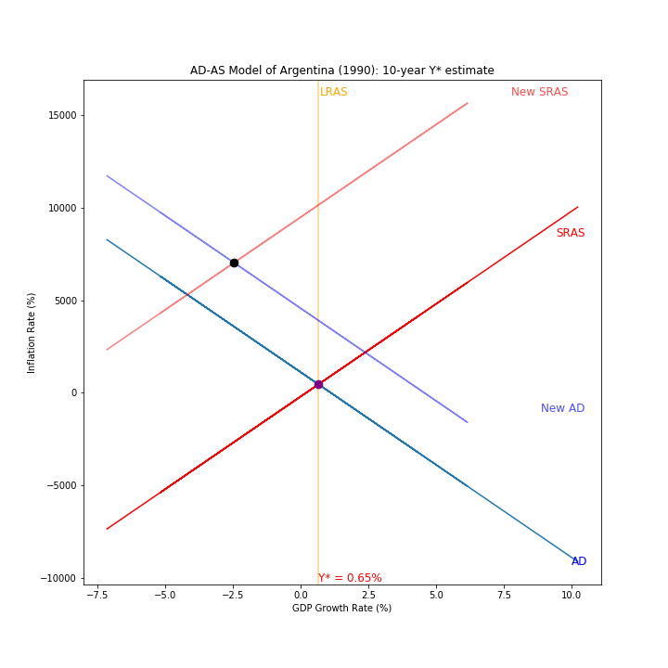

While the primary insights explored are not significantly affected, it is still worth noting the positive output growth rate in a 10-year estimate. This means that the economy’s long-run equilibrium would still involve economic growth, in contrast to the 5-year estimate indicating a need to contract so that inflation levels can be low and sustainable. In addition, the other limitation relates to the assumed slopes of the AD and AS curves. For instance, were a different slope for AD adopted that intersects with points A and B, then the analysis would indicate that only AS had shifted. The current model in figures 1 and 3 were used since relevant facts supported the likelihood of the two curves shifting the way they have.

1. As stated, this report assumes the year is 1990; thus, any reference to ‘current’ states of the economy is referring to the state in the year 1990.
2. Of course, given the assumptions of the slopes, it can be made out that with another set of slopes, the model would indicate different shifts in the curves –– especially the AD curve. For instance, if the slope of the AS curve was much steeper, it could be reasoned that not only did AS shift left, but the AD curve also shifted left. Given the research carried out, we are satisfied with the assumption that the current slope of the AD curve is a useful benchmark.
3. Luigi Manzetti and Marco Dell’Aquilla, ‘Economic Stabilisation in Argentina: the Austral Plan’ (1988) 20(1) *Journal for Latin American Studies* 1-26.
4. Ibid This will be further explored in the following section Policy Suggestions.
5. Ibid.
6. Ibid, 14. Of course, such an increase in internal consumption (if not offset by anything else) may affect aggregate expenditure and therefore AD, but as explored, it had a relevant effect on AS.
7. Ibid, 14.
8. Ibid.
9. Ibid.
10. Ibid.
11. Refer to figures 1 and 3.
12. Manzetti and Dell’Aquilla (n 3).
13. Ibid.
14. This is the central hypothesis asserted and proven in Manzetti and Dell’Aquilla (n 3).
15. Manzetti and Dell’Aquilla (n 3), 15.