Py City Schools Report

# Analysis:

The data used for the analysis are two datasets containing information of different schools in the local government area. The analysis involved manipulating the datasets through merging and deriving statistical information.

## Figure 1 – Local Government Area Summary



This dataset contains information for 15 schools and almost 40,000 students.

It is worth noting here that the proportion of students who are passing both maths and reading is different to the proportion of students passing either maths or reading only. This likely indicates that the approximately 13% of students passing either maths or reading are not passing the other subject.

## Figure 2 – School Summary

## 

Exploratory insight in the summary table indicates that despite government schools having a higher budget than independent schools, the normalized statistic of the per student budget is roughly $600 across every school. This is reflected in the independent schools having a generally lower count of students.

## Figure 3 – Highest-Performing Schools

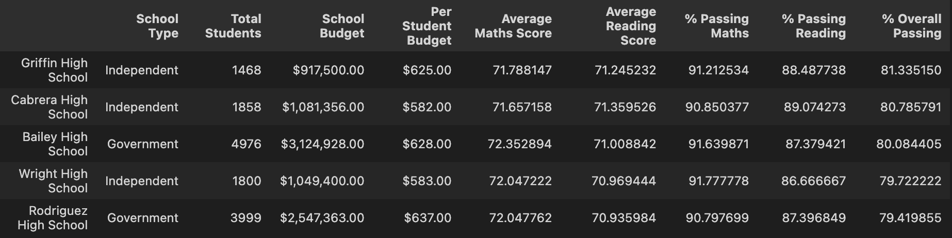

The above table showcases the 5 highest-performing schools in order. Note that three out of five of the schools are independent. Government schools on this list are placed 3rd and 5th.

This might indicate that independent schools perform better than government schools despite having similar per student budgets.

## Figure 4 –– Lowest-Performing Schools

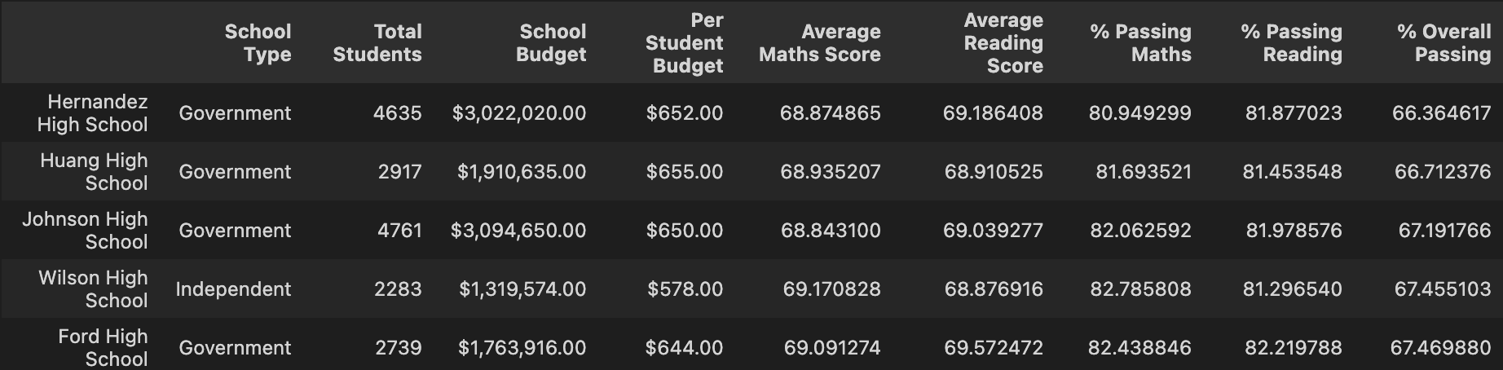

The analysis of figure 3 is further aided by the figure 4, which showcases the lowest-performing schools in order. Four out of five of the lowest-performing schools are government schools, in contrast to figure 3’s proportions.

## Figure 5 –– Scores by Year

5.A) Maths

5.B) Reading

Figure 5 indicates that the average scores do not change drastically by year.

All the schools appear to have roughly similar average scores, too.

## Figure 6 –– Scores by School Spending

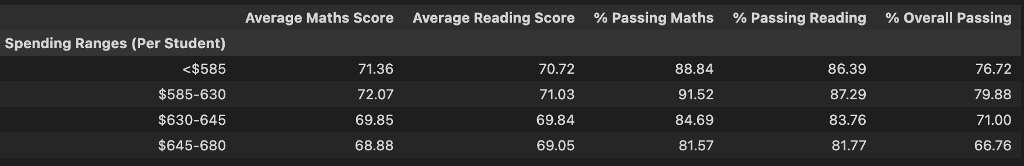

This table groups schools by their per student budgets. This table shows that schools with a per student budget between $585 and $630 have the highest overall passing rate.

Schools with a higher per student budget than this range progressively have a lower overall passing rate.

## Figure 7 –– Scores by School Size

Figure 7 indicates showcases that small and medium schools have roughly similar overall passing rates, but large schools have a lower overall passing rate by 8%.

## Figure 8 –– Scores by School Type

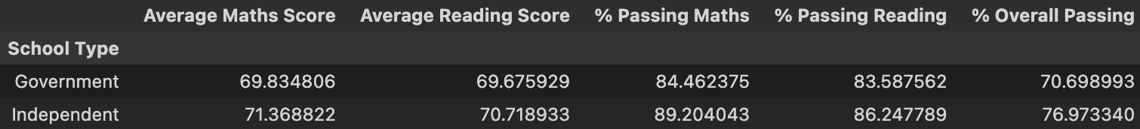

Figure 8 shows that independent schools have a higher passing rate than the government schools. It is worth noting here that the arithmetic average of the maths scores of both types of schools are roughly similar. It is worth looking into how the dispersion of each score differs between these two school types.

# Conclusions:

1. Government schools tend to have a lower passing rate for students.
2. Schools with a per student budget higher than $630 have a relatively lower passing rate to those with a per student budget under $630.
3. Schools with over 2000 students have a lower overall passing rate.