December 5, 2019

Poverty Pal

CS 207 Project

Table of Contents
1. Introduction & Background 3
2. Design & Building Phase 4
2.1 Assembling Parts 4
2.1.1 Images: Circuit Design 6
2.2 Code 7
2.2.1 Images: Code Examples 8
2.3 Images: Poverty Pal Assembly 9
3. Setting Up Poverty Pal 11
#.# References 12

1. Introduction & Background

Our project we have worked on for the semester is named: Poverty Pal. Poverty Pal is a “robot” that searches for objects in its surroundings. If an object is detected, it reacts to the object, and also remembers it’s location. This means while Poverty Pal is searching for an object, and finds a previously detected object, will not react to it. Poverty Pal rotates it’s neck from left to right repeatedly, as well as its neck moving up and down until it senses an object within its vicinity. The minimum distance it reacts to an object is 20cm. Anything past is not noticed, and continues to search. The neck ranges from 0 to 160 degrees, and the head 0 to 40 degrees.
The robot’s protective outer shell consists of styrofoam. Within the styrofoam contains the Arduino Uno Rev3 and breadboard component, the SunFounder model PCA9685, 16-channel Servo driver, and the dedicated 5 x AA battery power source for the servo driver. The Servo driver is used to power the three servos that are used for Poverty Pal. One MG996R metal gear servo is used to rotate the neck portion on the yaw axis, another additional one for the pitch and one HXT900 plastic gear micro servo for the roll axis for the head. The head itself is made up of the plastic gear servo, and an Elegoo HC-SR04 ultrasonic distance measuring sensor.
Comparing Poverty Pal to the original “Buddy” project based in the proposal, many functionalities and components were unfortunately cut. Our original proposal was to 3d print the body, neck, and head parts of Buddy. We also wanted to include audio playback using an SD card which would store Trevor’s voice recordings he used from lectures through the semester. The audio was to be used to express different emotions that Buddy was feeling at any given time while sensing an object in its area. The reasoning for cut functionalities/components was due to time constraint, as well as difficulties actually building Buddy. The original project we were to build off of is called is LittleBot’s Social Buddy, which was found on the create.arduino.cc [1] website. When the time came to create Buddy,4 the period to help support the Kickstarter program [2] had ended. The benefits to supporting was to attain the parts to build Buddy. Since it was no longer an option, we attempted to model our own parts to 3d print. The problem we encountered was the neck part of Buddy, which we eventually opted out of doing entirely. After conferring our dilemma with Trevor, we decided to model our project using popsicle sticks, hot glue, and styrofoam. This is the reasoning to why it is now labeled as Poverty Pal.

2. Design & Building Phase

2.1 Assembling Parts

The main physical components to create Poverty Pal consist of:
- 1x Elegoo HC-SR04 ultrasonic sensor.
- 1x elastic band
- 1x HXT900 plastic gear micro servo
- 2x MG996R metal gear servo
- 1x 200m x 99mm styrofoam hollow dome base (body)
- 1x 111m x 55m styrofoam solid dome base (base for head & neck)
- 1x Arduino Uno Rev3
- 1x Breadboard
- 1x SunFounder PCA9685 16-channel servo driver
- 1x AA Battery holder with barrel jack
- 5x AA 1.5v battery
- Jumper wires
- Glue
- Popsicle sticks

To assemble Poverty Pal, we first had to order from Amazon: the ultrasonic sensor, the metal gear servos, and the servo driver. We then gathered the styrofoam body and neck/head base, and popsicle sticks from Michaels. We used our own hot glue gun to combine the parts together. We first cut a ~45mm diameter hole at the top of the hollow body dome. The neck/head base had the rounded end shaved off roughly 5mm, to have a flat base to rest the first metal gear servo on. We then used a hot glue gun to glue the servo to the solid base. This first servo acts as our yaw axis to rotate the neck. With the other metal gear servo, we glued two halves of a popsicle stick to both sides of it. After it dried, we glued the other end of the popsicle sticks to the first servo. The third plastic gear servo was glued to the second servo, and then the ultrasonic sensor was attached to it with an elastic band. The solid dome is placed within the hollow dome, and the neck is then attached to the servo through the hole created earlier in the hollow dome. Below in section 2.3, are pictures of the progress thus far. The Arduino, servo driver, and power source are placed inside the hollow dome as well. The ultrasonic sensor is connected to the Arduino, while the servos are connected to the servo driver. The servo driver is connected to the Arduino via I2C communication, and also powered with the battery pack with barrel jack connector. The barrel jack was stripped off of the wires since the servo driver’s power block was used in conjunction with individual 5v and ground pole connectors, and not a 2.1 mm jack port.

2.1.1 Images: Circuit Design

2.2 Code

The coding aspect is original code created by us. There is uncompleted code provided on the create.arduino.cc website, but we decided only to refer to it instead of copying it directly. The sensor detects an object if it is 20cm or less from the ultrasonic sensor.

***To be confirmed/added to***
If it detects an object for the first time in that location, it is recorded in the “map” of its environment. The sensor has three “states”. Detecting a new object, detecting an already detected object, and searching for an object. A value is returned depending which state it has detected. If the object location is new, it reacts to it, and includes it into the map. If it comes across an object that has already been detected, it will read from the map that is has been noticed, and disregard it. The third state is straightforward. If it does not detect anything at 20cm or lower at its current location, it does not react, and continues to scan for a new object. Since Poverty Pal is stationary, objects can be mapped relative to servo position. That means if a new object is detected, the position of the servos are stored in arrays. While scanning, if an object’s distance is detected at that same servo position, it is deemed already detected, and continues the scan.

2.2.1 Images: Code Examples

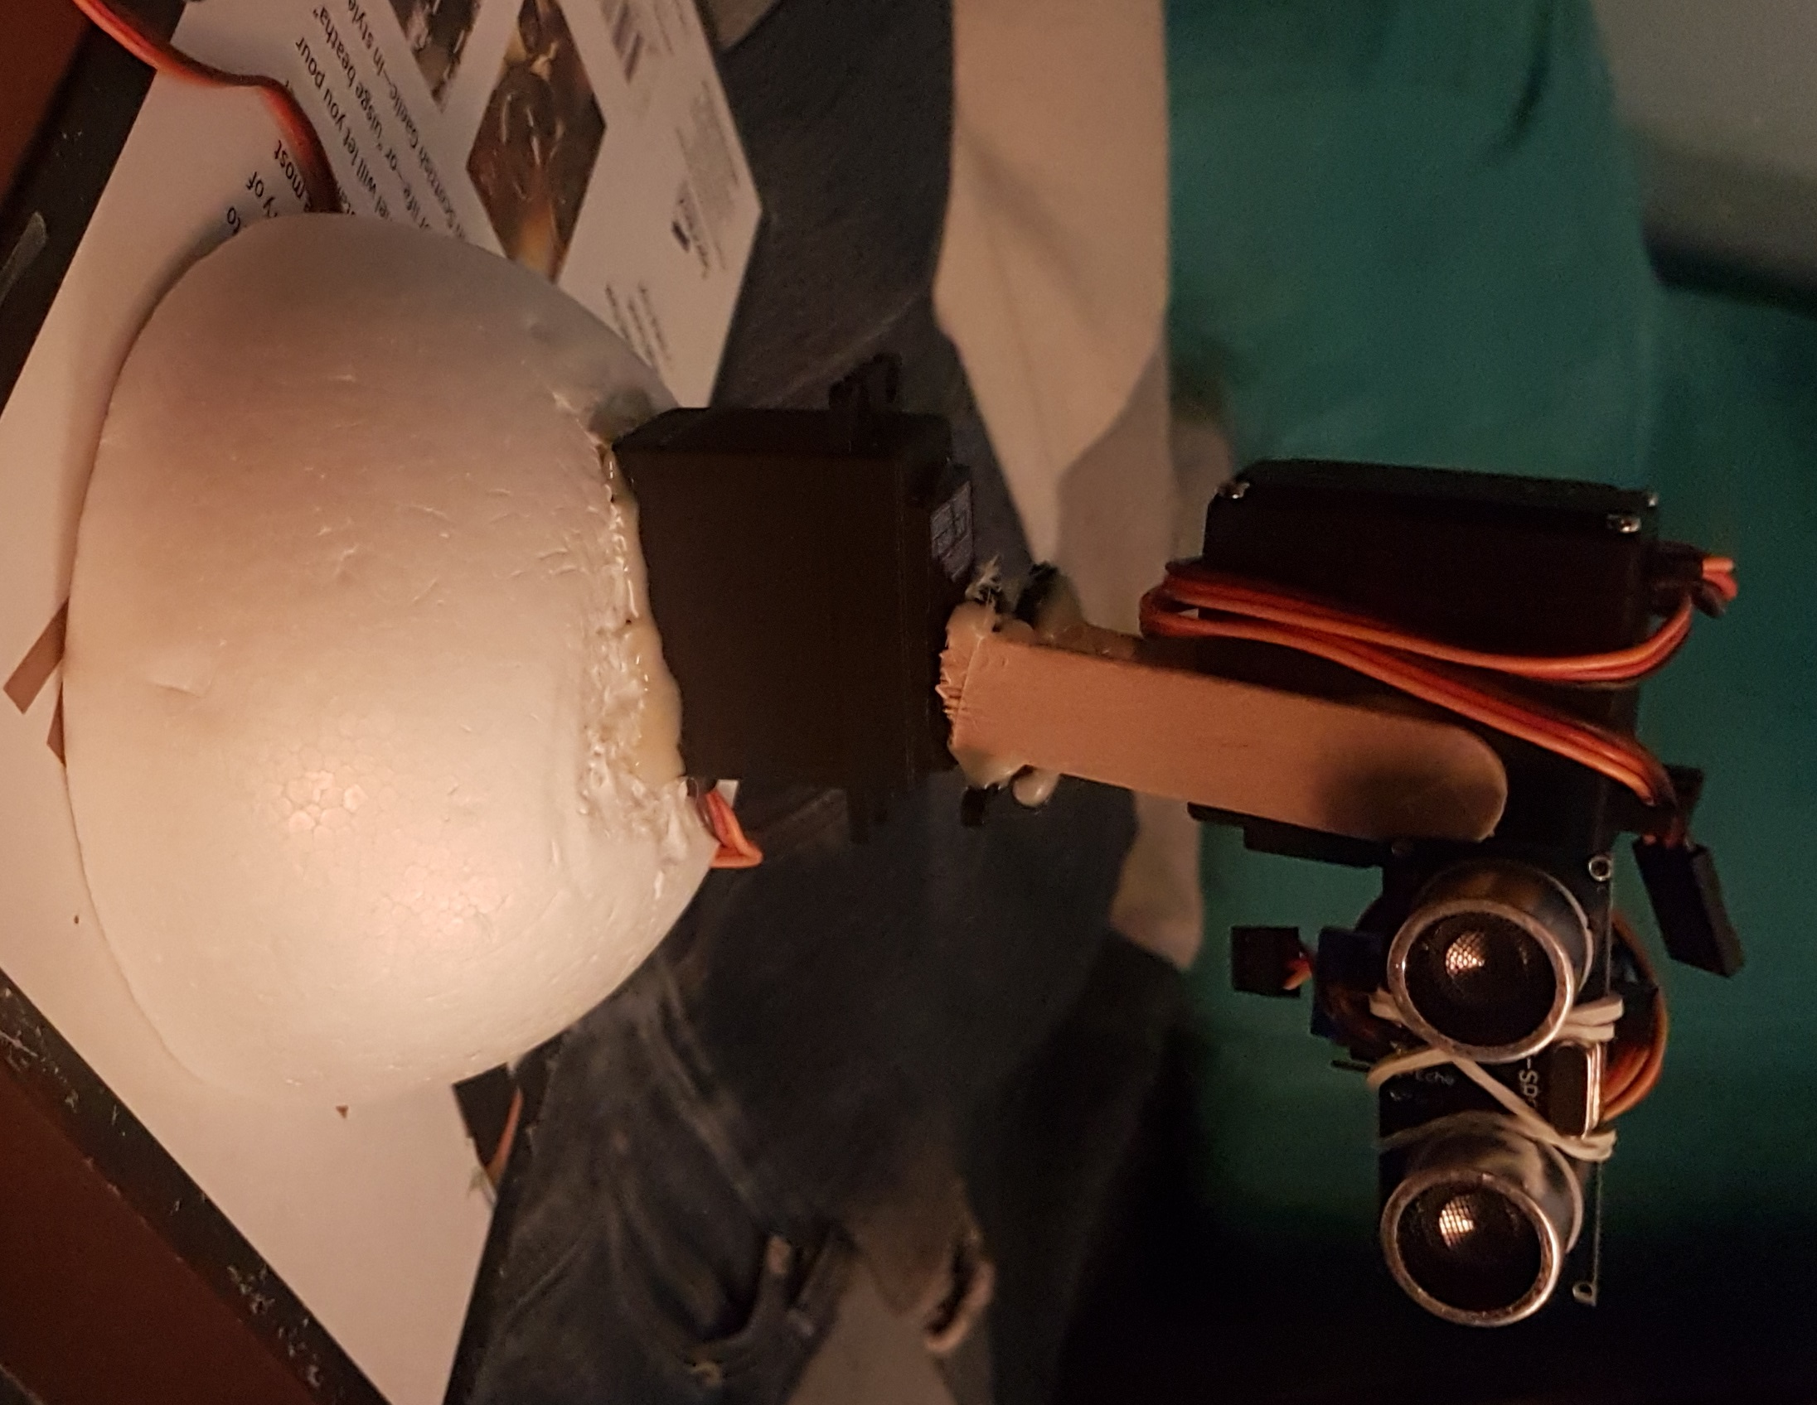
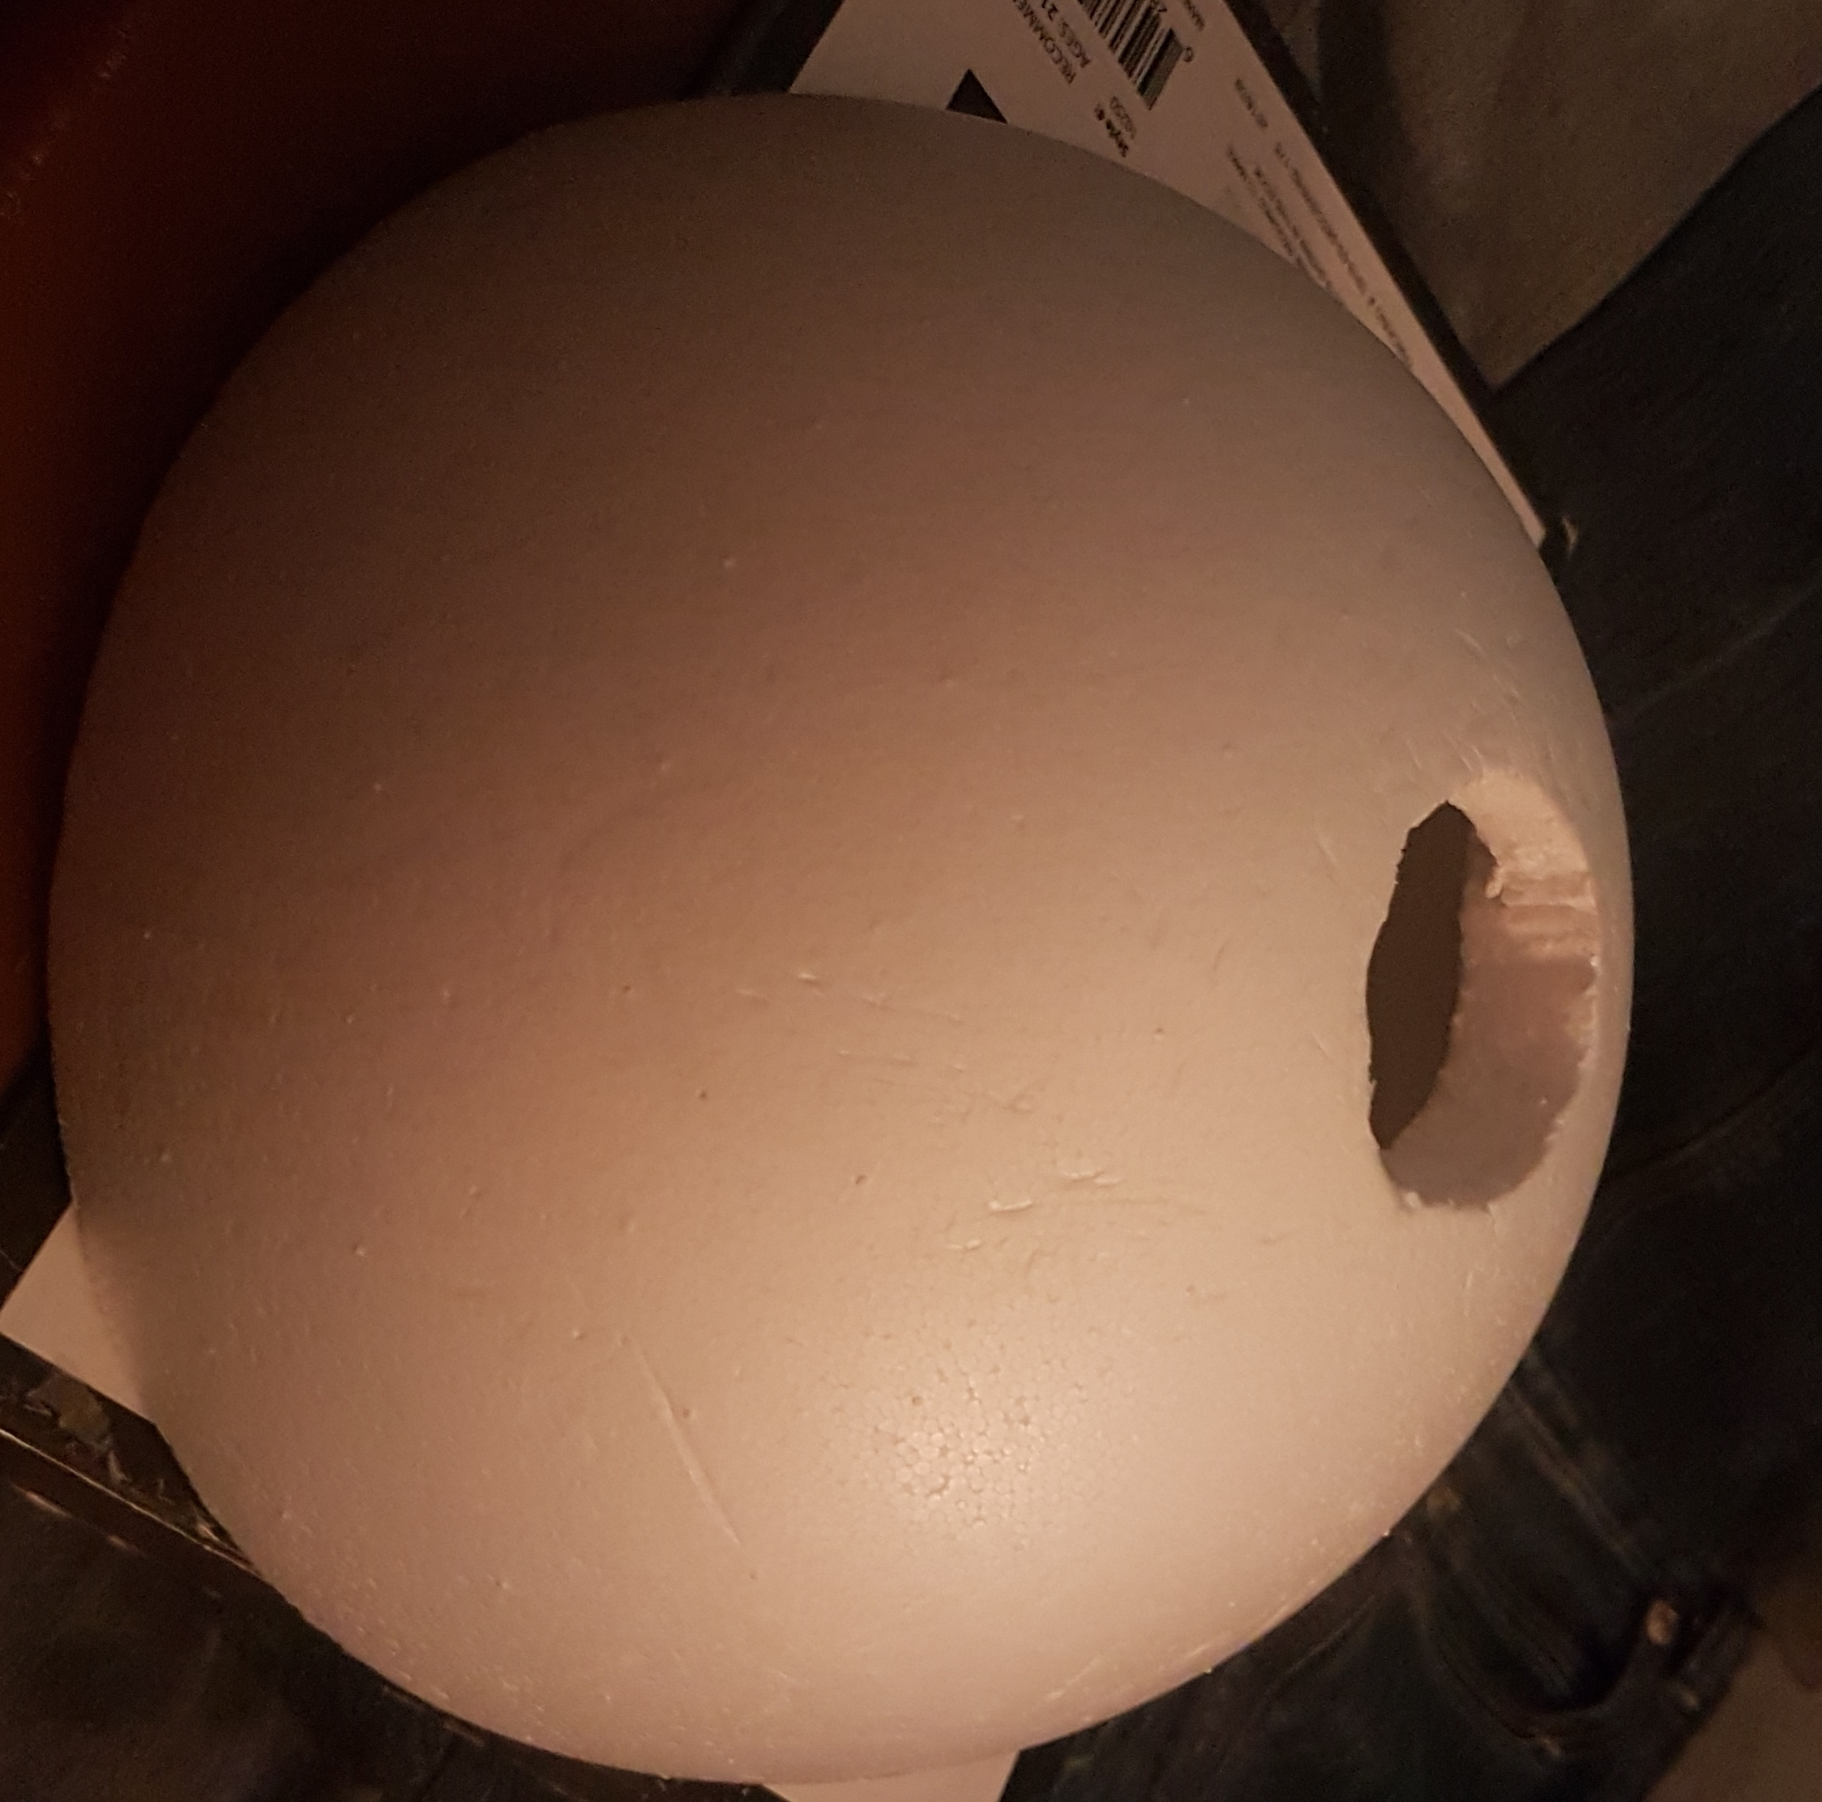
2.3 Images: Poverty Pal Assembly
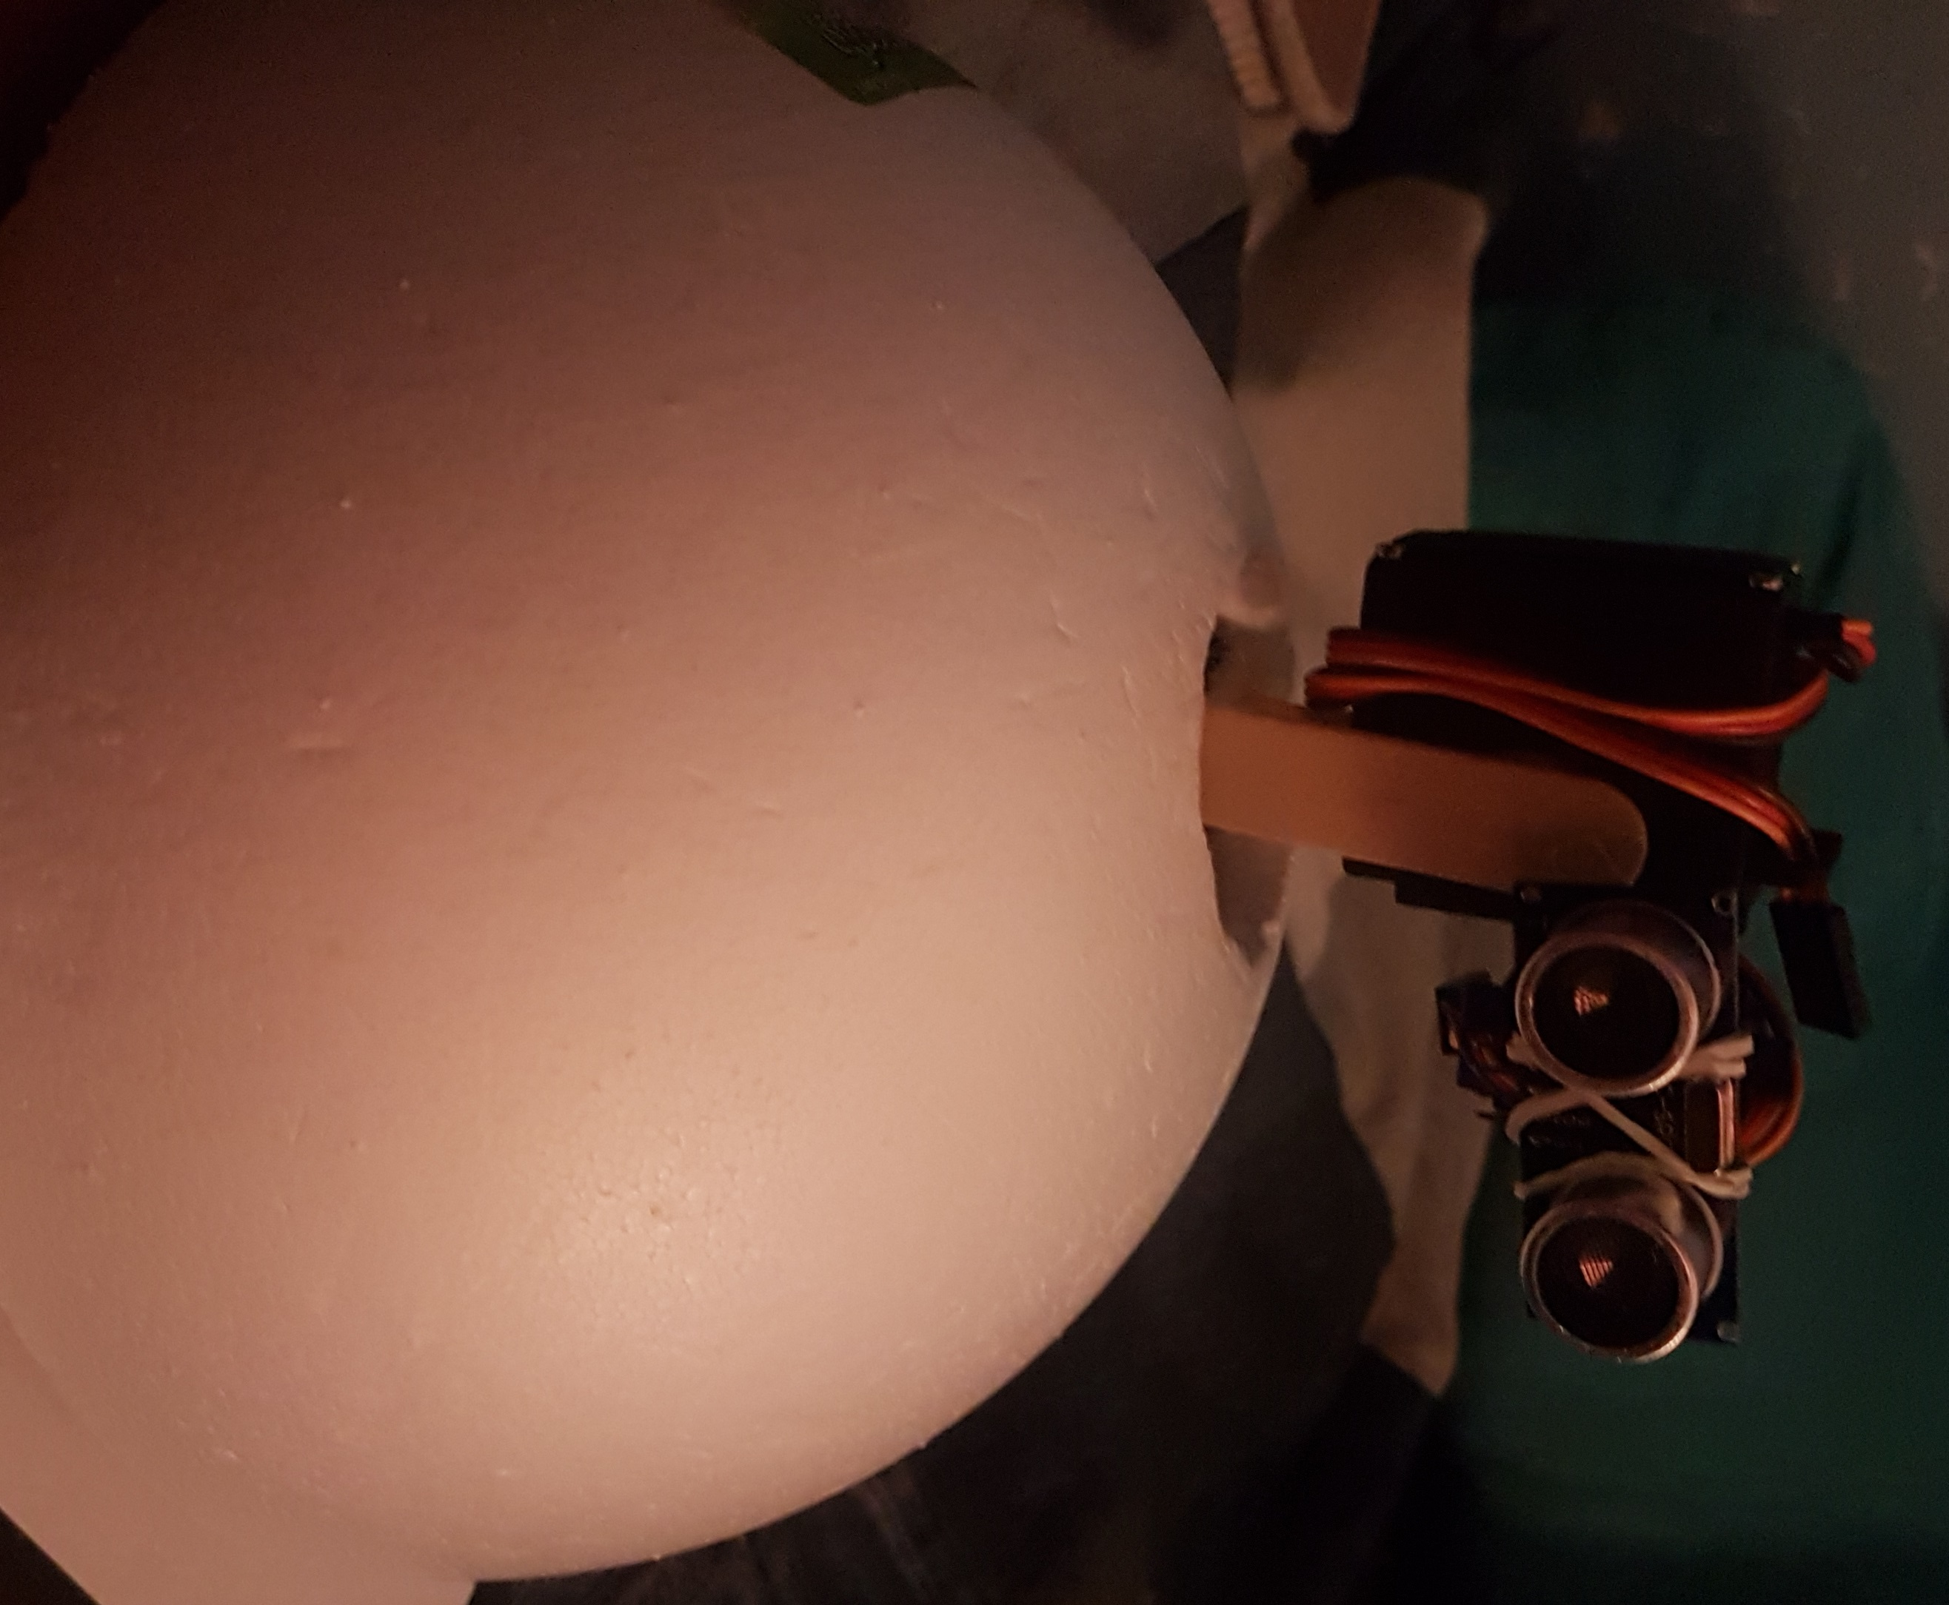

3. Setting Up Poverty Pal

3.1 SunFounder 16-channel servo driver

Setting up Poverty Pal has been briefly discussed throughout the report. Assuming all the parts are gathered and prepared, ie: styrofoam body base has been cut, setup is fairly straightforward. All that needs to be done is connecting the jumper wires to the correct interfaces and components. The I2C connection between the servo driver and Arduino is potentially the most difficult aspect. 4 female to male jumper wires are needed to connect both components together. Starting with the female and servo driver, and mapping to the Arduino, connect the wires from:

Servo Driver | Arduino Uno
GND | GND
SCL | A5
SDA | A4
VCC | 5V

To connect the servos, we see that there are 16 channels on the driver labeled from 0 to 15. Connect the 3 pin servo to the 3 pin channels accordingly at the 0, 1, and 2 positions. We can then connect the dedicated power supply to the servo driver, to power the servos. A diagram example can be viewed at section below here in section 3.1.1.

3.1.1 Image: I2C for servo driver & Arduino

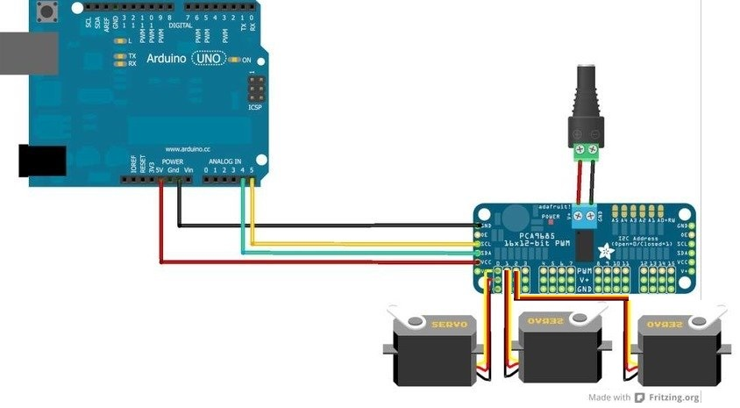

[#] *Note: Was unable to find a servo driver model in Fritzing. Taken from: https://learn.adafruit.com/16-channel-pwm-servo-driver/hooking-it-up

3.2 Elegoo HC-SR04 Ultrasonic Sensor

The ultrasonic sensor [4] is rated to have a minimum range of 4 cm, and a max range of 450 cm. Using it in practice however, we found anything after 150 cm to be a little unreliable at times. The HC-SR04 has 4 pins to attach to the Arduino. Similarly to the servo driver, there are 4 female end wires to be attached to the sensor, and the male end to the Arduino. An example would be:

Ultrasonic sensor | Arduino Uno
GND | GND
ECHO | 11
TRIG | 12
VCC | 5V

The ultrasonic sensor [#] works by creating a short 10uS or greater burst of soundwaves at a frequency of ~40hz when its trigger pin is sent a signal. At this time, a timer is started and then stopped when the soundwaves sent out are bounced back to the receiver. To take into account of the soundwave being sent out, and then back to the sensor, the timing value is divided by 2. An image is provided below in section 3.2.1.

** Mention what servos do when senses object **

3.2.1 Image: 4-pin connection between SR-04 sensor and Arduino Uno

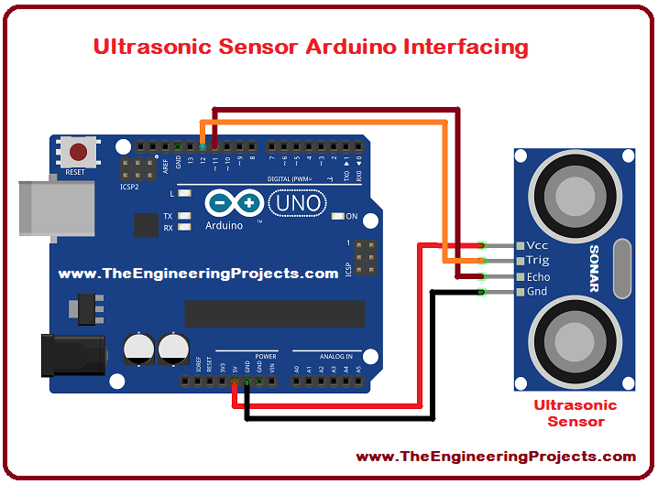

[#] *Note: Again, was unable to find an ultrasonic sensor model in Fritzing. Taken from: https://www.theengineeringprojects.com/wp-content/uploads/2017/08/Ultrasonic-Sensor-Arduino-Interfacing_1.png

4. Milestones

#.# References

[1] LittleBots. Buddy, the 3D-Printed Arduino Social Robot. Retrieved December 2, 2019 from:
https://create.arduino.cc/projecthub/slantconcepts/buddy-the-3d-printed-arduino-social-robot-ec3dca

[2] Slant Robotics. Buddy. An Arduino Social Robot. Retrieved December 2, 2019 from:
https://www.kickstarter.com/projects/slantrobotics/littlebot-buddy?ref=creator_nav

[#]Adafruit. Hooking it Up. Retrieved December 3, 2019 from:
https://learn.adafruit.com/16-channel-pwm-servo-driver/hooking-it-up

[4] Components101. HC-SR04 Ultrasonic Sensor. Retrieved December 3, 2019 from:
https://components101.com/ultrasonic-sensor-working-pinout-datasheet

[#] ElecFreaks. Ultrasonic Ranging Module HC - SR04 . Retrieved December 3, 2019 from:
https://cdn.sparkfun.com/datasheets/Sensors/Proximity/HCSR04.pdf

