Duan Nguyen

12th September 2025

CSCI 507 – Computer Vision

Assignment 1

1. 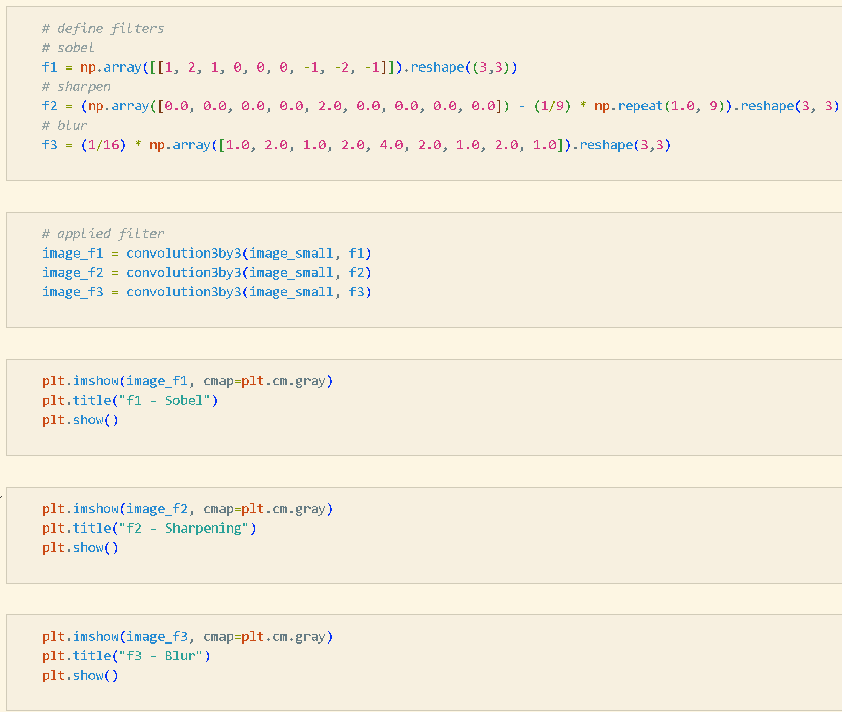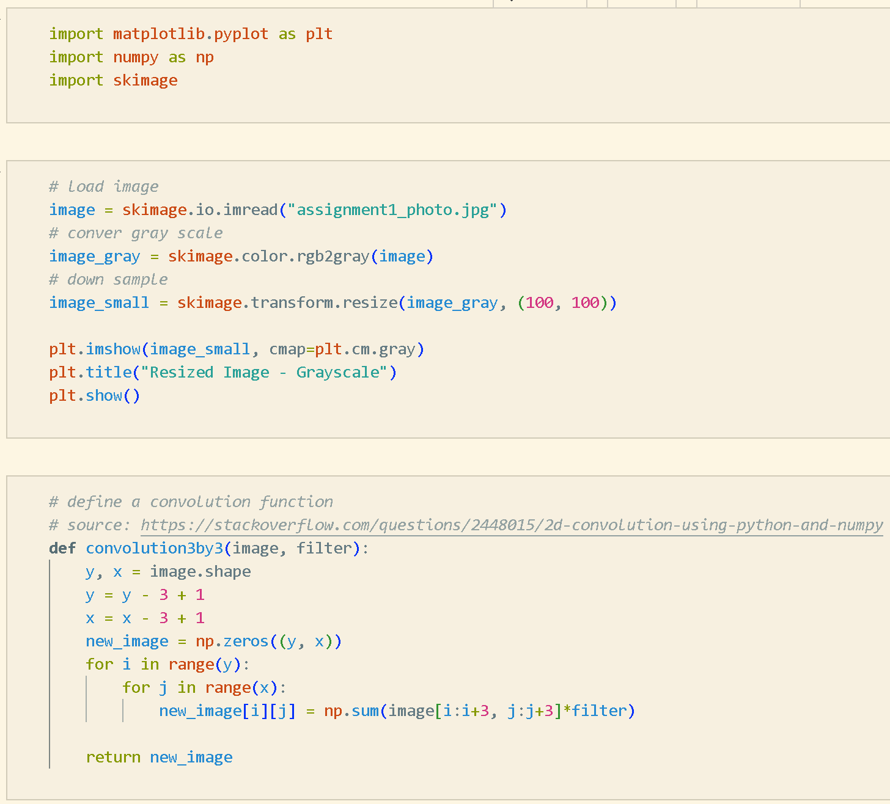Code snapshot
2. Gray scaled image

1. 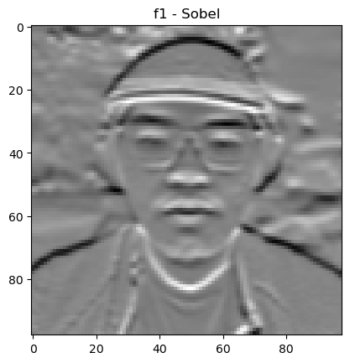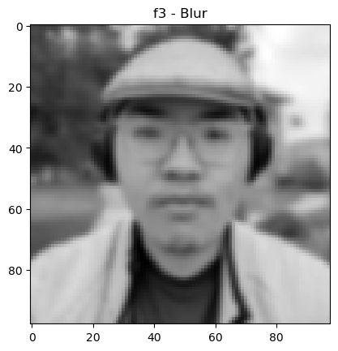A person wearing glasses and a hat

   AI-generated content may be incorrect.Filtered images
2. Filter explanation

F1: Sobel filter of horizontal edge, insert into the new image with the targeted pixel location its horizontal neighboring pixels

F2: Sharping, insert into the new image with the targeted pixel location and its heightened value then subtracted with mean blur

F3: Gaussian blur, insert into the new image with the targeted pixel location with its heightened value that is normalized with its neighbor and multiplication with 1/16.