Duan Nguyen
17th October 2025
CSCI 507 – Computer Vision
Assignment 7
EXERCISE 1:
- Code
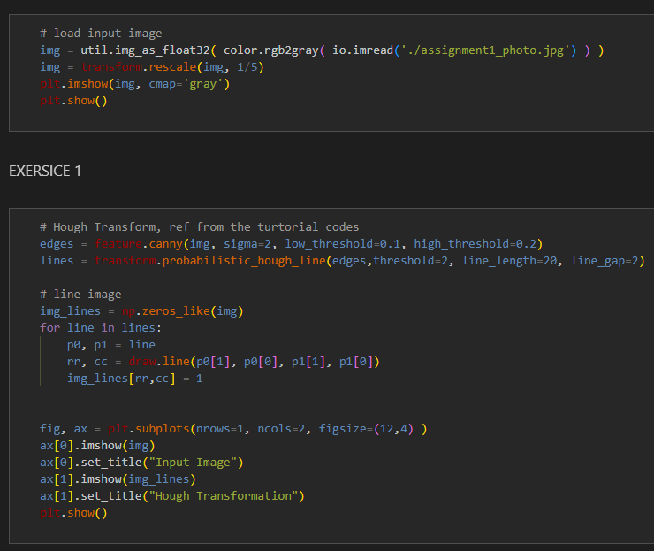
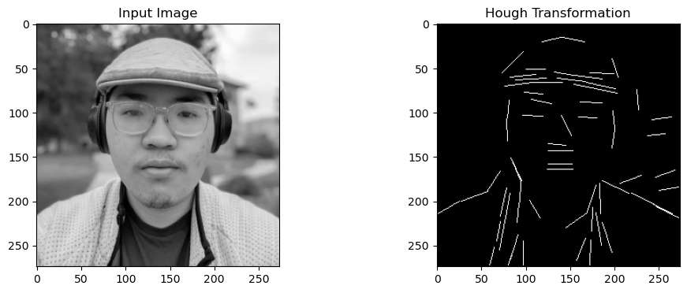
- Images

EXERCISE 2:
- Code
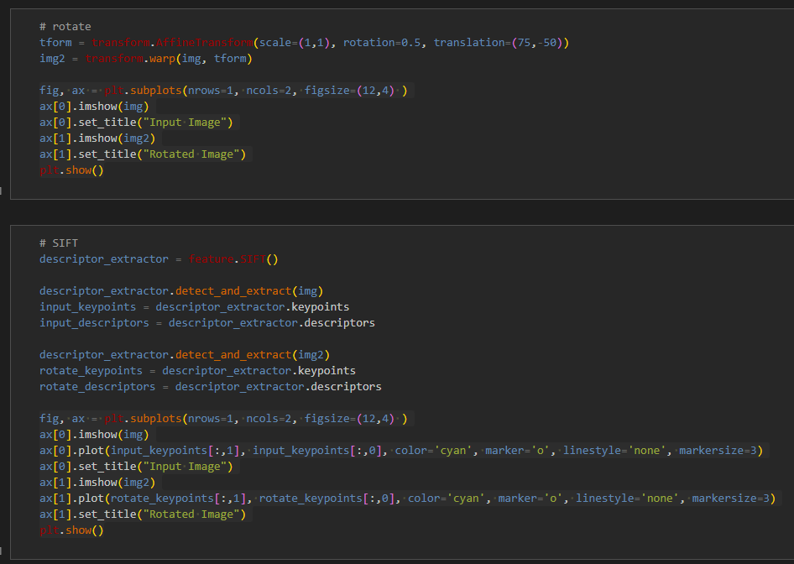
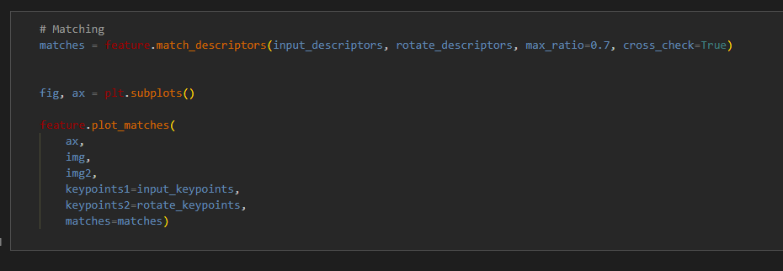

- Images
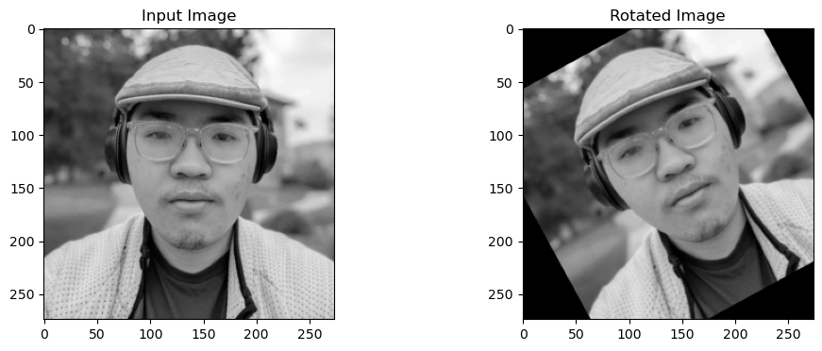
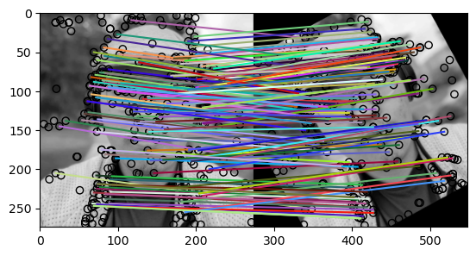
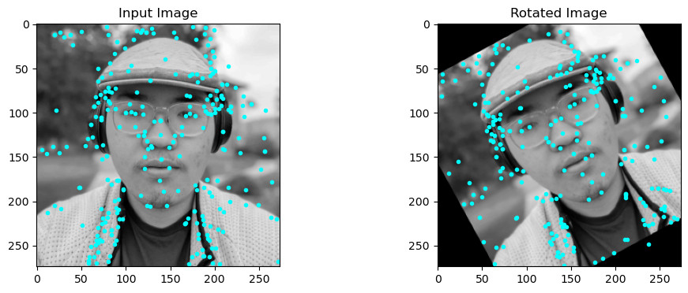

EXERCISE 3:
- Code
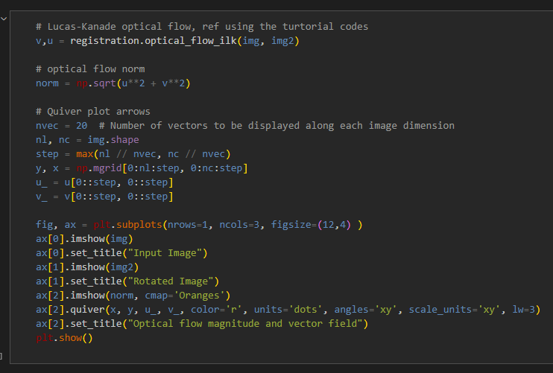
- Images
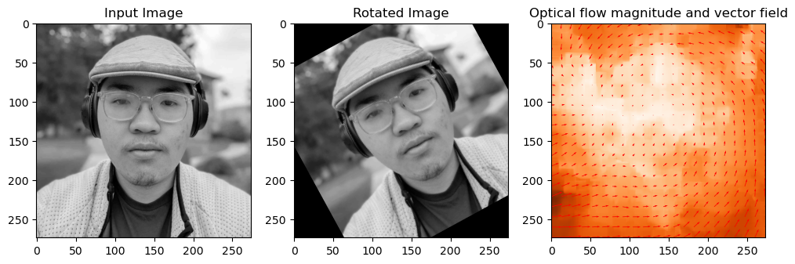
- Question and Answer
Is the optical flow computed correctly for all pixels in the image? Are there pixels for which the optical flow is wrong? If yes, explain why.
The optical flow for each pixel seems to follow the direction of the rotation and shift of center, so the computed optical flow is correct for all pixels in the image.

