Duan Nguyen
October 2nd, 2025
CSCI 507 – Computer Vision
Assignment 5
- Code
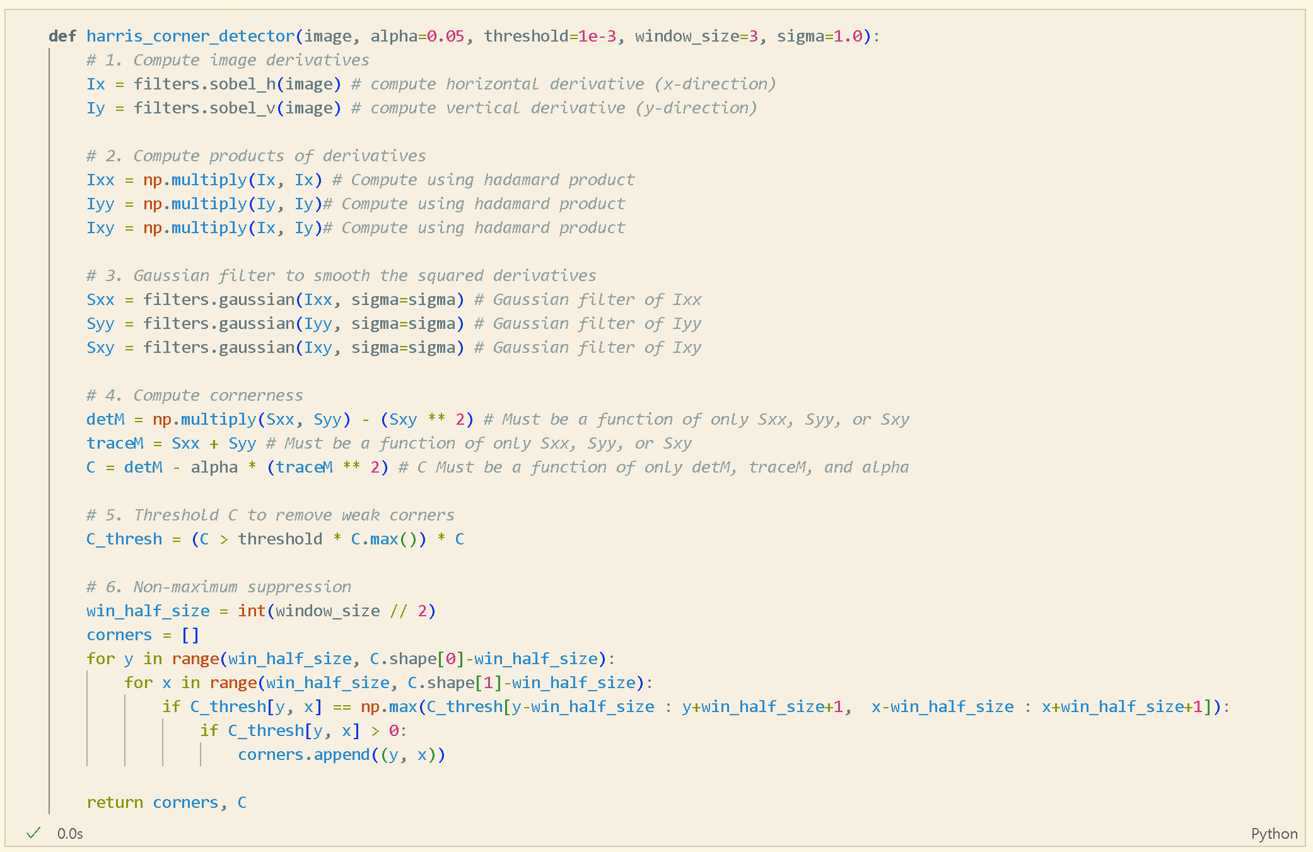
- Input image
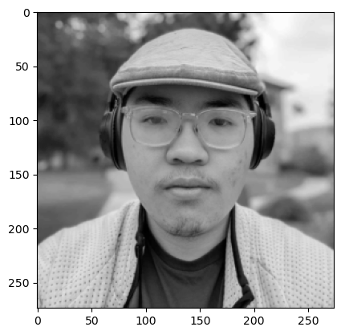
- Correctness image output and Harris corners overlayed
