The Devil’s Dance
Definitions
//base attributes – decided at beginning of game
Weapon Proficiency – WP : indicates how well you can use weapons
Musical Proficiency – MP : indicates your overall skill in understanding and playing music
Creativity – CR : indicates your ability to think of solutions and come up with unique answers
Intelligence – INT : indicates how well you recognize things and how well you make decisions
Communication – COM : indicates how well you can speak and communicate to others
Faith – FA : indicates your faith in God
Strength – STR : indicates your overall physical ability
Luck – LU : indicates how much rng is on your side
Goodwill – GW : indicates how well you have lived your life and how much of a good force you have been
//unique attributes – decided at beginning of game
Sliver Tough – ST : given a high enough creativity and communication attribute or a profession, will grant person the ability to talk their way out of situations or convince others to do something
Man of God – MoG : your high faith in god with your high goodwill has given you His blessing, you will suffer from less tricks from the devil and any demonic creatures will run from you.
Prodigy – PRO : given a high intelligence and creativity, you will be able to come up with unique situations
Barbarian – BAR : given a high strength, low intelligence, and communication, you will be unable to make certain decisions that would not be seen as “common sense”. Gain ability to make stupid decisions, but give you new options.
Good Krama – GK : your last decision has given you good krama, your next decision will have extra luck (+10) and +1 goodwill
Bad Krama – BK : your last decision has given you bad krama, your next decision will have less luck (-10) and -1 goodwill
BornSinner – BS : given a low enough goodwill, you will lose immediately no matter what point you are in the game and the Devil takes your soul
//abilities – acquired through playing game found in maze
Seer – S : You are able to look at what your attributes are at cost of -2 luck per viewing
Gain Skill – GS : You are able to gain one unique skill you don’t have at the expense of one you do (if you don’t have a skill take a (-20 debuff to luck)
Foresight – FS : gain the ability to see what is coming up in the next step you take in the maze (causes insanity -> must finish rest of game in 20 turns)
//unique character options if player gets stats in range, these 3 opinions are made available and a unique ending can be given
Jordan: the lawyer – Wrath
Jordan worked as a defense attorney for the state. Though they could have worked for much better pay doing work for a private firm, they had decided to make sure people were given a fair chance in representation in court when they couldn’t afford it. They often received death threats for defending people accused of some of the worst crimes. They even had their tires slashed one time. They did not let these threats get to them, they believed too much in their work Jordan had worked their whole life trying to make the system they worked in better but having seen the corruption and injustice firsthand had become consumed by an anger built up after these years working. It sent them to a breaking point in which they were driven to act. It was the last case they worked, a young 20 something had been accused of rape. They had pleated with Jordan that they were innocent as the victim could not be allowed to have a child being themselves a member of the clergy and were trying to pass the blame. Jordan had taken the case as they began to see they were not lying. Though it was all for not as the defendant was put to death. This drove Jordan to commit his own crime. Murdering the victim by strangulation. It was on their way back from this event in which they came face to face with the Devil.
Player Requirements
- City
- Play Music
- Lawyer
- Wrath
Sam : the pastor – Sloth
A devout member of the church, Sam had lived a simple life. Giving sermons to their followers every Sunday, they relished in spreading the word of the Lord. Their followers would often come to them for advice. “Pastor, how can I strength my faith? Pastor, what is it that I should do to renew the bonds in my family? Pastor, how can I turn around my life for the better?” Each question was returned with wise words often with passage recited from scripter. What a good life it was until Sam was approached by a outsider wishing for forgiveness. They came to Sam after the congregation had left for that day. A later session during the darker hours of the day. The outsider had admitted to a terrible lie and that they needed the pastor’s help as it concerned a member of their church. They had evidence but could not act for fear of their life. The pastor was taken aback by the accusation that their fellow clergy had done something so appalling. Sam had thought about what something like this would do to their congregation. They also thought this was not their responsibility and thus told a lie of their own. They had promised the outsider that they would act. Relieved, the outsider would leave. Sam took the evidence, burned it, and started his way back to his car. As strange figure would be on the way there, blocking his path.
Player Requirements
- suburbs
- write
- Pastor
- Sloth

Charlie : the doctor – Pride
Charlie was an excellent doctor. They were praise all their life about their skills in saving lives. They enjoyed working the E.R. as they loved feeling the thrill of the high stress situations in which they had to demonstrate how calm and collected they could be compared to their fellow doctors. This particular joy in doing their job made it all the worthwhile. Until, he had started to forget things. Simple things at first an appointment to meet a friend, their keys leaving the house, a birthday or two all thought to be as a result of over work. Charlie liked pushing themselves, but they wondered if all the work was getting to them. A ridiculous thought to be sure is what they used to reassure themselves. Later one normal night at the E.R. a patient was rushed in after a car accident. There were wounds all over their body. This would have been a normal night for Charlie but they were suffering from massive fatigue and so while making a standard incision to start fixing a large gash in the leg of the patient, they happened to nick an artery. The patient had already lost a lot of blood so this would for certain lead to their death. After taking time of death, Charlie refuse to admit their mistake, claiming the movement of the patient caused a greater wound to open. They were sent home for the time being. Charlie was extremely frustrated that they would be accused of such a grave mistake. Who were they to question someone who was there only because they enjoyed it. Charlie could have been doing more lucrative surgery. Deep in thought, they came across a figure in the middle of their path.
Player Requirements
- City
- read
- Doctor
- Pride

//events in the maze
Ability pool – Gaze into the pool to absorb its power : gain one of the 3 abilities based on the color of the pool
Trap – You’ve fall into one of the traps sent by the Devil : traps can be avoided with the foresight ability, with the right attribute stats or with an item found in the maze
Item find – You found something along the maze’s path : items can be used to progress story or disarm certain traps
Vicious Demon – You’ve run into the Demon wondering the maze! Choose your next actions carefully. This demon wanders the maze each time you do an action the demon moves one space
//other game defs
Action – the use of any skill or item to overcome a trap or otherwise or movement to another space in the maze. Inspecting and turning in a spot does not count as actions.
Path – location player or Demon can move to
Hedge – location player can move to but results in almost certain death.
Wall – location outlining maze, player or demon cannot move to

Story Progression
On a normal night out, walking back home you come across a figure in a hooded cloak. You try to walk past but the figure blocks your way and turns toward you.
He asks who are you?
Confused you ask what.
He asks now where are you from?
city | Suburbs | country
After you answer he asks, what is it you like to do?
read books | play sports | play music | write

Again he asks another, what is it you do for a living?
Law man | journalist | pastor | politician | doctor | engineer | Musician | Lawyer

At last he asks what is your sin?
Pride | greed | wrath | envy | lust | gluttony | sloth

With that he reveals himself. You are face to face with the Devil, and he has come to collect you for your sins but today he wants some entertainment and so has given you a chance to escape with your soul. You are transported to a dimly lit maze with large red hedges emanating with some evil you’d rather not go too nearby. You hear the Devil’s voice in your head, “In this maze I have hidden several caches of items you can use to challenge me. Navigate the maze as you wish. I promise I won’t kill you until you have decided on what you choose to challenge me with. I look forward to see what you’ll do.” With that you have several options….
- inspect in front of you
  - enter hedges
  - inspect hedges
  - look at what could be to the path in front of you
- look left, right, backward
  - turn different direction see other options
- go forward
  - progress toward the current path
Goal: progress through the maze in order to find one of the stores of items that can be used to defeat the Devil

Design Structures
//Game Screen Designs
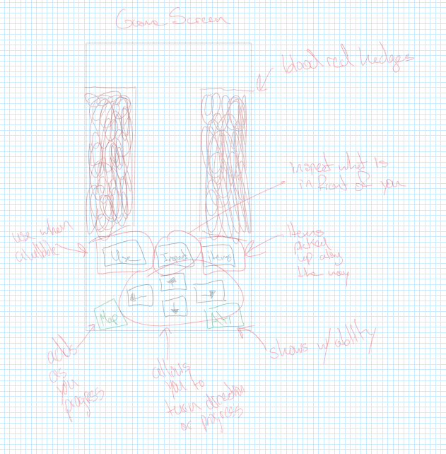
Progress through maze by inspecting the path in front to determine what to do. As you progress an Demon will be wandering the maze looking to kill you. One action will progress the demon’s movement by one.
//Maze Generation
https://medium.com/analytics-vidhya/maze-generations-algorithms-and-visualizations-9f5e88a3ae37
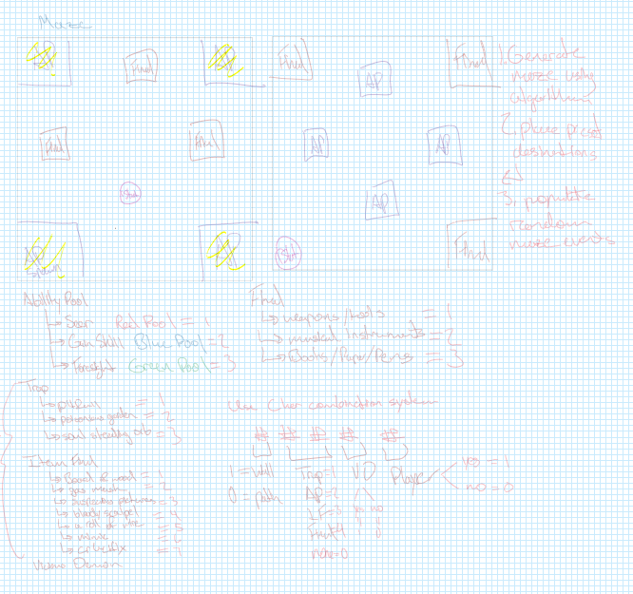
Maze will be a 2D array using the value to determine what is in that spot in the maze
Determines If you can progress here | Determines what type of thing is in the space | Determines what is in the space
- Path = 0  - Hedge = 1  - Wall = 2 | - None =0  - Ability Pool =1  - Trap = 2  - Item Find = 3  - Final = 4

