SRI KRISHNA POLYTECHNIC-90

(Affiliated and Approved by AICTE, New Delhi and Recognized by DTE, Government of

Karnataka), HesaraghaTta Main Road, Chimney Hills Chikkabanavara – 560090

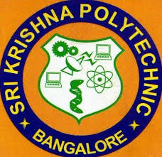

BOARD OF TECHNICAL EDUCATION

ONLINE COURSE REPORT

This to certify that the ‘CLOUD COMPUTING ’

Report has been submitted

COMPUTER SCIENCE ENGINEERING

During the Academic year 2024-25

NAME : GOWTHAM.B

REG NO : 487CS22009

CLASS : 5TH  SEM

SIGN OF LECTURER SIGN OF HOD SIGNATURE

DEPT OF CSE DEPT OF CSE PRINCIPAL