Peer-graded Assignment: R Markdown and Leaflet

*8/9/2020*

This is the R Markdown document containing an interactive map created using the **leaflet** R library.

The map

**library**(leaflet)

**library**(dplyr)

##

## Attaching package: 'dplyr'

## The following objects are masked from 'package:stats':

##

## filter, lag

## The following objects are masked from 'package:base':

##

## intersect, setdiff, setequal, union

ita_cities <- data.frame(name = c("Rome", "Milan", "Neaples", "Turin",

"Palermo", "Genova", "Bologna", "Florence",

"Catania", "Bari"),

pop = c(2618900, 1212900, 995000, 865700, 671100, 594900,

375800, 356100, 315100, 310500),

lat = c(41.890, 45.480, 40.850, 45.080, 38.120, 44.420,

44.500, 43.780, 37.500, 41.120),

lng = c(12.500, 9.190, 14.270, 7.680, 13.360, 8.930,

11.340, 11.240, 15.080, 16.870))

ita_popup <- c(

"<a href = 'https://en.wikipedia.org/wiki/Rome' target = '_blank'>Rome</a>",

"<a href = 'https://en.wikipedia.org/wiki/Milan' target = '_blank'>Milan</a>",

"<a href = 'https://en.wikipedia.org/wiki/Neaples' target = '_blank'>Neaples</a>",

"<a href = 'https://en.wikipedia.org/wiki/Turin' target = '_blank'>Turin</a>",

"<a href = 'https://en.wikipedia.org/wiki/Palermo' target = '_blank'>Palermo</a>",

"<a href = 'https://en.wikipedia.org/wiki/Genova' target = '_blank'>Genova</a>",

"<a href = 'https://en.wikipedia.org/wiki/Bologna' target = '_blank'>Bologna</a>",

"<a href = 'https://en.wikipedia.org/wiki/Florence' target = '_blank'>Florence</a>",

"<a href = 'https://en.wikipedia.org/wiki/Catania' target = '_blank'>Catania</a>",

"<a href = 'https://en.wikipedia.org/wiki/Bari' target = '_blank'>Bari</a>"

)

ita_cities %>%

leaflet() %>%

addTiles() %>%

addCircles(weight = 1, radius = sqrt(ita_cities$pop) * 30) %>%

addMarkers(popup = ita_popup)

## Assuming 'lng' and 'lat' are longitude and latitude, respectively

## Assuming 'lng' and 'lat' are longitude and latitude, respectively

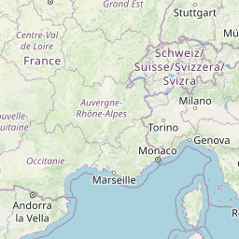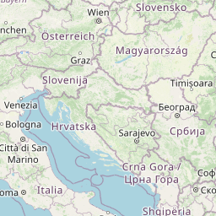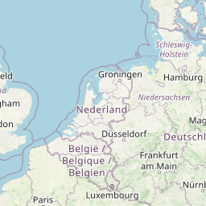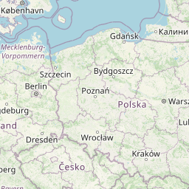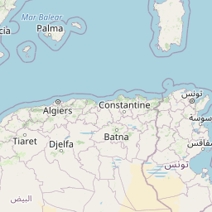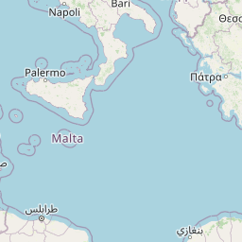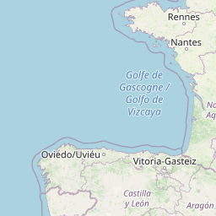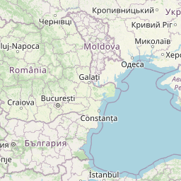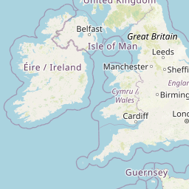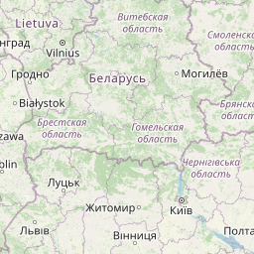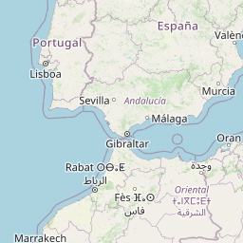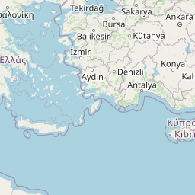

http://cdn.leafletjs.com/leaflet-0.7.3/images/marker-shadow.pnghttp://cdn.leafletjs.com/leaflet-0.7.3/images/marker-shadow.pnghttp://cdn.leafletjs.com/leaflet-0.7.3/images/marker-shadow.pnghttp://cdn.leafletjs.com/leaflet-0.7.3/images/marker-shadow.pnghttp://cdn.leafletjs.com/leaflet-0.7.3/images/marker-shadow.pnghttp://cdn.leafletjs.com/leaflet-0.7.3/images/marker-shadow.pnghttp://cdn.leafletjs.com/leaflet-0.7.3/images/marker-shadow.pnghttp://cdn.leafletjs.com/leaflet-0.7.3/images/marker-shadow.pnghttp://cdn.leafletjs.com/leaflet-0.7.3/images/marker-shadow.pnghttp://cdn.leafletjs.com/leaflet-0.7.3/images/marker-shadow.png

http://cdn.leafletjs.com/leaflet-0.7.3/images/marker-icon.pnghttp://cdn.leafletjs.com/leaflet-0.7.3/images/marker-icon.pnghttp://cdn.leafletjs.com/leaflet-0.7.3/images/marker-icon.pnghttp://cdn.leafletjs.com/leaflet-0.7.3/images/marker-icon.pnghttp://cdn.leafletjs.com/leaflet-0.7.3/images/marker-icon.pnghttp://cdn.leafletjs.com/leaflet-0.7.3/images/marker-icon.pnghttp://cdn.leafletjs.com/leaflet-0.7.3/images/marker-icon.pnghttp://cdn.leafletjs.com/leaflet-0.7.3/images/marker-icon.pnghttp://cdn.leafletjs.com/leaflet-0.7.3/images/marker-icon.pnghttp://cdn.leafletjs.com/leaflet-0.7.3/images/marker-icon.png