==================================================================================

Step 1 > to register

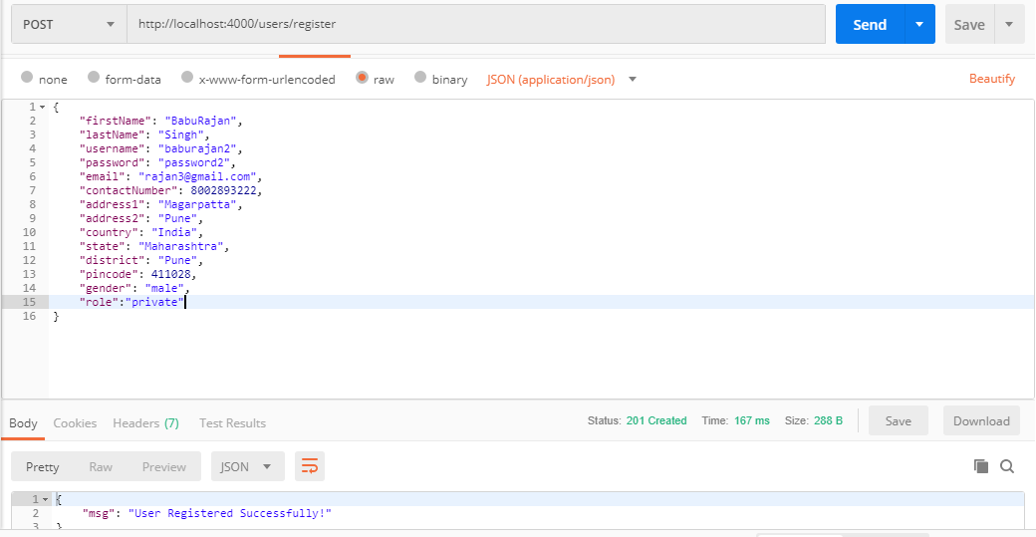

Step 2 > authentication

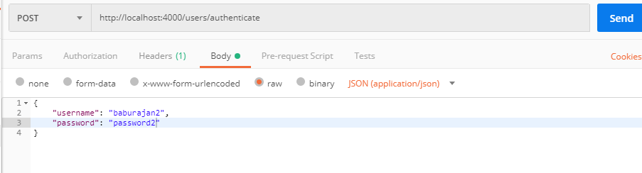

=================================================================================

==================================================================================

> getting token …

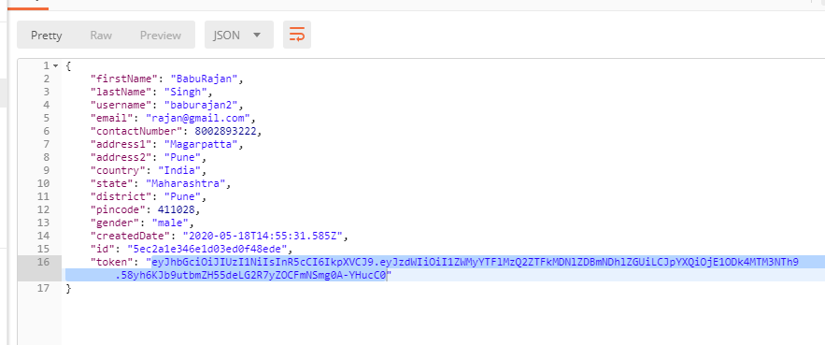

==================================================================================

Step 3> login

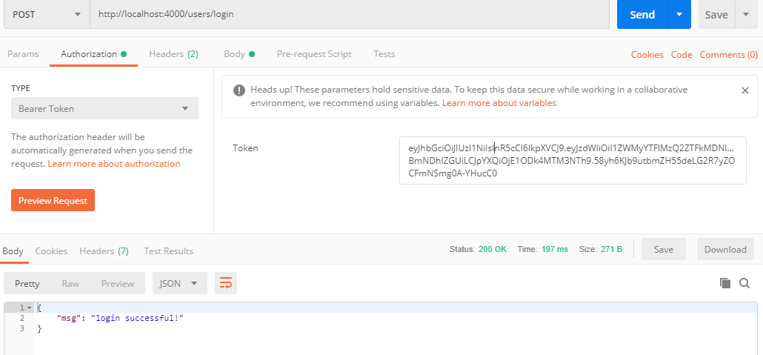

=================================================================================

step 4 >>> get user details by id.



