HR SYSTEM REPORT

INTRODUCTION

The designed solution for Human Resource management is a Java Graphical User Interface System.The used APIs are Abstract Window Toolkit(AWT),utilities(util),Swing and the input-output API(io).

PURPOSE

The system manages employees of the a company using a read only file containing information about the employees.

STATUS REPORT

Currently the system is able to read information about employees from a file, Select and display employees by title, in a scrollable screen, Calculate and display each employee salary, allow a search for an employee and salary calculated, Display a scrollable list of all employees and their net salaries.All this is provided in a responsive and interactive Graphical User Interface.Data is formatted using string format.

TEST CASES

Test:Display all records

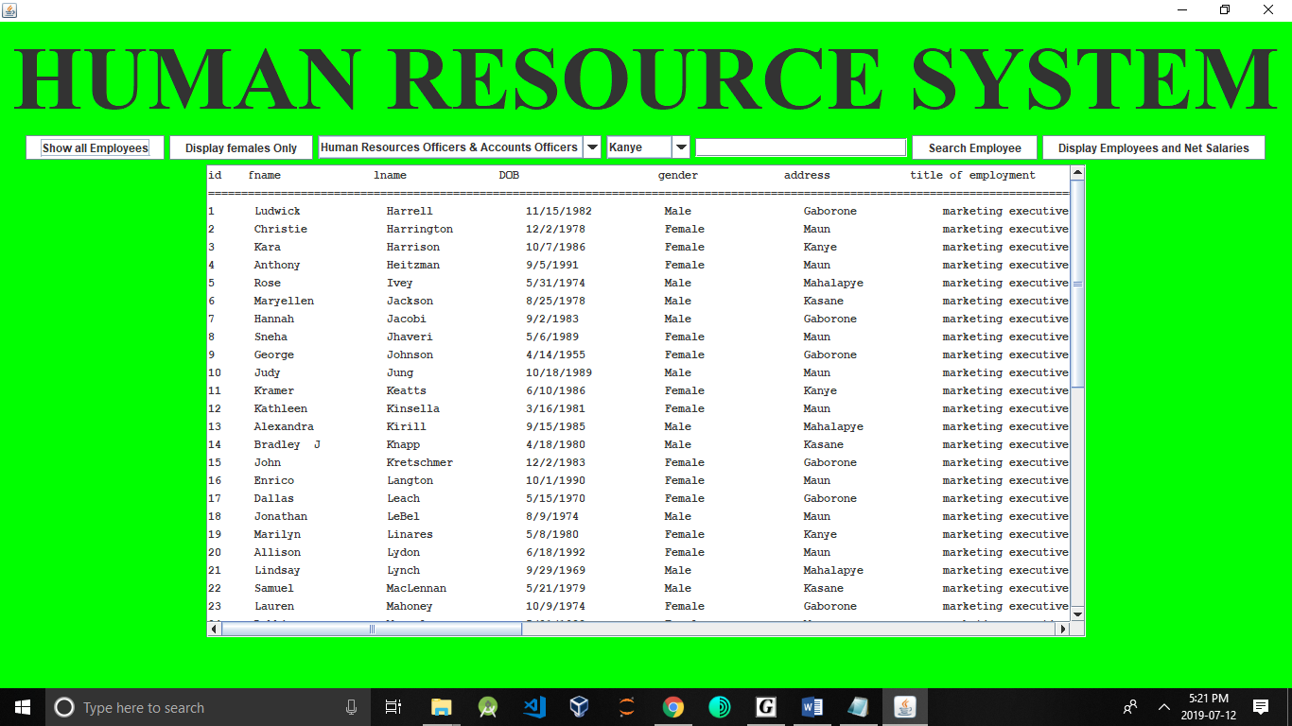

Test:Display Females only

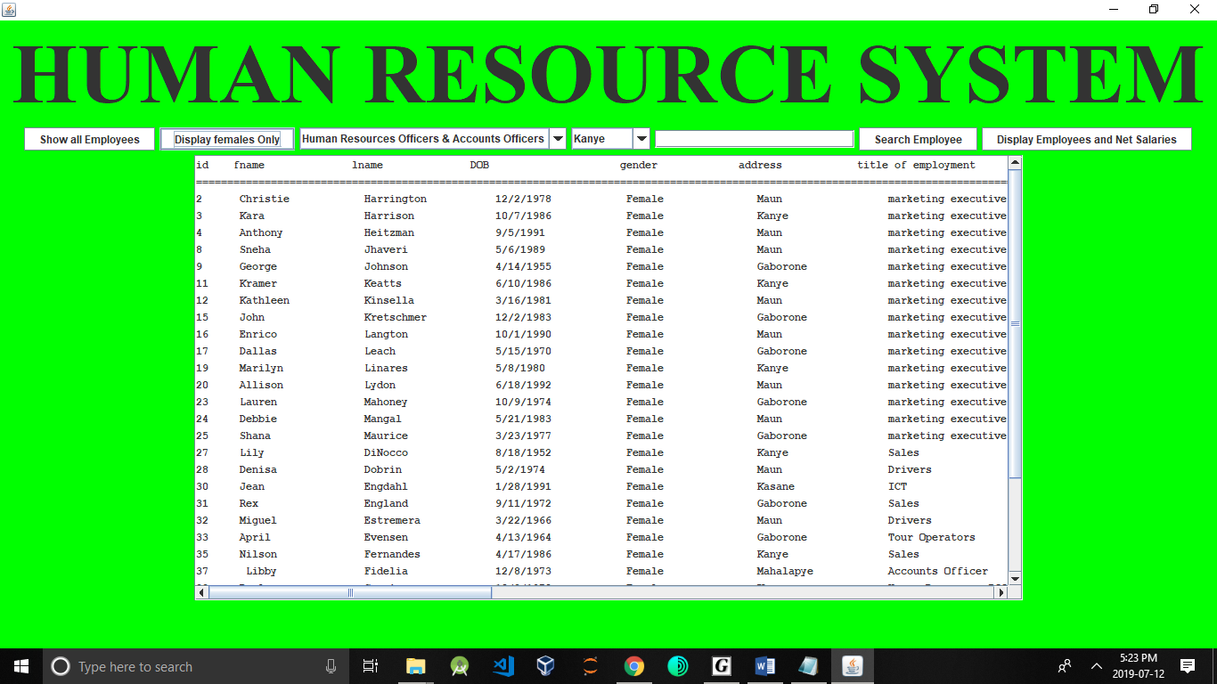

Test: Select and display employees by title

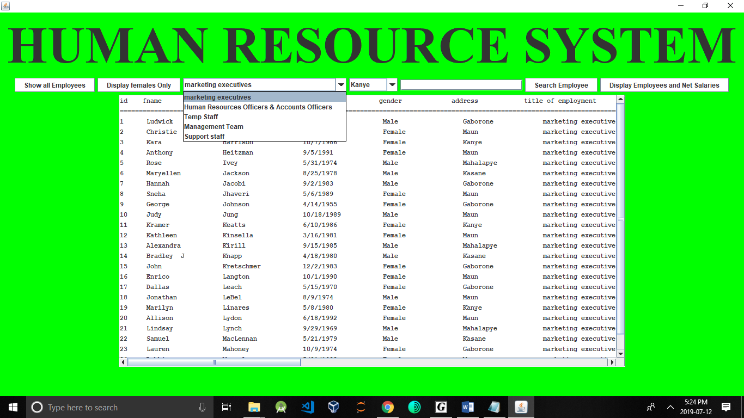

Test:Search record by last name

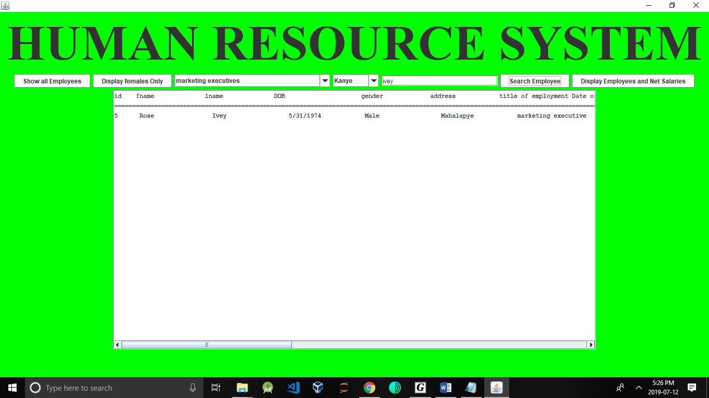

Test: Display a scrollable list of all employees and their net salaries

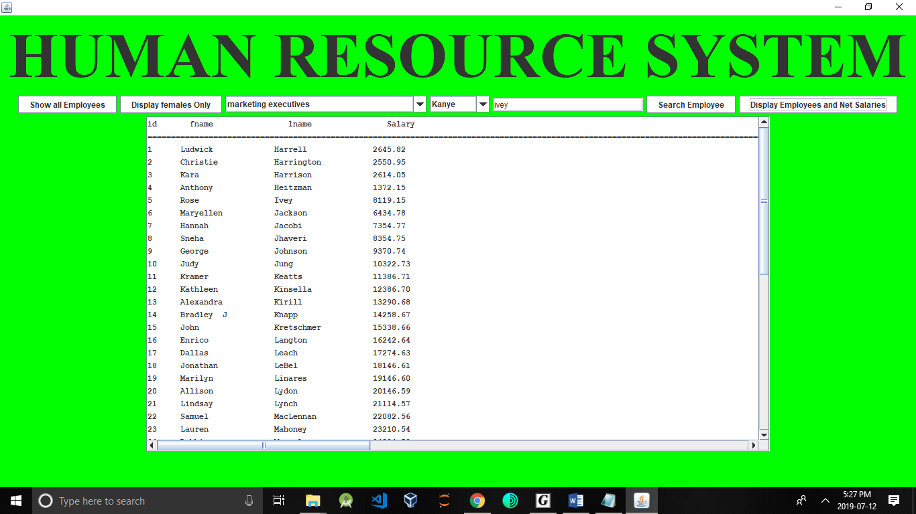

Test:Display total number of employees per city or town based

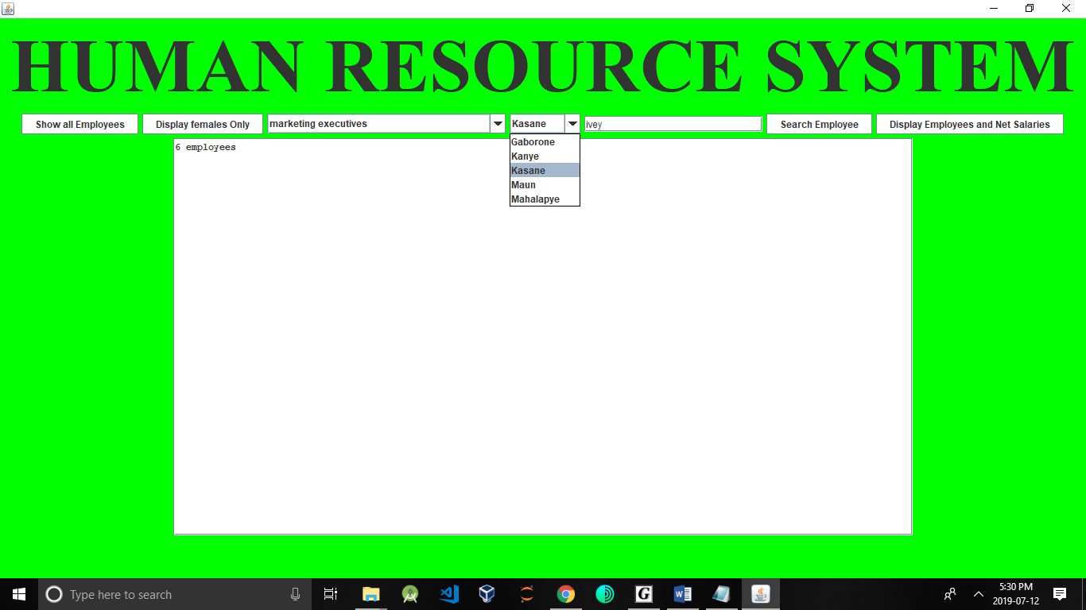

CONCLUSIONS

The system is simple,functional and better than using a traditional human resource management system.Data was well formatted using string format.