Introduction

We have been required to design a system to produce an output of various sorts, whether it be audio, video, motion (using a speaker, LED, motor respectively). We have chosen to drive the input to produce outputs that will include LEDs, speakers and a visual display on a computer (collection of data).

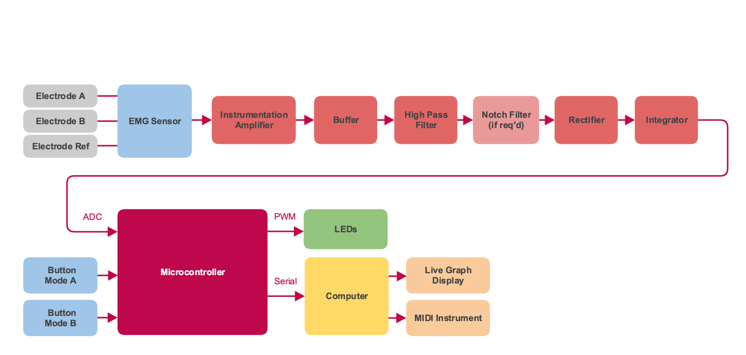Overall system level diagram:

Electronic components:

|  |  |
| --- | --- |
| Component | Quantity |
| Instrumentation Amplifier – LMC660  + buffer stage | 2 |
| TL074 (notch filter) | 1 |
| Push Button – 3CTL9 | 2 |
| Arduino Mega 2560 | 1 |
| Bar LED | 1 |
| ECG electrode | 3 |
| Conductive Gel Ten20 | 1 |
| PP3 Battery | 1 |
| PP3 Battery Clip | 1 |
| Assorted resistors | - |
| Assorted capacitors | - |
| Assorted diodes for half wave rectifier | 2 |

Plan

Franky Saxena – Project Manager/ADC programming

Bruno Calogero – Circuit Diagrams

Theo Velon – PCB Design

Daniel Saul – ADC Programming

Theo

Daniel

Bruno

Theo

Franky

Bruno

Franky

Daniel

ADC Programming/microcontroller

Breadboard Test

Circuit design

Collecting input data from sensors – EMG Sensor , electrodes