**NFL2K5Tool**

NFL2K5Tool is a program you can use to modify NFL2K5 franchise and roster files. Its concept is the same as TSBToolSupreme (<http://tecmobowl.org/forum/topic/11106-tsb-editor-tsbtool-supreme-season-generator/>). Where you can list out the contents of a gamesave, copy/paste the text into the editor, modify it and apply it to a Gamesave file.

Its purpose is to make it quick to edit NFL2K5 gamesaves, applying a lot of data at a time.

**Basic usage**

Load Save:

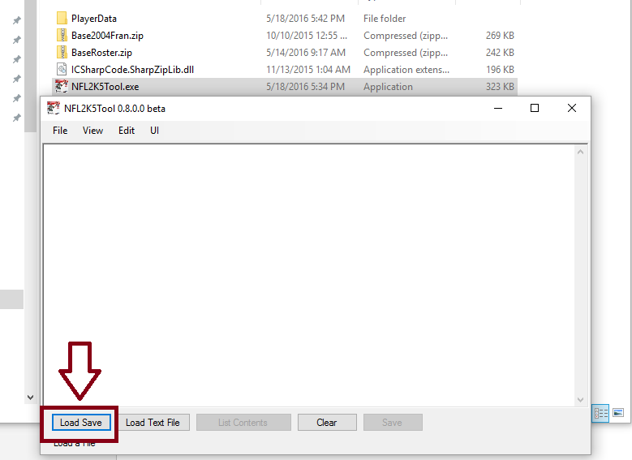

Select items to list:

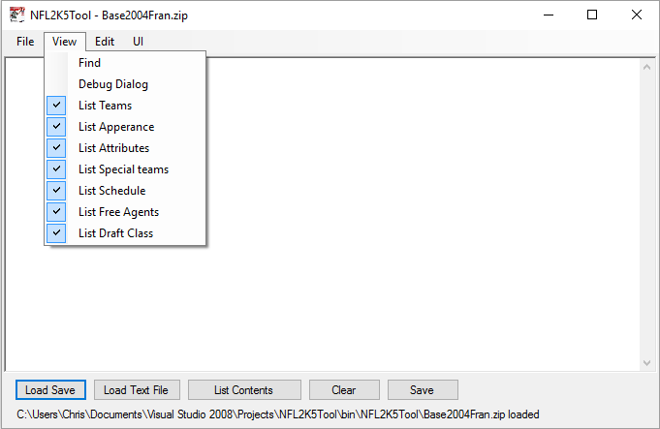

List Contents:

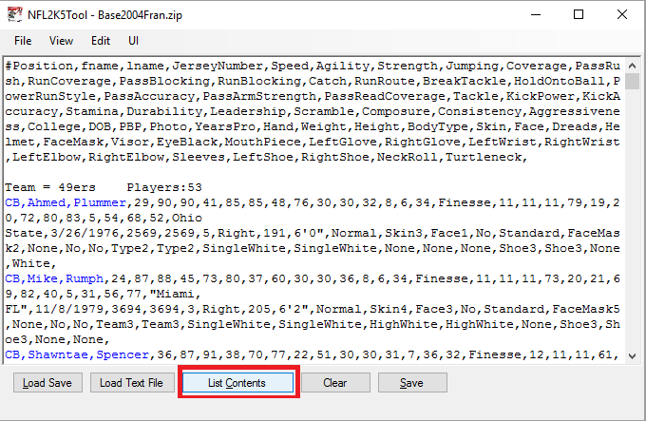

Edit Player:

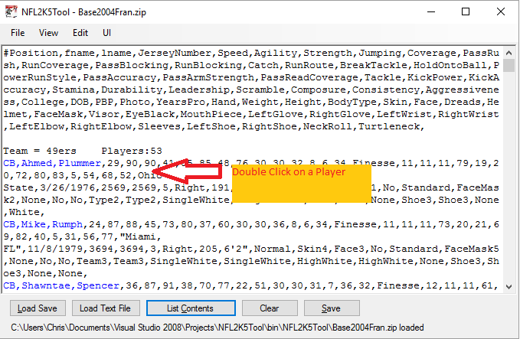

Use Player editor form:

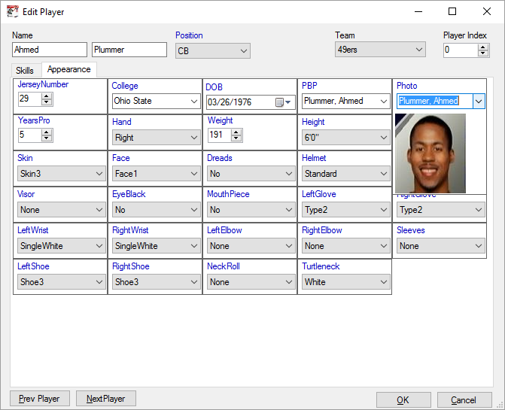

Instead or using the player editor form, you could also just hand edit the text. But it’s harder to see what field you’re editing.

The player editor form changes the text in the editor when you press the ‘OK’ button, it does not apply the changes to the gamesave until you press the ‘Save’ Button.

Names

In the initial release (0.8.0.0 beta), NFL2K5Tool does not work well with shared names (when 2 or more players share the same name). It will read the names correctly, but when applying the data, the name will get overwritten by the last guy’s data. So you’re fine extracting data from a gamesave but when applying that data, you should load and apply to a gamesave that doesn’t have shared names (like the base files).

User Interface Elements

Buttons:

* Load Save → Loads a save File (Franchise or roster zip file) to program memory.
* Load Text File → Loads a text file into the editor.
* List Contents → Lists the contents of the roster or franchise currently loaded into program memory to the Program’s text area.
* Clear → Clears the text from the text area.
* Save → Applies the data in the text area to the file loaded into program memory, prompts you to save to a file (warns about overwriting a file).
  + In General, you probably want to be saving to a new file and not overwriting an existing one.

Menus:

**File:**

* Load Save → Same action as ‘Load Save’ button.
* Load Text File → Loads a text file into the editor.
* Apply data without saving → Applies the data in the editor to the Gamesave file loaded into the program’s memory.
* Save → Same action as ‘Save’ button.
* Exit → Exits the program.

**View:**

* Find → Search for text in the text area (‘F3’ advances to next match, Shift + ‘F3’ goes to the previous match).
* Debug Dialog → Used as a debugging/ searching tool. You probably won’t find it useful.
* List <thing> → instructs the program to list the checked items when the ‘List contents’ button is pressed.

**Edit:**

* Show Schedule Now → Appends the schedule to the end of the text area.
* Auto Correct Schedule → When checked, will fill out the schedule preserving all games entered (sometimes pushing games into the next week). It is highly recommended to keep this option checked.
* Show Team Players now → List players, overwrite data in the text area.
* Validate Players → Checks through the players and shows warnings based on player weight and body type.
* Sort Players → Sorts the currently listed players based on the formulas listed in 'SortFormulas.csv'
* Edit Sort formulas → Lets the user edit the formulas used to sort players
* Auto Update Special teams depth → Assigns fast (non-starting) RB, CB or WR to return punts and kicks. Assigns a Center to be long snapper. (works on gamesave data in memory, not the text) Use this option after you have applied data to a gamesave, before saving to a file.
* Auto Update Depth chart → Automatically updates the teams' depth charts (in program memory) based on player index and position. Players listed higher will be at the top of the depth chart, players listed lower will be lower on the depth chart.
* Auto update Photo → Automatically update the 'Photo' attribute of each player based on name. (uses ''ENFPhotoIndex.txt' file, operates on text )
* Auto Update PBP → Automatically Update what name gets called for a player (operates on text).
* Player Editor → Bring up the player editor.

**Depth Chart Info**

There is no special UI element to update the depth chart. Instead, an ‘Automatic Update Depth Chart’ option is provided. It orders the depth chart based on player order. So if your QBs are listed like:

QB,Joe,Blow,13,64,81,13,44,27,16,19,24,24,16,22,7,28,Balanced,78,75,77,27,7,11,21,63,70,34,71,66,24,Louisiana Tech,3/15/1977,2715,2715,5,Right,200,6'0",Normal,Skin17,Face6,No,Standard,FaceMask2,None,No,No,None,None,DoubleWhite,DoubleWhite,None,None,None,Shoe3,Shoe3,None,None,

QB,Pony,Boy,7,69,67,35,64,31,20,42,30,27,36,28,47,28,Balanced,70,67,71,42,17,18,33,73,79,22,53,70,24,"Miami, FL",4/22/1981,5070,5070,2,Right,205,6'4",Normal,Skin17,Face5,No,Standard,FaceMask7,None,No,No,None,None,ElasticLarge,ElasticLarge,None,None,None,Shoe3,Shoe3,None,None,

QB,Little,Mac,11,67,77,26,64,26,20,26,12,10,12,22,33,28,Balanced,40,61,59,27,11,13,20,76,40,48,45,50,20,BYU,12/29/1976,3556,3556,3,Right,210,6'1",Normal,Skin17,Face7,No,Standard,FaceMask3,None,No,No,None,None,SingleBlack,SingleBlack,None,None,None,Shoe3,Shoe3,None,None,

The tool will assign Joe Blow as the #1 QB, Pony Boy as the #2 QB and Little Mac as QB #3 (when you select ‘Edit → Auto update depth chart’).

Likewise for Wide receivers (or other positions that have 2 starting spots):

WR,Glass,Joe,85,82,85,45,76,6,12,9,43,40,88,83,30,80,Finesse,23,20,17,16,18,15,72,73,45,5,21,77,51,Illinois,7/15/1981,5158,5158,2,Right,184,6'0",Normal,Skin6,Face6,No,Standard,FaceMask5,None,No,No,Team3,Team3,None,None,None,None,White,Shoe3,Shoe3,None,None,

WR,Bald,Bull,1,85,82,36,82,12,7,8,37,40,85,84,41,55,Balanced,21,20,15,14,10,13,55,72,49,5,89,66,24,USC,3/13/1971,0358,0358,12,Right,196,6'1",Normal,Skin5,Face6,No,Standard,FaceMask2,None,No,No,Team1,Team1,None,None,None,None,None,Shoe6,Shoe6,None,None,

WR,Piston,Hondo,81,87,92,34,85,11,11,8,51,60,86,80,68,74,Balanced,21,20,14,15,6,11,50,82,53,5,60,47,24,Oklahoma State,7/11/1981,6677,6677,1,Right,194,6'1",Normal,Skin12,Face1,No,Standard,FaceMask2,None,No,No,Team3,Team3,SingleWhite,SingleWhite,HighWhite,HighWhite,None,Shoe3,Shoe3,None,None,

WR,Don,Flamenco,84,91,87,32,82,36,22,14,46,50,71,77,24,65,Finesse,19,17,14,32,11,16,46,74,40,5,24,90,56,Tennessee,12/17/1978,3238,3238,4,Right,183,5'10",Normal,Skin3,Face2,No,Standard,FaceMask2,None,Yes,No,Type2,Type2,SingleBlack,SingleBlack,None,None,None,Shoe3,Shoe3,None,None,

WR,Von,Kaiser,83,83,91,46,73,35,15,19,29,33,75,70,21,64,Balanced,20,17,14,24,9,13,28,74,25,5,21,79,57,Notre Dame,2/22/1980,5031,5031,2,Right,217,6'1",Normal,Skin4,Face1,No,Standard,FaceMask7,None,No,No,Type4,Type4,None,None,HighBlack,HighBlack,None,Shoe1,Shoe1,None,None,

WR,King,Hippo,88,90,80,32,88,11,8,9,51,50,75,72,33,76,Balanced,21,20,16,10,14,19,69,84,46,5,41,68,24,Clemson,5/30/1981,6428,6428,1,Right,213,6'4",Skinny,Skin13,Face1,No,Standard,FaceMask3,None,No,No,Team3,Team3,None,None,HighWhite,HighWhite,None,Shoe1,Shoe1,None,None,

The WR depth chart should look like:

|  |  |
| --- | --- |
| **Left Receiver** | **Right Receiver** |
| Glass Joe | Bald Bull |
| Piston Hondo | Don Flamenco |
| Von Kaiser | King Hippo |
| King Hippo | Piston Hondo |
| Bald Bull | Von Kaiser |

**Sorting Players (depth chart related)**

Also, there is an option to sort the team players (Edit →Sort Players) so that the ‘Automatic update depth chart’ feature can be more effective. Players are sorted based on their ‘Goodness’ (which are formulas that you can edit). Let’s look at the default WR sort formula (Edit → Edit sort formulas):

WR: (3*Speed + 2*Catch + RunRoute + 2*Consistency)/7

The WRs on a team will be sorted based on this formula. So in the above example with the Punch out players, the following order will result (after sort option):

1. Don Flamenco [(3*91 + 2* 71 + 77 + 2*90)/7] = **96**
2. Glass Joe [(3*82 + 2*88 + 83 + 2*77)/7] = **94.1428571428571**
3. Bald Bull [(3*85 + 2*85 + 84 + 2*66)/7] = **91.5714285714286**
4. King Hippo [(3*90 + 2*75 + 72 + 2*68)/7] = **89.7142857142857**
5. Von Kaiser [(3*83 + 2*75 + 70 + 2*79)/7] = **89.5714285714286**
6. Piston Hondo [(3*87 + 2*86 + 80 + 2*47)/7] = **86.7142857142857**

You can use any of the player attributes in the formulas:

Speed,Agility,Strength,Jumping,Coverage,PassRush,RunCoverage,PassBlocking,RunBlocking,Catch,RunRoute,BreakTackle,HoldOntoBall,PassAccuracy,PassArmStrength,PassReadCoverage,Tackle,KickPower,KickAccuracy,Stamina,Durability,Leadership,Scramble,Composure,Consistency,Aggressiveness.

**Command line interface**

NFL2K5Tool also supports a command line interface. Type the following at the command line to list available options: “NFL2K5Tool /?”

The command line interface could be useful for scripting, or feeding input from another program.

**Text Commands**

The following 'commands' can be used to change the order in which attributes are displayed:

Key

CoachKEY

The following command can be used to apply arbitraty edits which would normally be

applied with a hex editor:

SET

The following commands can be processed to perform common operations instead of having to run them from

the menus.

Modification Commands:

LookupAndModify

AutoUpdateDepthChart

AutoUpdatePBP

AutoUpdatePhoto

ApplyFormula(<arguments>)

Note:

To Apply Data without saving to the gamesave file.

Use:

File -> Apply Data without saving

This will update the gamesave file in-memory, but won't save to a file. (sometimes useful)

I like to use this feature when appling multiple sets of data to a gamesave file.

====== Key ======

To change the displayed attributes of players listed you can set the 'Key' to list

only the attributes you wish to see.

This will also apply when setting player data.

Example:

Key=Position,fname,lname,Photo,Skin

To reset the key to default use:

<clear text content>

type/paste into text area:

Key=

<apply data without saving >

Note:

The player Gui only works with the default Key

====== CoachKEY ======

Similar in functionality as 'Key', only for Coaches

====== SET ======

Sets data in the gamesave

Example:

#"St. Louis" -> "L.A. "

SET(0x7633e,0x4C002E0041002E0020002000200020002000)

SET(0x79898,0x4C002E0041002E0020002000200020002000)

In the above example the intent is to set the string "St. Louis" to "L.A. ".

The locations of strings changes with each gamesave file. You can find string and their

locations in the DebugDialog.

====== LookupAndModify ======

If we wish to modify player data without specifying all the data we can use this feature.

It is meant to be used in conjunction with the 'Key' command.

The 'Position','fname' and 'lname' attributes must be specified for player lookup.

Example:

LookupAndModify

Key= Position,fname,lname,Photo

QB,Jimmy,Garoppolo,0481,

QB,Nick,Mullens,0799,

RB,Tevin,Coleman,0187,

RB,Matt,Breida,0242,

The above example will lookup the specified players and set their photo the the one specified.

====== AutoUpdateDepthChart ======

Simple command that will update the depth chart according to player occurance in the gamesave.

So for QB, the first QB to occur on a roster will become the starter, the 2nd QB to occur will

become 2nd string the 3rd QB to occur will become 3rd string on the depth chart.

Same for the other positions too.

Example:

<clear data>

type/paste into text area:

AutoUpdateDepthChart

<apply data without saving>

====== AutoUpdatePBP ======

The "PBP" stands for 'Play by play' name used by the commentators in the game.

So for all the players with the last name 'Smith', the 'Smith' name will be mentioned

by the commentators when they talk about the player.

The name to pbp mappings are stored in 'PlayerData\ENFNameIndex.txt'

Example:

<clear data>

type/paste into text area :

AutoUpdatePBP

<apply data without saving>

====== AutoUpdatePhoto ======

Updates the player photos according to their names.

Name file is located at 'PlayerData\ENFPhotoIndex.txt'.

Example:

<clear data>

type/paste into text area :

AutoUpdatePhoto

<apply data without saving>

====== ApplyFormula ======

Can be used to modify players meeting specified attributes.

The 'Global Edit Form' Can be used to craft and apply formulas.

The formulas will print to the console when they are run from the

Global edit form so you can more easily see/create/use/re-use them.

Basic syntax:

ApplyFormula(<formula>, <target attribute>, < target value>, [positions], <Mode (optional)>)

Examples:

# For all kickers, punters or quarterbacks who have a white turtleneck, take away 1 speed point

ApplyFormula('Turtleneck = White','Speed',-1, [K,P,QB], Add)

# For all quarterbacks who wear a RightGlove, set their RightGlove to 'None'

ApplyFormula('RightGlove <> None','RightGlove','None', [QB])

# For all quarterbacks who have speed greater than 80, set their 'Stamana' to 95% of what it currently is

ApplyFormula('Speed > 80','Stamina',95, [QB], Percent)

# For all kickers and punters, set their stanama to '95'

ApplyFormula('Always','Stamina',95, [K,P])

**Source code**

Available at GitHub (<https://github.com/BAD-AL/NFL2K5Tool>).