Business Problem

Access to nutritional food remains a critical issue throughout the world. Many governments subsidize funds needed to assist individuals and families in need. Identifying areas at high risk of food scarcity can help with resource allocation planning so that funds get to the most critical areas.

Background/History

When individuals and families cannot provide fully for themselves, they may need to participate in the Supplemental Nutrition Assistance Program (SNAP). SNAP helps millions of people in the United States each year. I investigated which counties in Ohio need food assistance and compared how Ohio ranks among other states for food scarcity risk. By assessing food scarcity risk, it will allow agencies to proactively plan for food assistance needs and allocate resources effectively. The goal of this project was to predict where food scarcity is at highest risk over the next 6 months based on past data collected related to SNAP participation.

Data Explanation

I used the U.S. Department of Agriculture (USDA) website to download and unzip datasets for 2023 at the county level pertaining to the monthly number of SNAP participants, sufficient access to food, and poverty levels. Counties are identified by a unique Federal Information Processing Standards (FIPS) code. Datasets were merged on the FIPS code.

SNAP Participation: https://www.fns.usda.gov/sites/default/files/resource-files/snap-zip-fns388a-7.zip

Food Access: https://www.ers.usda.gov/data-products/food-environment-atlas/data-access-and-documentation-downloads

Poverty Data: https://www.ers.usda.gov/data-products/county-level-data-sets/county-level-data-sets-download-data

After downloading datasets, I selected data applicable to SNAP and the year 2023 from the datasets, and formatted data to fit into a machine learning pipeline. This included handling missing values for FIPS, assigning descriptions to the variables that are more reader friendly for optional plotting purposes in the future, and creating monthly lag features about SNAP participants.

Methods

I trained a regression model, Random Forest Regressor, to predict county level SNAP participation. I encoded the categorical variables and made sure other variables are numeric. I split the data using a typical 80% training and 20% testing set for predictions. Model performance is determined using the R-squared score.

Analysis

The R-squared score of 0.652 shows that the model is capturing a good amount of the variability in SNAP participation. The scatter plot in Figure 1 allows us to see how the predicted values compare to the actual values and how they fit to the perfect prediction line.

Figure 1. Predicted versus Actual SNAP Participants

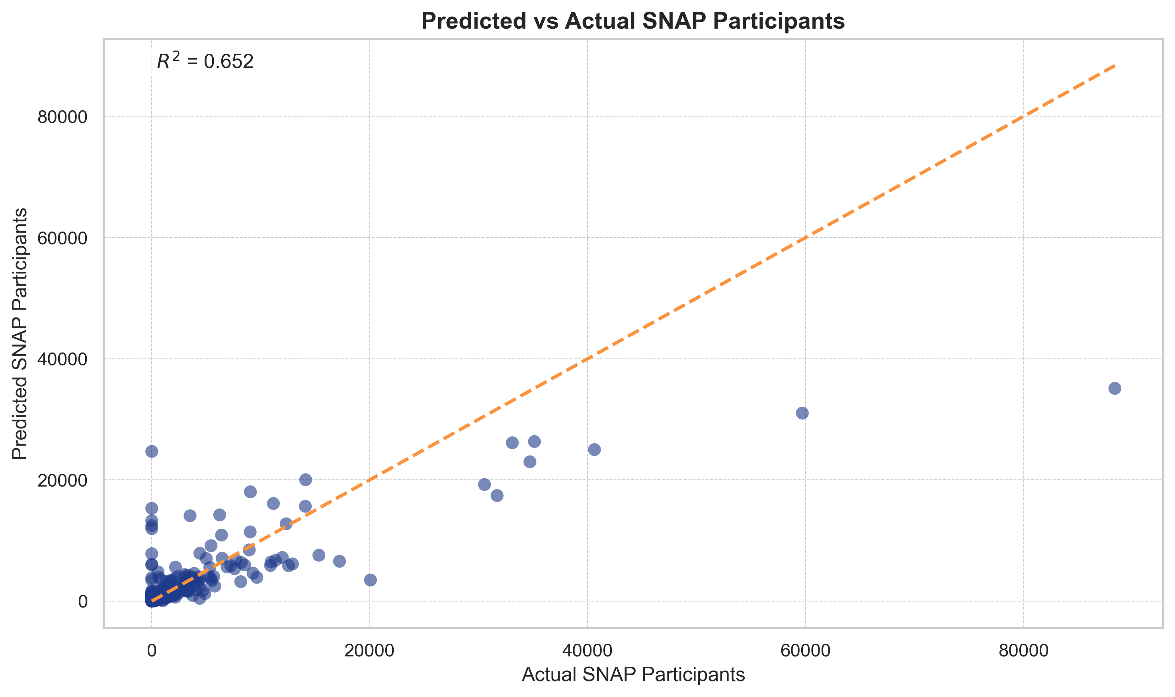

National SNAP Participation is led by heavily populated areas in California and New York (Figure 2). Even though counties in Ohio do not rate top in the nation, there are still food scarcity needs that need to be addressed. These Ohio counties are displayed in Figure 3 and align with heavily populated areas as well.

Figure 2. Top 15 Counties Nationwide by predicted SNAP Participants

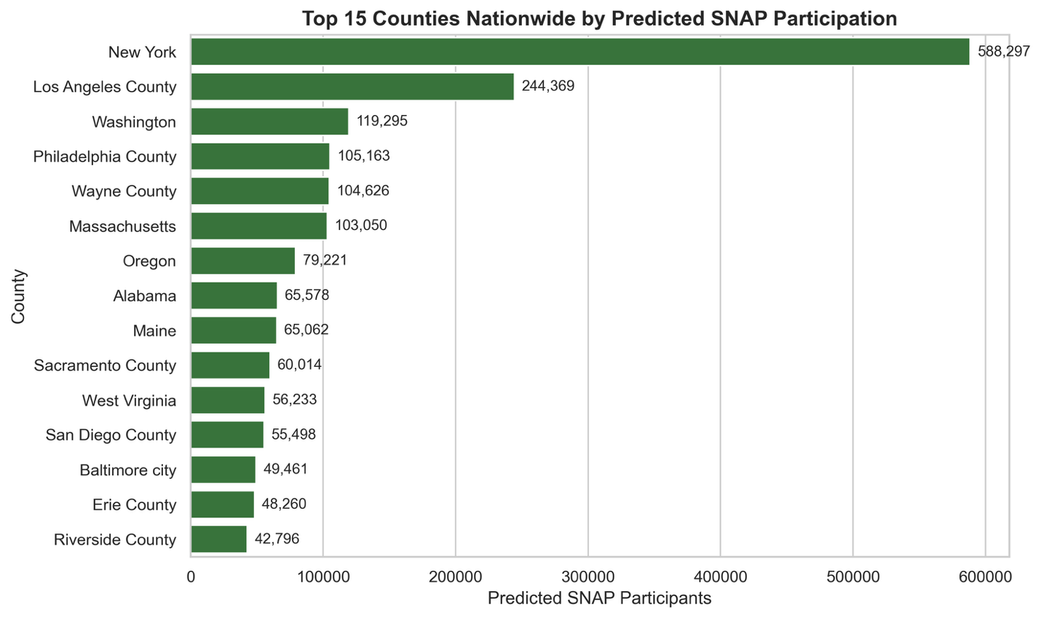

Figure 3. Top 15 Ohio Counties by average SNAP Participants

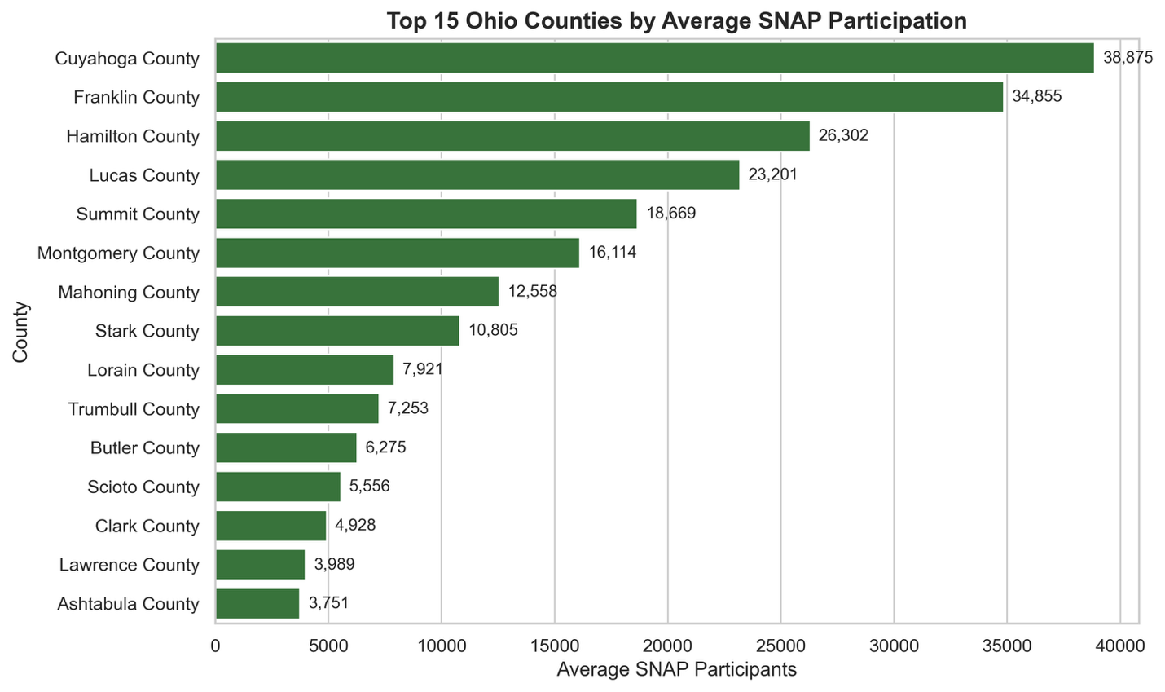

The scatterplot in Figure 4 shows the top 5 counties in Ohio that are predicted to need SNAP. The trend line indicates that when access to food is limited, SNAP participation is increased.

Figure 4. Ohio Counties: Food Access Index versus Predicted SNAP Participants

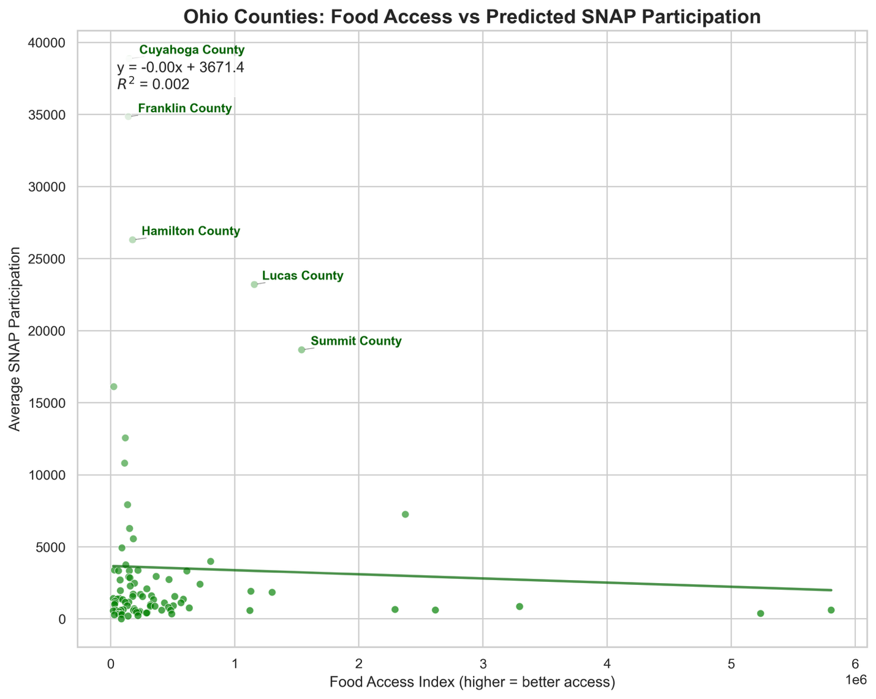

Assumptions

When training this model, I’m assuming that, other than past SNAP participants, access to nutritional food is a predictor of SNAP participation. I’m also assuming that comparisons between counties and states are feasible for this analysis.

Limitations

Some limitations are whether data is high quality and available for all counties. Factors that influence SNAP participation could be missing, since we have a limited scope of only evaluating past participation and access to food factors. Economic and policy factors can also influence participation, and this project is not considering any policy data.
Challenges/Issues

Some of the challenges that I had were the variable codes being used and the need to attach them to the data dictionary to get human readable descriptions. I did not use visualizations with these descriptions. However, in the future if I wanted to use them in plots, I may need to map the variable descriptions at the end of the model training to get the expected benefit from obtaining the variable descriptions. Another challenge is choosing the correct variables to determine the food access index to use.

Future Uses/Additional Applications

This model could be enhanced to change features and to pull in most recent data to run predictions in closer to real-time to have more of an impact on resource allocation and funding plans.

Recommendations

Prioritize counties predicted to have a food scarcity need for SNAP benefit distribution. Set aside funding to provide better access in counties with limited access to nutritional food in prevention efforts to reduce need to participant in SNAP.

Implementation Plan
Work with state agencies to establish regular monitoring of food assistance needs per county, while also pushing for development of easier access to food in those areas at high risk of food scarcity. Communities should also be engaged in developing access to nutritional food resources.

Ethical Considerations/Assessment

The datasets are already aggregated to county level so there is not a risk of violating any privacy or individual identity issues. However, since data can be misused, it is important that my pitch for assistance to the predicted counties at risk for food scarcity is not used in a way to penalize those counties or make it harder for them to receive needed support.

Conclusion

This project evaluates food access for counties and SNAP participation allowing the model to predict which Ohio counties face food scarcity relative to the rest of the nation. By predicting where need exists, we can then plan more efficiently for changes in need throughout the state.

Audience Questions/Answers
- What motivated this project and why focus specifically on Ohio?
  - Ohio represents both urban and rural areas and provides some insight into national food needs since it ranks close to the national average for SNAP participation.
- What data sources were used and how reliable are they?
  - Data was obtained from free publicly available government websites from the United States Department of Agriculture (USDA). The datasets are updated periodically to remain accurate and relevant.
- How was the Food Access Index constructed and what does a higher value mean?
  - This was created by averaging several SNAP related indicators at the county level for 2023. Higher index values indicate better access to nutritional, affordable food.
- What predictive model was used and why was it chosen?
  - A Random Forest Regressor can handle complex relationships and both categorical and numerical data. It was chosen due to its ability to distinguish important features to make predictions.
- How accurate is the model?
  - The R-squared score of 0.652 indicates that the previous (lag) SNAP participation features along with the Food Access Index accounts for a moderate amount of the variability in SNAP participation.
- What were the main insights gained from Ohio’s access to food compared to other states?
  - It seems representative of the nation, given the diverse regions in Ohio where some may have less access and transportation barriers than others.
- How does food access and SNAP participation correlate to each other in Ohio?
  - The scatterplot of Ohio shows as access to food is better (index gets higher), SNAP participation also decreases which is expected.
- What are some limitations of the study?
  - The food access index is an average of several factors and SNAP related indicators from one year which can obscure real predictive value if too much unhandled noise is in the chosen factors. This project should only be used as a guide to help prediction.
- How can state agencies use the results from this study?
  - The agencies can prioritize funding and enhance community engagement to provide better access to food. It can also reveal counties that may have risen in risk of food scarcity that were not previously known.
- What are some future enhancements for improving this analysis?
  - Time series modeling to capture changes in SNAP participation over time and choosing best features to use in the food access index to make the model more robust.
References

Federal Communications Commission. (n.d.). FIPS state and county codes. Federal Communications Commission. https://transition.fcc.gov/oet/info/maps/census/fips/fips.txt
OpenAI. (2025). ChatGPT (November 25 version) [Large language model]. https://chat.openai.com/
U.S. Department of Agriculture, Economic Research Service. (2025). Food Environment Atlas data (2025 release) [Data set]. U.S. Department of Agriculture. https://www.ers.usda.gov/data-products/food-environment-atlas/
U.S. Department of Agriculture, Economic Research Service. (2023). County-level poverty estimates, 2023 [Data set]. U.S. Department of Agriculture. https://www.ers.usda.gov/data-products/county-level-data-sets/poverty/
U.S. Department of Agriculture, Food and Nutrition Service. (2025). SNAP monthly data (FNS-388A & FNS-7 reports) [Data set]. U.S. Department of Agriculture. https://www.fns.usda.gov/pd/supplemental-nutrition-assistance-program-snap

