**MODEL**

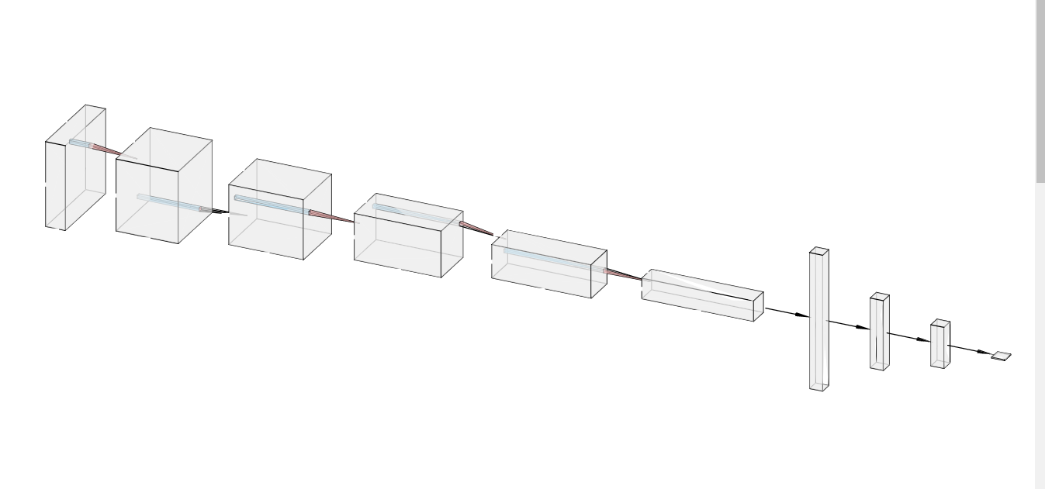

_________________________________________________________________ Layer (type) Output Shape Param # ================================================================= input_1 (InputLayer) (None, 96, 96, 3) 0 _________________________________________________________________ conv0 (Conv2D) (None, 96, 96, 32) 896 _________________________________________________________________ bn0 (BatchNormalization) (None, 96, 96, 32) 128 _________________________________________________________________ activation_1 (Activation) (None, 96, 96, 32) 0 _________________________________________________________________ mp0 (MaxPooling2D) (None, 48, 48, 32) 0 _________________________________________________________________ conv1 (Conv2D) (None, 48, 48, 64) 18496 _________________________________________________________________ bn1 (BatchNormalization) (None, 48, 48, 64) 256 _________________________________________________________________ activation_2 (Activation) (None, 48, 48, 64) 0 _________________________________________________________________ mp1 (MaxPooling2D) (None, 24, 24, 64) 0 _________________________________________________________________ conv2 (Conv2D) (None, 24, 24, 128) 73856 _________________________________________________________________ bn2 (BatchNormalization) (None, 24, 24, 128) 512 _________________________________________________________________ activation_3 (Activation) (None, 24, 24, 128) 0 _________________________________________________________________ max_pool (MaxPooling2D) (None, 12, 12, 128) 0 _________________________________________________________________ conv3 (Conv2D) (None, 12, 12, 256) 295168 _________________________________________________________________ bn3 (BatchNormalization) (None, 12, 12, 256) 1024 _________________________________________________________________ activation_4 (Activation) (None, 12, 12, 256) 0 _________________________________________________________________ mp2 (MaxPooling2D) (None, 6, 6, 256) 0 _________________________________________________________________ conv4 (Conv2D) (None, 6, 6, 512) 1180160 _________________________________________________________________ bn4 (BatchNormalization) (None, 6, 6, 512) 2048 _________________________________________________________________ activation_5 (Activation) (None, 6, 6, 512) 0 _________________________________________________________________ mp3 (MaxPooling2D) (None, 3, 3, 512) 0 _________________________________________________________________ flatten_1 (Flatten) (None, 4608) 0 _________________________________________________________________ fc0 (Dense) (None, 50) 230450 _________________________________________________________________ fc1 (Dense) (None, 10) 510 _________________________________________________________________ fc2 (Dense) (None, 1) 11 ================================================================= Total params: 1,803,515 Trainable params: 1,801,531 Non-trainable params: 1,984 _________________________________________________________________

**EXTRACTED-DATA:**

The extracted-data used for this model can be found here

(https://drive.google.com/open?id=1t7bu5ppcYLopIQbTMTK3qdAfuTXOG_RZ)

**ACCURACIES AND MATRIXES:**

Test Accuracy = 0.984313725490196

Train Accuracy = 0.984313725490196

Test Matrix:

[[ 74, 2], [ 0, 179]]

Train Matrix:

[[269, 1], [ 6, 744]]

**MISSCLASSIFIED PICTURES:**

