**TAM**

The Technology Acceptance Model (TAM) is a theoretical framework that provides a structure for understanding and predicting the intentions of users adopting and using technology. Since it was first introduced by Fred Davis in 1986, it has become one of the most widely used models for studying technology acceptance and usage behavior.

TAM posits that two main factors, perceived usefulness and perceived ease of use, play an important role in users' decision to adopt technology. Perceived usefulness refers to the extent to which an individual believes that using technology will improve their work performance and overall life. Perceived ease of use refers to the degree to which an individual believes the technology is easy to use. TAM suggests that these two factors can lead to an overall positive attitude towards technology.

The original TAM model has been widely used and has seen several extensions and adaptations over the years. For example, the TAM 2 incorporated additional variables such as social influences and compatibility with individual values. The TAM 3 then incorporated contextual and cultural variables

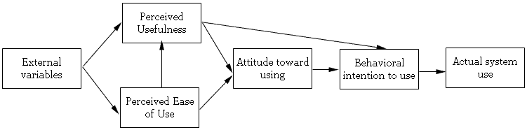

**External variables:**

External variables such as social influence are important factors in determining this attitude. When these things (TAM) are in place, people have attitudes and Intention to use artificial intelligence. However, the perception may change depending on the situation. Predisposition to technology, image, experience, spontaneity, quality of output, Expected Performance, Expected Effort, Social Impact, Age, Gender.

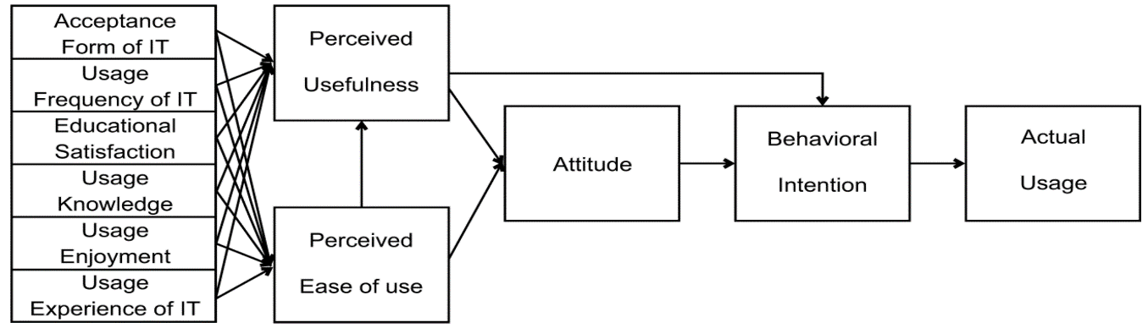

**Perceived usefulness :**

Perceived usefulness is defined as the degree to which a person believes that Using the system improves performance.

Perceived benefits depend on many factors.

* Relationship with research
* Learning outcomes
* Integration with other sources
* Personal preference

**Perceived usability of use:**

Perceived usability refers to how much people believe in its use. Artificial intelligence made easy It depends on several factors:

* Student background and past experience with AI
* AI tool design and user interface
* Compatibility of AI with existing systems and processes