

Documentation

Team: DNA

Table of Contents

[1. Team 3](https://d.docs.live.net/6c33bdc79629dce9/Работен%20плот/-T-O-E/Documentation/JustCodeDocumentation.docx#_Toc121884848)

1.1 Yavor Penkov 10G – Scrum Trainer 3

1.2 Bozhidar Dimov 10V – Back-End Developer 3

1.3 Gospodin Radev 10A – Back-End Developer 3

1.4 Kristian Gaidov – 10B Front-End Developer 3

[2.Goals 4](https://d.docs.live.net/6c33bdc79629dce9/Работен%20плот/-T-O-E/Documentation/JustCodeDocumentation.docx#_Toc121884853)

3. Stages of development 4

3.1 Start of the project and planning 4

4.Stages of realization 4

4.1 Planning 4

4.3 Testing 4

5. Site description and structure 5

5.1 Structure 5

5.2 Description 5

6.Table with functions and explanations 5

# 1. Team

# 1.1 Yavor Penkov 10G – Scrum Trainer

# I am the leader of the team. I made the presentation and documentation, I created the repository and the files inside so that my team could work on them. In order to organise my team I made issues and projects.

# 1.2 Bozhidar Dimov 10V – Back-End Developer

# I am Bozhidar Dimov, one of the Back-End Developers on the team. I conceptualized the game idea and collaborated with my teammates to bring it to fruition. I integrated the graphic library Raylib into the project, establishing a functional environment for the team and organising components into folders. I consistently contributed to the project's development alongside my teammates, working towards the final product. Additionally, I took charge of designing the README and the repository, incorporating the MIT license, security policy, and code of conduct. I assisted the Scrum Trainer in overseeing the team and shaping the overall presentation of the repository. Me and the other developers took an equal part in the making of the QA documentation. I am pleased with the outcome of this project, the valuable lessons I gained, and the opportunity to collaborate with these exceptional individuals.

# 1.3 Gospodin Radev 10A – Front-End Developer

# My name is Gospodin Radev, and I was a Back-End developer on the project. I collaborated closely with Bozhidar Dimov, and together, we implemented mechanisms for avatars, rain, and clouds. Additionally, we were responsible for creating the question bank and importing answers. Both Back-End developers provided support to the Front-End developer in constructing the main menu and the rules page. We also made a QA documentation. Working alongside these intelligent and creative individuals was a rewarding experience, and I look forward to the possibility of collaborating with them again in the future.

# 1.4 Kristian Gaidov – 10B - Front-End Developer

**My name is Kristian and I’m the Front-End Developer of the team. During the period of the project, I designed the logo of the team and the logo of the game. I also created the sprites of the game and helped with designing the looks of the main menu. Apart from the designing part, I also helped the two Back-End Developers with a few parts of the code. I am very happy for being part of this team and I’m very grateful to the things my teammates showed me during the process.**

Интр

# 2.Goals

**Our goal is to create a game which is based on ecology, biology and chemistry. We managed to make the game with our knowledge in the language C++ and we tend to think that it is a fun, relaxing and easy game, with which you can learn a lot of interesting facts about ecology, biology and chemistry.**

# 3. Stages of development

# 3.1 Start of the project and planning

**After our team’s formation we started by organising our work in Microsoft Teams. Then our Scrum Trainer registered us, made a repository in GitHub and the project began by discussing ideas for the final product and then we started work.**

# 4.Stages of realization

# 4.1 Planning

**After we had assigned the roles and did everything at first the developers had ideas to make an easy computer game with words and numbers.**

**4.2 Realization**

# We decided what is the project going to include. During the process we maintained communication with frequent meetings in Discord and Teams and deciding what we were going to do. Every single one of us has helped each other and we maintained good balance between the work.

# 4.3 Testing

**The developers made sure that all of our functions and the code itself were functioning correctly and if not they made sure that we knew that there was a mistake and correct it as soon as possible.**

# 5. Site description and structure

# 5.1 Structure

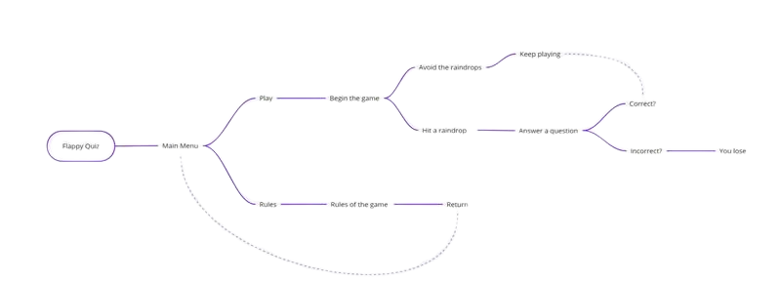

# 5.2 Description

**In our game you will find two options when you first get into the main menu: 1. a play button, 2. a rules button. When you click the play button you enter our game called "Flappy Quiz". You can control your avatar with the left and right arrow keys and your task is to avoid the falling raindrops. If you get hit by one of them you answer a question and if it is correct, you can keep playing, but if not - you lose. When you click the rules button it shows you the rules of the game. It is a pretty simple and addictive learning game!**

# 6.Table with functions and explanations

|  |  |
| --- | --- |
| Function name | Description |
| void rules() | Draws the rules of the game. |
| void game() | In this function there are the main game mechanisms. |
| void question(bool& checkAnswer) | In this function there are the question mechanisms, |
| int main() | The main function. |