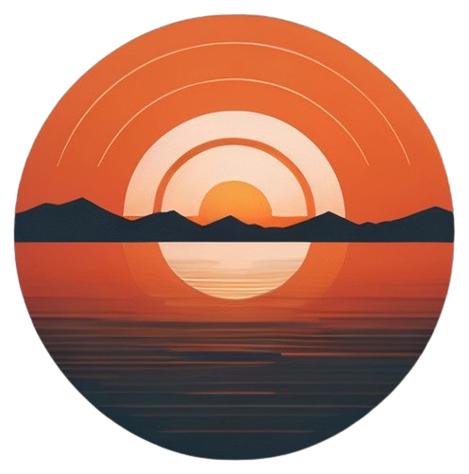

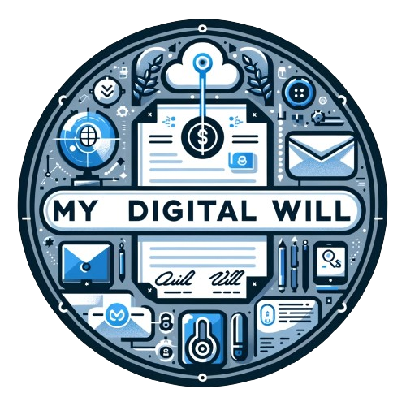

Horizon

**Table of Contents**

I. About us 3

II. The idea of the project 3

III. Stages of work 4

Assembling the team 4

The process of creating 4

Finishing the project 4

Presenting the product 4

IV. Used Technologies 5

V. Block diagram 5

VI. Functions 6

## About us

|  |  |  |
| --- | --- | --- |
| Name | Role | Grade |
| Filipa H. Popova | Scrum Trainer | 10B |
| Bozhidar A. Dimov | Front-End Developer | 10V |
| Gospodin S. Radev | Back-End Developer | 10A |
| Teodor T. Tanev | Back-End Developer | 10G |

## The idea of the project

The goal of our application is to ensure security and efficiency for its users when creating their digital will. They can ensure a secure future for their heirs, even when they are no longer physically present, thanks to the simplified and understandable mechanics of "Horizon". No matter how uncertain the future may be, you will be prepared for it!

## Stages of work

|  |  |
| --- | --- |
| № | Stages |
| **1st week** | Assembling the team We gathered and distributed the roles, so each person can work on the field that is most competent with. We started thinking about an idea for the project |
| **2nd week** | The process of creating Every week we met and discussed how we were progressing with the project. Each member fulfilled their duties and if we fell behind with our project we helped each other. |
| **3rd week** | Finishing the project After we finished with the project and the documentation, we fixed some bugs and made the overall user experience a bit more pleasant. |
| **4th week** | Presenting the product After weeks of hard working and sleepless nights we finished the project and now it is ready to be presented. |

## Used Technologies

1. C++ - for creating the app.
2. Python – for creating the Python version of the app.
3. Github – for the synchronization.
4. Raylib – for app visualization.
5. MS PowerPoint – for creating presentation.
6. MS Word – for creating documentations.
7. MS Excel – for creating QA testing table.
8. Visual Studio 2022
9. Visual Studio Code

## Block diagram

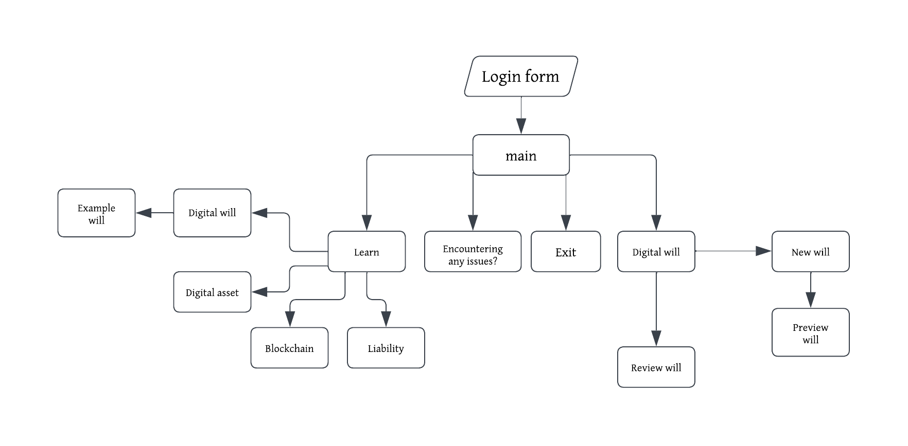

## Functions

|  |  |
| --- | --- |
| Type | Name |
| void | addAccount() |
| void | addDigitalWill() |
| void | addUserWill() |
| void | digitalWill() |
| static void | newWill() |
| static void | reviewWill() |
| static void | blockchainDef() |
| static void | digAssetDef() |
| static void | digWillDef() |
| void | learn() |
| static void | liabilityDef() |
| static bool | checkCollisionPointRec() |
| static bool | checkTextClick() |
| void | login() |
| const bool | doesAccountExist() |
| const bool | doesWillExist() |
| const bool | isPasswordCorrect() |
| const bool | openWill() |
| const bool | validateAddress() |
| const bool | validateID() |
| const bool | validateName() |
| const bool | validatePassword() |
| const bool | validateUsername() |