So to give us a platform to somewhat build off of I went ahead and put together something for us to build off of. I have tried to include directions that make sense. I didnt go into setting up mySQL, there are tutorials online. I use DBeaver, its pretty straightforward. I tried to follow our statement in the docs where sql for database, python for back end, html/CSS for front. This shows basic integration so we can expand from here.

Setting up test environment:  
  
Using a database management software; set up mySQL

Once connected to your localhost, use this script to make the database and fill it with some basic values:  
  
-- Step 1: Create Database

**CREATE** **DATABASE** soft_project;

**USE** soft_project;

-- Step 2: Create Users Table (Student Registry)

**CREATE** **TABLE** student_information (

id **INT** **AUTO_INCREMENT** **PRIMARY** **KEY**,

name **VARCHAR**(255) **NOT** **NULL**,

email **VARCHAR**(255) **UNIQUE** **NOT** **NULL**,

password_hash **VARCHAR**(255) **NOT** **NULL**, -- Store hashed passwords

created_at **TIMESTAMP** **DEFAULT** **CURRENT_TIMESTAMP**,

updated_at **TIMESTAMP** **DEFAULT** **CURRENT_TIMESTAMP** **ON** **UPDATE** **CURRENT_TIMESTAMP**

);

-- Step 3: Create Subjects Table (List of Available Subjects)

**CREATE** **TABLE** available_subjects (

id **INT** **AUTO_INCREMENT** **PRIMARY** **KEY**,

subject_name **VARCHAR**(255) **UNIQUE** **NOT** **NULL**

);

-- Step 4: Create Student-Subjects Table (Many-to-Many Relationship)

**CREATE** **TABLE** student_subjects (

student_id **INT**,

subject_id **INT**,

**PRIMARY** **KEY** (student_id, subject_id),

**FOREIGN** **KEY** (student_id) **REFERENCES** student_information(id) **ON** **DELETE** **CASCADE**,

**FOREIGN** **KEY** (subject_id) **REFERENCES** available_subjects(id) **ON** **DELETE** **CASCADE**

);

-- Step 5: Create Availability Table (Stores Student Available Times)

**CREATE** **TABLE** student_availability (

id **INT** **AUTO_INCREMENT** **PRIMARY** **KEY**,

student_id **INT** **NOT** **NULL**,

day_of_week **ENUM**('Monday', 'Tuesday', 'Wednesday', 'Thursday', 'Friday', 'Saturday', 'Sunday') **NOT** **NULL**,

start_time **TIME** **NOT** **NULL**,

end_time **TIME** **NOT** **NULL**,

timezone **VARCHAR**(50) **DEFAULT** 'UTC',

**FOREIGN** **KEY** (student_id) **REFERENCES** student_information(id) **ON** **DELETE** **CASCADE**

);

-- Step 6: Insert Sample Data (Optional)

**INSERT** **INTO** student_information (name, email, password_hash)

**VALUES**

('Alice Johnson', 'alice@example.com', 'hashedpassword1'),

('Bob Smith', 'bob@example.com', 'hashedpassword2');

**INSERT** **INTO** available_subjects (subject_name)

**VALUES**

('Mathematics'),

('Physics'),

('Computer Science');

**INSERT** **INTO** student_subjects (student_id, subject_id)

**VALUES**

(1, 1), -- Alice studies Mathematics

(1, 2), -- Alice studies Physics

(2, 3); -- Bob studies Computer Science

**INSERT** **INTO** student_availability (student_id, day_of_week, start_time, end_time, timezone)

**VALUES**

(1, 'Monday', '14:00:00', '16:00:00', 'UTC'), -- Alice available Monday 2-4 PM

(2, 'Wednesday', '10:00:00', '12:00:00', 'UTC'); -- Bob available Wednesday 10AM-12PM

Hosting API Functions locally:

Install fastapi, uvicorn, mysql connector, sqlalchemy

pip install fastapi uvicorn mysql-connector-python sqlalchemy

Inside your project folder use the main.py. This main file will contain all the api calls to the database

You need to open a python terminal and run (make sure you are trying to run this from the same folder main.py is in)

uvicorn main:app --host 127.0.0.1 --port 5000 --reload

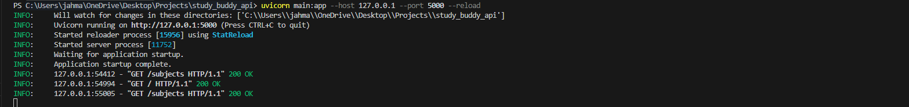

To locally host the api. After that you should be able to type in that IP(127.0.0.1) into your browser and see the connection message.

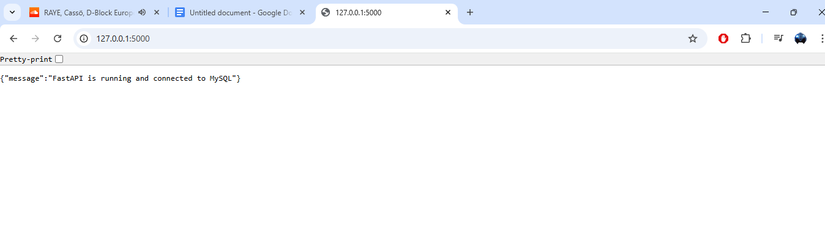

From there you should be able to open the index.html in a browser and see the available subjects.  
  
Sqlalchemy commands are being used in lieu of direct sql calls.

<https://docs.sqlalchemy.org/en/20/orm/quickstart.html>

