Submission Document: RW-CODING-ACADEMY-I.s11.nx201.pdf  
Project: Remote Control – NX201 Network Research  
Student Name: Bagabo Bonny  
Program Code: NX201  
Unit: RW-CODING-ACADEMY-I  
Lecturer: NZEYIMANA Celestin

Installing the needed applications and anonymity checks

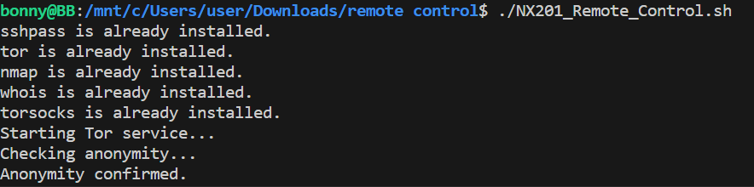

Content in the audit_log.txt file

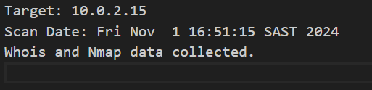

Fetching the data in whois file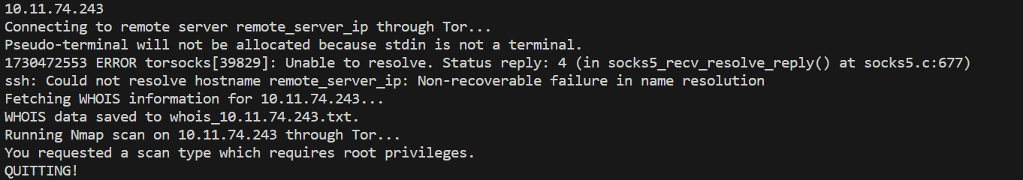

Content in whois file

