Project 3 Written Technical Report

Brock Hoover

April, 6, 2026

Table of Contents
Executive Summary: 3
Introduction: 3
Methods: 3
Code Setup 3
Bar Chart 4
Boxplot 4
Histogram 5
IDM Acceleration Function Setup 5
Loading in NGSIM data 5
Setting and Running the IDM simulation 5
Plotting Data from IDM simulation 6
Subplot Data for a given trajectory pair. 7
Results and Discussion 8
Bar Chart 8
Box Plot 9
Histogram 10
Leader vs Follower vs Simulated Follower plot. 11
Vehicle Data for trajectory pair two. 12
References: 12

Executive Summary:
In this project, the project team was tasked with creating a box plot, histogram, and bar chart using variables from the NHTS dataset, and using the NGSIM dataset to create at least two time series plots and to provide a simulation study. For our box plot we chose make and household size as the variables, for the histogram we chose age of vehicles, and for the bar chart we chose make and household income. Our box plot found that brands such as Audi and Lincoln were typically driven by smaller households, while our histogram showed that the majority of vehicles are under 10 years old, but with vehicles 1-2 years old being the mode of the dataset. For the acceleration simulation study, we found that there wasn’t smooth correlation between the simulated follower and the real follower. For the time series plots we found that gap distance increased when both vehicles were accelerating. Overall we got some good insights into transportation behavior and trends with this analysis

Introduction:
In this project, the project team was tasked with creating a box plot, histogram, and bar chart using variables from the NHTS dataset, and using the NGSIM dataset to create at least two time series plots and to provide a simulation study. Our objectives for this project were to use data from the NHTS survey to find information on customer trends for the FHWA to observe. For example, it is good for them to know the data for ages of vehicles on the roads when designing infrastructure to know whether the cars on the road are equipped with modern safety features. For the NGSIM modeling, our project team wanted to observe how accurate modelling behavior was with real world driving behavior. We also wanted to observe what the reaction time was of followers in follower-leader diagrams.

Methods:

Code Setup
In this project, the packages imported into the project environment include pandas, numpy, matplotlib, and seaborn, this is done in the first coding block. Pandas is used for ease of importing both the NHTS data and the NGSIM data. NumPy is used for some of the calculation work regarding the NGSIM data. Matplotlib is used for plotting data, and seaborn is used for color palettes and plotting presentation. The data is then made into a dataframe using the pd.read_csv function. This data is then displayed so the user can make sure that the correct data was loaded. .describe() is then used to give a five number summary of the numerical variables. The .value_counts() function is then used for make and household_income variables to give count information for those. ,isnull().sum() is used to check for null or invalid data values in the data.

Bar Chart
The code block for the bar chart can be seen in Figure 1. The selected variables were make and household income, as our team wanted to see how the values compared. It first involved clearing up the order because strings sort alphabetically by default. The .isin and .copy panda methods were used to create a new copy of the data only including values in the income_order string. Make was then filtered by the total number of vehicles, and the data was grouped and sized based on how much it appeared under each make. The figure was then plotted and the seaborn library was used to select a color pallete, and matplotlib was used to clean up the chart by assigning a title, x and y labels, angling the labels, providing a legend, and putting a grid on the chart to make it more legible. The chart is then displayed in the Jupyter notebook.
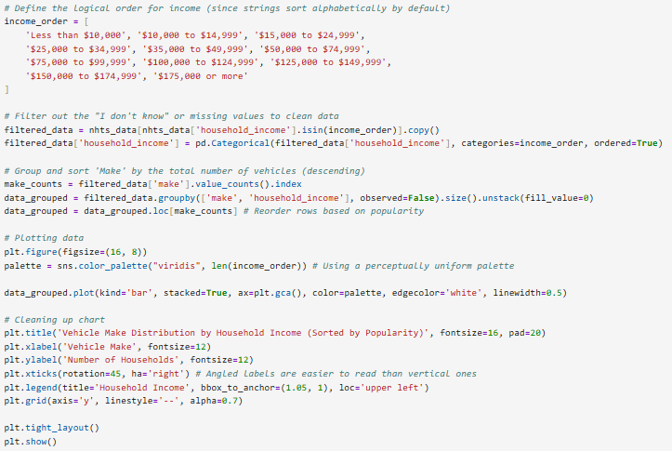
Figure 1, code used to create the bar chart.

Boxplot
For the boxplot, the selected variables were make and household size, which was created by using the .boxplot method and assigning the column to household_size and by to make. The chart was then plotted and matplotlib was used to assign an x label, y label, title and the default pandas title was removed.

Histogram
For the histogram, it was made in a similar way to the boxplot, with the variable selected being vehicle age, and the only difference besides calling a boxplot was setting a bin amount for the histogram and setting a alpha value to control bar transparency.

IDM Acceleration Function Setup
For the IDM acceleration function, the first step is to assign all of the variables in the function, which involves setting all of the variables for the function and creating the function. The function returns acceleration. The function then is tested with dummy values to make sure that it is working correctly.

Loading in NGSIM data
The NGSIM data is loaded in using the same pd.read_csv method used for the NHTS data. The NGSIM data includes many trajectory pairs, so one is selected and the leaders position and speed over time are then pulled from the dataset, and a time step of .1 seconds is chosen by the project team. The time data is then printed so it can be seen if it was done correctly.

Setting and Running the IDM simulation
The IDM parameters are set, and then arrays are initialized to store the simulation results. This code block can be seen in Figure 2. The code is than ran in a different code block which can be seen in Figure 3, and the code block prints when the simulation is complete to notify the user when it is done.
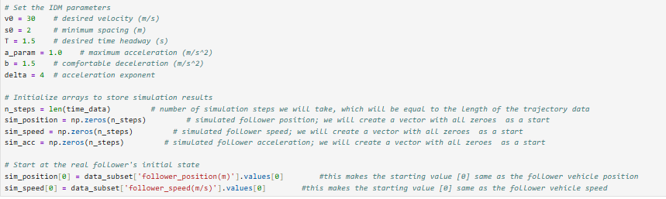
Figure 2, block to set up arrays to store simulation results
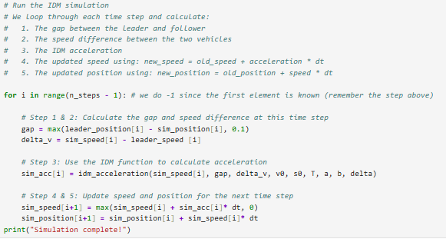
Figure 3, block to run simulation.

Plotting Data from IDM simulation
For the IDM simulation, the client requested us to plot acceleration of the leader, real follower, and simulated follower. The leader and real follower were found by using the data subset and the time interval. All of the data was then plotted, and the plot was formatted for clarity, the code block can be seen in Figure 4.
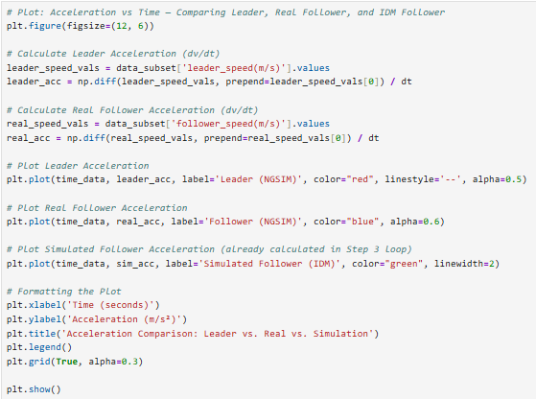
Figure 4, IDM simulation result plotting

Subplot Data for a given trajectory pair.
The client for this project requested two time series graphs, but the project team has provided four. This was done by using the subplot function, which allows for the presentation of multiple graphs. The selected variables include Gap Distance vs time, speed vs time, acceleration vs time, and position vs time of a leader and of a follower. The coding for this can be seen in Figure 5.
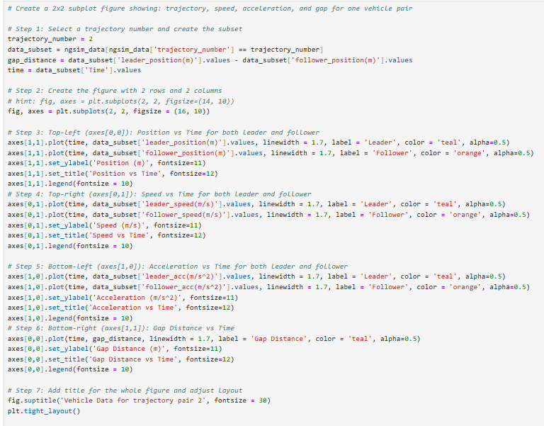
Figure 5, Subplot data for a given trajectory pair.

Results and Discussion

Bar Chart
For our bar chart in Figure 6, it can be seen which makes are most popular, and the distribution of typical household income for the makes of the cars. Toyota, Ford, Chevy, and Honda stand out from the rest as the top four automakers in the US, and have similar data trends, with Toyota biasing slightly towards higher household income compared to Ford, Chevy, and Honda. This chart does identify which brands are bought more frequently by people with higher income, with luxury brands such as BMW (erroneously listed as BMV in the dataset), Mercedes, and Audi all having a significant portion of their household income by customer being over 175,000 dollars. Brands that seem to be more popular with lower income customers are Dodge, Buick, Ford, and Chevrolet, which are all notably American car brands.
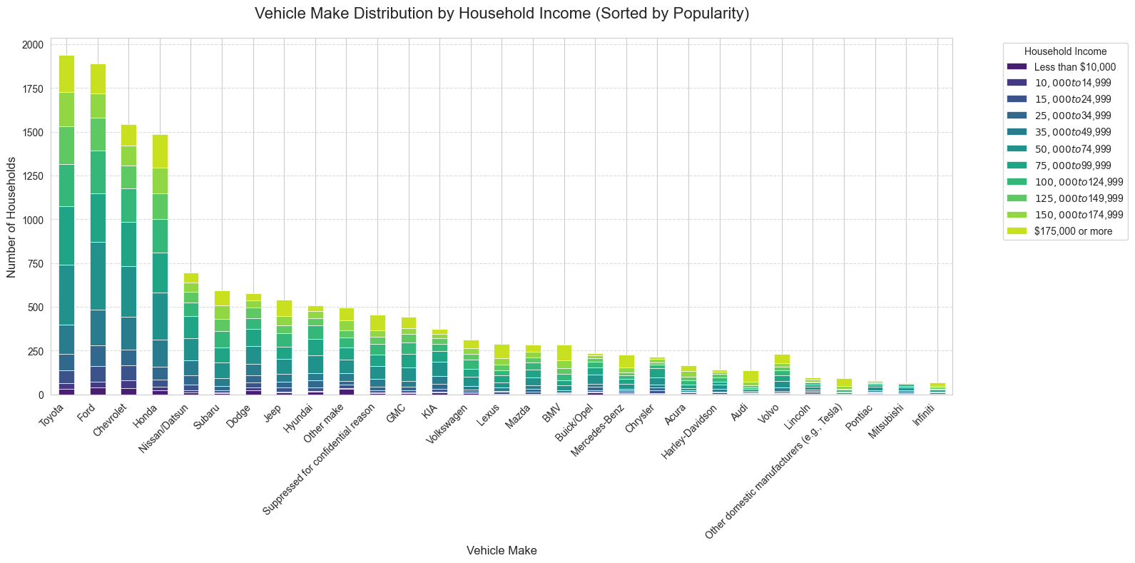
Figure 6, Vehicle Make Distribution by Household Income (Sorted by Popularity)

Box Plot
For our box plot in Figure 7, it can be seen which brands are more commonly found in larger and smaller households. Lincoln, Harley Davidson, and Audi are all commonly found in smaller households. While there is some correlation between brands that are more typical in higher income households and brands in smaller households, Acura, and Infiniti go against that trend. Brands such as Dodge and Honda are found in larger households, as well as Chrysler. As brands such as Dodge have vehicles such as the Grand Caravan, and Honda has vehicles such as the Pilot and Odessey, it makes sense that they would be typically found in larger households. Our team finds it interesting that Chrysler, who has primarily only sold the pacifica the last few years as mentioned in an 2024 article by Chris Isidore at CNN, isn’t the clear outlier for being in the largest household.
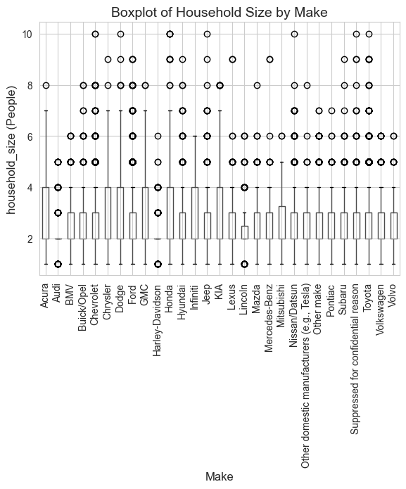
Figure 7, Box Plot of Household Size by Make

Histogram
In our histogram plotting vehicle age in Figure 8. It can be seen that the ages of vehicles goes down consistently, with only a few very small jumps. Our project team finds it surprising that the mode of the vehicle age distribution is the 1-2 year age range, and that there is a spike of vehicles listed at 40 years old. Our project team believe that the age spiking at 40 years old is either related to classic cars, or a possible error with the data collection where a unknown age is marked as 40+ in the dataset. The biggest drop comes after the 7-8 year range. Knowing that features such as backup cameras are required on all cars made after May 2018, transportation planners can assume that most people have backup cameras and modern safety features.
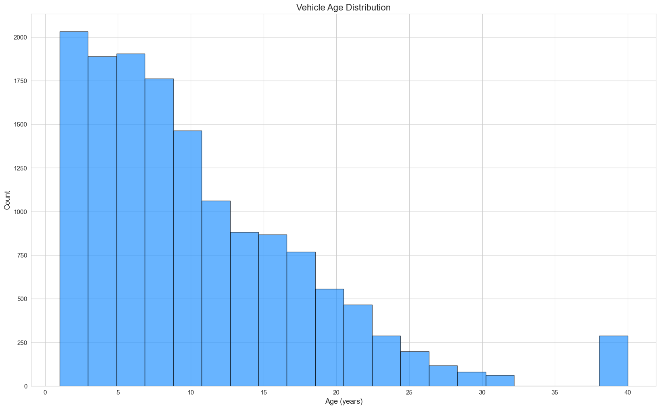
Figure 8, Histogram of Vehicle Age Distribution

Leader vs Follower vs Simulated Follower plot.
The plot of the simulation results can be seen in Figure 9. As you can see, while the simulation generally follows the trend of the follower acceleration, the real follower acceleration is far more jerky. Human drivers are not perfect for many reasons, and tend to make sudden, imprecise moves, and this needs to be accounted for when doing simulation work, the simulation needs to be tweaked to further model this, or transportation officials need to keep this in mind when using simulation data.
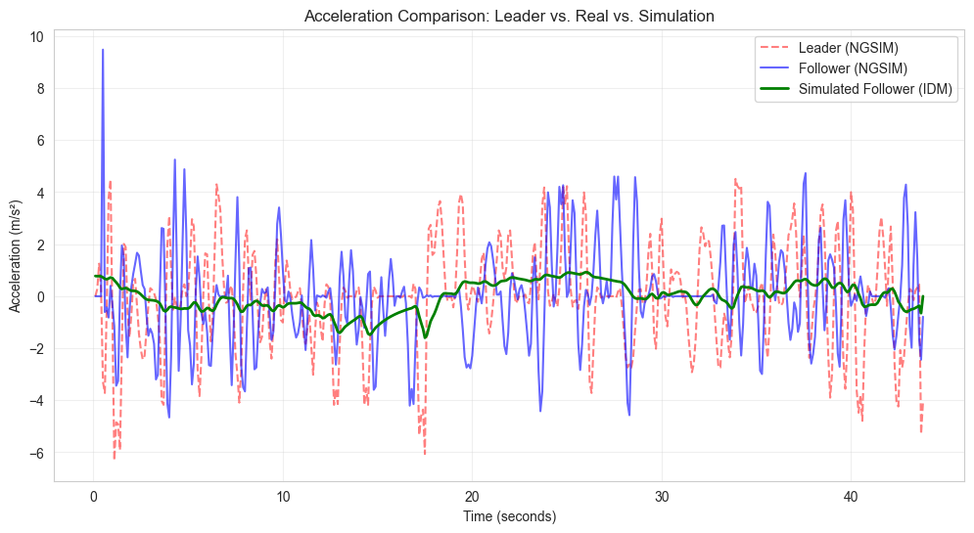
Figure 9, plot of simulation and real results

Vehicle Data for trajectory pair two.
The plots for trajectory pair two can be seen in Figure 10. As mentioned earlier with the simulation work, acceleration data fluctuates wildly, speed has some fluctuation, and position and gap distance plots are all smooth. Our team believe that this might be because of the fact that the only directly controlled human factor are the gas and brake pedals of a vehicle, which both act as accelerators. As every other vehicle function is based from that, they are smoother as they don’t have the same human influence.

References:
National Highway Traffic Safety Administration. (2014, March 31). NHTSA announces final rule requiring rear visibility technology. U.S. Department of Transportation. https://www.transportation.gov/briefing-room/nhtsa-announces-final-rule-requiring-rear-visibility-technology

Valdes-Dapena, P. (2024, December 5). Chrysler’s future is in doubt as Stellantis struggles. CNN Business. https://www.cnn.com/2024/12/05/business/chrysler-stellantis-future

