Group I Project 2 Written Technical Report

Bryce Ripley, Brock Hoover, Ryan Kramer

February, 24, 2026

Table of Contents
Introduction: 3
Client Goals: 3
Methods: 3
Initial Project Information: 3
Defining Engineering Functions: 4
Collecting User Inputs: 5
Calculating From User Inputs: 6
Displaying Mix Design Summary from User Inputs 7
Scenario Testing for NDOT Compliant Mix Designs: 8
User Inputs and Output list 10
Mix Design Scenarios: 11
Mix Design Scenario 1 – Class 47BD Typical Composition: 11
Mix Design Scenario 2 – Class SF Composition: 12
Mix Design Scenario 3 – Class 47B IP(25) Typical Composition: 12
Mix Design Scenario 4 – Class 47B IP(20) Composition: 13
References: 15

Introduction:
For this project, which the client of which is the Nebraska Department of Transportation, we were tasked with migrating the existing concrete mix design excel spreadsheet (which can be seen in Figure 1 into a python-based system.

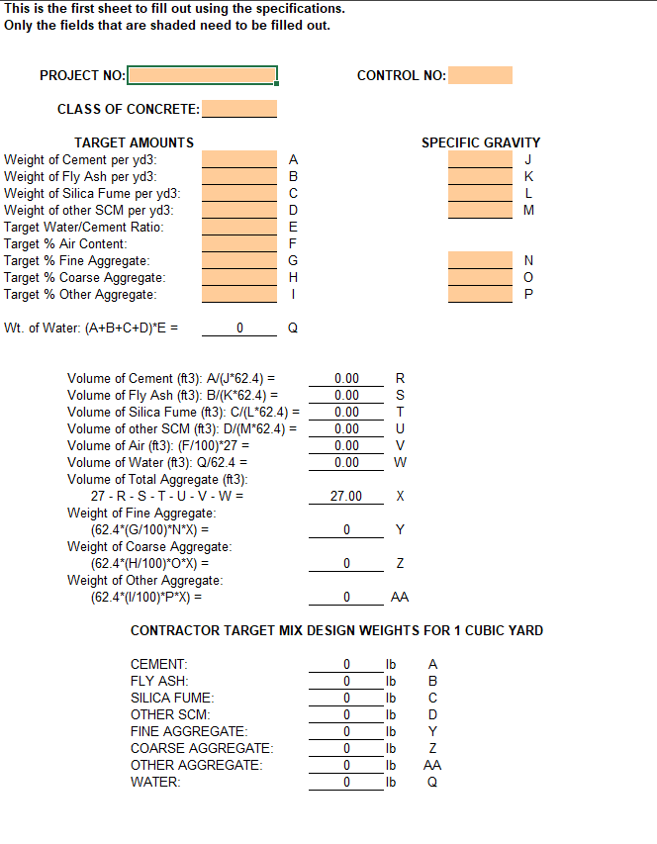
Figure 1, example of what the input for the NDOT excel spreadsheet looks like

Client Goals:
For this project, NDOT requested the following technical requests: Translating the excel logic into python, implementing sequential user inputs, generating a final mix design output, and preparing and evaluating four concrete mix design scenarios.

Methods:

Initial Project Information:
The first part of the code initiates the project. It sets up the projects information and defines all the engineering constants such as cubic yards in ft, unit weight of water, and default specific gravities for SCM’s. All of which will be used throughout the concrete mix designs. The first part stores the project name and client, then prints the results so the user can confirm that the correct project is being ran. Following this, fundamental constants such as the volume of one cubic yard of concrete, the unit weight of water, and the default specific gravities for supplementary cementitious materials (SCMs) which are all the same throughout mixes according to NDOT. These constants will be required later when converting material weights into volumes. The final print statements display those constants back to the user, allowing them to verify that the values are correctly defined before any further calculations are to be performed. This code block sets up some of the underlying constants that currently exist in the NDOT excel sheet. The respective code block can be seen in Figure 2.
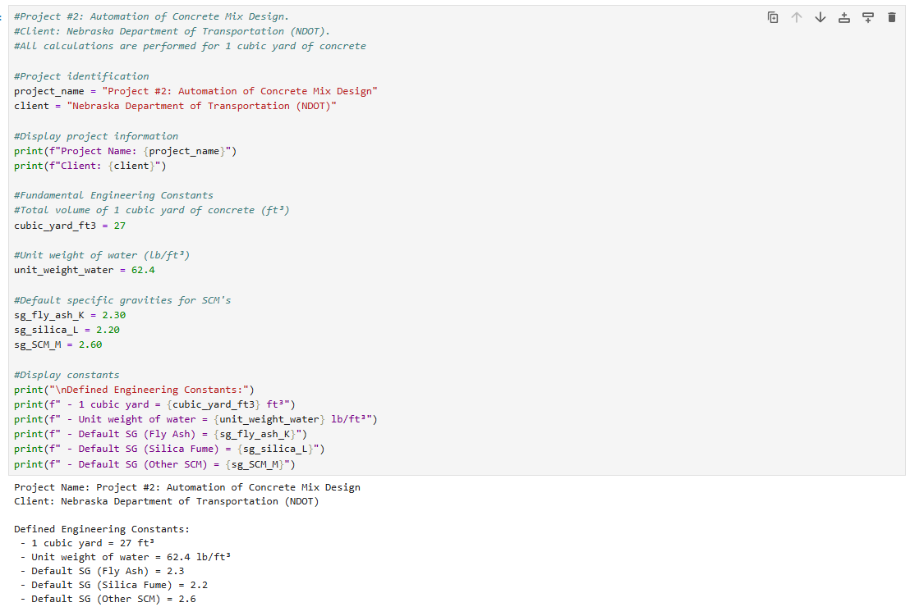
Figure 2, first code block and the output for this project

Defining Engineering Functions:
This chunk of code defines a series of engineering functions that are identical to a specific formula from the NDOT “Mix Design” tab on the excel worksheet provided. Every function performs one calculation that is required when determining the material weight and volumes for one cubic yard of concrete. Functions that were computed consist of water weight, individual cementitious material volumes, air and water volumes, total aggregate volume, and the final weights of fine, coarse, and other aggregates. Each formula was separated to make the code easier to read and more understandable and make it easy to follow with the NDOT’s “Mix Design” tab in order. These functions are later called in sequence to automate the full concrete mix design process. The second code block has a backend role, and as such does not report anything directly back to the user after running it. The second code block can be seen in Figure 3
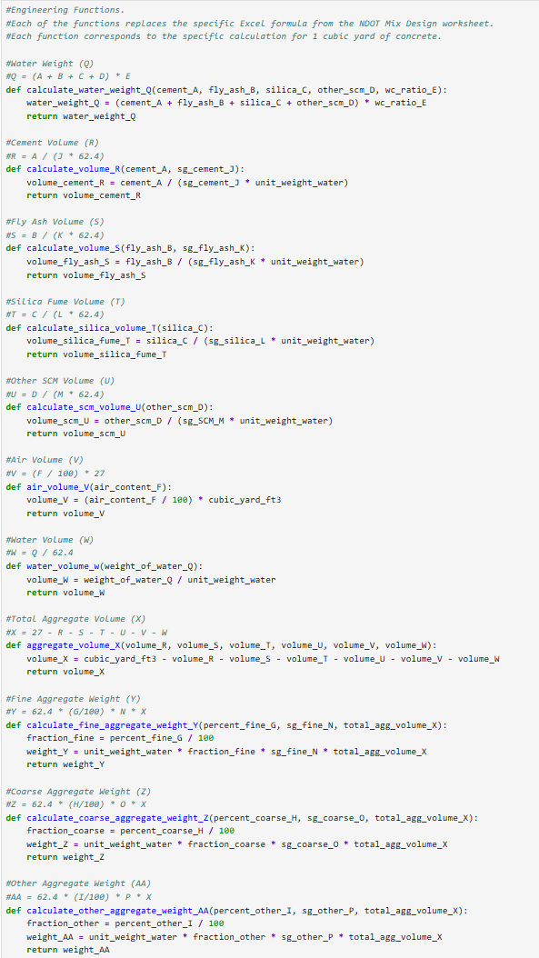
Figure 3, the second code block in the project.

Collecting User Inputs:
The third block of code is where the user inputs are collected. This is where the user inputs information such as the project number, the class of concrete, cementitious material weights, desired w/c ratio and air content, desired aggregate proportions, and specific gravities of each material, once the values are inputted by the user, the code block confirms that all inputs have been collected. This mimics the user input from the excel sheet, but makes it a sequential process. The code block and its output can be seen in Figure 4
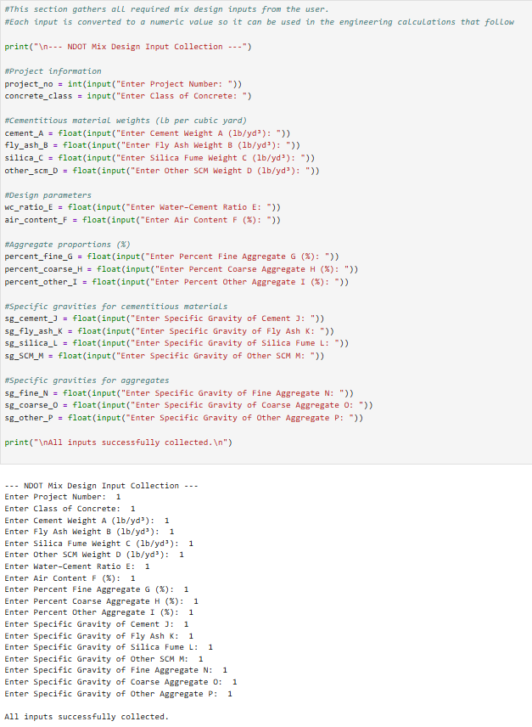
Figure 4, the third code block in the project

Calculating From User Inputs:
The fourth code block is where the user inputs are calculated from the functions defined earlier. The water weight is calculated from the cementitious materials, and cementitious material volumes are calculated from those weights and the specific gravities of those materials, air volume and water volume are then calculated from the user inputted water weights and air content. Aggregate volume is determined as a function of cementitious material volumes and air and water volumes, and aggregate weights are determined from the user inputted percentages. When this cell runs it’s calculations, it prints a message letting the user know that the calculations were completed successfully. The code block can be seen in Figure 5.

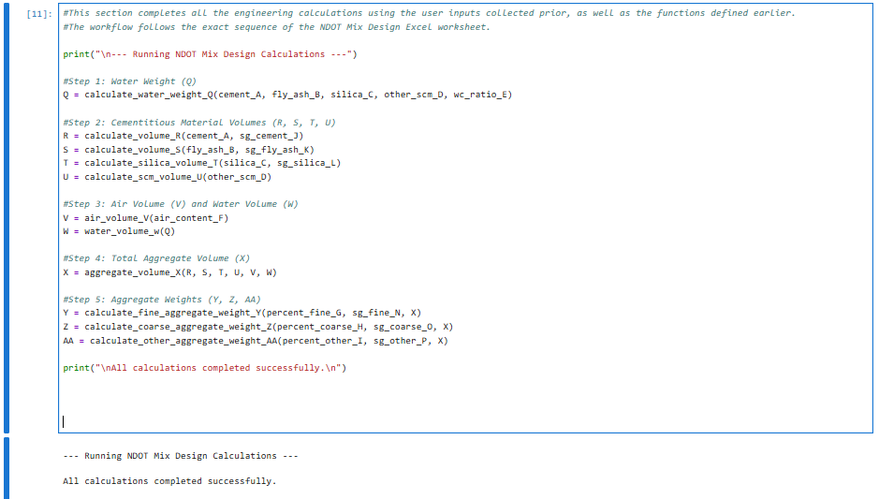
Figure 5, Code block running NDOT mix design calculations

Displaying Mix Design Summary from User Inputs
Code Block 5 in this project gives a mix design summary from the user inputted information. This is given in a digestible format. The information that is given to the user is the required amount of water, and the required aggregate weights. The code block can be seen in Figure 6
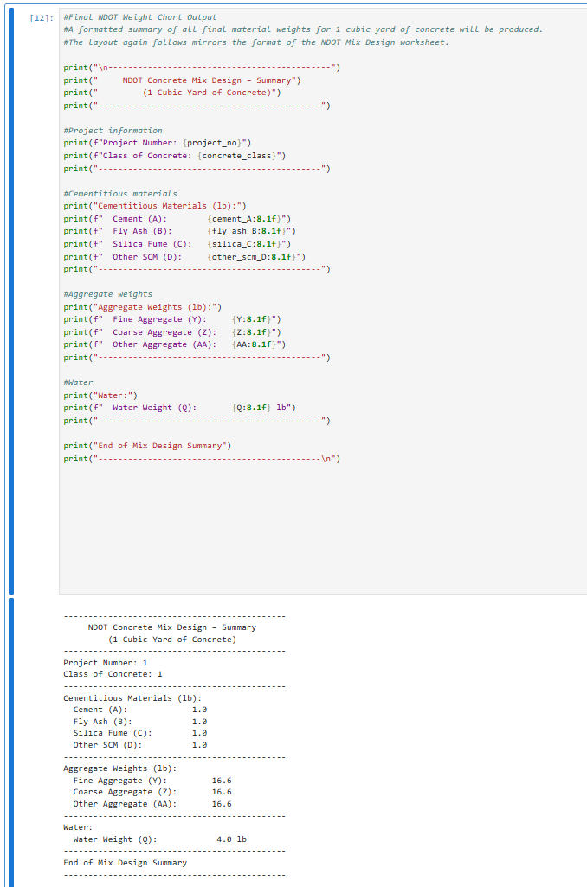
Figure 6, code block printing the mix design summary

Scenario Testing for NDOT Compliant Mix Designs:
Code Block 6 in this project gives four pre-prepared mix designs and prints out the required aggregate weights and water amount. These are baked directly into the code, so the only thing the user needs to do is run the mix scenarios, this code block can be seen in Figure 7 and the output in Figure 8.
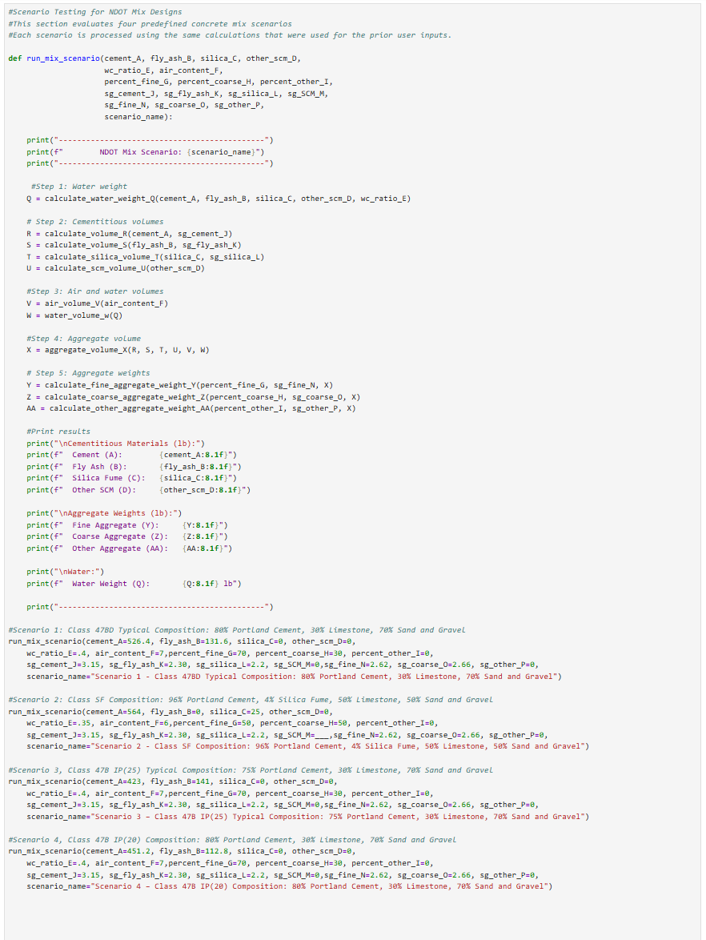
Figure 7, sixth code block with mix design scenarios
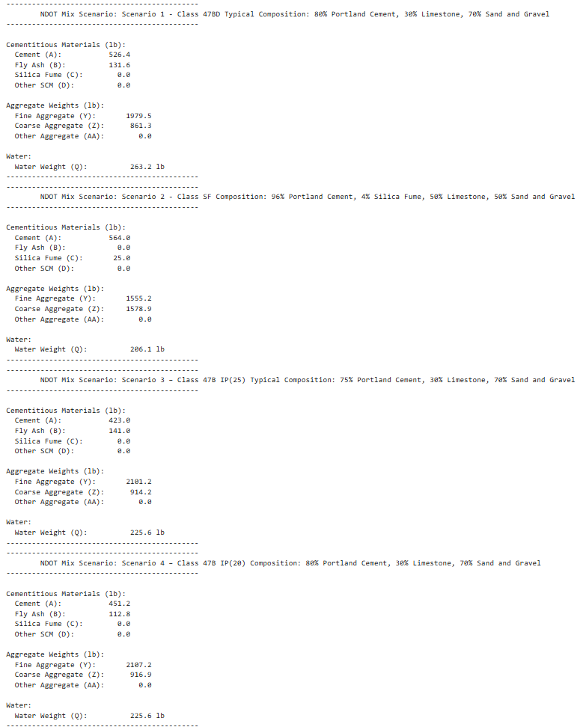
Figure 8, resulting output from the mix design scenarios code block

User Inputs and Output list
NDOT has requested a list of input and output parameters for the code, which can be seen in Table 1:

Table 1, Inputs and Output lists in code
Inputs: | Outputs:
Project Number,  Class of Concrete,  Cement Weight A (lb/yd³)  Fly Ash Weight B (lb/yd³)  Silica Fume Weight C (lb/yd³)  Other SCM Weight D (lb/yd³)  Water–Cement Ratio E  Air Content F (%)  Fine Aggregate G (%)  Coarse Aggregate G (%)  Other Aggregate G (%)  Specific Gravity of Cement J  Specific Gravity of Fly Ash K  Specific Gravity of Silica Fume L  Specific Gravity of Other SCM M  Specific Gravity of Fine Aggregate N  Specific Gravity of Coarse Aggregate O  Specific Gravity of Other Aggregate P | Project Name  Client  Engineering Constants  - 1 cubic yard = 27 ft³  - Unit weight of water = 62.4 lb/ft³  - Default SG (Fly Ash) = 2.3  - Default SG (Silica Fume) = 2.2  - Default SG (Other SCM) = 2.6  Mix Design Summary:  - inputted cementitious material weights  - Aggregate Weights  - Water Weights  Scenario 1-4 Mix Design Summaries

Mix Design Scenarios:
For this project, four mix designs were created using NDOT standards. All mix designs are assumed to be using Limestone for the coarse aggregate and Sand and Gravel for the fine aggregate. Cementitious material was assumed to be Portland Cement and Class F Fly Ash for all mixes. Specific gravity for sand and gravel and limestone was found to be 2.62 and 2.66 respectively using the data from a UNL report that tested sand and gravel and limestone specific gravity from Nebraskan samples (Halsey & Heyen, 2019, Table 1). The specific gravity values for Portland cement, fly ash, and silica fume were found from looking at SDS sheets for the materials from Diversified Materials Inc.

Mix Design Scenario 1 – Class 47BD Typical Composition:
Class 47BD Concrete is the design criteria for concrete that NDOT uses for applications such as bridge deck repair (Nebraska Department of Transportation, 2017, Section 102.01). For this concrete, the minimum total cementitious material allowed in a cubic yard mix design is 658 lbs per cubic yard, and the total aggregate range is between 2500 and 3000 lbs per cubic yard, with a air content range between 6.0 and 8.5%, with a ledge rock (coarse aggregate) % allowance of 30%, and a water/cement ratio max of .42. (Nebraska Department of Transportation, 2017, Table 1002.02). For this mix design scenario, we used 526.4lbs of Portland cement with 131.6 pounds of fly ash, a w/c ratio of .4, an air content of 7%, a fine aggregate percentage of 70%, and a coarse aggregate percentage of 30%. The resulting Mix Design Summary can be seen in Figure 9, with the mix design having a total aggregate weight of 2,840.8lbs, which is in the acceptable range.
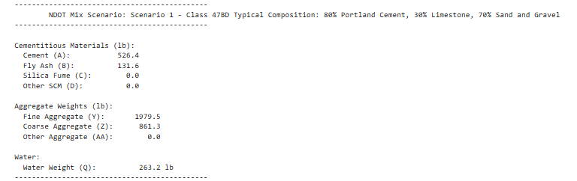
Figure 9, Mix Design Scenario 1 Results

Mix Design Scenario 2 – Class SF Composition:
Class SF Concrete is the design criteria for concrete that contains silica fume, “silica fume concrete with a low water content is highly resistant to penetration by chloride ions eliminating corrosion induced by deicing or marine salts” (Concrete Alberta, n.d., para. 3). For this concrete, the minimum cementitious material allowed in a cubic yard mix design is 589 lbs per cubic yard, and the total aggregate range is between 2850 and 3200 lbs per cubic yard, with a air content range between 6.0 and 8.5%, with a ledge rock (coarse aggregate) % allowance of 50%, and a water/cement ratio max of .36. (Nebraska Department of Transportation, 2017, Table 1002.02). This concrete notably has a higher coarse aggregate amount and a lower water/cement ratio compared to other mixes. According to NDOT section 1002.02 regarding SF concrete “Minimum Portland Cement shall be 564 lbs/cyds and the total Silica Fume added shall be 25 lbs/cyds” (Nebraska Department of Transportation, 2017, Section 1002.02). For this mix design scenario, we used 564lbs of Portland cement with 25 pounds of silica fume, a w/c ratio of .35, an air content of 6%, a fine aggregate percentage of 50%, and a coarse aggregate percentage of 50%. The resulting Mix Design Summary can be seen in Figure 10, with the mix design having a total aggregate weight of 3134.1lbs, which is in the acceptable range.
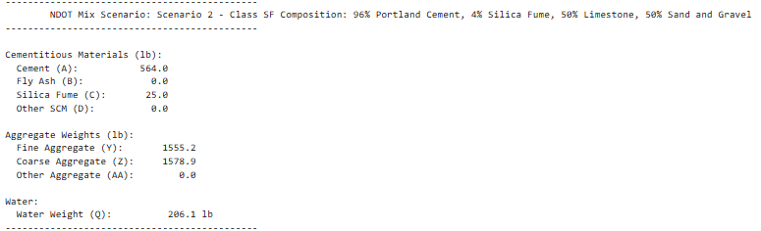
Figure 10, Mix Design Scenario 2 Results

Mix Design Scenario 3 – Class 47B IP(25) Typical Composition:

NDOT defines the traditional 47B mix design as the following: “Traditional 47B Mix Design is defined as an IP(25) cement, 70% Class B Aggregate and 30% Class E Aggregate” (Nebraska Department of Transportation, 2017, Section 1002.04). Class 47B concrete is the type that is used in pavement construction (Nebraska Department of Roads, 2002, Page 3). For this concrete, the minimum total cementitious material allowed in a cubic yard mix design is 564 lbs per cubic yard, and the total aggregate range is between 2850 and 3150 lbs per cubic yard, with a air content range between 6.5 and 9%, with a ledge rock (coarse aggregate) % allowance of 30%, and a water/cement ratio max of .45. (Nebraska Department of Transportation, 2017, Table 1002.02). For this mix design scenario, we used 423lbs of Portland cement with 141 pounds of fly ash, a w/c ratio of .4, an air content of 7%, a fine aggregate percentage of 70%, and a coarse aggregate percentage of 30%. The resulting Mix Design Summary can be seen in Figure 11, with the mix design having a total aggregate weight of 3015.4 lbs, which is in the acceptable range.
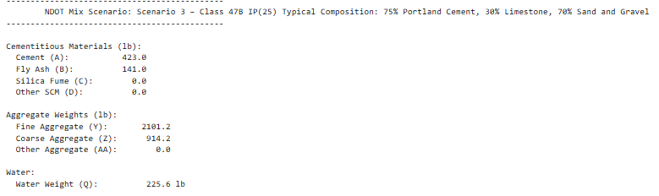
Figure 11, Mix Design Scenario 3 Results

Mix Design Scenario 4 – Class 47B IP(20) Composition:
For this mix design scenario, the amount of fly ash has been slightly reduced from the other Class 47B mix. This might be desirable due to the amount of fly ash produced by coal-fired power plants decreasing (Federal Highway Administration [FHWA], 2020). For this concrete, the minimum total cementitious material allowed in a cubic yard mix design is 564 lbs per cubic yard, and the total aggregate range is between 2850 and 3150 lbs per cubic yard, with a air content range between 6.5 and 9%, with a ledge rock (coarse aggregate) % allowance of 30%, and a water/cement ratio max of .45. (Nebraska Department of Transportation, 2017, Table 1002.02). For this mix design scenario, we used 451.2lbs of Portland cement with 112.8 pounds of fly ash, a w/c ratio of .4, an air content of 7%, a fine aggregate percentage of 70%, and a coarse aggregate percentage of 30%. The resulting Mix Design Summary can be seen in Figure 12, with the mix design having a total aggregate weight of 3024.1 lbs, which is in the acceptable range.
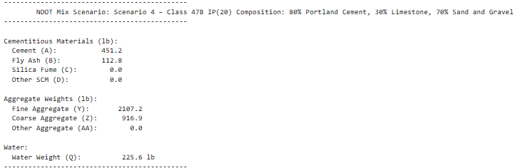
Figure 12, Mix Design Scenario 4 Results

References:
Concrete Alberta. (n.d.). Silica fume. https://www.concretealberta.ca/concrete-101/silica-fume

Diversified Minerals Inc. (2015, June 1). Safety data sheet: Silica fume [SDS]. https://dmicement.com/wp-content/uploads/bsk-pdf-manager/DMI-SDS-Silica-Fume-2015_1.pdf

Diversified Minerals Inc. (2017). Technical data sheet: Portland cement Type II/V. https://dmicement.com/wp-content/uploads/bsk-pdf-manager/Tech_Data_Type_II_V_-_2017_4.pdf

Diversified Minerals Inc. (2020, March 18). Technical data: Fly ash. https://dmicement.com/wp-content/uploads/bsk-pdf-manager/2021/11/Tech-Data-Fly-Ash-03182020.pdf

Federal Highway Administration. (1995). Silica fume user's guide (Report No. FHWA-IF-05-016). U.S. Department of Transportation. https://highways.dot.gov/media/401

Morcous, G. (2012). Self-consolidating concrete for precast/prestressed concrete bridge elements (Report No. SPR-P1(08) P311). Nebraska Department of Roads. https://digitalcommons.unl.edu/cgi/viewcontent.cgi?article=1230&context=ndor

Nebraska Department of Roads. (2014, January 10). Special provisions for state project no. S-13-4(1041). http://www.nebraskatransportation.org/letting/c-let-020314/f07ad303.pdf

Nebraska Department of Roads. (2017). Standard specifications for highway construction. https://dot.nebraska.gov/media/g4qp4y0d/2017-specbook.pdf

