definition of product
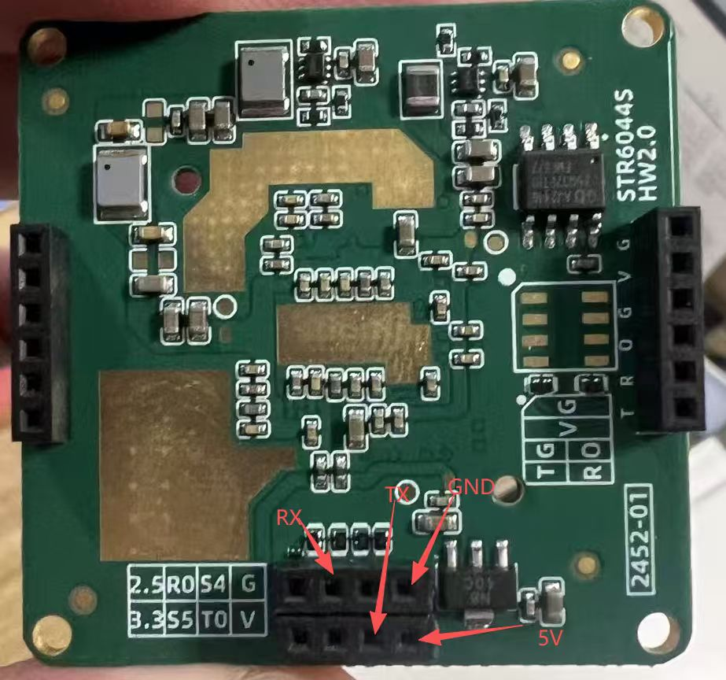

2. Radar end reporting message format
String of BK
protocol outputing: ID 1: P 42.75, R 4.32, V 0.00, A 27.50, E 30
ID | Data | Description
ID | 1 | ID,As many goals, as many ID
P | 42.75 | Target signal strength
R | 4.32 | The distance of the object from the radar, unit (meter)
V | 0.00 | The Sspeed of the object from the radar, unit (m/s)
A | 27.50 | The angle between the target and the central axis in the horizontal direction.
E | 30 | The angle between the target and the central axis in the vertical direction.
If there are multiple targets, multiple IDs will appear, with a maximum of 64 targets. BK is a combination of static and dynamic data, and the end marker for BK is "BK_END". AK is only dynamic data, and the end marker for AK is "AK_END". The # symbol serves as the end marker for one frame of data.

3 .Data Command List
The data command list is shown in the following table.
Type | Function | Command | Description
Communication | Data Report | scan start\r\n | Start output
Communication | Data Report | scan stop\r\n | stop output

4. other description
After the radar operates normally, it actively reports detection results at approximately 10ms intervals,default Serial port baudrate is 3000000bps.No external device is required to issue query commands.

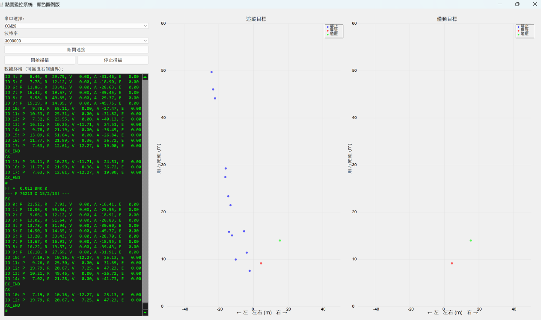
60G radar vehicle detection test, ranging from 50 meters to 0.5 meter.

