UOP LAB REPORT

M2 (DIFFUSION THROUGH SINGLE DROP)

PREPARED BY: -

DHRUV BAJAJ (230365)

NONIT GUPTA (230712)

SHAGUN (230948)

STUTI SHUKLA (231040)

# OBJECTIVE:

* 1. To study the effect of drop size on the terminal velocity of the drops.
  2. To study the effect of drop size on the overall and individual mass transfer coefficients.
  3. To study the effect of drop formation on the overall mass transfer coefficient

# AIM:

To determine the terminal velocity, individual and overall mass transfer coefficients for a single drop.

# DESCRIPTION:

The movement of liquid droplets in another liquid and the transfer of dissolved substances between them are crucial in chemical engineering. Studying single droplets helps in designing efficient liquid-liquid extraction systems, where droplet size affects mass transfer rates and settling speed influences equipment capacity..

# SCALING LAW:

**Ficks First Law:**

It states that the molar flux JJ (amount of substance diffusing per unit area per unit time) is proportional to the concentration gradient

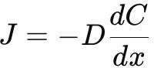

Therefore, it is expected that Diffusion will be slower in contaminated MIBK than in pure MIBK.

# THEORY:

**Motion of drops:**

The study of the shapes of moving drops has been found useful in understanding the dynamics of moving drops since the drag on the drops depends on their shapes during movement in another medium. The shape of a liquid drop depends upon several factors

such as the viscosity of the drop fluid, viscosity of the surrounding medium and the drop volume. Small drops are generally spherical. For large drops, the shape changes periodically from ellipsoidal to prolate (Laddha and Degaleesan, 1976).

A comparison with the fall of a solid sphere in a liquid would help in understanding the motion of drops in a fluid medium. The velocity of the fluid at the surface of a solid body is zero (no slip condition) but this is not the case for a liquid drop due to its mobility. In the latter case, only the normal velocity component is zero whereas the tangential velocity component is nonzero. In the liquid drops, the interfacial area is continuously changing, new area is being continuously created in the forward regions and equivalent area is being destroyed in the rear portion of the drop. This is called internal circulation and mass transfer increases due to this circulation. Very small drops at low Reynolds number settle in a manner similar to solid spheres and the terminal velocity increases with drop size. As the drop size is further increased, due to internal circulation, the terminal velocity attains a maximum value. After this peak point, further increase in drop diameter does not result in any appreciable change in the terminal velocity. Various correlations have been attempted to relate terminal velocity, drop size, peak velocity and maximum drop size to the physical properties of the system.

By considering the force balance on a moving spherical drop, it can be shown that

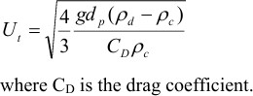

The following correlations have been suggested (Laddha and Degaleesan, 1976) for the drag coefficient for liquid drops:

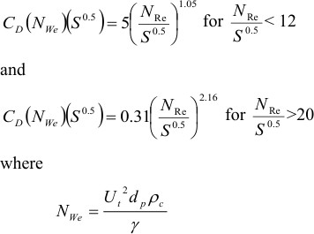

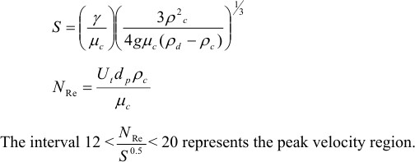

**Mass Transfer from drops:**

A solute encounters three resistances as it transfers from the interior of the drop to the surrounding fluid. These are:

(i) The resistance encountered in the transfer from the bulk of the drop to the surface. (ii) The resistance encountered in transfer through the interface.

(iii) The resistance encountered in the transfer from the interface to the bulk of the continuous phase.

If the drops are falling in a stagnant liquid column, then the concentration of solute in the dispersed phase will change along the column length. Let us consider the situation at a particular level in the column. Assuming that this solute is diffusing from the dispersed phase into the continuous phase, there must be a concentration gradient in the direction of mass transfer within each phase. This is graphically shown in Figure 1.

Dispersed

Phase Interface

CAd CAc*i*

CAd*i*

CAc

Continuous Phase

*Figure 1****: The two resistance concept***

The concentration of solute A in the main body of the drop is CAd and is assumed to be uniform due to internal circulation. This concentration falls to CAd*i* at the interface. In the continuous phase, the concentration falls from CAc*i* at the interface to CAc in the bulk liquid. It is generally assumed that there is no resistance to solute transfer across the interface separating the two phase as a result, CAd*i* and CAc*i* are equilibrium values, given by the system’s equilibrium distribution curve (Treybal, 1981).

The various concentrations can also be shown graphically as in Figure 2, whose coordinates are those of the equilibrium distribution curve.

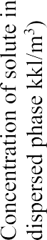CA CA

P

Q

M

B

CA

CA

C*

A

* A

C

Concentration of solute in

continuous phase kmol/m3

Equilibrium Distribution curve

Figure 2: Departure of bulk-phase concentration from equilibrium

Point P represents the two bulk-phase concentrations and point M those at the interface. For spherical drops, at steady state, we can write the rate of mass transfer of A in terms of individual or overall mass transfer coefficients as

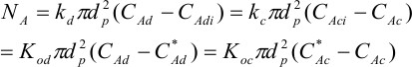

where C*Ad is the dispersed phase concentration which would be in equilibrium with CAc.

Similarly C*Ac is the concentration which would be in equilibrium with CAd. It can be shown that

where m is the slope of the line joining points B and M (Figure 2). If the concentration of solute in the continuous phase is negligible, eqn (5) simplifies to

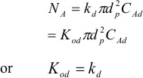

Since mass is transferred as the drop falls down, CAd decreases from the top to the bottom of the column. Hence, we have to use the log mean concentration difference to evaluate the average rate of mass transfer. In such a case

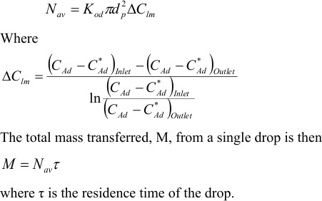

Correlation for kd and kc

Several correlations have been proposed for estimating the individual mass transfer coefficients (Laddha and Degaleesan, 1976).

The following correlations have been reported from correlation of experimental data for single file drops:

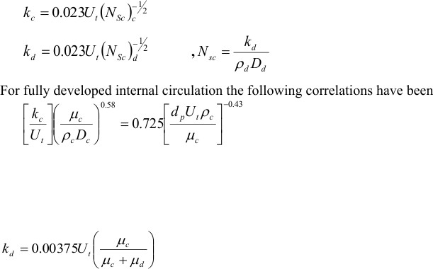

**Effect of Drop Formation and Coalescence on Mass Transfer**

The mass transferred during drop formation before detachment of the drop from the dispersing nozzle is reported to form a major fraction of the total extraction, as observed in many investigations. This marked increase in the rate of mass transfer may be explained by considering the extent of internal circulation in the drop.

#### Experimental Apparatus and Procedure:

**Apparatus :**The apparatus consists of a glass column which is filled with either pure benzene or benzene containing some acetic acid. The dispersed phase consists of an aqueous solution of acetic acid. Drops of acetic acid-water are generated using nozzles of various diameters. The dispersed phase collected at the bottom can be withdrawn through an opening at the bottom of the column. Besides this, burettes, pipettes, beakers etc are required to perform the titrations.

#### Utilities Required:

* 1. Glass Column
  2. Distilled Water (To Prepare Solution).
  3. 5 Conical Flasks.
  4. Measuring cylinder.
  5. Stopwatch.
  6. 3 Burettes.
  7. CHEMICALS: QUANTITY:

N/10 Acetic Acid 100 ml

N/10 NaOH 100 ml

Ethyl Acetate 200 ml

Indicator (phenolphthalein

and methyl orange) Few drops

# OBSERVATIONS:

**Contaminated MIBK:**

##### Needle size: 0.5mm

**Observation table for time required for drop to fall in 1ml**

|  |  |  |
| --- | --- | --- |
| Sr. No | Number of Drops (in 1ml) | Total time required for number of drops (s/ml) |
| Trial 1 | 96 | 523.72 |
| Trial 2 | 99 | 539.4 |
| Trial 3 | 110 | 583.12 |

Avg. number of drops=(T1+T2+T3)/3

Vdrop= 1 mL/Avg. number of drops​

Vdrop=4/3*π*r3

r=(3*Vdrop/4π)^(1/3)​

Diameter of Drop: 2.69 * 10-3m

**Table of Titration:**

|  |  |  |  |
| --- | --- | --- | --- |
| Total volume of disperse phase collected | Total volume taken for titration (Disperse phase) (5 ml disperse phase) | Burette reading (NaOH) (Volume required to neutralize Acetic acid in disperse  phase) | Concentration of acetic acid in disperse phase (mol/lit) |
| 12.4 | 5 ml | 21 ml | 1.86 |

**Needle size: 0.9mm**

**Observation table for time required for drop to fall in 1ml**

|  |  |  |
| --- | --- | --- |
| Sr. No | Number of Drops (in 1ml) | Total time required for number of drops |
| Trial 1 | 134 | 746.4s/ml |
| Trial 1 | 146 | 743.06 s/ml |
| Trial 1 | 126 | 728.48 s/ml |

Diameter of Drop: 2.42 * 10-3m

**Table of Titration:**

|  |  |  |  |
| --- | --- | --- | --- |
| Total volume of disperse phase collected | Total volume taken for titration (Disperse phase) (5 ml disperse phase) | Burette reading (NaOH) (Volume required to neutralize Acetic acid in disperse  phase) | Concentration of acetic acid in disperse phase (mol/lit) |
| 6.8 ml | 5ml | 21.5 ml | 1.935 |

**Needle size: 1.6mm**

**Observation table for time required for drop to fall in 1ml**

|  |  |  |
| --- | --- | --- |
| Sr. No | Number of Drops (in 1ml) | Total time required for number of drops |
| Trial 1 | 92 | 552.48 |
| Trial 2 | 84 | 476.74 |
| Trial 3 | 91 | 541.29 |

​

Diameter of Drop: 2.80 * 10-3m

##### Table of Titration:

|  |  |  |  |
| --- | --- | --- | --- |
| Total volume of disperse phase collected | Total volume taken for titration (Disperse phase) (5 ml disperse phase) | Burette reading (NaOH) (Volume required to neutralize Acetic acid in disperse  phase) | Concentration of acetic acid in disperse phase (mol/lit) |
| 8.1ml | 5 ml | 21 ml | 1.89 |

**Pure MIBK:**

##### Needle size: 0.5 mm

**Observation table for time required for drop to fall in 1ml**

|  |  |  |
| --- | --- | --- |
| Sr. No | Number of Drops (in 1ml) | Total time required for number of drops |
| Trial 1 | 211 | 1306.09 s/ml |
| Trial 2 | 221 | 1390.09 s/ml |
| Trial 3 | 204 | 1307.64 s/ml |

​

Diameter of Drop: 2.11 * 10-3m

**Table of Titration:**

|  |  |  |  |
| --- | --- | --- | --- |
| Total volume of disperse phase collected | Total volume taken for titration (Disperse phase) (5 ml disperse phase) | Burette reading (NaOH) (Volume required to neutralize Acetic acid in disperse  phase) | Concentration of acetic acid in disperse phase (mol/lit) |
| 9.2 | 5 ml | 7 ml | 0.63 |

**Needle size: 0.9mm**

**Observation table for time required for drop to fall in 1ml**

|  |  |  |
| --- | --- | --- |
| Sr. No | Number of Drops (in 1ml) | Total time required for number of drops |
| Trial 1 | 146 | 897.9 s/ml |
| Trial 2 | 151 | 952.81 s/ml |
| Trial 3 | 163 | 1088.84 s/ml |

​Diameter of Drop: 2.35 * 10-3m

**Table of Titration:**

|  |  |  |  |
| --- | --- | --- | --- |
| Total volume of disperse phase collected | Total volume taken for titration (Disperse phase) (5 ml disperse phase) | Burette reading (NaOH) (Volume required to neutralize Acetic acid in disperse  phase) | Concentration of acetic acid in disperse phase (mol/lit) |
| 6.8 ml | 5 ml | 7.1 ml | 0.64 |

**Needle size: 1.6mm**

**Observation table for time required for drop to fall in 1ml**

|  |  |  |
| --- | --- | --- |
| Sr. No | Number of Drops (in 1ml) | Total time required for number of drops |
| Trial 1 | 91 | 548.73 s/ml |
| Trial 2 | 106 | 592.54 s/ml |
| Trial 3 | 96 | 525.12 s/ml |

Diameter of Drop: 2.2 8* 10-3m

**Table of Titration:**

|  |  |  |  |
| --- | --- | --- | --- |
| Total volume of disperse phase collected | Total volume taken for titration (Disperse phase) (5 ml disperse phase) | Burette reading (NaOH) (Volume required to neutralize Acetic acid in disperse  phase) | Concentration of acetic acid in disperse phase (mol/lit) |
| 9.6 ml | 5ml | 8.1 ml | 0.729 |

# CALCULATIONS/ANALYSIS:

## Drop Size:

* + Volume of liquid collected: 1 ml
  + Number of Drops: (N1+N2+N3)/3 [Average value]
  + For a needle:

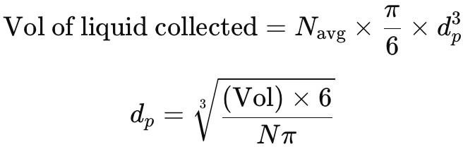

##### Pure MIBK:

1. Needle size: 0.5 mm → dp: 0.00211 m
2. Needle size: 0.9 mm → dp: 0.00235 m
3. Needle size: 1.6 mm → dp: 0.0027 m

##### Contaminated MIBK:

1. Needle size: 0.5 mm → dp: 0.00269 m
2. Needle size: 0.9 mm → dp: 0.00242 m
3. Needle size: 1.6 mm → dp: 0.0028 m

## Terminal Velocity & Average Time of Residence:

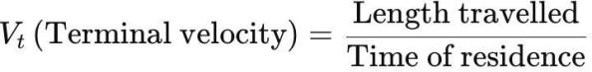

Length travelled = 52 cm = 0.52 m

##### Pure MIBK:

1. Needle size: 0.5 mm
   * Tavg(Residence time) = (6.19 + 6.29 + 6.41)/3 = 6.29
   * Vt = 0.52 / 6.29 ≈ 8.267 ×10−2 m/s
2. Needle size: 0.9 mm
   * Tavg(Residence time) = (6.15 + 6.31 + 6.68)/3 = 6.38
   * Vt = 0.52 / 6.38 ≈ 8.15 ×10−2 m/s
3. Needle size: 1.6 mm
   * Tavg(Residence time) = (6.03 + 5.59 + 5.47)/3 = 5.69
   * Vt = 0.52 / 5.69 ≈ 9.138×10−2 m/s

##### Contaminated MIBK:

1. Needle size: 0.5 mm
   * Tavg(Residence time) = (5.34 + 5.42 + 5.50)/3 = 5.42
   * Vt = 0.52 / 5.42 ≈ 9.59 ×10−2 m/s
2. Needle size: 0.9 mm
   * Tavg(Residence time) = (5.64 + 5.18+ 5.68)/3 = 5.5
   * Vt = 0. 52 / 5.5 ≈ 9.45 ×10−2 m/s
3. Needle size: 1.6 mm
   * Tavg(Residence time) = (5. 84+5.92+ 5.96)/3 = 5.90
   * Vt = 0.52 / 5.90 ≈ 8.81×10−2 m/s

## Calculations KD

Given Data:

γ: Interfacial Tension = 0.0236 N/m

Viscosity of continuous phase(μc) :0.00058 Pa.sec Viscosity of dispersed phase(μd) : 0.00115 Pa.sec density of continuous phase = 802 kg/m³

density of dispersed phase = 1049 kg/m³ Length of Column(L) = 52cm

KD = 0.00375 × Vt × (μc/(μc+μd))

where KD is individual dispersed phase mass transfer coefficient

##### Pure MIBK

* 1. Needle size(0.5 mm) : KD = 0.00375 × 10.016×10⁻² × (0.00058/0.00058+0.00115)

= 0.000126

* 1. Needle size(0.9 mm) : KD = 0.00375 × 9.87 ×10⁻² × (0.00058/0.00058+0.00115) = 0.000124
  2. Needle size(1.6 mm) : KD = 0.00375 × 11.03×10⁻² × (0.00058/0.00058+0.00115) = 0.000138

##### Contaminated MIBK

1. Needle size(0.5 mm) : KD = 0.00375 × 11.63×10⁻² × (0.00058/0.00058+0.00115) = 0.000146
2. Needle size(0.9 mm) : KD = 0.00375 × 11.53 ×10⁻² × (0.00058/0.00058+0.00115)

= 0.000145

1. Needle size(1.6 mm) : KD = 0.00375 × 10.66×10⁻² × (0.00058/0.00058+0.00115) = 0.000134

## Calculation of Mass Transfer rate

NA = KD πdp² (CAD,i – CAD)

CAD,i = 2mol/L

##### Pure MIBK

* 1. Needle(0.5 mm) : NA = 0.000126 × π × (2.11×10⁻³)² × (2-0.63)× 103 = 2.41 ×10⁻⁶

### mol/s

* 1. Needle(0.9 mm) : NA = 0.000124 × π × (2.35×10⁻³)² × (2-0.64)× 103 = 2.92×10⁻⁶

### mol/s

* 1. Needle(1.6 mm) : NA = 0.000138 × π × (2.70×10⁻³)² × (2-0.729)× 103 = 4.015

### ×10⁻⁶ mol/s

##### Contaminated MIBK

1. Needle(0.5 mm) : NA = 0.000146 × π × (2.69×10⁻³)² × (2-1.89)×103 = 3.65

### ×10⁻7 mol/s

1. Needle(0.9 mm) : NA = 0.000145 × π × (2.42×10⁻³)² × (2-1.935)× 103 =

### 1.73×10⁻7 mol/s

1. Needle(1.6 mm) : NA = 0.000134 × π × (2.80×10⁻³)² × (2-1.89)× 103 = 3.63

×10⁻7 mol/s

## Total Mass Transferred:

M = NA × Tavg , where NA is molar flux, Tavg is residence time and M is total moles transferred

##### Pure MIBK

* 1. Needle size(0.5 mm) : M = 2.41×10⁻⁶ × 6.29 = 1.516×10⁻⁵ moles
  2. Needle size(0.9 mm) : M = 2.92×10⁻⁶ × 6.38 = 1.863×10⁻⁵ moles
  3. Needle size(1.6 mm) : M = 4.015×10⁻⁶ × 5.69 = 2.284×10⁻⁵ moles

##### Contaminated MIBK

1. Needle size(0.5 mm) : M = 3.65×10⁻7 × 5.416 = 1.977×10⁻⁶ moles
2. Needle size(0.9 mm) : M = 1.73×10⁻7 × 5.463 = 0.945×10⁻⁶ moles
3. Needle size(1.6 mm) : M = 3.63×10⁻7 × 5.91 = 2.145×10⁻⁶ moles
4. **NRe & S value:**

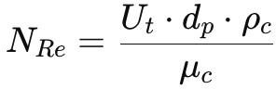

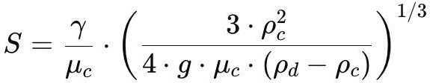

|  |  |  |
| --- | --- | --- |
| **Pure MIBK** |  | |
| Needle (0.5 mm) : | NRe = 292.229 | & S = 2848.9797 |
| Needle (0.9 mm) : | NRe = 320.274 | & S = 2848.9797 |
| Needle (1.6 mm) : | NRe = 413.293 | & S = 2848.9797 |

##### Contaminated MIBK

Needle (0.5 mm) : NRe = 432.592 & S = 2848.9797 Needle (0.9 mm) : NRe = 385.825 & S = 2848.9797 Needle (1.6 mm) : NRe = 412.726 & S = 2848.9797

## NRe/S0.5 value

##### Pure MIBK,

Needle (0.5 mm) : NRe/S0.5 = 5.479 Needle (0.9 mm) : NRe/S0.5 = 6.000 Needle (1.6 mm) : NRe/S0.5 = 7.743

##### Contaminated MIBK

Needle (0.5 mm) : NRe/S0.5 = 8.1046 Needle (0.9 mm) : NRe/S0.5 = 7.228 Needle (1.6 mm) : NRe/S0.5 = 7.732

## Nwe & CD Value:

Since Nre/S0.5 < 12, we have,

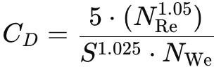

|  |  |  |  |
| --- | --- | --- | --- |
| **Pure MIBK** |  | | |
| Needle 0.5 mm: | Nwe= 0.7190 | & CD= | 0.7766 |
| Needle 0.9 mm: | Nwe= 0.7779 | & CD= | 0.7903 |
| Needle 1.6 mm: | Nwe= 1.1244 | & CD= | 0.7146 |

##### Contaminated MIBK,

Needle 0.5 mm: Nwe= 1.2364 & CD= 0.6817

Needle 0.9 mm: Nwe= 1.0932 & CD= 0.6838

Needle 1 .6 mm: Nwe= 1.0812 & CD= 0.7421

## Theoretical Value of Terminal Velocity:

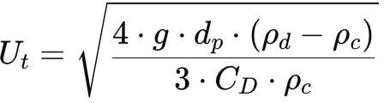

##### Pure MIBK

1. Needle 0.5 mm: Ut = 0.1049 m/s
2. Needle 0.9 mm: Ut = 0.1096 m/s
3. Needle 1.6 mm: Ut = 0.1237 m/s

##### Contaminated MIBK,

1. Needle 0.5 mm: Ut = 0.1261 m/s
2. Needle 0.9 mm: Ut = 0.1190 m/s
3. Needle 1.6 mm: Ut = 0.1238 m/s

## Error:



##### Pure MIBK,

1. Needle (0.5 mm) : Error = 4.23 %
2. Needle (0.9 mm ) : Error = 9.76 %
3. Needle (1.6 mm) : Error = 10.28 %

##### Contaminated MIBK,

1. Needle (0.5 mm) : Error = 7.74 %
2. Needle (0.9 mm) : Error = 3.49 %
3. Needle (1.6 mm) : Error = 13.61 %

# SUMMARY:-

The experiment was conducted with both pure and contaminated MIBK, which shows that since driving force was severely less in contaminated MIBK, hence the molar flux was effectively very small in comparison to other.

Needle size also was varied per case to show effect of drop size in diffusion. In general, size of droplets was seen increasing the mass transfer.

Ultimately, the experiment signified the effect of single drop in diffusion in terms of resistance and mass transfer coefficients.