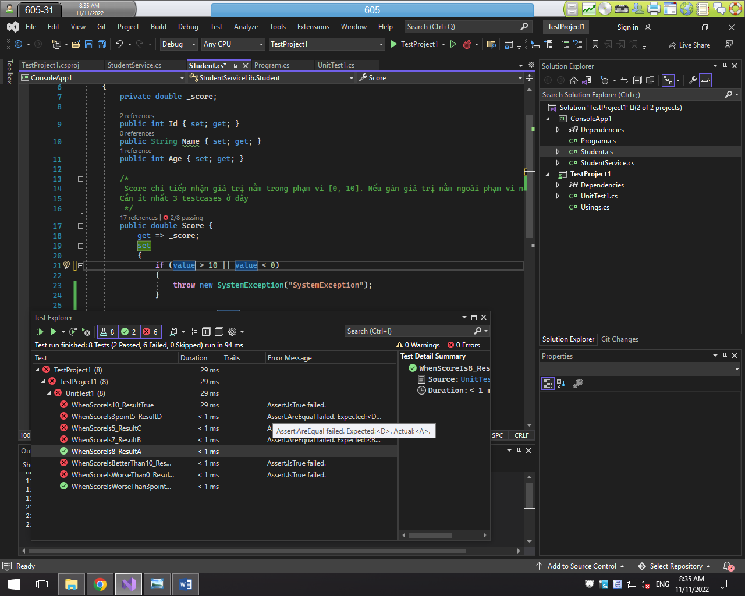

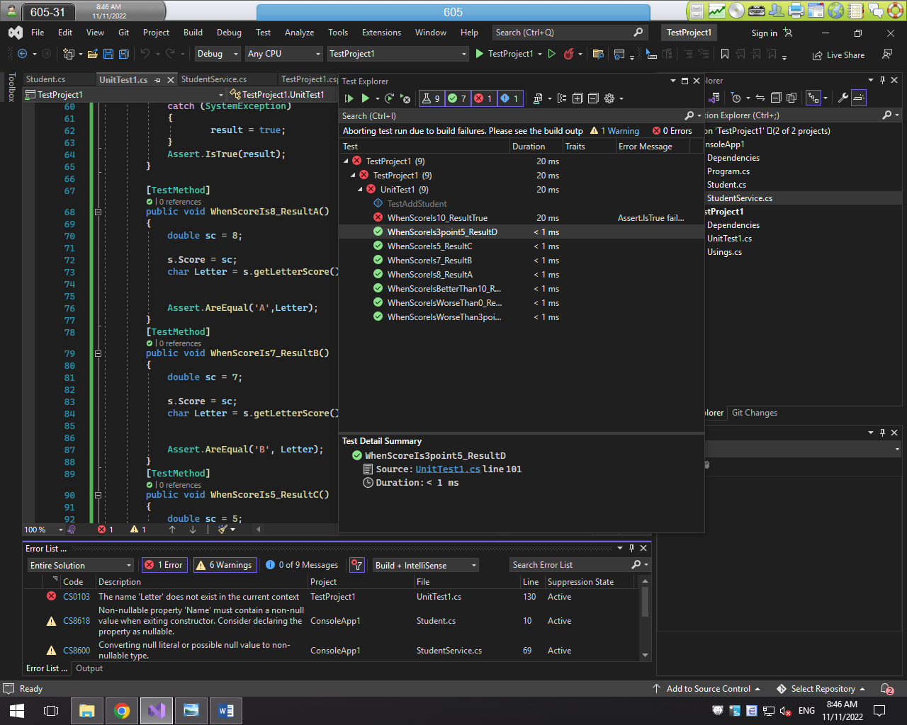

File GitHub: https://github.com/BAK151/520H0079_Lab9.git