**Brainstorming & Idea Prioritization Template**

|  |  |
| --- | --- |
| Date | 31 October 2025 |
| Team ID | NM2025TMID01330 |
| Project Name | Educational Organisation Using ServiceNow |
| Maximum Marks | 4 Marks |

**Brainstorming & Idea Prioritization Template**

Brainstorming provides a creative environment that encourages team members to collaborate and generate innovative ideas. In this project, our goal is to develop a centralized educational management system using ServiceNow that automates administrative, academic, and student-related tasks within educational institutions. The brainstorming session helped us identify key operational problems, generate solutions, and prioritize the most effective ideas for implementation.

**Step 1: Team Gathering, Collaboration and Problem Selection**

Our team collaborated to identify a **real-world challenge** in the education sector that could be simplified through automation using ServiceNow.  
After several discussions, we selected **“Educational Organisation Using ServiceNow”** as our focus project.  
The main challenge was to create a **centralized platform** for managing students, staff, courses, and communication efficiently, while reducing manual effort and data redundancy.

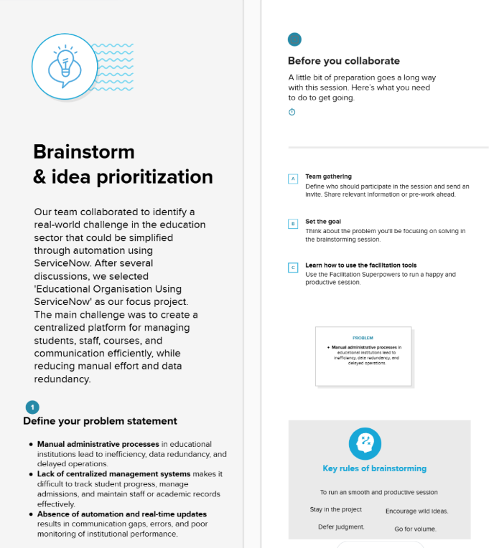

**Step 2: Brainstorming, Idea Listing and Grouping**

We conducted an open brainstorming session where all team members contributed potential ideas.  
Each idea was evaluated and grouped based on its **relevance, feasibility, and potential impact** on improving institutional operations.

**Ideas generated included:**

* Creating a **student management module** for enrollment, attendance, and performance tracking.
* Developing a **faculty portal** for handling course materials, evaluations, and communications.
* Integrating **automated notification systems** for announcements, grades, and deadlines.
* Implementing a **centralized dashboard** for administrators to monitor institutional data.
* Automating **course scheduling and resource allocation** using ServiceNow workflows.
* Enabling **real-time chat and query resolution** between students and faculty.
* Generating **analytical reports** for decision-making and progress tracking.
* 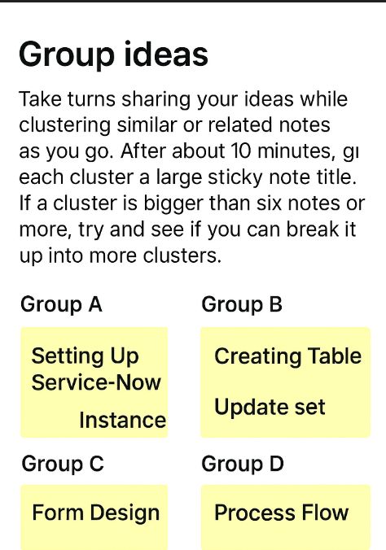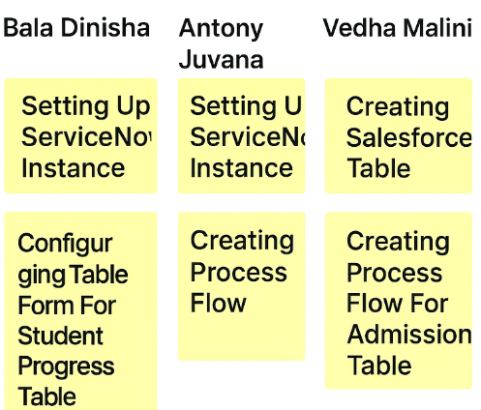

**Step 3: Idea Prioritization**

After idea collection, we used **impact vs. feasibility analysis** to prioritize the best solutions.  
The high-impact and easy-to-implement ideas were chosen for the first implementation phase.

**Prioritized ideas:**

1. Development of centralized student and staff management modules.
2. Creation of automated communication and alert systems.
3. Implementation of dashboard-based performance and analytics tools.
4. Workflow automation for academic scheduling and reporting.
5. Integration of feedback and helpdesk support features.

